RAILWAYS MANAGEMENT SYSTEM

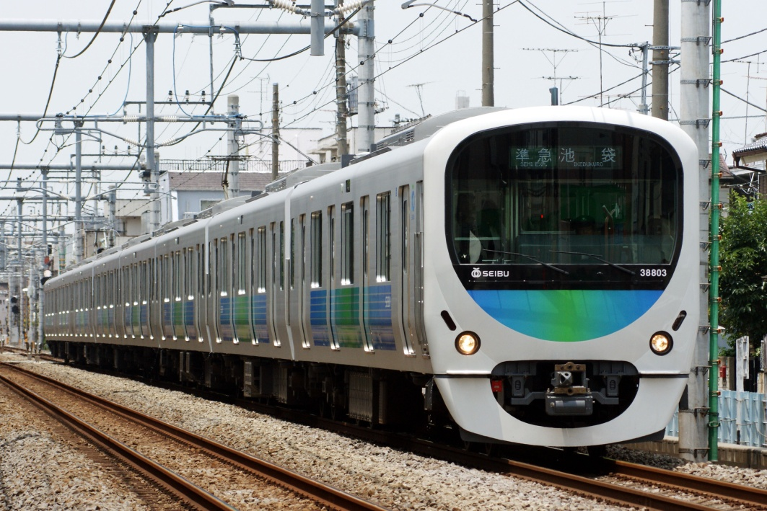

**PARAS MEHAN**

**XII – A**

**ROLL NO.**

CERTIFICATE

This is to certify that **PARAS MEHAN** of class XII –A has successfully completed the project –“**RAILWAYS MANAGEMENT SYSTEM**” in C++ as a partial requirement for the exam AISSC-2018 in COMPUTER SCIENCE (083).

I wish him all the success in his future endeavors in the field of Computer Science

-------------------------------

(Mr.RAJ KUMAR PAL)

ACKNOWLEDGEMENT

With Profound respect and guidance ,I take this privileged opportunity to convey my thanks to Mr. RAJ KUMAR PAL ,my COMPUTER SCIENCE teacher ,for my Project “**RAILWAYS MANAGEMENT SYSTEM**” .

A Profound sense of gratitude is due to their valuable suggestion and co – operation for the report preparation.

Their help and guidance have been instrumental in successful completion of this project. I would like to express my gratitude towards them for their support during my research on the subject and also for their constant encouraging and guidance.

THANKING YOU!!

INDEX

|  |  |  |
| --- | --- | --- |
| SNO. | TOPIC. | PAGE NO. |
| 1. | **INTRODUCTION** | 1 |
| 2. | **ADVANTAGES AND**  **DISADVANTAGES** | 2 |
| 3. | **DATA STRUCTURES**  **USED** | 3-4 |
| 4. | **SOURCE CODE** | 5-34 |
| 5. | **OUTPUT** | 35-41 |
| 6. | **BIBLIOGRAPHY** | 42 |

INTRODUCTION

This project introduces railway reservation system. It explains how reservation is being done

In Indian Railway. This project is developed in **C++ Language**.

All most all the header files have been used in this project.

Proper comments have been given at desired locations to make the project user friendly. Various functions and structures are used to make a complete use of the language. This project is well versed with the programming.

Railway reservation can easily accompanied with the help of this PROPOSED SYSTEM.

ADVANTAGES

* The program is user friendly , it allows to select options through arrow keys.
* The code is written with best indentation and formatting.
* The program allows users to create new station ,new trains, plan journey between stations of different trains.
* It also allows users to create their profiles and **book tickets.**

DISADVANTAGES

* The program didn’t used global variables.
* The code is very long thereby making it difficult to understand.

DATA STRUCTURES USED

* **CLASSES**
  + Idc - used to give id’s to various objects.
  + Station - used to create an object of type station.
  + Train - used to create an object of type train.
  + Pass - used to create an object of type passenger.
  + Tic - used to create an object of type ticket.
  + Emp - used to create an object of type employee.
* **STRUCTURE**
  + Pinfo **-** used to create an object to store the passengers information.
* **FILES**
  + infoc.dat - used to store objects of class pass.
  + Infoe.dat - used to store objects of class emp.
  + Infost.dat - used to store objects of class station.
  + Infot.dat - used to store objects of class train.
  + Infotic.dat - used to store objects of class tic.
  + Id.dat - used to store objects of class idc for passengers.
  + Ide.dat - used to store objects of class idc for employees.
  + Idst.dat - used to store objects of class idc for stations.
  + Idtr.dat - used to store objects of class idc for trains.
  + Idt.dat - used to store objects of class idc for tickets.

SOURCE CODE

/* PARAS MEHAN

XII-A

MIRA MODEL SCHOOL */

#include<fstream.h>

#include<conio.h>

#include<string.h>

#include<stdio.h>

#include<stdlib.h>

#include<iomanip.h>

#include<ctype.h>

#define o1 gotoxy(31,5); \

cout<<"I.R.C.T.C"; \

gotoxy(25,6); \

cout<<"(INDIAN RAILWAY CATERING "; \

gotoxy(22,7); \

cout<<"AND TOURISM CORPORATION LIMITED)";

#define o2 gotoxy(32,5); \

cout<<"I.R.C.T.C.";

#define o3 o2; \

gotoxy(31,7); \

cout<<"RESERVED ZONE";

#define o3b gotoxy(28,3); \

cout<<"I.R.C.T.C.";\

gotoxy(43,4); \

cout<<"ID :"<<id;

#define o4 clrscr(); \

o3b; \

gotoxy(27,5); \

cout<<"TRAIN NO."<<ob.ret_id();

#define o3c clrscr(); \

gotoxy(32,2); \

cout<<"I.R.C.T.C."; \

gotoxy(15,4); \

cout<<"BILL DESK";\

gotoxy(38,4); \

cout<<"PASSENGERS :"<<r;

class idc //FILES USED -infoc.dat,infoe.dat,id.dat,ide.dat,idst.dat,idtr.dat,infost.dat,infot.dat,idt.dat,infotic.dat

{ private:

int i;

public:

idc()

{

}

idc(int a)

{ i=a;

}

int ret_id()

{ return i;

}

};

class station

{ private:

int id,n,tr[10];

char stname[50];

public:

int ret_id()

{ return id;

}

void create_ob();

void show();

void ret_info(int &a,char b[50])

{ a=id;

strcpy(b,stname);

}

};

void station::create_ob()

{ ifstream f("idst.dat",ios::binary);

idc ob;

int flag;

do

{ flag=0;

randomize();

id=random(100);

while(f.read((char *)&ob,sizeof(ob)))

{ if(ob.ret_id()==id)

{ flag=1;

break;

}

}

}while(flag==1 || id==0);

f.close();

ofstream f1("idst.dat",ios::binary|ios::app);

idc ob1(id);

f1.write((char *)&ob1,sizeof(ob1));

f1.close();

clrscr();

o2;

gotoxy(13,7);

cout<<"-ENTER THE STATION NAME :";

gets(stname);

show();

}

void station::show()

{ clrscr();

o2;

gotoxy(13,7);

cout<<"-STATION NAME :"<<stname;

gotoxy(13,8);

cout<<"-STATION ID :"<<id;

getch();

}

class train

{ private:

int id,stno[10],c,n,cap,oc; //oc-occupied

char tname[50];

public:

train()

{ c=0;

oc=0;

}

void create_ob();

void show();

int ret_id()

{ return id;

}

int ret_c()

{ return c;

}

void train::journey(int a,int b[10]);

void ret_st(int &a,int &b)

{ a=stno[0];

b=stno[n-1];

}

void ret_info(int &a,char b[50])

{ a=id;

strcpy(b,tname);

}

int ret_av()

{ return cap-oc;

}

int ret_n()

{ return n;

}

void dec(int a)

{ oc+=a;

}

};

void train::journey(int a,int b[10])

{ c=1;

n=a;

for(int i=0;i<n;i++)

stno[i]=b[i];

}

void train::create_ob()

{ ifstream f("idtr.dat",ios::binary);

idc ob;

int flag;

do

{ flag=0;

randomize();

id=random(100);

while(f.read((char *)&ob,sizeof(ob)))

{ if(ob.ret_id()==id)

{ flag=1;

break;

}

}

}while(flag==1 || id==0);

f.close();

ofstream f1("idtr.dat",ios::binary|ios::app);

idc ob1(id);

f1.write((char *)&ob1,sizeof(ob1));

f1.close();

clrscr();

o2;

gotoxy(13,7);

cout<<"-ENTER THE TRAIN NAME :";

gets(tname);

gotoxy(13,8);

cout<<"-ENTER THE CAPACITY :";

cin>>cap;

show();

}

void train::show()

{ clrscr();

o2;

gotoxy(13,7);

cout<<"-TRAIN NAME :"<<tname;

gotoxy(13,8);

cout<<"-TRAIN ID :"<<id;

gotoxy(13,9);

cout<<"-CAPACITY :"<<cap;

gotoxy(13,10);

cout<<"-SEATS AVAILABE :"<<cap-oc;

if(c==1)

{ gotoxy(13,11);

cout<<"-THE NO. OF THROUGH WHICH THE TRAIN PASSES :"<<n;

gotoxy(13,12);

cout<<"-THE STATIONS ARE :";

gotoxy(25,13);

cout<<"-STARTING FROM ";

gotoxy(25,12+n);

cout<<"-LAST STATION";

for(int i=0;i<n;i++)

{ gotoxy(14,13+i);

cout<<i+1<<") "<<stno[i];

}

}

getch();

}

class pass

{ private:

int id,pnr[50],n,age;

char name[50],hoad[50];//home address

public:

void create_ob();

void show();

int ret_id()

{ return id;

}

void addpnr(int a)

{ pnr[n]=a;

n++;

}

void ret_info(int &a,int b[50]);

void ret_inf(int &a,char b[50])

{ a=id;

strcpy(b,name);

}

};

void pass::create_ob()

{ clrscr();

o2;

gotoxy(14,7);

cout<<"ENTER THE FOLLOWING DETAILS -";

gotoxy(13,9);

cout<<"-NAME :";

gets(name);

gotoxy(13,10);

cout<<"-HOME ADDRESS :";

gets(hoad);

gotoxy(13,11);

cout<<"-AGE :";

cin>>age;

int flag;

do

{ flag=0;

randomize();

id=random(100);

ifstream f("id.dat",ios::binary);

idc ob;

while(f.read((char *)&ob,sizeof(ob)))

{ if(ob.ret_id()==id)

{ flag=1;

break;

}

}

f.close();

}while(flag==1 || id==0);

ofstream f("id.dat",ios::binary|ios::app);

idc ob(id);

f.write((char *)&ob,sizeof(ob));

f.close();

n=0;

show();

}

void pass::show()

{ clrscr();

o2;

gotoxy(14,7);

cout<<"DETAILS ARE-";

gotoxy(13,9);

cout<<"-NAME :"<<name;

gotoxy(13,10);

cout<<"-HOME ADDRESS :"<<hoad;

gotoxy(13,11);

cout<<"-AGE :"<<age;

gotoxy(13,12);

cout<<"-ID :"<<id;

if(n>0)

{ gotoxy(13,13);

cout<<"-TICKETS BOOKED:";

gotoxy(14,14);

cout<<"PNR NO.";

for(int i=0;i<n;i++)

{ gotoxy(11,15+i);

cout<<setw(2)<<setiosflags(ios::left)<<i+1<<")"<<pnr[i];

}

}

getch();

}

void pass::ret_info(int &a,int b[50])

{ a=n;

for(int i=0;i<n;i++)

b[i]=pnr[i];

}

struct pinfo

{ char name[50],g; //g-gender

int age;

};

class tic

{ private:

pinfo pa[10]; //passengers

int trid,pnr,n,f,bprice,tprice; // n - no of passengers

char tname[50];

public:

tic()

{ f=-1;

}

void create_ob(int a,int b);

int entry(pinfo a)

{ if(f<n-1)

{ f++;

pa[f]=a;

return 1;

}

return 0;

}

void price(int a)

{ bprice=a;

tprice=(bprice/100)*118*n; //18 % GST

}

void show();

int ret_pnr()

{ return pnr;

}

};

void tic::create_ob(int a,int b)

{ trid=a;

n=b;

int flag;

do

{ flag=0;

randomize();

pnr=random(100);

ifstream f("idt.dat",ios::binary);

idc ob;

while(f.read((char *)&ob,sizeof(ob)))

{ if(ob.ret_id()==pnr)

{ flag=1;

break;

}

}

f.close();

}while(flag==1 || pnr==0);

ofstream f("idt.dat",ios::binary|ios::app);

idc ob(pnr);

f.write((char *)&ob,sizeof(ob));

f.close();

ifstream f1("infot.dat",ios::binary);

train ob2;

while(f1.read((char *)&ob2,sizeof(ob2)))

{ int a;

ob2.ret_info(a,tname);

if(a==trid)

break;

}

f1.close();

}

void tic::show()

{ clrscr();

o2;

gotoxy(14,7);

cout<<"TICKET DETAILS ARE -";

gotoxy(14,9);

cout<<"PNR NO. :"<<pnr;

gotoxy(45,9);

cout<<"TRAIN NAME :"<<tname;

gotoxy(14,10);

cout<<"BASE PRICE :"<<bprice;

gotoxy(45,10);

cout<<"TAX :GST 18%";

gotoxy(14,11);

cout<<"TOTAL PRICE (inc. of taxes):"<<tprice;

gotoxy(14,12);

cout<<"PASSENGERS INFO :";

gotoxy(45,12);

cout<<"PASSENGERS :"<<n;

gotoxy(14,13);

cout<<"NAME";

gotoxy(30,13);

cout<<"AGE";

gotoxy(34,13);

cout<<"GENDER";

for(int i=0;i<n;i++)

{ gotoxy(12,14+i);

cout<<setw(2)<<setiosflags(ios::right)<<i+1<<")"<<pa[i].name;

gotoxy(30,14+i);

cout<<pa[i].age;

gotoxy(34,14+i);

cout<<pa[i].g;

}

getch();

}

class emp

{ private:

char na[50],had[50]; //home address

int age,id;

public:

void create_ob();

void show()

{ clrscr();

o2;

gotoxy(14,7);

cout<<"DETAILS ARE-";

gotoxy(13,9);

cout<<"-NAME :"<<na;

gotoxy(13,10);

cout<<"-HOME ADDRESS :"<<had;

gotoxy(13,11);

cout<<"-AGE :"<<age;

gotoxy(13,12);

cout<<"-ID :"<<id;

getch();

}

int ret_id()

{ return id;

}

};

void emp::create_ob()

{ clrscr();

o2;

gotoxy(13,9);

cout<<"-ENTER YOUR ID :";

int a,flag=0;

cin>>a;

ifstream f("ide.dat",ios::binary);

idc ob;

while(f.read((char *)&ob,sizeof(ob)))

if(ob.ret_id()==a)

{ flag=1;

id=a;

break;

}

f.close();

if(flag==0)

{ gotoxy(14,11);

cout<<"ERROR!! INVALID ID";

getch();

}

else if(flag==1)

{ clrscr();

o2;

gotoxy(14,7);

cout<<"ENTER THE FOLLOWING DETAILS -";

gotoxy(13,9);

cout<<"-NAME :";

gets(na);

gotoxy(13,10);

cout<<"-HOME ADDRESS :";

gets(had);

gotoxy(13,11);

cout<<"-AGE :";

cin>>age;

show();

}

}

void password(char p[50]);

void login(int &op);

void mainmenu(int &op);

void reserved();

int emp_login();

int entr(train &ob,int id);

void plan_j(train ob,int id);

void e_login();

void p_main();

int booktic(int id);

void main()

{ int op=0;

login(op);

if(op==1)

{ for(;;)

{ clrscr();

mainmenu(op);

if(op==4)

break;

else if(op==1)

{ pass ob;

ob.create_ob();

ofstream f("infoc.dat",ios::binary|ios::app);

f.write((char *)&ob,sizeof(ob));

f.close();

}

else if(op==2)

p_main();

else if(op==3)

{ tic ob;

clrscr();

o2;

gotoxy(14,7);

int a,flag=0;

cout<<"ENTER THE PNR NO. :";

cin>>a;

ifstream f("infotic.dat",ios::binary);

while(f.read((char *)&ob,sizeof(ob)))

if(ob.ret_pnr()==a)

{ flag=1;

break;

}

if(flag==1)

ob.show();

else if(flag==0)

{ gotoxy(14,9);

cout<<"ERROR!! INVALID PNR";

getch();

}

}

else if(op==5)

{ emp ob;

ob.create_ob();

ofstream f("infoe.dat",ios::binary|ios::app);

f.write((char *)&ob,sizeof(ob));

f.close();

e_login();

}

else if(op==6)

e_login();

else if(op==7)

reserved();

else if(op==8)

{ clrscr();

o2;

gotoxy(14,7);

cout<<"-THIS SOFTWARE LETS YOU CREATE PASSENGER ACCOUNT,";

gotoxy(15,8);

cout<<"EMPLOYEE ACCOUNT,NEW STATION,NEW TRAIN ";

gotoxy(15,9);

cout<<"AND BOOK TICKETS!!";

gotoxy(14,10);

cout<<"-YOU CAN CREATE A NEW TRAIN,STATION FROM";

gotoxy(15,11);

cout<<"EMPLOYEE LOGIN BY ENTERING A FEW BASIC INFORMATION";

gotoxy(14,12);

cout<<"-YOU CAN CREATE AN EMPLOYEE ID FROM RESERVED MENU";

gotoxy(15,13);

cout<<"ONCE CREATED YOU HAVE TO SIGNUP USING THIS ID";

gotoxy(15,14);

cout<<"BY SELECTING \"CREATE A NEW ACCOUNT \"FROM THE MAIN MENU";

gotoxy(14,15);

cout<<"-TICKET INFORMATION CAN BE DIRECTLY CHECKED FROM MAIN MENU";

getch();

}

}

}

getch();

}

void login(int &op)

{ clrscr();

o1;

gotoxy(17,11);

cout<<"ENTER PASSWORD TO CONTINUE -";

gotoxy(17,13);

cout<<"ENTER THE PASSWORD :";

char p[50];

password(p);

if(strcmpi(p,"paras")==0)

{ op=1;

gotoxy(17,14);

cout<<"PASSWORD CORRECT !!";

gotoxy(17,15);

cout<<"LOGIN SUCCESSFULL !!";

gotoxy(17,16);

cout<<"(press any key to continue)";

getch();

}

else

{ gotoxy(17,14);

cout<<"BETTER LUCK NEXT TIME !!";

gotoxy(17,15);

cout<<"(press any key to continue)";

}

}

void mainmenu(int &op)

{ for(;;)

{ clrscr();

o2;

gotoxy(15,6);

cout<<"-------------------MENU----------------------";

gotoxy(14,8);

cout<<"- PASSENGER ZONE -";

gotoxy(14,10);

cout<<"-CREATE AN ACCOUNT"; //op=1

gotoxy(14,11);

cout<<"-LOGIN";//op=2

gotoxy(14,12);

cout<<"-CHECK PNR STATUS"; //op=3

gotoxy(14,15);

cout<<"-EXIT THE PROGRAM"; //op=4

gotoxy(45,8);

cout<<"- EMPLOYEE ZONE -";

gotoxy(45,10);

cout<<"-CREATE AN ACCOUNT"; //op=5

gotoxy(45,11);

cout<<"-LOGIN"; //op=6

gotoxy(45,15);

cout<<"-RESERVED ZONE"; //op=7

gotoxy(45,16);

cout<<"-GENERAL INSTRUCTIONS"; //OP=8

if(op==1)

gotoxy(13,10);

else if(op==2)

gotoxy(13,11);

else if(op==3)

gotoxy(13,12);

else if(op==4)

gotoxy(13,15);

else if(op==5) //77-> 75<-

gotoxy(44,10);

else if(op==6)

gotoxy(44,11);

else if(op==7)

gotoxy(44,15);

else if(op==8)

gotoxy(44,16);

cout<<"->";

int a=getch();

if(a==0)

{ a=getch();

if(a==80 && op!=4 && op!=8)

op++;

else if(a==72 && op!=1 && op!=5)

op--;

else if(a==77 && (op==1 || op==2))

op+=4;

else if(a==77 && op==4)

op=7;

else if(a==75 && (op==5 || op==6))

op-=4;

else if(a==75 && op==7)

op=4;

}

else if(a==13)

break;

}

}

void password(char p[50])

{ for(int i=0;;)

{ char a=getch();

if(a==13)

{ p[i]='\0';

break;

}

else if(a=='\b' && i>0)

{ cout<<"\b \b";

i--;

}

else if(a!='\b')

{ p[i++]=a;

cout<<"*";

}

}

}

void reserved()

{ clrscr();

o2;

gotoxy(14,7);

cout<<"ENTER PASSWORD TO CONTINUE :";

char p[50];

password(p);

if(strcmpi(p,"irctc")!=0)

{ gotoxy(14,9);

cout<<"INVALID PASSWORD !!";

getch();

}

else

for(int o=1;;)

{ clrscr();

o3;

gotoxy(15,9);

cout<<"-MAKE AN EMP'S ID"; //O=1

gotoxy(15,10);

cout<<"-VIEW EXISTING STATIONS"; //O=2

gotoxy(15,11);

cout<<"-VIEW EXISTING TRAIN"; //O=3

gotoxy(15,12);

cout<<"-VIEW EXISTING PASSENGERS"; //O=4

gotoxy(15,13);

cout<<"-EXIT"; //O=5

if(o==1)

gotoxy(14,9);

else if(o==2)

gotoxy(14,10);

else if(o==3)

gotoxy(14,11);

else if(o==4)

gotoxy(14,12);

else if(o==5)

gotoxy(14,13);

cout<<"->";

int a=getch();

if(a==13)

{ if(o==1)

{ int a,flag;

do

{ flag=0;

randomize();

a=random(89);

ifstream f("ide.dat",ios::binary);

idc ob;

while(f.read((char *)&ob,sizeof(ob)))

if(ob.ret_id()==a)

{ flag=1;

break;

}

f.close();

}while(flag==1);

a+=10;

idc ob(a);

ofstream f("ide.dat",ios::binary|ios::app);

f.write((char *)&ob,sizeof(ob));

f.close();

clrscr();

o3;

gotoxy(14,9);

cout<<"ID CREATED!!";

gotoxy(14,10);

cout<<"ID No."<<a;

getch();

}

else if(o==2)

{ clrscr();

o2;

station g;

ifstream f("infost.dat",ios::binary);

int i=0;

while(f.read((char *)&g,sizeof(g)))

{ int a;

char b[50];

g.ret_info(a,b);

i++;

gotoxy(14,6+i);

cout<<i<<") NAME :"<<b<<" ID :"<<a;

}

if(i==0)

{ gotoxy(14,7);

cout<<"NO STATION FOUND!!";

}

getch();

f.close();

}

else if(o==3)

{ clrscr();

o2;

train g;

ifstream f("infot.dat",ios::binary);

int i=0;

while(f.read((char *)&g,sizeof(g)))

{ int a;

char b[50];

g.ret_info(a,b);

i++;

gotoxy(14,6+i);

cout<<i<<") NAME :"<<b<<" ID :"<<a;

}

if(i==0)

{ gotoxy(14,7);

cout<<"NO TRAINS FOUND!!";

}

getch();

f.close();

}

else if(o==4)

{ clrscr();

o2;

pass g;

ifstream f("infoc.dat",ios::binary);

int i=0;

while(f.read((char *)&g,sizeof(g)))

{ int a;

char b[50];

g.ret_inf(a,b);

i++;

gotoxy(14,6+i);

cout<<i<<") NAME :"<<b<<" ID :"<<a;

}

if(i==0)

{ gotoxy(14,7);

cout<<"NO PASSENGERS FOUND!!";

}

getch();

f.close();

}

else if(o==5)

break;

}

else if(a==0)

{ a=getch();

if(a==80 && o<5)

o++;

else if(a==72 && o>1)

o--;

}

}

}

int entr(train &ob,int id) // id is of passenger not of train as required for o3

{ ifstream f("infot.dat",ios::binary);

int a;

clrscr();

o3b;

gotoxy(14,7);

cout<<"ENTER THE TRAIN ID:";

cin>>a;

while(f.read((char *)&ob,sizeof(ob)))

if(ob.ret_id()==a)

return 1;

return 0;

}

void plan_j(train ob,int id)

{ o4;

gotoxy(14,7);

cout<<"ENTER THE NO. OF STATIONS THROUGH WHICH THIS TRAIN PASSES :";

int a;

cin>>a;

if(a>1 && a<=10)

{ int i=0,b[10];

do

{ o4;

int ci=0;

for(;ci<i;ci++)

{ gotoxy(14,7+ci);

cout<<ci+1<<") STATION NO."<<b[ci];

}

gotoxy(14,7+ci);

cout<<"ENTER THE STAION NO.THROUGH WHICH THE TRAIN PASSES";

gotoxy(14,10+ci);

cout<<"ENTER THE STATION NO.:";

int d,flag=0;

cin>>d;

ifstream f("idst.dat",ios::binary);

idc p;

while(f.read((char *)&p,sizeof(p)))

if(p.ret_id()==d)

{ b[i++]=d;

flag=1;

break;

}

f.close();

if(flag==0)

{ gotoxy(14,9+ci);

cout<<"ERROR INVALID STATION ID!!";

getch();

}

}while(i!=a);

ob.journey(a,b);

ifstream f1("infot.dat",ios::binary);

train temp;

while(f1.read((char *)&temp,sizeof(temp)))

if(temp.ret_id()==ob.ret_id())

{ ofstream f2("infot.dat",ios::binary|ios::ate);

f2.seekp(f1.tellg()-sizeof(ob),ios::beg);

f2.write((char *)&ob,sizeof(ob));

f2.close();

break;

}

f1.close();

clrscr();

o4;

gotoxy(14,7);

cout<<"JOURNEY SUSSESSFULLY PLANED!!";

getch();

ob.show();

}

else

{ gotoxy(14,9);

cout<<"ERROR!! CANNOT ADD "<<a<<" TRAINS";

getch();

}

}

int emp_login()

{ int l;

clrscr();

o2;

gotoxy(13,8);

cout<<"-ENTER ID :";

cin>>l;

ifstream f("ide.dat",ios::binary);

idc o;

while(f.read((char *)&o,sizeof(o)))

if(o.ret_id()==l)

return l;

gotoxy(14,10);

cout<<"ERROR INCORRECT ID!!";

getch();

return 0;

}

void e_login()

{ int id=emp_login();

if(id!=0)

{ for(int o=1;;)

{ clrscr();

o3b;

gotoxy(13,6);

cout<<"-EMPLYOEE ZONE ";

gotoxy(13,8);

cout<<"-ENTER A NEW STATION"; //O=1

gotoxy(13,9);

cout<<"-INFO OF A STAION"; //O=2

gotoxy(13,10);

cout<<"-ENTER A NEW TRAIN"; //O=3

gotoxy(13,11);

cout<<"-INFO OF A TRAIN"; //O=4

gotoxy(13,12);

cout<<"-PLAN A JOURNEY OF A TRAIN"; //O=5

gotoxy(13,14);

cout<<"-EXIT"; //O=6

if(o==1)

gotoxy(12,8);

else if(o==2)

gotoxy(12,9);

else if(o==3)

gotoxy(12,10);

else if(o==4)

gotoxy(12,11);

else if(o==5)

gotoxy(12,12);

else if(o==6)

gotoxy(12,14);

cout<<"->";

int b=getch();

if(b==13)

{ if(o==6)

break;

else if(o==1)

{ station ob;

ob.create_ob();

ofstream f("infost.dat",ios::binary|ios::app);

f.write((char *)&ob,sizeof(ob));

f.close();

}

else if(o==2)

{ station ob;

ifstream f("infost.dat",ios::binary);

int a,flag=0;

clrscr();

o3b;

gotoxy(14,7);

cout<<"ENTER THE STATION ID:";

cin>>a;

while(f.read((char *)&ob,sizeof(ob)))

if(ob.ret_id()==a)

{ flag=1;

ob.show();

break;

}

if(flag==0)

{ gotoxy(14,8);

cout<<"ERROR!! INVALID ID!";

getch();

}

}

else if(o==3)

{ train ob;

ob.create_ob();

ofstream f("infot.dat",ios::binary|ios::app);

f.write((char *)&ob,sizeof(ob));

f.close();

}

else if(o==4 || o==5)

{ train ob;

int a=entr(ob,id);

if(a)

{ if(o==4)

ob.show();

else if(o==5)

{ if(ob.ret_c()==0)

plan_j(ob,id);

else if(ob.ret_c()==1)

{ for(int s=1;;)

{ o4;

gotoxy(14,7);

cout<<"JOURNEY ALREADY PLANNED!!";

gotoxy(14,9);

cout<<"-PLAN THE JOURNEY AGAIN"; //s=1

gotoxy(14,10);

cout<<"-RETURN TO PREVIOS MENU"; //s=2

if(s==1)

gotoxy(13,9);

else if(s==2)

gotoxy(13,10);

cout<<"->";

int g=getch();

if(g==13)

break;

else if(g==0)

{ g=getch();

if(g==80 && s==1)

s=2;

else if(g==72 && s==2)

s=1;

}

}

if(s==1)

plan_j(ob,id);

}

}

}

else

{ gotoxy(14,8);

cout<<"ERROR!! INVALID ID!";

getch();

}

}

}

else if(b==0)

{ b=getch();

if(b==80 && o<6)

o++;

else if(b==72 && o>1)

o--;

}

}

}

}

void p_main()

{ int id,flag=0;

clrscr();

o2;

gotoxy(13,8);

cout<<"-ENTER ID :";

cin>>id;

ifstream f("id.dat",ios::binary);

idc o;

while(f.read((char *)&o,sizeof(o)))

if(o.ret_id()==id)

{ flag=1;

break;

}

if(flag==0)

{ gotoxy(14,10);

cout<<"ERROR INCORRECT ID!!";

getch();

}

else

{ pass ob1;

ifstream f1("infoc.dat",ios::binary);

while(f1.read((char *)&ob1,sizeof(ob1)))

if(ob1.ret_id()==id)

break;

for(int o=1;;)

{ clrscr();

o3b;

gotoxy(13,6);

cout<<"-PASSENGER ZONE ";

gotoxy(13,8);

cout<<"-BOOK A TICKET"; //O=1

gotoxy(13,9);

cout<<"-VIEW PNR OF BOOKED TICKETS"; //O=2

gotoxy(13,11);

cout<<"-EXIT"; //O=3

if(o==1)

gotoxy(12,8);

else if(o==2)

gotoxy(12,9);

else if(o==3)

gotoxy(12,11);

cout<<"->";

int b=getch();

if(b==13)

{ if(o==1)

{ int a=booktic(id);

if(a)

{ ob1.addpnr(a);

ofstream f2("infoc.dat",ios::ate);

f2.seekp(f1.tellg()-sizeof(ob1),ios::beg);

f2.write((char *)&ob1,sizeof(ob1));

f2.close();

}

}

else if(o==2)

{ clrscr();

o3b;

int d=0,pnr[50];

ob1.ret_info(d,pnr);

if(d>0)

{ gotoxy(14,7);

cout<<"BOOKED TICKETS ARE :";

for(int i=0;i<d;i++)

{ gotoxy(12,9+i);

cout<<setw(2)<<setiosflags(ios::right)<<i+1<<")"<<pnr[i];

}

}

else

{ gotoxy(14,7);

cout<<"ERROR!! NO BOOKED TICKETS FOUND!!";

}

getch();

}

else if(o==3)

break;

}

else if(b==0)

{ b=getch();

if(b==80 && o<3)

o++;

else if(b==72 && o>1)

o--;

}

}

}

}

int select_st(int &st)

{ ifstream f("infost.dat",ios::binary);

int i=0;

station ob;

while(f.read((char *)&ob,sizeof(ob)))

{ i++;

int a;

char b[50];

ob.ret_info(a,b);

gotoxy(13,10+i);

cout<<"-"<<b;

}

f.close();

if(i==0)

return 0;

for(;;)

{ gotoxy(12,10+st);

cout<<"->";

int a=getch();

if(a==13)

{ gotoxy(12,10+st);

cout<<" ";

return 1;

}

else if(a==0)

{ a=getch();

gotoxy(12,10+st);

cout<<" -";

if(a==80 && st<i)

st++;

else if(a==72 && st>1)

st--;

}

}

}

int booktic(int id)

{ clrscr();

int st1=1;

o3b;

gotoxy(25,7);

cout<<"TICKET BOOKING";

gotoxy(14,9);

cout<<"FROM STATION -";

if(select_st(st1))

{ int id1,id2,st2=1,t=0,ti[50],i=1;

char st1name[50],st2name[50];

station ob;

ifstream f("infost.dat",ios::binary);

f.seekg((st1-1)*sizeof(ob),ios::beg);

f.read((char *)&ob,sizeof(ob));

ob.ret_info(id1,st1name);

gotoxy(40,9);

cout<<"FROM STATION :"<<st1name;

gotoxy(14,9);

cout<<"TO STATION : ";

select_st(st2);

f.seekg((st2-1)*sizeof(ob),ios::beg);

f.read((char *)&ob,sizeof(ob));

ob.ret_info(id2,st2name);

clrscr();

o3b;

gotoxy(25,7);

cout<<"TICKET BOOKING";

gotoxy(14,9);

cout<<"FROM STATION :"<<st1name;

gotoxy(14,10);

cout<<"TO STATION :"<<st2name;

gotoxy(14,12);

cout<<"TRAIN NAME";

gotoxy(30,12);

cout<<"BASE PRICE";

gotoxy(41,12);

cout<<"SEATS AVAILABLE";

f.close();

ifstream f1("infot.dat",ios::binary);

train ob2;

while(f1.read((char *)&ob2,sizeof(ob2)))

{ int l1,l2;

ob2.ret_st(l1,l2);

if(l1==id1 && l2==id2 && ob2.ret_av()>0)

{ t++;

char a[50];

ob2.ret_info(ti[t-1],a);

gotoxy(13,12+t);

cout<<"-"<<a;

gotoxy(41,12+t);

cout<<ob2.ret_av();

gotoxy(30,12+t);

cout<<100*ob2.ret_n();

}

}

f1.close();

if(t==0)

{ clrscr();

o3b;

gotoxy(14,7);

cout<<"SORRY NO TRAINS FOUND MATCHING YOUR REQUIRMENT.";

getch();

}

else

{ for(;;)

{ gotoxy(12,12+i);

cout<<"->";

int a=getch();

if(a==13)

break;

else if(a==0)

{ a=getch();

gotoxy(12,12+i);

cout<<" -";

if(a==80 && i<t)

i++;

else if(a==72 && i>1)

i--;

}

}

ifstream f2("infot.dat",ios::binary);

while(f2.read((char *)&ob2,sizeof(ob2)))

if(ob2.ret_id()==ti[i-1])

break;

clrscr();

o3b;

tic ob3;

int r;

do

{ gotoxy(30,7);

cout<<"BILL DESK";

gotoxy(14,9);

cout<<"ENTER THE NO. OF PASSENGERS :";

cin>>r;

if(r<=0 || r>ob2.ret_av() || r>10)

{ gotoxy(14,11);

cout<<"ERROR !! CANNOT ADD "<<r<<" PASSENGERS";

getch();

gotoxy(14,11);

clreol();

gotoxy(14,9);

clreol();

}

}while(r<=0 || r>ob2.ret_av() || r>10);

ob2.dec(r);

ofstream f3("infot.dat",ios::binary);

f3.seekp(f2.tellg()-sizeof(ob2),ios::beg);

f3.write((char *)&ob2,sizeof(ob2));

f2.close();

f3.close();

ob3.create_ob(ob2.ret_id(),r);

o3c;

for(int k=0,c=0;k<r;k++,c++)

{ if(k==7)

{ o3c;

k=0;

r-=7;

}

pinfo ob4;

gotoxy(11,6+3*k);

cout<<setw(2)<<setiosflags(ios::right)<<c+1<<")NAME :";

gets(ob4.name);

gotoxy(40,6+3*k);

cout<<"AGE :";

cin>>ob4.age;

do

{ gotoxy(14,7+3*k);

cout<<"GENDER (M/F): ";

cin>>ob4.g;

if(ob4.g!='m' && ob4.g!='M' && ob4.g!='F' && ob4.g!='f')

{ gotoxy(14,8+3*k);

cout<<"ERROR! INVALID GENDER";

getch();

gotoxy(14,8+3*k);

clreol();

gotoxy(14,7+3*k);

clreol();

}

}while(ob4.g!='m' && ob4.g!='M' && ob4.g!='F' && ob4.g!='f');

ob4.g=toupper(ob4.g);

ob3.entry(ob4);

}

ob3.price(100*ob2.ret_n());

ob3.show();

ofstream f3b("infotic.dat",ios::binary|ios::app);

f3b.write((char *)&ob3,sizeof(ob3));

f3b.close();

clrscr();

o3b;

gotoxy(14,7);

cout<<"TICKET BOOKED SUCCESSFULLY!!";

getch();

return ob3.ret_pnr();

}

}

else

{ clrscr();

o3b;

cout<<"ERROR!! NO STATION FOUND";

getch();

}

return 0;

}

OUTPUT

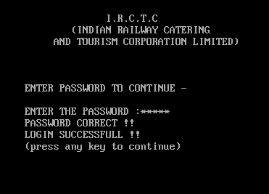

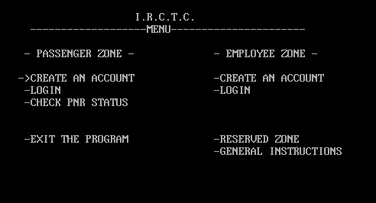

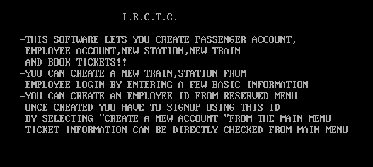

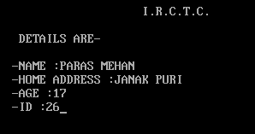

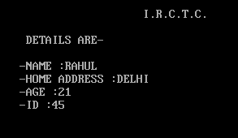

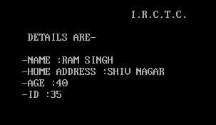

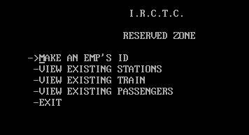

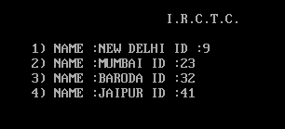

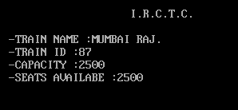

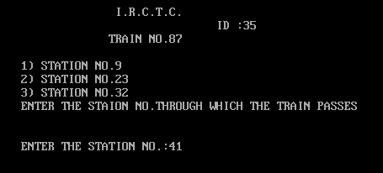

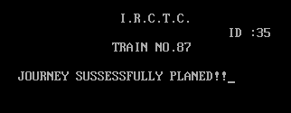

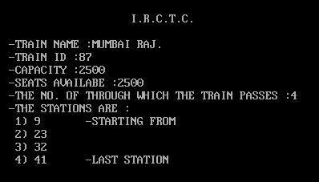

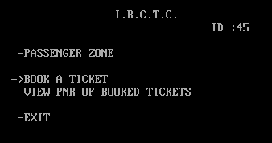

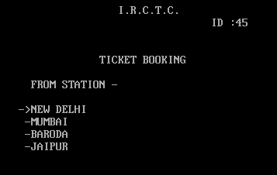

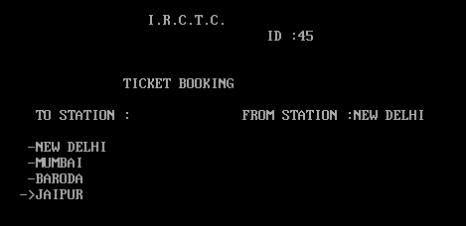

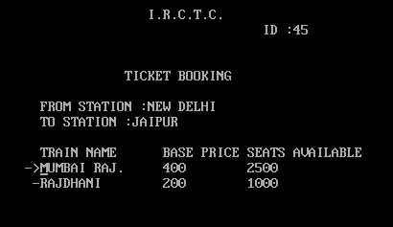

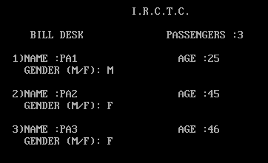

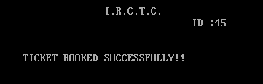

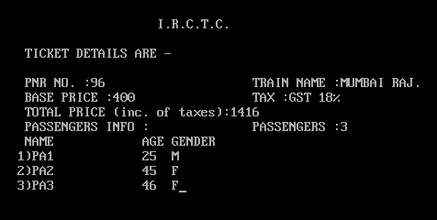

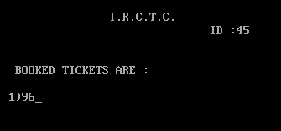

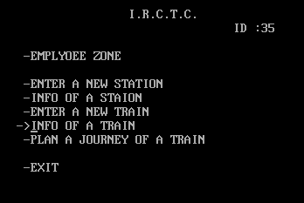

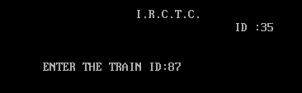

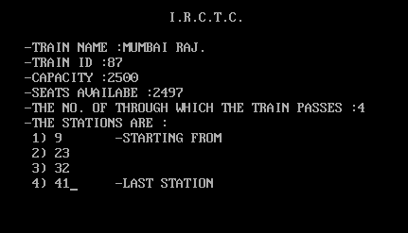

BIBLIOGRAPHY

* STACKOVERFLOW.COM
* WIKIPEDIA