EFFECTIVENESS OF ALTERNATIVE DISPUTE RESOLUTION (ADR) IN RURAL AREA OF BANGLADESH: A STUDY ON VILLAGE SHALISH SYSTEM OF MADHUKHALI UPAZILLA

Md. Zarif Rahman*

The Purpose of this is to evaluate the effectiveness of shalish system in light of the field experience of Madhukhali upazilla of Faridpur in Bangladesh. This study has applied mainly the qualitative research technique to fulfill the research objectives. The primary data has been collected through KIIs (Key informative interviews) and FGD (Focus Group Discussion). “Targeted Sampling” has been followed for conducting KIIs and FGD. In this context experienced village leaders (Matobbor) and beneficiary of shalish system in these areas were the main respondents. To collect the secondary data, information has been also collected from relevant websites, journal articles and books. The study shows that the villagers still relay on the system confidently. Generally, there are two types of process can be observed, which are top-down process and bottom-up process. The top-down process stresses that the shalish may initiate from village leaders end. On the other hand, the bottom-up process stresses that the shalish may initiate from the beneficiary ends. There is no specific conditions and criteria to be a member of shalish board. However, most common types of disputes resolved by shalish are family dispute, land disputes, arson or other kinds of violence, stealing or robbery etc. The major challenges the system have been faced including interference of politics, lack of documentations, lack of legal basis.
Keywords: Alternative Dispute Resolution (ADR), Village Shalish, Village disputes.

1. INTRODUCTION

Alternative Dispute Resolution (ADR) refers any kind of extra-courtroom means of settling disputes including negotiation, conciliation, mediation, arbitration, different local mechanisms etc (American Bar Association of Dispute Resolution, 1997). ADR allows to overcome the existing limitations of traditional litigation-based justice system. Rising costs of litigation, time delays, complicated procedures, backlogs etc. decrease the efficiency of traditional justice system. More often than not, even in the case of simple claims, they can get delayed due to formalities and administrative complications. Thus, experimenting with different ADR methods is increasing all over the world. Some of the programs binding or mandatory and some of them are non-binding or voluntary. Specially the people from rural area find it more convenient as a social structure already exists there which allows them to practice the methods of ADR. Furthermore, given that formal judicial systems are normally located in urban areas, it is difficult for the majority of the population to have physical access to them given that eight in ten Bangladeshis reside in villages.
Although the constitution of Bangladesh gives all the people of the country equal access to justice system, the actual scenario is much more different from the theory. Due to costs, case backlogs and limitations of resources and knowledge the people of Bangladesh specially people from rural area and indigenous community hardly enjoy the full potentiality of the rights. Therefore, informal and local mechanisms for settling disputes such as the Shalish remain relevant strongly in the society of Bangladesh. Through these mechamisms disputants can solve their problems quicker, with few to no costs, and in a way where they are able to express themselves freely given their informal nature. Also, this platform for addressing local disputes can effectively prevent the escalation of violence of these areas (Akram, 2017). Hence, the purpose of this is to evaluate the effectiveness of ADR in Bangladesh in light of village shalish. The study is conducted in Madhukhali upazilla in Faridpur of Bangladesh. The study will explore the procedure of the shalish system, its pros and cons and the challenges it faces from different dimensions.

2. ADR IN BANGLADESH

In Bangladesh, the concept of ADR was first inserted in Section, 10(3) and 13(1) of the Family Court Ordinance of 1985, wherein there is provision for compromise or reconciliation even before pronouncement of judgment. However, there was no real action of implementation of these provisions until 2000. In 2000, a special pilot project was taken on 'Mediation as a measure of ADR'. The project was supervised by the then chief justice of Bangladesh. Under that project, three assistant judge's courts of Dhaka were specified as exclusive Family Courts for the purpose of mediation. Consequently, ADR mechanism in the was introduced for the first time in general judiciary system (civil litigation) in 2003. The Code of Civil Procedure, and the Artha Rin Adalat Ain become the very first acts of quasi-formal mechanism of dispute settlement in Bangladesh. The Code of Civil Procedure (Amendment) Act, 2003 embodied two new sections (89A, 89B) designed for ADR mechanism in all civil suits and cases. The mechanism of ADR in the Artha Rin Adalat was given the look of settlement conference, to be presided over by the trial judge and held in camera (Halim, 2011).
Different NGOs also follow ADR method for settling disputes of their beneficiaries. For example, BLAST, one of leading legal aid-based NGO of Bangladesh, primarily tries to conduct mediation between complaints (BLAST, 1996; Peace Insight, n.d). MLAA (Madaripur Legal Aid Association) is another leading organization who promotes and facilitates ADR. Starting its activities with Free Legal Aid program, we are flourishing through Mediation, activated Village Court and Arbitration Council that are dispute resolution mechanisms of local justice system. Further, providing legal support to reduce overcrowding in prisons, facilitating to activate govt. legal aid services, justice reform and advocacy to legal reforms are also have been brought in our organization’s interventions (MLAA, 2018).
There are three streams of ADR in Bangladesh: 1. Extra-judicial or community-based ADR (Informal) 2.ADR in quasi-formal systems and 3. ADR in formal legal systems. Figure and figure show the structure of formal and informal ADR in Bangladesh (Khair, 2004). This paper particularly gives focus on community-based or informal ADR.

Fig 1: Informal ADR in Bangladesh
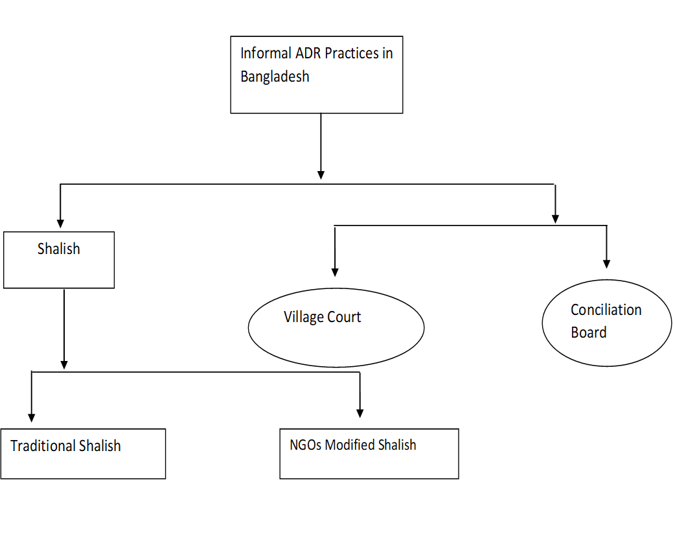

3. METHODOLOGY

The study has conducted at Madhukhali Upazila of Faridpur. Madhukhali Upazila (Faridpur district) area 230.20 sq. km, located in between 23°28' and 23°37' north latitudes and in between 89°29' and 89°44' east longitudes. This study has applied mainly the qualitative research technique to fulfill the research objectives. The target of the data collection part is to evaluate the real scenario of shalish system in the Madhukhali Upazilla. Thus, qualitative method is perfect to find in-dept information. Although quantitative method may help to defend those findings more strongly but for the limitation of budget and time, we cannot adopt the method. The primary data has been collected through KIIs (Key informative interviews) and FGD (Focus Group Discussion). “Targeted Sampling” has been followed for conducting KIIs and FGD. In this context experienced village leaders (Matobbor) and beneficiary of shalish system in these areas were the main respondents.

4. SHALISH AS ALTERNATIVE DISPUTE RESOLUTION IN MADHUKHALI

Like other rural area of Bangladesh, the shalish system is part and parcel in daily life of Madhukhali. It has its traditional values and most of the general people are totally relaying on this system, regarding any kind of dispute they face. Thus, it helps to create a strong social bond within the area just like other rural areas of Bangladesh. The next section of this part of the report will try to evaluate the overall process of the procedures as well as its challenges.

4.1 Overall Process of The Salish

4.1.1 Preconditions: The precondition of conducting the shalish is that the parties must be agreed to obey the decision of the board. When a dispute takes place, sometimes, there head of village, call for Shalish from self-motivation to mitigate the tension in the society. On the other hand, sometimes the conflicting groups call us for making a reconciliation through Shalish. Then a shalish board has been formed to take the final decision. In some cases, the shalish board is formed at the preface. Generally, a conductor is selected to run a shalish. But everyone who are presented in the place of the shalish has the right to speak. During shalish, general people also ask questions. The audience play the role of advocate here but neutral. They raise different questions to bring the truth in light. If answer of the respondents seems doubtful, the audience can raise question about that. The main fact is, the members of shalish board, actually try to evaluate the main scenario. The final verdict is come from the board. However, most of the shalish has been conducted after the litigation. If the both sides are able to reach an understanding, most of the times the case files will be withdrawn. However, if the court already gives a decision, then generally it becomes final. No shalish takes place after the court decision (Personal communication , March 29, 2019).

4.1.2 During Shalish: Generally, there are two parties of the dispute. Both sides are presented in the place of Shalish. At first the members of the board listen the full complaints in details from the complainant. Then the accused person got the chance of defending themselves. If both of the parties give same kind of statement like and the accused person confess the complaints and agree with the decisions of the members of the shalish board, then the board members take the written consent from each group. And finally, they made a decision, documented in the written form. All the present audiences also give signs in that written document of judgement. Generally, the document should be preserved by the chairman of the Shalish board. If necessary, the document is presented in front of court or Thana. If anybody files a litigation, initially some attempts have been taken to mitigate the problem through settlement. In this process, the both sides engage themselves in the Shalish. And after the shalish, the documents are submitted to the officer in charge of the police station for withdrawing the case (Personal communication , March 29, 2019). However, when the verdict has been complete, the board declares it unitedly (Personal communication , March 29, 2019). One of the limitations of the Salish system is that the documents are not preserved. Usually those documents are not needed for further use. However, sometimes the members/organizers take signs from both sides in a blank sheet. Thus, it makes an invisible pressure for obeying the decision. There is an additional condition will be attached that if any of them break the contact the other side can take legal action against them. In that case, the documented paper can be helpful as the evidence (Personal Communication, March 29, 2019).

4.2 Structure of A Shalish Board and The Major Actors

Generally, after the hearing, the members for the shalish board have been chosen. The total number of the members should be odd to avoid the majority problem. The members of the board can be selected by the conflict groups or by the chairman of the shalish (Personal communication , March 29, 2019). Generally, there are 5 to 7 members of a shalish board including the member of Union Parishad and other important persons of the local society. Although there are no distinct criteria to determine this importance which make a person eligible for being a member of the shalish board. These persons may be educated or non-educated, it doesn’t matter. For example, the most renowned “Matobbor” of this village has only studied till class eight. But still the people of the society respect and depend on his opinion. Actually, the persons who are trusted by both conflicting parties. Generally, the persons who are engaged in different social welfare activities and nominated by both parties can be the member of the board (Personal communication, March 29, 2019). Another procedure described by another respondents is both groups called some persons for conducting the Shalish. They format a board with the consent of both groups and conducting the hearing and then make a realistic decision. Generally, a board consists a chairman and six members (3 from each conflicting sides) (Personal communication , March 29, 2019).
There are no specific criteria required for being the member of a shalish board in this context. Most of cases the people who are socially acceptable and respectable are conducted the shalish regardless their economic or political status or educational status. In other words, the people who are dedicated themselves for social works, help other people in terms of any kind of problem are one who are called for the shalish. Because this kind of people have minimum influence in the society. The fact is that the member of the Union Parishad does not have that much function in the society apart from these types of events like Shalish or reconciliation. Village court has a specific pattern in this context. But shalish does not have this kind standard structure. But an age group can be identified in this context. People who are at least 40 or above generally conduct the shalish. In this context, the young people are not welcomed for conducting the shalish. Experience in terms of age is a vital point, in this context (Personal Communication , March 29, 2019).

4.3 Types of Dispute

The respondents from the field has mentioned several types of disputes which are frequently handled by Shalish. Most of the dispute are non-violent in nature in this context. However, in the case of violent conflict and criminal activities the stakeholders primarily go for the litigation. But for the time delays and costs of the litigation process the stakeholders (victims) eventually turn to the Shalish system. Following section describe the major types of disputes/conflicts which are handled by Shalish.

Land Conflict: Land conflict or dispute is the most common type of dispute handled by the Shalish board. According to the respondents there are several types of land conflict take place such as family dispute, dispute between neighbors, land grabbing by force, dispute over isle of arable land etc. However, when it comes to the land documents, the Shalish board generally steps aside because of legal factors. However, most of the solutions do not sustain permanently (Personal Communication , March 29, 2019).

Criminal Activities: Criminal activities such as robbery, stealing, arson, even murder case are handled by Shalish. The respondents reveal that in many cases the decisions of the Shalish are ignored and the perpetrators lobby with the politically influential persons to get away with the crime. Domestic violence is another issue which can be discussed in this context. The village leaders have claimed that the Shalish system is Madhukhali area is gender sensitive and women friendly. They give top priority to domestic violence case and ensure the punishment of the perpetrators. However, this claim is contradictory with the overall scenario of Bangladesh as violence or discrimination against women by Shalish conductors are very common in this country. Damaging the crop is another common type of violence in this area according to the respondents. The shalish board also deal with this type of crime. (Personal Communication , March 29, 2019). Another types of issues like the incidents of stealing or robbery can be raised to the shalish for the justice. (Personal Communication , March 29, 2019).

Family Dispute: Family dispute is one of the most frequent types of conflict in this context. It includes dispute between husband and wife, dispute between brothers or other family stakeholeders etc. Sometimes land conflict and family may overlap with each other. (Personal Communication , March 29, 2019).

4.4 Punishment

Most of the case, both conflicting sides come to an understanding. Mainly financial fine and apology are most common procedures in this context. Both can take place in one case or one of these takes place. In the past, there was a tradition of separating the whole family from the society. But now, the traditional “Somaj” is dissolved. That’s why these kinds of punishment also got extinct (Personal Communication , March 29, 2019). In the past time, different kinds of punishment had been given to guilty persons. Even after the liberation war, punishments like beating them or insult them in front people were common. It has been decreased significantly in the recent times as different human rights organizations come to the rural area and raise aware about human rights. However, the village leaders believe that these violent actions actually worked. According to them, the people who had received these kinds of treatment did not repeat the crime. (Personal Communication , March 29, 2019).

5. EFFECTIVENESS OF ADR SYSTEM IN BANGLADESH: FROM THE LIGHT OF THE CASE

From the discussion from the previous section of the report, this section will try to evaluate the trues effectiveness of ADR system in Bangladesh. There are several dimensions of effectiveness can be addressed in this context such as reducing the cost of justice, reducing case backlogs from the court, building social capital, reducing corruption, biasness.

Reducing the Cost of Justice: The members of the shalish board do not get any kind of honorarium (Personal Communication , March 29, 2019). Sometimes, when any kind of violence takes place, the board asked the accused side to bear all the expanses of medical treatment for the wounded. Sometimes the board fined the accused side and gives the money to the complainants. But the people who conduct the shalish do not get a penny for their service. They do it from their responsibility towards the society. There are social workers. They do not get discouraged for that they do not get any payment. Rather they enjoy the whole process (Personal Communication , March 29, 2019). Thus, it significantly reduces the cost of the justice.

Reducing the Workload of the Court: As some of the case studies shows that the disputes of the village area are protracted in nature. Thus, when any party files a case, there is a big chance that will hang in the court for a long time. It also time consuming for the court also. Even some serious cases don’t get much attention for some silly cases. In this case, the village shalish is able to resolve these cases within a few moments

Building Empathy and Social Norms: The shalish system encourages the people to compromise on any kind of issue. In other words, it encourages the win-win situation. Thus, it plays a significant role in terms of reconciliation within the party.

Success rate: One of the respondents said that the success rate of the Salish is about 80%. Another one told its more 95%. This high success rate shows that shalish is able to establish the true justice within the society.

Relationship with court: In the sensitive cases, like murder case, if the parties come to a settlement, the trick has been played with witness. The judge may also understand the fact but remain silent. Sometimes the police may create obstacle. In this context, the parties somehow manage them through bribe or fine (Personal Communication , March 29, 2019). Thus, it can be said that the relationship with court is good.

Free from Corruption: In the village shalish, power does not play any vital role. Because the members of the court are also powerful. So, whatever the power status of the complainants and defendants, it does not play any role in this context. So, there is no space for any kind of corruption.

6. CHALLENGES and LIMITATIONS

Intrapersonal Conflict: Bad blood between different important persons in the society is one of main challenges for the Shalish system. Some the influential persons outside of the Shalish board, who have bad relations with members of the Shalish board, try to influence one of the parties for breaking the understanding or disagreeing with Shalish Board. Sometimes some conflicts may serve some interests to someone. Those persons may not want to let the conflict get resolved. That’s why try to make obstacle in the reconciliation procedure in different ways. However, there is no issue in terms of security in village (Personal Communication , March 29, 2019).

Role of Politics: The main challenge or obstacle of shalish is the politics. The party centric politics destroys the nobility of the shalish system. The politics is the biggest obstacle in this context. If the victim has not close people from the ruling party or got relatives from opposing parties, there is a high chance that they may not get the justice. The little conflictual incidences directly come to shalish. But big and sensitives issues firstly raise to the court but when it becomes long times, then they turn to shalish (Personal Communication , March 29, 2019). However, one of the limitations is that Shalish board cannot take any serious decision or impose any kind of serious punishment apart from financial fine. If anybody does not obey the decision, the shalish board cannot impose it (Personal Communication , March 29, 2019).

Reluctance of Parties: Sometimes one of the parties may not want to engage in a shalish for a particular person. The main problem of Shalish is its lack of power. If any party break the control, the board has no power to do anything. In presents, the traditional shalish system is almost extinct. They don’t have any kind of force. Another reason of failure of Shalish that sometimes the members themselves may involve in nepotism, which may turn very harmful for the procedure. Even sometimes they take bribe from the parties. (Personal Communication , March 29, 2019).

Lack of enforcement capacity: One of the main things which reduces the effectiveness of ADR is the lack of enforcement capacity of the ADR. The village leaders have not any kind of force to impose the decision. Thus, gradually the bindings of the shalish system get loosen from the society.

6. CONCLUSION

The shalish system is the undivided part of the culture of rural Bangladesh. The study shows that the villagers still relay on the system totally. Generally, there are two types of process can be observed, which are top-down process and bottom-up process. The top-down process stresses that the shalish may initiate from village leaders end. On the other hand, the bottom-up process stresses that the shalish may initiate from the beneficiary ends. There is no specific conditions and criteria to be a member of shalish board. However, most common types of disputes resolved by shalish are family dispute, land disputes, arson or other kinds of violence, stealing or robbery etc. The major challenges the system have been faced including interference of politics, lack of documentations, lack of legal basis. However, the village shalish system plays a great role for resolving conflict and help the overall judiciary system. The whole system should be promoted and protected as a cultural heritage and effective conflict tool through all the means.

7. RECOMMENDATIONS

- The interference of politics in the shalish system should be reduced. In this context, social awareness should be built.
- Proper documentations of the shalish session should be maintained. In this context, the administration should supervise the issue, at least about the documentation.
- More research should be conducted to evaluate the real scenario of the shalish system.
- Proper promotions of the system are needed for the system.
- Specific amount of fund should be allocated for the procedures.
- Public dialogue session can be initiated where the leaders of village will be presented as the resource person. Their experience can be valuable for resolving conflict in other dimensions even in the international arena.
- More enforcement power should be provided to the village leader.

REFERENCES
ADR Register, (2019). Info about (candidate) ADR practitioners. [online] Adr-register.com. Available at: https://adr-register.com/for-adr-practitioners [Accessed 25 Apr. 2019].
Akram, S. (2017). A Critical Analysis of Access to Justice in Bangladesh. International Journal of Humanities and Social Science Invention, 6(8).
American Bar Association of Dispute Resolution. (1997). Focus on the Rand Report. Dispute Resolution magazine, Volume 3, p. 4.
BLAST (1996). BLAST Annual Report 1996, viewed 16th April, 2019. Retrieved from https://www.blast.org.bd/content/anualreport/1995-96.pdf
Community Legal Services. Bangladesh Legal Aid and Services Trust (BLAST), 2016. viewed 20th April,2019. Retrieved From http://communitylegalservice.org/bangladesh-legal-aid-and-services-trust-blast/>
Halim, A. (2011). ADR in Bangladesh: Issues and Challenges, January, p- 49
Madhukhali Upazila - Banglapedia. (2015). Retrieved from http://en.banglapedia.org/index.php?title=Madhukhali_Upazila
Khair, S. (2004). Alternative Dispute Resolution: How it works in Bangladesh, Dhaka University Studies, Part- F, Vol- XV (1).
MLAA (2018). Activity Report, Madaripur: Madaripur Legal Aid Association.
Peace Insight. (n.d.). Bangladesh Legal Aid and Services Trust (BLAST) viewed 20th April,2019.< https://www.peaceinsight.org/conflicts/bangladesh/peacebuilding-organisations/bangladesh-legal-aid-and-services-trust-blast/>
Siddiqui, K. (1998). 'In Quest of Justice at the Grass Roots', Journal of Asiatic Society of Bangladesh, Vol. 43, No.1, 1998; Fazlul Huq, Towards' a Local Justice System for the Poor, Dhaka.

Respondents of KIIs:
Md. Habibur Rahman, Principle, Makrail Madrasa, Madhukhali, Faridpur. Date of interview: March 29, 2019.
Biplob Kumar Biswas. Beneficiary of village Shalish and Non-government Employee. Date of interview: April 15, 2019.

Participants of Focus Group Discussion:
1. Abul Hashem Fakir, Village Leader
2. Sohorab Hossen Khan, Village Leader
3. Md. Arafat Ali, Mosque Imam
4. Md. Ziaur Rahman, Retired Government Officer

* Research Assistant and President of the Youth Forum, Right to Peace. Email: zarifrahman111@gmail.com

