A Comparative Study and factors affecting Online and Offline Shopping Behavior of Consumers in Bareilly, UP
Dr.Dayaram, Mr.Himanshu
__________________________________________________________________
ABSTRACT This paper uses a Google forms questionnaire survey to gather data, which is then analyzed to study consumer behavior and the relationship between consumer characteristics and online and offline shopping in order to make predictions about how to best serve both online and offline businesses' interests.102 questionnaires in total are gathered. To compute frequency and percentages and to examine the relationships between different variables spss, and Google forms are utilized. By examining the linear relationship and the data distribution, the relationship between the two is inferred. Analysis reveals that despite becoming a trend, the majority of individuals still like internet purchasing. However, individuals continue to use an offline method of shopping that is comparable to online shopping. While offline products typically consist of clothing, groceries, snacks, skincare, and make-up products, etc., internet products are typically comprised of clothing, cosmetics, skincare, and snacks. Online purchasing has also become popular in the future. In order to increase the number of people who buy offline, offline retailers can enhance the overall shopping experience for customers by focusing more on the sensations and actual consumption that shopping brings about.
Keywords: - online shopping, offline shopping, consumer behaviour, attitude, products

Authors
- First Author- Dr.Dayaram, Associate Professor, Department of Commerce, Bareilly College, Mahatma Jyotiba Phule Rohilkhand University, Bareilly, Uttar Pradesh, India. dayaramgangwar@gmail.com
- Second Author- Mr.Himanshu, PhD. Research Scholar, Department of Commerce, Bareilly College, Mahatma Jyotiba Phule Rohilkhand University, Bareilly, Uttar Pradesh, India. Himanshuk2013@gmail.com
- INTRODUCTION
To purchase products and services, people used to visit the market or a retail establishment (Tauber, 1972). During the purchasing process, they go through many stages (Engel et al., 1995). Because of evolving lifestyles and the accessibility of modern technology, consumer behavior
Has altered Consumers now use technology to aid them in performing daily actions including obtaining, consuming, and discarding goods and services (Cho et al., 2006). Is online shopping more popular than offline shopping (Bidhuri, 2020)? Or, to put it another way, do people prefer to purchase offline or online when it comes to their purchasing habits? This is crucial to understand from the standpoint of a retailer and marketer (Kacen, Hess, & Chi, 2013). For a marketing company to survive and succeed in the current marketing environment, it is essential
To voice certain concerns and look for solutions any person who purchases goods or services for personal use is referred to as a "consumer." This style of shopping has been practiced all throughout the world since ancient times. The majority of business operations follow this mode
The development of internet technology has given marketers and retailers new business opportunities. Marketers want to give customers a wide range of channel buying options throughout a shopping excursion. Online shopping is anticipated to significantly increase in importance in consumers' daily lives. Online shopping describes buying and selling goods and services over the internet. It promotes merchants to make their products and services available online in order to expand their customer base. Marketers develop cutting- edge advertising campaigns for their products and services. Customers now have new options at traditional stores as well. Some companies give their customers the opportunity to shop both online and offline. A wide range of factors affects people's purchasing choices. In the past, numerous researches has been conducted to better understand consumer behavior and to pinpoint all of the factors that affect it. Technology is currently developing quickly, and this has a significant impact on people's purchasing decisions (Cho et al., 2006). In addition, COVID-19 unexpectedly occurred in 2020. Since the majority of them will be stranded at home due to this catastrophe, many people have shifted their shopping from offline to online. The popularity of online purchasing has skyrocketed throughout this time. The number of offline physical stores is steadily declining, and some businesses are in financial trouble. Therefore, it is important to study consumer attitudes and psychology regarding online and offline shopping in order to help online and offline retailers enhance their offerings and draw more customers in order to maximize their own interests and value. This research will offer some useful market recommendations to online and offline merchants by examining the views of various customer types on online and offline shopping, as well as the categories of items they consume and some suggestions made to create a comprehensive arrangement.

- LITERATURE REVIEW
Aron M. Levin, Irwin P. Levin, and Joshua A. Weller all noted that consumer preferences for various items, customers, and shopping experience phases would vary between online and offline buying. Their study's sample reveals that while males are more inclined than women to purchase electronics and computer equipment online, women are more likely to do so when purchasing apparel. Additionally, Chayapa asserts that consumers' decision-making processes are remarkably similar whether they shop offline or online. However, some variations in the retail environment and marketing practices could affect consumers' decisions. Additionally, in the Bukola Olamidun Falode study, the main focus is on the online and offline shopping motivations of consumers of apparel in Nigeria's Ibadan Metropolis. They think that the majority of people prefer to shop locally. The proportion of consumers that just purchase online is quite modest because consumers shop both offline and online. They think that because people love to buy as a pleasurable pastime, some offline ambient elements would also influence how they shop. Retailers still need to understand how to combine online and offline marketing methods to optimize their worth even while Internet technology can help businesses increase service quality, cut costs, increase production efficiency, and boost profitability. To optimize our own interests and value from target to all clients, a business should operate both online and offline. However, shopping online is preferable since it offers individuals convenience and speed that offline shopping does not. Additionally, there are certain issues with offline stores that need to be resolved. Since consumers believe that buying makes them happy, offline businesses should focus more on making customers happy when they shop and have a positive shopping experience in order to draw in more customers. In the Indian consumer group, there are notable disparities between how customers shop through online and offline media based on particular criteria, according to a study by Raja Sarkar and Dr. Sabyasachi Das. The majority of Indian shoppers still favor the supposedly "genuine" shopping experience in brick-and-mortar stores, despite the fact that internet sales are increasing quickly in India and are predicted to continue growing. According to Aron M. Levin, Irwin P. Levin, and C. Edward Heath's research, various products have various requirements for boosting their online or offline presence. However, the ongoing use of online shopping by consumers may allay their concerns and alter their current position. While some aspects of the offline shopping experience are preferred, some aspects of the internet shopping experience are thought to be superior (Yan, 2020).

  - FATORS AFFECTING SHOPPING
Attitude: Online grocery shoppers' judgments are influenced by their personal values (Hansen, 2008). According to a survey, consumer opinions toward online grocery shopping are crucial to how often they will utilize the service (Jasti & Syed, 2019). Consumer attitudes are influenced by perceived benefits and consumer trust (Al-Debei et al., 2015). Consumer behavior is influenced by consumer mindset (Kanade & Kulkarni, 2020). The primary determining factor for internet shopping was found to be attitude (Jadhav & Khanna, 2016). The survey's findings showed that customers' past experiences had a substantial impact on their intention to repurchase (Lodorfos et al., 2006). In addition to the simplicity of use, enjoyment, and usefulness, Exogenous factors including product qualities, consumer traits, prior online buying experiences, situational considerations, and trust in online purchasing also have an impact on attitudes toward and intention to shop online (Monsuwe et al., 2004). Consumer perceptions of the benefits of online shopping have been found to have a significant impact (Al-Debei et al., 2015). According to a study, situational factors have an impact on customer decision-making about the purchasing channels. A number of factors affect attitudes toward internet shopping and the willingness to do so (Huang & Oppewal, 2006). Although this association depends on whether the consumer has previously made an online purchase or an online grocery buy, personal values are related to views toward online food shopping (Monsuwe et al., 2004). The consumer's prior experience with online shopping also has an impact on this relationship (Hansen, 2008).
Demographic variables: Demographic traits and brand preferences differ significantly from one another (Shamshuddi et al., 2020). Male respondents are more inclined to shop for technical items, but female respondents are more interested in online shopping and more likely to buy clothing and accessories (Saluja et al., 2018). Because they don't understand technology as well as younger people, those over 35 are less likely to shop online. (2017) Sivanesan etal there is a correlation between gender and online shopping, but not between online shopping and education (Choudhury & Dey, 2014). It was shown that the consumer desire to switch from physical to online buying is strongly moderated by gender (Handayani et al., 2020). The findings show that females' hedonic shopping motivation and purchase intentions across all product categories are significantly impacted by offline gendered behavior (Davis et al., 2014). A study conducted in the Jorhat region of Assam to identify the factors that influence online purchasing behavior discovered a positive and substantial relationship between family income and online shopping services (Dutta, 2020).

Trust: Online shopping services are positively and significantly correlated with users' trust in websites and risk aversion (Dutta, 2020). The results show that trust is the main determinant of consumers' attitudes toward internet buying (Al-Debei et al., 2015). Trustworthiness was shown to be the key factor influencing factors for internet purchases (Jadhav & Khanna, 2016). During offline buying, the most important consideration was a manufacturer's reputation (Gupta & Sharma, 2018). The results show that trust has a significant influence on online purchasing decisions (Napitupulu & kartavianus, 2014). Customers' judgments of the importance of trust were significantly influenced by their interactions with an online brand (Lodorfos et al., 2006). Trust has a positive and significant influence on online purchasing decisions (Irawan, 2018). Consumers' perceptions of e-commerce are influenced by the quality of e-commerce, which determines trust (Ha & Stoel, 2009).
Perceive risk: The respondents' risk aversion is positively and significantly correlated with their use of online shopping services (Dutta, 2020). The results imply that one of the elements influencing customers' intentions to switch from offline to online purchasing in Indonesia is perceived channel risk. People may avoid making online purchases due to perceived risk (Handayani et al., 2020). Internet purchasing is influenced by risk perception (Forsythe & Shi, 2003). People are cautious to make online purchases due to the perceived risk (Yousaf et al., 2012). Risk perception is impacted by the delivery cost (Wiryawan, 2009). In the study, the researcher discovered factors that affect consumer behavior, including perceived risk (risk associated with the product, money, information, debit or credit card, non-delivery, poor delivery, and so on) (Kanade & Kulkarni, 2020). The most important factors, according to a study on consumers' opinions of online buying, our privacy, the company's reputation, and accurate product information (Shanthi & Kannaiah, 2015) When it comes to returning, exchange, and refund procedures, online businesses are thought to have a competitive disadvantage (Kacen et al., 2013).
Convenience: The study identified access, search, assessment, transaction, and possession/post- purchase convenience as the components of online shopping convenience (Jiang et al., 2013). Convenience is one of the elements that affect online shopping (Yousaf et al., 2012). A study found that despite the perceived ease of buying online, consumers remain unwilling to do it. The perceived convenience is influenced by delivery costs (Wiryawan, 2009). Convenience is the main factor pushing customers to make purchases online (Baubonien & Guleviit, 2015). The most significant influencing factor for internet purchase was identified as convenience (Jadhav & Khanna, 2016). Consumers' contact with an e-brand had a significant impact on how they perceived the value of convenience in the online world (Lodorfos et al., 2006). The results showed that convenience has a positive and significant impact on online shoppers' decisions (Irawan, 2018).
Delivery: According to the study, one element influencing consumers' intentions to switch from offline to online shopping in Indonesia is the perceived difference in delivery time (Handayani et al., 2020). Customer sensitivity to delivery delays is very high (Bauerová, 2018). Delivery time is one of the most crucial factors in online shopping (Shanthi & Kannaiah, 2015). Respondents are reluctant to shop online for three reasons: perceived convenience, perceived danger, and perceived fun. The price of delivery affects a person's feeling of satisfaction and risk (Wiryawan, 2009).
Perceived Enjoyment: Perceived enjoyment affects online purchases; claims research (Yousaf et al., 2012). Respondents are reluctant to make online purchases because they want to feel like they're having fun. The delivery price has an impact on how much pleasure is felt (Wiryawan, 2009). The quality of online shopping affects consumers' opinions of it, which in turn affects how much they enjoy it (Ha & Stoel, 2009). Perceived enjoyment was demonstrated to affect attitudes toward online purchasing and the propensity to shop online (Monsuwe et al., 2004). Perceived enjoyment was demonstrated to affect attitudes toward online purchasing and the propensity to shop online (Monsuwe et al.2004).
Price: According to Baubonien and Guleviit (2015), the main factor influencing people to shop online is the lower price. If the price of the goods was less than the going rate, they would choose to shop online. According to a study, online buying is crucial (Sivanesan et al., 2017). Price, according to another study, is the most crucial factor (Shanthi & Kannaiah, 2015). Price was found to be the most important consideration while shopping online. There is a significant association between online purchasing and product pricing (Jadhav & Khanna, 2016; Choudhury & Dey, 2014). Price plays a big role in people's decision to shop online (Liao & Cheung, 2001). Online shopping is impacted more than physical shopping is by perceived cost (Yousaf et al., 2012). Repurchase intent and perceived cost are positively correlated (Wu et al., 2014).The results of a study show that consumers' intentions are impacted by the perceived cost of converting from offline to online buying (Handayani et al., 2020).

Security: The product's security factors were found to be the most crucial component (Shanthi & Kannaiah, 2015). Interactions with an e-brand had a significant impact on how consumers perceived the importance of security (Lodorfos et al., 2006). Security has a little and unfavorable impact on online purchasing decisions (Irawan, 2018). Transaction security has a significant impact on consumers' initial propensity to shop online (Liaoa & Cheung, 2001).
Ease of use: The study found that factors like usability have an impact on consumer behavior (Kanade & Kulkarni, 2020). The ease of use was identified as the primary determining factor for online shopping (Jadhav & Khanna, 2016). The results suggest that perceived ease of payment has a significant influence on online purchasing decisions (Napitupulu & Kartavianus, 2014) Although perceived ease of use has little impact on opinions of e-commerce (Ha & Stoel, 2009). People's opinions toward online purchasing and desire to shop online are influenced by how easy it is to use (Monsuwe et al., 2004).
Variety of Product Choice: Product availability was thought to be the factor that affected online shopping the most (Jadhav & Khanna, 2016). A survey found that most respondents preferred internet shopping because it gave them access to a broader selection of goods (Saluja et al. 2018). Product variety was thought to be the factor that most affected internet shopping (Jadhav & Khanna, 2016). When purchasing offline, the variety of products available was incredibly important (Gupta & Sharma, 2018)
Technology: The study discovered that factors related to technological adoption had an immediate positive effect on customer satisfaction and e-loyalty (Lin & Sun, 2009). According to a different study, while new technology may enhance the shopping experience, apps must be customized to meet the unique requirements of various consumer segments and product categories (Burke, 2002).
Purchase Intention: Consumers' prior experience with online shopping is crucial in deciding which mode to use since it ties personal values to attitudes about attitudes toward online food buying (Hansen, 2008). Another study found that consumer experiences with an e-brand had a significant impact on how important ease and trust were to them in the online environment (Lodorfos et al., 2006). According to research by Monsuwe et al. (2004), exogenous factors like prior online buying experience can affect attitudes about and intentions for online shopping. Website service quality may directly influence customer e-loyalty and e-satisfaction, according to Grace T.R. Lin and Chia-Chi Sun's 2009 study on the factors influencing consumer happiness and loyalty in online buying (Lin & Sun, 2009). According to research, the level of customer service has a positive and significant influence on people's decisions to shop online (Irawan, 2018).The results of a study indicate that the caliber of the material has a significant influence on online purchasing decisions (Napitupulu & kartavianus, 2014). IT Education has a significant impact on the initial desire to shop online, according to a study carried out in Singapore to ascertain Singaporeans' initial inclination to do so (Liao & Cheung, 2001). The results of this study show that consumers' perceived value and each cost factor are positively related to their propensity to make another purchase (Wu et al., 2014). The investigation found that guarantees are the one that has the largest influence (Shanthi & Kannaiah, 2015). The results of a study indicate that the benefits of online shopping have a significant influence on those selections (Napitupulu & kartavianus, 2014). The study claims that online shops offer a wider variety of brands (Kacen et al., 2013). The product's brand had a significant impact on offline purchases (Gupta & Sharma, 2018).

3. RESEARCH METHODOLOGY
3.1Study area
This research based on primary data that was gathered by a Google Forms in Bareilly city, Uttar Pradesh, India.
3.2 Population, Sample size, and Technique
The target population used in this survey belongs to Bareilly city and the sample size used here is 102, which was collected by random sampling method.
3.3 Data Collection and Procedure
Data collection for this research was done through Google Forms in which 15 multiple choice questions were prepared and the link to Google form was sent to different people to take the responses from the people of Bareilly city.
3.4 Data Analysis
Statistical Package for the Social Sciences (spss) version 25 and Google Forms was used to analyze the data using Descriptive statistics such as frequency, percentage, and relationship between different variables. And 102 questionnaires were administered.

- RESULTS
4.1 Social demographics and preferred retail setting. Table 1 shows the descriptive statistics of the samples and information about the respondents' demographic characteristics, including sex, education, marital status, and income. More men (54.9%) than women Responded, overall (45.1%). 92.2% of people reported being single (not married), and 7.8% reported being married. People with school level education (5.9%), College undergraduates (49%), graduate students (40.2%), and people with other levels of education (4.9%). According to the statistics results in this survey, 13.7 percent of respondents prefer internet shopping, 5.9 percent prefer offline shopping, and 80.4 percent use both methods of purchasing.
TABLE.1 SOCIO-DEMOGRAPHIC CHARACTERISTICS OF RESPONDENTS

Frequency |  |  | Percentage
Sex Male |  | 56 | 54.9%
 | female | 46 | 45.1%
 | Total | 102 | 100%
Marital status Single |  | 94 | 92.2%
 | married | 8 | 7.8%
 | Total | 102 | 100%
Educational level School level |  | 6 | 5.9%
 | Undergraduate | 50 | 49.0%
 | Postgraduate | 41 | 40.2%
 | Others | 5 | 4.9%
 | Total | 102 | 100%
Income per month 10000-20000 |  | 33 | 32.4%
 | 20000-30000 | 10 | 9.8%
 | 30000-40000 | 8 | 7.8%
 | 40000-50000 | 5 | 4.9%
 | Others | 46 | 45.1%
 | Total | 102 | 100%
Preferred-shopping Online environment shopping |  | 14 | 13.7%
 | Offline shopping | 6 | 5.9%
 | Both | 82 | 80.4%
 | Total | 102 | 100%

4.2 Description of consumer’s shopping frequency. The descriptive statistics of the samples are shown, which provide information about the shopping frequency of consumers. In online shopping 40.2% of consumers shop about once a month, 23.5% once a quarter, 23.5% once a week, and less than 10% once a year and others. In offline shopping 36.3% of the consumer shop about once a week, 32.4% once a month, 17.6% on daily basis, and less than 10% once a quarter and year.
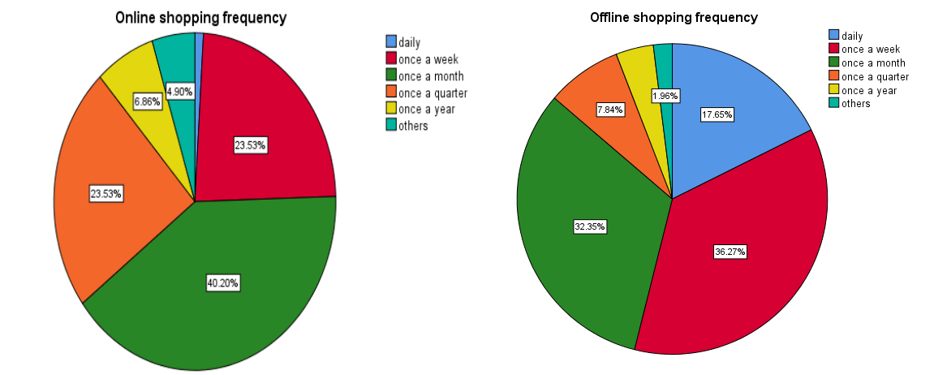
4.3 Description of characteristics of consumers related to shopping online and offline.
The descriptive statistics of the samples are shown in the following figures, which provide information about the relationship between consumers' characteristics and their preferences for online and offline. As can be seen from the chart, online shopping has become a trend in males and females, marital status, and educational backgrounds. Consumers of any type are more likely to shop online or both ways of shopping. Male tends to do more shopping than female and also choose both ways of shopping more than female. Single are choosing more to shop than married people as per the data collected. Undergraduate, postgraduate, and people with other educational levels tend to do more online shopping than offline. People with higher income shop more online than offline and allover people do more online shopping than offline shopping as per the data collected in Bareilly.
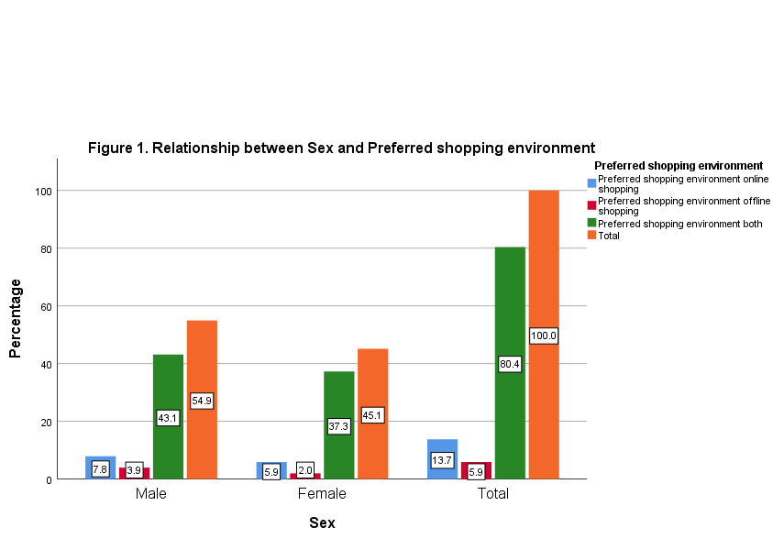

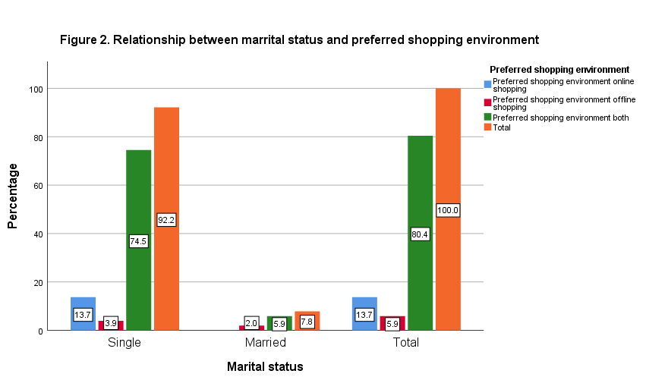

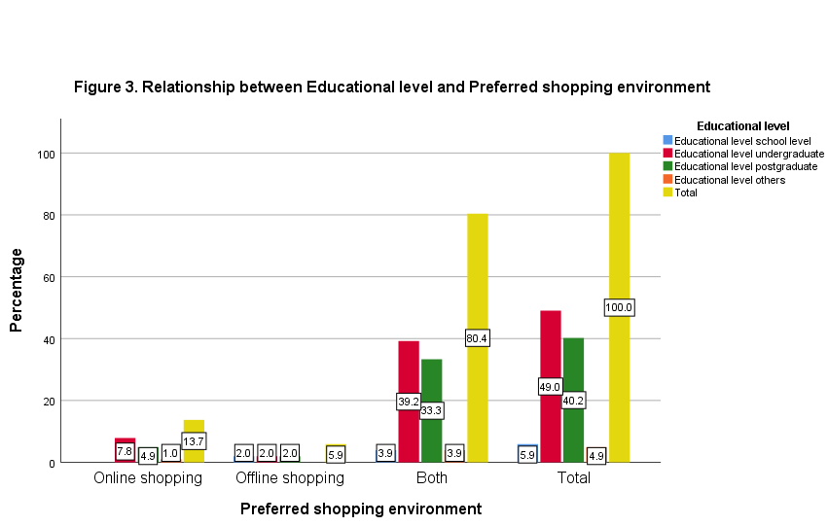

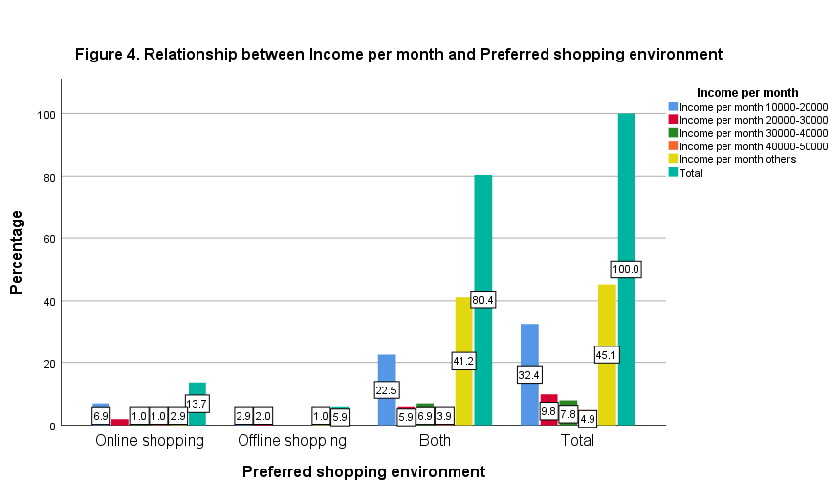

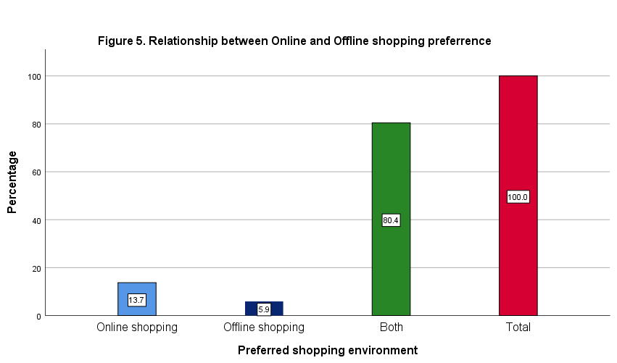
4.4 Description of consumers’ motivation for shopping online and offline. The descriptive statistics of the samples are shown in Figure 6 and 7, which provides information about consumers' consumption motivations both online and offline. The reason why more than 50% like online shopping is that it saves them time, so they can buy the products they like very quickly and conveniently. Another 45.1% and 47.1% are due to the greater variety and discounts offered online. The reason why more than 60% of people like offline shopping is that they can touch and feel the actual quality of the product, and they can try on clothes and buy clothes that fit them better. Part of the reason is that there are quality and easy returns.
Figure 6 Consumer’s motivation for shopping online

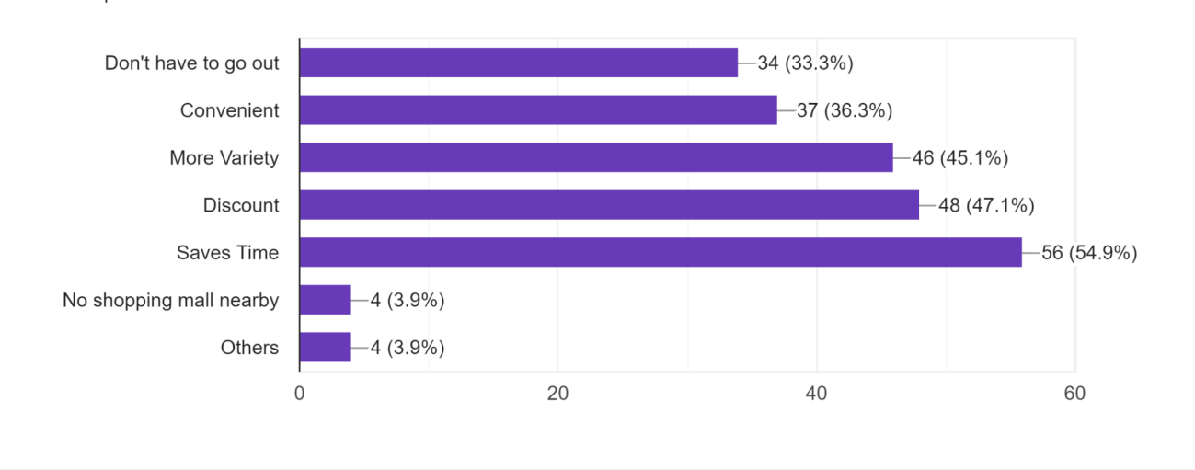

Figure 7 Consumer’s motivation for shopping offline
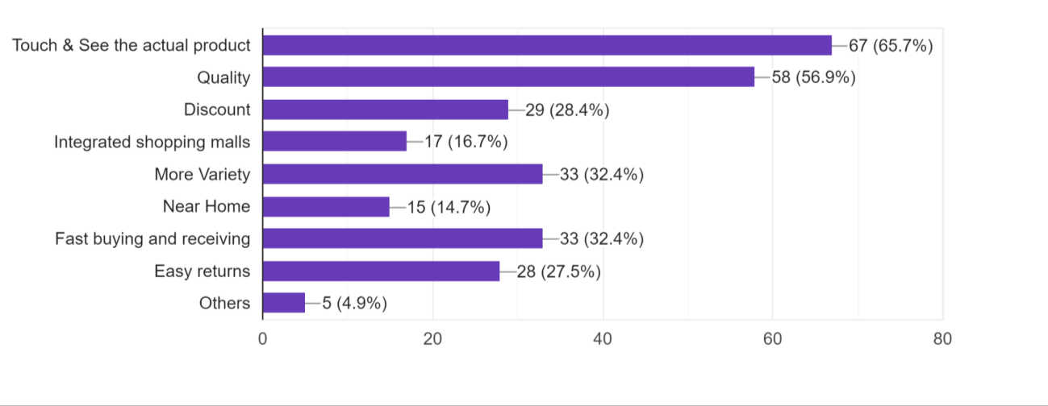
4.5 Description of consumer’s preferred shopping categories of shopping online and offline.
The descriptive statistics of the samples are shown in Figure 8 and 9, which provides information about consumers' online and offline consumption products. Most online shoppers prefer to buy clothing products, skincare, and make-up, as well as readymade food. Most offline shoppers prefer to buy clothes, groceries, snacks, skincare and make- up, readymade food, and jewelry.
Figure 8 Consumer’s shopping categories for shopping online

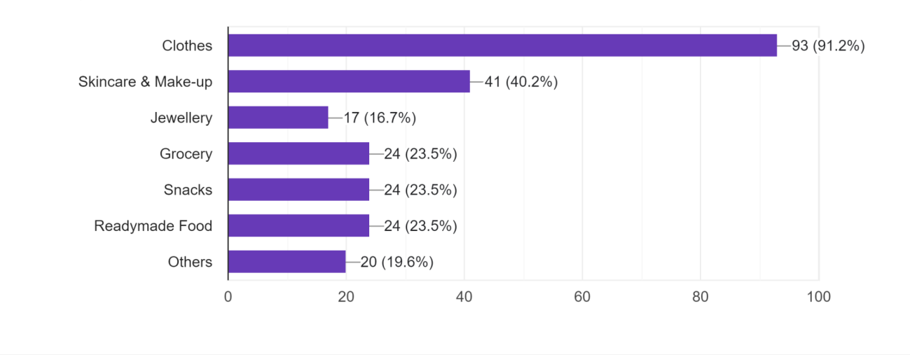
Figure 9 Consumer's shopping categories for shopping offline

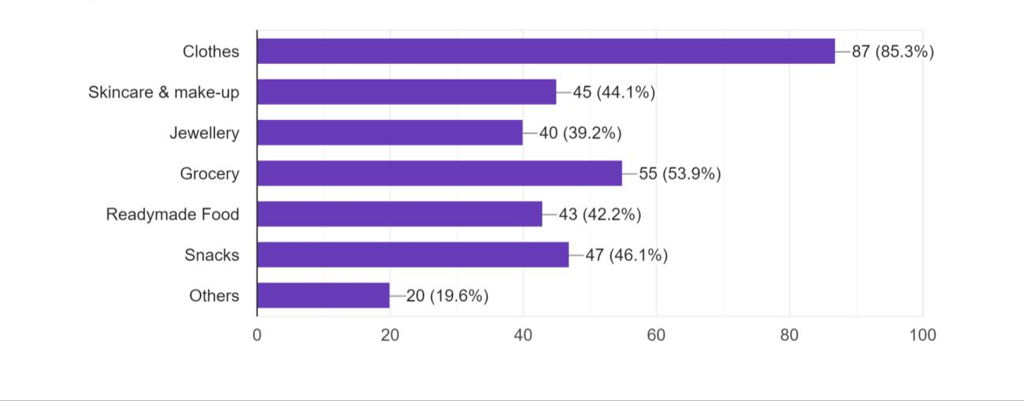

5. IMPLICATIONS
Managerial implications
The findings have significant ramifications for businesses that already offer or intend to offer online and offline retail services. The initial conclusion is that online modes must to be dependable, easy to use, pleasurable, and in keeping with customers' ideals and lives. This can be accomplished by working with influencers who can persuade other customers to use the new technology (Siyal, Ding, Siyal, 2019). Marketers and retailers must therefore concentrate on infrastructure that is relevant to security (Giovanis, Assimakopoulos, & Sarmaniotis, 2018).
Policy implication
The government should spend a lot of money fostering digital literacy, according to the study's main policy suggestion (Rastogi & E, 2018). Governmental organisations and service providers from the commercial sector should be encouraged to foster digital literacy, especially in rural areas. The user must be instructed as well electronic services. The digital divide and digital illiteracy must be closed, and this calls for a friendly atmosphere. The institutional design should make sure that the internet is properly connected, even in isolated areas. The government should seek to foster an atmosphere that will increase internet access, motivate businesses to accept digital payments from their customers, and increase awareness of their availability and use (Sobti, 2017).
Theoretical Contribution
By outlining what is now understood about the relationship between factors and consumer purchasing behavior as well as what isn’t; this study contributes to the body of knowledge in this area. The study closes the gaps by identifying the underlying barriers that consumers face while making purchases, whether they are made offline or online. It talks about some of the most crucial ramifications for the studied field. Research in the topic is also advanced by studying the central concepts that have served as the basis for inquiries.

- RECOMMENDATION FOR FUTURE RESEARCH
We are happy to provide new opportunities for future research, which indicates a potential for future investigation given the expanding interest in the subject of consumer behaviour. Doing thorough empirical investigations on the application of various strategies/approaches to comprehend customer purchasing behaviour is another important recommendation. Additionally, as no much research on this subject has been found, as this article indicates. Similar to that, no research on user post-adoption behaviour was discovered. Researchers need to focus more on the factors that persist even after an offline or online mode is adopted. Lastly, we underlined the need for future research to appropriately take into account the existence of retailers and service providers as well as their impact on customer purchasing decisions. We encourage academics to investigate how companies and marketers provide answers to their offerings.

- LIMITATIONS OF STUDY
Due to the time, the number of questionnaires is only 102, which is not enough to represent the views and experiences of the majority of consumers and the research covers only the geographical area of Bareilly Additionally, additional information is required to draw a fair conclusion, and single-blind and double-blind trials are necessary to gather accurate data and make ideas for improvement.

- CONCLUSION
Online shopping has become commonplace. People are more likely to shop online, regardless of their career, gender, or educational level. Customers can purchase the most desirable things in the shortest amount of time thanks to online shopping's increased convenience for consumers in terms of the brands offered and the variety of products. Online buying offers higher discount than physical purchasing because of how convenient Internet technology makes it for retailers. Online shopping is unavoidably becoming more and more popular due to its convenience and competitive pricing for online retailers. The advantage of offline shopping, according to the findings, is that customers can avoid waiting by grabbing the goods as soon as they are purchased. To truly understand a product's quality, you need to touch and feel it. You may also try things on in real stores to select the best outfits and lessen the likelihood of changing and returning them, which saves time and energy. The types and brands of offline shopping are gradually expanding thanks to the construction of large shopping malls, and they are on par with those of internet shopping. Additionally, in order to get consumer feedback on how offline shopping may be improved, consumers are asked if they have any issues with local parking lots and shopping guides' customer service. Therefore, offline purchasing is still necessary. Therefore, offline businesses should focus more on the customer's shopping experience, and retailers can hold some offline activities that are appropriate, exclusive, or guided, or use tools like artificial intelligence (AI) to change clothes to enhance our offline shopping experience. At the same time, advertisements can also persuade you to go out and shop with friends, using the lens of social media to encourage people to do so likewise, online shopping can make people feel more social.

- REFERENCES
Al-Debei, M.M., Akroush, M.N. and Ashouri, M.I. (2015), "Consumer attitudes towards online shopping: The effects of trust, perceived benefits, and perceived web quality", Internet Research, Vol. 25 No. 5, pp. 707-733. https://doi.org/10.1108/IntR-05-2014- 0146
Aron M. Levin, Irwin P. Levin, C. Edward Heath. PRODUCT CATEGORY DEPENDENT CONSUMER PREFERENCES FOR ONLINE AND OFFLINE SHOPPING FEATURES AND THEIR INFLUENCE ON MULTI-CHANNEL RETAIL ALLIANCES. 2003.
Aron M. Levin, Irwin P. Levin, Joshua A. Weller A MULTI-ATTRIBUTE ANALYSIS OF PREFERENCES FOR ONLINE AND OFFLINE SHOPPING: DIFFERENCES ACROSS PRODUCTS, CONSUMERS, AND SHOPPING STAGES. 2005.
Baubonienė, Ž. & Gulevičiūtė, G. (2015). E-commerce factors influencing consumers ‘online shopping decision. Socialinės Technologijos, 5(1),74-81, DOI:10.13165/ST-15-5- 1-06
Bauerová, R. (2018). Consumers’ Decision-Making in Online Grocery Shopping: The Impact of Services Offered and Delivery Conditions. Acta Universitatis Agriculturae et Silviculturae Mendelianae Brunensis, 66(5), 1239-1247. https://doi.org/10.11118/actaun201866051239
Bidhuri, A (2020, June 20). Online VS Offline Shopping: Which one do you prefer? Retrieved March 07, 2021, from https://www.pinkvilla.com/lifestyle/people/online-vs- offline-shopping-which-one-do-you-prefer-542972
Burke, R. R. (2002). Technology and the customer interface: what consumers want in the physical and virtual store. Journal of the Academy of Marketing Science, 30(4), 411-432. https://doi.org/10.1177/009207002236914
Chayapa. K. Online shopper behavior influences of online shopping decision. 2011.
Cho, C. H., Kang, J.,&Cheon, H. J. (2006). Online shopping hesitation. CyberPsychology & Behavior, 9(3), 261-274. https://doi.org/10.1089/cpb.2006.9.261
Choudhury, D., & Dey, A. (2014). Online shopping attitude among the youth: A study on university students. International Journal of Entrepreneurship and Development Studies, 2(1), 23-32. : Retrieved March 08, 2021, from https://www.researchgate.net/publication/274696373
Davis, R., Lang, B., & San Diego, J. (2014). How gender affects the relationship between hedonic shopping motivation and purchase intentions? Journal of Consumer Behaviour, 13(1), 18-30. https://doi.org/10.1002/cb.1450
Dutta, M. (2020) Factors Affecting Internet Purchasing Behaviour in Jorhat District of Assam. International Journal of Recent Technology and Engineering, 8(6), 1223-1226. DOI:10.35940/ijrte.F7398.038620
Engel, J.F., Blackwell, R.D. and Miniard, P.W. (1995) Consumer Behavior. 6th Edition, Dryden Press, Chicago, New York
Falode, B. O., Amubode, A. A., Adegunwa, M. O., & Ogunduyile, S. R. (2016). Online and offline shopping motivation of apparel consumers in Ibadan metropolis, Nigeria. International Journal of Marketing Studies, 8(1), 150-160.
Forsythe, S. M., & Shi, B. (2003). Consumer patronage and risk perceptions in Internet shopping. Journal of Business Research, 56(11), 867-875. https://doi.org/10.1016/S0148- 2963 (01)00273-9
Giovanis, A., Assimakopoulos, C., & Sarmaniotis, C. (2019). Adoption of mobile self-service retail banking technologies: The role of technology, social, channel and personal factors. International Journal of Retail & Distribution Management, 47(9), 894-914. DOI:10.1108/IJRDM-05-2018-0089
Gupta, R., & Sharma, N. (2018). Factors Affecting Offline & Online Shopping Behavior of Respondents: An Empirical Study of Pune City.
Ha, S., & Stoel, L. (2009). Consumer e-shopping acceptance: Antecedents in a technology acceptance model. Journal of business research, 62(5), 565-571. http://dx.doi.org/10.1016/j.jbusres.2008.06.016
Handayani, P. W., Nurahmawati, R. A., Pinem, A. A., & Azzahro, F. (2020). Switching intention from traditional to online groceries using the moderating effect of gender in Indonesia. Journal of Food Products Marketing, 26(6), 425-439. https://doi.org/10.1080/10454446.2020.1792023
Hansen, T. (2008). Consumer values, the theory of planned behavior, and online grocery shopping. International Journal of Consumer Studies, 32(2), 128-137. https://doi.org/10.1111/j.1470-6431.2007.00655.x
Huang, Y. and Oppewal, H. (2006), "Why consumers hesitate to shop online: An experimental choice analysis of grocery shopping and the role of delivery fees", International Journal of Retail & Distribution Management, Vol. 34 No. 4/5, pp. 334-353. https://doi.org/10.1108/09590550610660260
Irawan, I. A. (2018). Effect of trust, convenience, security, and quality of service on online purchase decision (consumer case study in tangerang selatan area). Jurnal Ekonomi, 23(1), 114-122. http://dx.doi.org/10.24912/je.v23i1.337
Jadhav, V., & Khanna, M. (2016). Factors influencing online buying behavior of college students: A qualitative analysis. The Qualitative Report, 21(1), 1-15. Retrieved March 07, 2021, from http://nsuworks.nova.edu/tqr/vol21/iss1/1
Jasti, D., & Syed, A. A.(2019). Leveraging the Internet for Grocery Shopping: A Study of Factors Influencing the Indian Consumer. International Journal on Emerging Technologies, 10(3), 436-443. ISSN No. (Online): 2249-3255
Jiang, L. A., Yang, Z., & Jun, M. (2013). Measuring consumer perceptions of online shopping convenience Journal of Service Management, 24(2), 191-214. https://doi.org/10.1108/09564231311323962
Kacen, J. J., Hess, J. D., & Chiang, W. Y. K. (2013). Bricks or clicks? Consumer attitudes toward traditional stores and online stores. Global Economics and Management Review, 18(1), 12-21. https://doi.org/10.1016/S2340-1540 (13)70003-3
Kanade, V. S., & Kulkarni, M. P. M. (2020). Understanding Consumer Buying Behavior in an Online (Web store) and offline (Service Retail store) for Entertainment Services in Nashik City. Purakala .Vol-31-Issue-21-May-2020. ISSN: 0971-2143
Liao, Z., & Cheung, M. T. (2001). Internet-based e-shopping and consumer attitudes: an empirical study. Information & Management, 38(5), 299-306. https://doi.org/10.1016/S0378-7206 (00)00072-0
Lin, G. T., & Sun, C. C. (2009). Factors influencing satisfaction and loyalty in online shopping: an integrated model. Online information review, 33(3), 458-475. DOI 10.1108/14684520910969907.
Lodorfos, G. N., Trosterud, T. A., & Whitworth, C. (2006). E-Consumers’ attitude and behavior in the online commodities market. Innovative Marketing, 2(3), 77-96. ISSN 1816-6326 (online).
Napitupulu. T. A and Kartavianus O. (2014). A Structural Equations Modeling of purchasing decisions through e-commerce. Journal of Theoretical and Applied Information Technology, 60 (2), 358-364. Retrieved March 07, 2021, from http://www.jatit.org/volumes/sixtyth_2_2014.php
Perea y Monsuwe, T., Dellaert, B. G. C., & de Ruyter, J. C. (2004). What Drives Consumers to ShopOnline? A Literature Review. International Journal of Service Industry Management, 15(1), 102-121. https://doi.org/10.1108/09564230410523358
Raja Sarkar, Dr. Sabyasachi Das.Online shopping vs. Offline Shopping: A Comparative Study. 2017.
Rastogi, S. and E., R. (2018), Financial inclusion and socioeconomic development: gaps and solution. International Journal of Social Economics, 45(7), 1122-1140. https://doi.org/10.1108/IJSE-08-2017-0324
Saluja, R., Soni, R., & Vardia, S. (2018). Online & Offline Consumer Buying Behavior (With reference to Udaipur City). Pacific Business Review International, 10(10), 74-83. Retrieved March 08, 2021, from http://www.pbr.co.in/2018/april9.aspx
Shamshuddin, S., Venkateswarulu, T., & Shaik, H. (2020). A Study on Consumer Buying Behaviour towards Fmcg’s Mosquito Refill Products With Reference To Selected Districts of State of Andhra Pradesh. EPRA International Journal of Economics, Business and Management Studies (EBMS).7(2), 18-28. https://doi.org/10.36713/epra1013
Shanthi, R., & Desti, K. (2015). Consumers' perception on online shopping. Journal of Marketing and Consumer Research, 13, 14-21. ISSN 2422-8451. Retrieved March 07, 2021, from https://iiste.org/Journals/index.php/JMCR/article/view/24487
Sivanesan, R., Monisha, C., Babisha, P. V., & Abisha, S. A. (2017). Comparative Study on Factors Influencing Online and Offline Shopping. International Journal of Research in Management & Business Studies, 4(3), 26-34. IJRMBS-4SPL-3-1705. http://ijrmbs.com/vol4issue3SPL1/monisha.pdf
Siyal, A. W., Ding, D., & Siyal, S. (2019). M-banking barriers in Pakistan: a customer perspective of adoption and continuity intention. Data Technologies and Applications, 53(1), 58-84. https://doi.org/10.1108/DTA-042018-0022
Sobti, N. (2019). Impact of demonetization on diffusion of mobile payment service in India: Antecedents of behavioral intention and adoption using extended UTAUT model. Journal of Advances in Management Research, 16(4), 472-497. https://doi.org/10.1108/JAMR-09-2018-0086
Tauber, Edward M. Marketing notes and communications: Why do people shop? Journal of marketing 36.4 (1972): 46-49. https://doi.org/10.1177/002224297203600409
Wiryawan, Z. Z. (2009). Why consumers hesitate to shop online: an experimental choice analysis of book shopping and the role of delivery fees. Karya Ilmiah Dosen, 3(2), 83- 100. Retrieved March 13, 2021, from http://ejournal.ukrida.ac.id/ojs/index.php/MB/article/view/113/111
Wu, L. Y., Chen, K. Y., Chen, P. Y., & Cheng, S. L. (2014). Perceived value, transaction cost, and repurchase-intention in online shopping: A relational exchange perspective. Journal of Business Research, 67(1), 2768-2776. http://dx.doi.org/10.1016/j.jbusres.2012.09.007
Yan, X. (2020). Research on Consumers’ Attitudes towards Online and Offline Shopping. E3S Web of Conferences, 218. https://doi.org/10.1051/e3sconf/202021801018
Yousaf, U., Altaf, M., Sarwar, N., & Hassan SHAH, S. A. (2012). Hesitancy towards Online Shopping, A Study of Pakistani Consumers. Management & Marketing Journal, 10(2), 273 284. Retrieved March 07, 2021, from https://EconPapers.repec.org/RxzePEc:aio:manmar:v:x:y:2012:i:2:p:273-284

