MIGRATION, DEVELOPMENT AND SUSTAINABILITY WITH REFERENCE TO CHAMPARAN REGION OF BIHAR

Manoj Kumar Chaudhary Doctoral Fellow
Department of Political Science Mahatma Gandhi Central University, Bihar

Abstract

Migration is an expression of the human aspiration for dignity, safety and a better future . It is part of the social fabric, part of our very make-up as a human family. Migration is an expression of the human aspiration for dignity a way to move from one place to another in order to live and work. There are many reasons to migrate from one place to another. Movement of people from their home to another city, shelter or some other reasons is called Migration. There are two types of migration: Internal and International. Internal migration or interstate migration takes place within a country while international is cross border migration. Adversely migrants are pulled into the destinations that are pulled into the destinations that are offer comparatively high wages and employment opportunities and better living standards. Social safety nets should have a special focus on the interstate migrant workers who are the poorest and most vulnerable.

keywords: Migration, Employment, Social safety, Interstate migrant workers, Sustainability

INTRODUCTION

Human migration is the most dominating socio-economic phenomena that have become the most dynamic aspect of human growth and knowledge. Migration Migration from rural areas to urban areas has increased in past five years in India. People from one area to another are wandering in search of employment. The changes in the migration pattern in recent decades are due to several reasons. The demographic change across the states and districts of India has a huge potential effect on labour migration. Seasonal migration is more predominant in Bihar. Most of them have the increasing pressure of job opportunities and disintegration of joint family system etc. act as pull factors and attract the rural migrants of Champaran region.
East Champaran district is also affected by the floods of the river Gandak, Burhi Gandak and their tributaries. The decreasing number of job opportunities in the local region of champaran led to the migration of people. The location of the area, administrative set-up reorganisation of smaller administration units and related aspects played an important role in the study. The study of newly carved district of East Champaran constists of the eastern portion of the old Champaran district. The natural condition like like flat surface or physiography, fertile soil, river condition, monsoon climate, jointly present the rapid growth of population of the district.

OBJECTIVE

The present study is based on the field survey of 4 wards of Fursatganj, East Champaran. During recent years almost all villages have been contributing migrant for urban centres of their own villages. The food security schemes made them sustainable during covid-19. At present time the study is also relevant to study the socio-economic consequences of labour class and movement of people for their survival. Further, to understand the implications of Covid-19 on the migrant workers of the rural area. The study also focuses on the opportunities for households and domestic workers.

CAUSES OF MIGRATION IN CHAMPARAN

Migration has differed from mobility that indicates when people change their residential area from one region to another in categorized as migration. The migration may include both voluntary and involuntary or a sometime mixture of both types. The process of migration has a very complex function. Migration is regarded as a significant variable in bringing changes in the size, characteristics, structure of the population in any given area besides fertility and mortality ( Mosse et. al.2002). People are generally moving from depressed areas in terms of physically, socially motivated factors to another where more opportunities are available (Sridharet al.,2013) Millions of people leave their places of birth and residence due to such type of many reasons.
Bihar is a state which is going through a socio-political and economic transformation in the 21st century. This state remained in the groups of the bottom the list in terms of development indicators including education, economy and health. Even within the states Bihar the levels of development indicators varied considerably across the districts of India. In this context, an assessment of internal migration or inter- district migration is needed to be carried out. So, the specific objectives of this study are to analyse the patterns of inter-districts migration in Bihar.

District wise Migration in Bihar

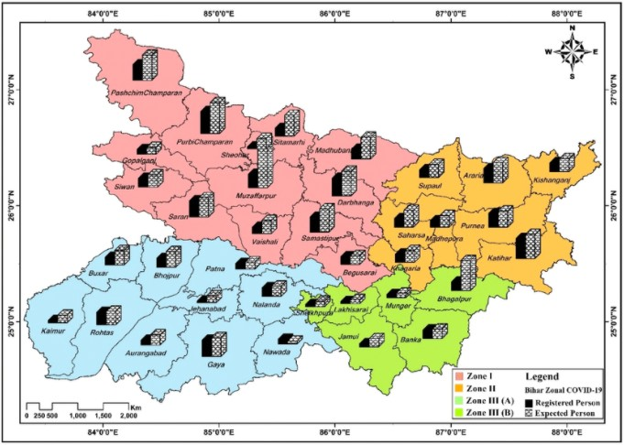

WELFARE PROVISION AND MIGRANT WORKERS IN EAST CHAMPARAN
East Champaran district of Bihar is backward in several aspects. It is facing lots of challenges in developments as well as access of welfare schemes. Last year, west Champaran district faced a crisis as over 1 lakh migrant workers returned home during the lockdown (Times of India). But
with district administration’s help the workers grouped to form manufacturing startups that could be a model for Bihar’s transformation.
For more than a century, labour has been Champaran most famous export. From the days when indentured labourers sailed to Mauritius, Fiji and the West Indians Islands, to the recent migration to Gulf countries and bigger Indian cities, leaving home for better economic prospects has been a way of life here. After interacting with villagers of Fursatganj, Bairiya, Chandhraiya and Turkauliya in which ward no. 5, 6, 7, 8, 9, 10, 11 found that maximum people from East Champaran are engaged in Jute Industry outside Bihar. Male workers prefer working in Vijayawada (Andhra Pradesh), Bangalore (Karnataka) and Kolkata (West Bengal). This Industry gives them good wages as well as opportunities for further growth. Migrant workers forced to stay in their village due to lockdown. This was the difficult time for them to stay at home and look after their families. People demanded small factories in their village or near by town so that it may fetch good opportunities.

CONCLUSION:

The findings from this study imply that the people living in centrally located wards and villages are more migratory as compared to the peripheral districts of Bihar. Several government schemes have led to the workers of the Champaran to live and survive. Food security schemes kept them motivated. The gross migrations in this district also comprises a high level of both in-migration rates. Although the gross migration is found to be higher in the centrally located districts, the pattern distribution of net migration rates is discrete in terms of regional dimension. The migration is the result of inequality in the distribution of opportunities and restrictions. Historically, migration was linked with urbanization, industrialization ,development and sustainable. This sustainability has led the villagers of East Champaran region to live a better and dignified life.

REFERENCE:
1. Ahmad. E. : “Migration in Bihar”, Bombay Geographical Magazine Vol. 8 & 9 : Planning
Patna, Patna Univertsity Journal 1962, Vol. VIII, PP. 31-44.
2.Backer, H. (1930-31) : “ Forms of population movement”, Social forms, pp. 147-61.
Bagai, S.B. (1956) : “Trends of urbanization and rural-urban migration in India 1905-51”,
Indian economic Journal conference No. 1956, pp. 15-29.
3 .Curry, L. (1972) : “ Spatial analysis of gravity flows,” Regional Studies Vol. 6.
Dasgupta, B.Laishley, R. and Lipton, M. (1975) : “Migration from Rural Areas, “ Institute of
Development Studies, Bridhton.
4 Foster, W. : “Early travels in India”, pp. 1583-1619, Oxford University Press. Gahurye, G.S
(1969) : “Caste and Race in India”, Popular Prakashan, Bombay, P.6.
Gangull, B.N (1947): “Population and Development”, S. Chand and Co. Ltd. New Delhi, P.
54
5.Johnston, M.A. (1983) : Urban squatting and migrants in peninsular Malaysia”, International
Migration Review, Vol.17, No. 1.
6.Kempinski, T. (1961) : “Rural migration”, Rural Sociology, Vol. 26, March, PP. 70-73.
Keyfitz, N. (1971) : “Migration as a means of population control”, Population Studies, Vol.
25, PP. 63-72.
7. Permi, M.K. (1976) : “Urban out-Migration : Its pattern Characteristics of Out- Migrants”,
Mukherji Shekhar, 2001, “Low Quality Migration in India: The Phenomena of distressed migration and acute urban decay, wp 1-24, International Institute of Population studies, Bombay, India.
8 Piketty Thomas, 2014, Capital in the Twenty- first Century P 104-108 Howard University Press.
9. Bhagwati, Jagdish, 2010; In Defense of Globalisation, New Delhi: Oxford University Press.
Brady, D., J. Beckfield, and M. Seeleib-Kaiser, 2005; "Economic globalisation and the welfare state in affluent democracies: 1975-2001,".
10.Dr. Gopala Menon V.M., Census of India (2011) “Rural Urban Distribution of Polulation” series. Provisional Population Totals paper Vol.2 P.63-69.

