GROWING POLITICAL PARTICIPATION OF WOMEN IN MENA REGION

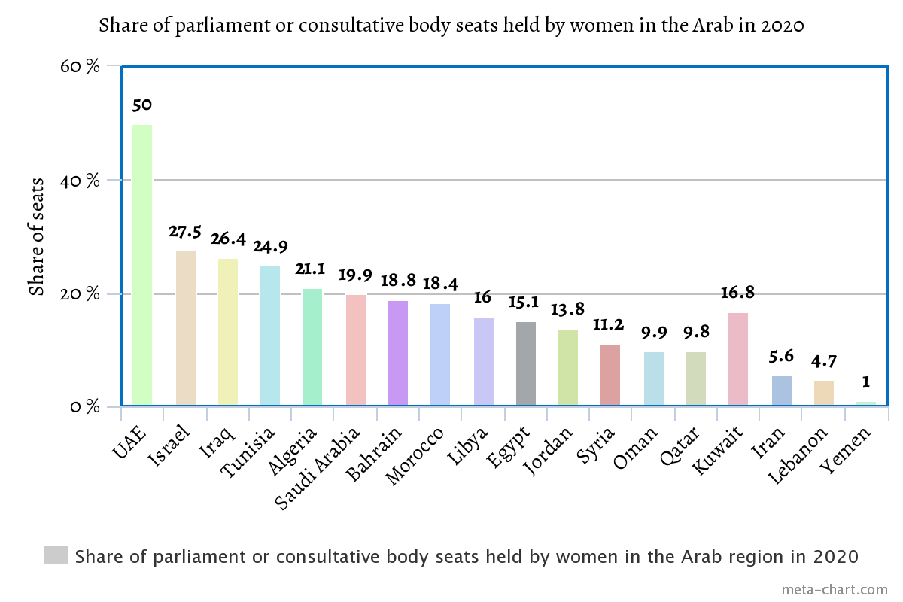
Women's participation in public life is the most successful and fastest way to advance any society. Public participation translates into economic participation in the labor force, social participation in the family and membership of civil society institutions, and cultural participation in the production of thought, art, and literature. Moreover, political participation in the local and national decision-making process through Legislative and executive decision-making institutions and councils. Perhaps political participation is the most important field of participation in public life. The participation of women in political life reflects the nature of the political and social system of any country and is an indication of the extent of democracy enjoyed by this system and the extent of its adherence to the principles of social justice and equality. The issue of women's political participation is an expression of Islamic societies' recognition and appreciation of the role that women played – and continues to play – in various aspects of social and economic life. At the same time, it represented an enlightenment of mindset and a broad horizon of the people in general. The freedom of women and their active participation in building the nation, its present, and its future, is closely linked to the base of democratic transformation. With regard to women's political participation in particular in relation to the democratic transition, it is necessary to remove the suspicion of bias and discrimination against a group of citizens because of gender and to prove that the state respects the role of women in building the future of their nation as much as it respects the special role of women through which they perform the process. However, the political participation of women in the process of democratic transition was met with many obstacles. Historically, women's political participation dates back to not so long-ago period in human history. In general, it remained limited to some areas of political action and the decision-making process. There exists a relative disparity in the level of women's political participation from one region to another region of MENA. Some of the challenges are cultural, some are political, and some are social. However, the major problem remains the cultural problem associated with some religious interpretations, because religion in Arab societies represents an important axis in political development. There is no legal impediment preventing a woman from assuming responsibility and assuming supreme authority in her state. The Islamic concept is a dynamic concept that is open to the movement of women in terms of its openness to humanity. Here are some examples that highlight the increasing role of women in MENA region in local as well as national politics.
Some examples of MENA countries encouraging women’s participation in politics are mentioned below:
TUNISIA:
The revolution that Tunisia witnessed in 2011 provided women with greater hope to participate not only in civil society, but also in political life, by engaging either in political parties or in elections (National Constituent Assembly in 2011, and presidential elections in 2014). Although the first Tunisian women's participation in elections was on the occasion of the municipal elections in 1957, they were excluded in the first electoral process that Tunisia witnessed after independence. They were recognized for their equality before the law, and the right to vote and contest elections. The Personal Status Law abolished polygamy, adopted the equal right to ask for a divorce, and set the minimum age for marriage at 18 years. Women in parliament increased from 1.1% in Parliament in 1959 to 27.5% in 2009, while the percentage of women's attendance in the House of Councilors is estimated at 19% (ibid). A woman in the same council held the position of Vice-President. Women represented 25% of the Constitutional Council. In 2004, for the first time in Tunisia, a female governor was appointed. 2009, witness a qualitative leap with the arrival of 59 women to Parliament and women occupied the position of second deputy speaker of the Aassembly of women’s representatives A woman chaired the Legislation Committee. Following the 2014 legislative elections, the representation of women in the Tunisian parliament reached about 31% of the total of 217 seats. The Tunisian House of Representatives received the 2015 Global Forum of Women Parliamentarians Award in recognition of Tunisia's leading Arab countries in terms of the rate of women's participation in parliament. The new constitution came into force in 2014 and it imposed on the state a series of obligations regarding the upliftment of women. Despite their participation in the social movement that preceded the revolution and their contribution to the overthrow of the regime, this did not translate into tangible results, since in various decision-making positions, we find only 7% of women. Parliaments The 2011 elections eventually resulted in the election of a National Constituent Assembly consisting of 217 deputies, 65 of whom are women. No woman chairs a parliamentary group. Of the 16 committees of committees that make up a total of 101 deputies, only 28 are women. In 2014, the representation of women in the Assembly of the Representatives of the People was about 31 percent out of a total of 217 representatives. Nidaa Tounes, which won 85 seats in the parliamentary elections, ranked first in terms of the number of women deputies, who numbered 35, while Ennahda won 96 seats, including 28 women. As for the Free Patriotic Union Party and the Popular Front coalition, female deputies each won a seat. It should be noted that since the election of the National Constituent Assembly in 2011, the position of the second representative speaker of the Assembly has been assigned to a woman, Mahrezia Al-Obeidi (from the Ennahda Movement). This precedent was reinforced with the 2014 elections in the House of People's Representatives, where Fouzia Benfadda (for the Free Patriotic Union) held the same position. With regard to women assuming ministerial portfolios, we find that both the government of Mohamed Ghannouchi (January 17, 2011-February 27, 2011) and the government of Mohamed Beji Qaid from the first (February 27 - December 13, 2011) and the second (December 13, 2011-December 24, 2011) and Muhammad Jebali (December 24, 2011) - March 13, 2013 and Mahdi Jomaa (January 27, 2014 - February 06, 2015) gave only two ministerial portfolios to women. As for the Al-Arayed government (from March 13, 2013 to January 9, 2014), only one ministry was assigned to women, and ministerial positions ranged between women, culture, health, environment, trade, traditional industries and tourism. After the appointment of the government following the 2014 elections, the representation of women improved, which rose to 19.5%: we saw three women hold ministerial portfolios. On the level of women's participation in civil society, the Center for Research, Studies, Documentation and Information on Women (CREDIF) published in 2013 a study on 700 women's and/or feminist associations out of a total of 16,000 registered associations in the country. Among the 224 associations surveyed, there are 1873 members of their governing bodies, with an average of 1 to 9 persons in each body. It was noted that the majority (59%) of the members of the governing bodies are women. However, the absence of official statistics on the percentage of women's representation in Tunisian political parties, which number more than 170, makes it difficult to know the representation of women. Women constituted 46% of all voluntarily registered voters, and 48% of all candidates on electoral lists. In 2021 Najla Bouden, Tunisia became the first female prime minister in the Arab world.

UAE:
There is a real need to involve women in the rapid development process that the country is witnessing, especially in the field of politics and decision-making. Many of the gains made by women were a result of the great efforts made by Her Highness Sheikha Fatima bint Mubarak, wife of the late Sheikh Zayed, to enhance the role of women. Her Highness, with the encouragement of the late Sheikh Zayed, played a major role in establishing the Women's Union in the Emirates in 1975, one of its first goals was to support female education and eradicate illiteracy among them. After these basic goals were satisfactorily achieved, Sheikha Fatima began strongly calling for Emirati women to become members of the Federal National Council, and these efforts received the support of the late Sheikh Zayed, who always declared that women are equal partners with men in all areas of life. This matter was crystallized in 2004, when the late Sheikh Zayed issued his decision to appoint the first woman to a ministerial position in the country, Sheikha Lubna Al Qasimi, as Minister of Economy and Trade. Her Highness Sheikha Fatima's call for women to enter the Federal National Council turned into a reality in 2006, when the first elections were held to choose half of the members of the National Council (twenty members) through electoral bodies that consisted of 6,595 members, including one thousand women. They have the right to run for council membership in addition to the right to vote. Sixty-five women out of (465) candidates for membership of the National Council have applied, i.e. (14.25%). These elections resulted in the election of the first Emirati woman to become a member of the Federal National Council (Dr. Amal Al Qubaisi), and eight other women were appointed at other posts. The inclusion of women in the National Assembly would lead to their further involvement in the formulation of public and private legislation related to women. However, the fact that only one woman received a parliamentary seat has raised some questions about the effectiveness of women's electoral campaigns, voters' perceptions of the suitability of female candidates, and gender considerations in the electoral process. In this regard, some studies have confirmed that reformulating the political experience of Emirati women requires consideration of the common obstacles facing women's political participation in the Arab region, and in particular in the Gulf Cooperation Council countries. These studies confirmed that there are four main research directions that represent influential factors on the scope of women’s political participation in the Gulf Cooperation Council countries, which are: Legislative and constitutional reforms towards expanding the means of participation and establishing the decision-making process; Continuing the “appointment” mechanism to allow women to participate in parliament; Continuing the general orientation of the state-led process of gender equality. It can be said that these trends apply to the status of women in the United Arab Emirates, where the main means of implementing women's political participation was the adoption of the "women's appointment" system in the Federal National Council. In general, the process of developing women's political participation can be carried out by taking the following measures:-
- The government shall present general policies to develop women’s participation in political and social life, and to join civil society organizations based on scientific foundations, so as to lead to tangible results.
- Evaluating and analyzing the experience, clarifying its steps, the reasons for its defects, and addressing the negatives that appeared in it.
- Opening the way for women’s participation in the political process and highlighting their role.
- Enact contemporary laws that recognize the basic and legitimate rights of women and guarantee the freedoms guaranteed to them.

In the Federal National Council elections on October 3, 2015, the number of female candidates reached 78, or 23.6 percent of the total number. Dr. Amal Al Qubaisi was elected Speaker of the Federal National Council, making her the first woman to head the parliamentary institution at the regional level. Emirati women hold diplomatic positions in the Ministry of Foreign Affairs and International Cooperation.

Bahrain:
Since adopting a new constitution in 2001, the government of Bahrain has promoted women’s rights and political participation. It has done this largely through the work of the Supreme Council for Women, chaired by the wife of the king, Princess Sabeeka bint Ibrahim al-Khalifa. With its high-level official mandate, the Supreme Council for Women has implemented equal opportunity committees in government bodies, provided training for women seeking to run for office, and promoted family services. However, women still make up only 15 percent of the lower, elected Council of Representatives, and 20 percent of the appointed upper house, the Shura Council, as well as just over 40 percent of executive positions in the government. Sociocultural factors remain that result in fewer women working in the public sphere, including a confidence gap between men and women.In the 2018 parliamentary elections, only 39 female candidates ran for office in comparison to 330 men.While women have not yet achieved equal political representation in Bahrain, there are no significant institutional or explicit legal barriers preventing women’s political participation. Some laws, however, render women unequal to men in society. The citizenship law prevents Bahraini women from passing down Bahraini citizenship if the father is not Bahraini. Under the rapist-marriage law an accused rapist can avoid legal consequences if he marries his victim before sentencing occurs. The political society with the greatest electoral success had been al-Wefaq, which refused to endorse or field female candidates. As the largest political society in Parliament, the unwillingness of al-Wefaq to endorse female candidates presented a structural barrier and sent a negative signal to Bahraini women seeking to fully engage with politics on equal footing with men. Since this crackdown on political societies, most candidates are running as independents. This means that women no longer need to depend on the endorsements of societies to win seats. But it also means that they don’t have the support of political societies in terms of funding and training when they do decide to run. Following the uprisings in 2011, the government’s alleged involvement in directing political outcomes may have enabled an increase in the number of women candidates. However, the changing political environment in Bahrain, while opening up opportunities for women, has had adverse effects on political openness overall. Considering the challenges for women’s political participation in Bahrain, there are a number of initiatives the Supreme Council for Women can undertake to help more women from all backgrounds to participate in government and politics, while also creating a more open political space. These include creating a fund to help lower-income women run for office; pioneering new training focusing on developing young women as leaders; developing a more effective data gathering strategy; and involving men as members of the council, encouraging a vibrant and independent civil society; considering a quota to increase the number of women in the appointed Shura Council; reforming laws that disadvantage women; and holding mixed-gender majlises – gathering spaces where state affairs are discussed – to create an equivalent public space to that traditionally enjoyed by men. The majlis has since become a common centrepiece of campaigns. Another way to increase the number of women in politics, and in leadership roles throughout society, is through the development and implementation of training programs that work with young women to enhance their public speaking skills, provide awareness of the gender gap in professional settings, teach the importance of speaking up and participating, and build confidence in their abilities. Bahraini politics is complex, considering the interplay of social norms, gender, and religion in the public sphere. It may not be easy for the ruling family and the Supreme Council for Women to chart a way forward to increase women’s political participation, but doing so, while also ensuring political openness, could lead to more vibrant and inclusive politics. The Supreme Council for Women was established in 2001. Princess Sabeeka bint Ibrahim Al Khalifa chairs the Council, which consists of at least 16 members, made up of female public figures who are considered leaders in women's affairs and related activities. The Council participates with relevant institutions to raise the status of women, as an expert-led organization specialized in supporting women's affairs in line with global standards. In 2020, women in the legislature made up 19% of participants, as 15% of them were elected to the House of Representatives, 23% of them are appointed to the Shura Council and 23% of them were elected to municipal councils. Women candidates for parliamentary elections constitute candidates 14% of all candidates. In 2002, King Hamad bin Isa Al Khalifa launched a reform project that gave women the right to political participation in municipal and parliamentary councils. In the 2006 elections, one woman won membership in the House of Representatives, being the first Bahraini woman in the Gulf to reach the parliament. In 2014, Six women were also appointed as members of the Capital Secretariat Council.

United Nations Economic and Social Commission for Western Asia. (2017). Women’s Political Representation in the Arab Region. https://archive.unescwa.org/publications/women-political-representation-arab-region
Data on women in national parliament. (n.d.). Parline: The IPU’s Open Data Platform. https://data.ipu.org/node/176/data-on-women?chamber_id=13546
International Republican Institute. (2022, January 19). SheVotes: Tunisia Understanding Barriers to Women’s Political Engagement in Tunisia | International Republican Institute. https://www.iri.org/resources/shevotes-examines-barriers-to-womens-political-engagement-in-tunisia/
Historic leap in Tunisia: Women make up 47 per cent of local government. (2018, August 27). UN Women Headquarters. https://www.unwomen.org/en/news/stories/2018/8/feature-tunisian-women-in-local-elections
Women Political Leaders. (2018, November 8). Awards 2015 - Women Political Leaders. https://www.womenpoliticalleaders.org/awards-2015/
Mannai, A. (2021, January 7). Women’s political participation in tunisia. Arab Reform Initiative. https://www.arab-reform.net/ar/publication/womenspoliticalparticipationintunisia/
UAE government. (n.d.). Women - The Official Portal of the UAE Government. The United Arab Emirates Government Portal. https://u.ae/en/information-and-services/social-affairs/women
United Arab Emirates. (2023, March 1). Parline: The IPU’s Open Data Platform. https://data.ipu.org/content/united-arab-emirates?chamber_id=13381
Bahrain. (2023b, March 2). Parline: The IPU’s Open Data Platform. https://data.ipu.org/content/bahrain?chamber_id=13566
Bahrain. (2023c, March 2). Parline: The IPU’s Open Data Platform. https://data.ipu.org/content/bahrain?chamber_id=13565
Bahraini Women Make Gains amid Tightening Political Freedom. (2019, June 25). Arab Gulf States Institute in Washington. https://agsiw.org/bahraini-women-make-gains-amid-tightening-political-freedom/

