Empowering Policing for a Safer Tomorrow: The Police Commissionerate System in Uttar Pradesh.

Gulshan Kumar Srivastava and Prof. Pankaj Kumar
Department of Political Science, University of Allahabad, Prayagraj - 211002
Email- gulshan.professional1994@gmail.com

Abstract
Uttar Pradesh, India’s most populous state, has a history of long tussle while maintaining law and order. In response to growing urbanization, crime rates, and administrative complexities, the state government adopted the Police Commissionerate System in selected cities. The Police Commissionerate System is a modern policing structure that deviates from the traditional model of policing, which was primarily organized under the district-based “Superintendent of Police (SP) or SSP” system. This change represents a paradigm shift in policing for emphasizing efficiency, specialization, and community-oriented approaches to tackle crime effectively. This paper explores the Police Commissionerate System in Uttar Pradesh, its objectives, functioning, and impact on public safety.
Keywords- (Uttar Pradesh, Police Commissionerate, Efficiency, Crime)

Introduction
In the Indian federal structure, the Police is a state subject. As such, the police in any state are significantly influenced by the socio-economic and political environment of the State. Yet, the police system in India, like various other organs of the government, is a legacy of the erstwhile British rule in the country. There is a great degree of similarity in the job content, responsibilities, and functions of the various police forces operating in different states of India.
Uttar Pradesh, along with being India’s most populous state, is also a state full of diversity and complexity in terms of tradition, culture, and population. Hence, maintaining law and order is such a tough task. And the situation has become tougher in the era of growing urbanization, crime rates, and administrative complexities. As a solution, to some extent, the state government has adopted the Police Commissionerate System in selected cities, particularly in those cities, that have denser populations. This system represents a paradigm shift in policing, emphasizing efficiency, specialization, and community-oriented approaches to tackle crime effectively.
Urbanization has been a prominent feature of human civilization for centuries, and it continues to shape the world we live in today. As more people move from rural to urban areas, cities are becoming more crowded, diverse, and complex. One of the key challenges that urbanization poses is maintaining law and order in these rapidly growing urban areas. Policing plays a crucial role in ensuring public safety and security, but it faces unique challenges in urban environments.
The growing expectations of citizens have found expression in a series of reform directives issued by the constitutional courts. These directives have led to a slow but sure-footed movement towards police reforms to convert the Indian police into a people-friendly and public service-oriented institution. The structural changes in the Indian economy, notably the surge in urbanization in recent decades, have not only multiplied the challenges for the police but also multiplied the burden of demands placed on them in Indian cities. In response to these increased expectations from the police, a dominant trend that has emerged in recent times is converting the traditional Superintendent of Police (SP) system to a comparatively modern and globally accepted model of the Police Commissionerate system. A police reforms committee formed in 2004 under R.S Mooshahary had recommended the Police Commissionerate system for effective handling of law and order in State capitals and cities that have a population of more than 10 lakh. Under this, the Police Commissioner is the head of a unified police command structure and is responsible for the force in the city, and directly accountable to the State government.
Hence, the role of the police becomes important in upholding the rule of law and maintaining law and order in the society. Police play a crucial role in the development of the country and it is extremely important to have a proper system of police so that work can be done more effectively.

Understanding the Police Commissionerate System
The Police Commissionerate System is a modern policing structure that deviates from the traditional model of policing, which was primarily organized under the district-based “Inspector-General of Police (IGP)” system. Under the Commissionerate System, the responsibilities for maintaining law and order are given to the senior police officer designated as the “Police Commissioner”, who leads the police force in a specific city or urban area. Traditionally, the district magistrate of the area was entrusted with issuing arrest warrants, and licenses while the SP had powers and responsibilities to investigate crimes and to arrest. The system is designed to ensure a lesser concentration of power to the District Magistrate. If the authority is under the police itself, it will help in the working of the police which will further help in the effective working of the Department.
The police Commissionerate System enhances efficiency by centralizing decision-making and streamlining operations. The system aims to enhance the efficiency and effectiveness of the police force. This ensures better resource allocation, quicker responses to emergencies, and a more coordinated approach to policing. The Commissionerate System also facilitates the creation of specialized units within the police force that are focused on specific areas like cybercrime, traffic management, anti-narcotics, and many more. This specialization equips the police with the tools and knowledge to address contemporary challenges more effectively and efficiently. The system fosters a closer relationship between the police and society. Police Commissioners are encouraged to engage with citizens, understand their concerns, and collaborate with local organizations to address public safety issues collectively.

Cities under the Police Commissionerate System
Uttar Pradesh, the fourth largest state in India has 75 districts. According to the density and area of a district, the State has the authority to bifurcate SP/SSP and Commissionerate model for any district. For the first time, the implementation of the Police Commissionerate system in Lucknow and Noida in 2020, has opened a new chapter in the management of the law-and-order situation in Uttar Pradesh. After the successful implementation, this system has been further extended to Ghaziabad, Varanasi, and Agra and recently in Kanpur and Prayagraj as well. Currently, there are a total of sixty-eight district police units headed by SP/SSP and seven by Police Commissioners in the state. As a result, many heinous crime cases were resolved and law-order issues were addressed promptly.

Functioning of the Police Commissionerate System
Under the Police Commissionerate System, the Police Commissioner is the highest-ranking officer responsible for the entire police force in the designated city. The Commissioner is supported by Deputy and Assistant Commissioners, each responsible for administrative functions, such as crime investigation, law and order, traffic management, and community engagement.
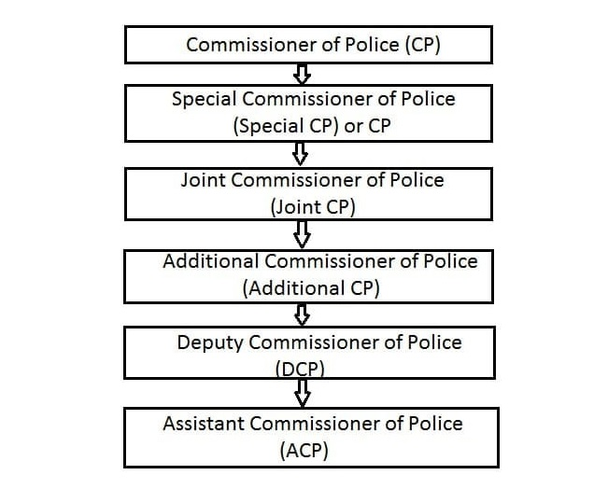
The Police Commissioner holds decision-making powers for all police-related matters within the Commissionerate’s jurisdiction, enabling a faster response to emerging situations. Under this new system, the Commissioner of Police (CP) will possess several powers that were previously held by district magistrates in the dual system. This includes the authority to enforce the Goonda or Gangster Act against criminals directly. CP has the power to issue orders to maintain public peace such as imposition of section 144, and ordering a curfew, he holds all the powers to initiate action under the Immoral Traffic (Prevention) Act, 1956. He can also take action under the Prevention of Cruelty to Animals Act, of 1960 to neutralize the animal, if in his opinion it would be cruel to keep animals alive. CP has also the power to regulate manufacture and issue licenses for explosives. If prisoners violate the rule of Jail Manuals, CP can charge a penalty for the same. Under the Act for Prevention and Safety from Fire, CP can issue penalties to violators, award compensation, and introduce safety measures in buildings. Under the Foreigners Act, 1946 he can take action against suspected foreigners staying in hotels, their departure, or documents with them to ensure their authenticity. There is also a court of Commissioner of Police where he works as a magistrate with those magisterial powers transferred to him from the dual system of District Magistrate and Superintendent of Police. The Police Commissionerate System enables the establishment of specialized units, such as cybercrime cells, women’s help desks, and anti-human trafficking squads, to address the diverse needs of modern urban policing. As any work is inefficient without proper coordination, this system enhances the close coordination with other civic authorities such as municipal corporations, and traffic departments. This ensures a comprehensive and integrated approach to public safety.

Impact of Police Commissionerate System
In a Commissionerate System, the Commissioner has magisterial powers, including regulation, control, and licensing. Due to these powers, this system could respond quicker to law & order situations. Police effectiveness is an outcome of resource utilization and autonomy in functioning while being held accountable for results. This system provides the required autonomy and resources. The system has led to quicker response times and better crime prevention strategies, resulting in improved law and order situations in the designated cities. The formation of specialized units has facilitated better handling of complex crimes and specific public safety issues, enhancing the overall effectiveness of the police force. The increased interaction between the police and the community has fostered trust and collaboration, leading to better intelligence gathering and crime prevention.

Challenges of the Police Commissionerate System
There is a famous saying, that with great power comes great responsibility, and great responsibility involves bigger challenges. Establishing the Commissionerate system requires additional resources, including personnel, training, and infrastructure, which can be a challenge in terms of budget and manpower. Expanding the system to cover more cities across the state might be a logistical challenge that requires careful planning and execution. To ensure the accountability of police, it is important to have clear norms of transparency and accountability imposed on an autonomous police machinery. Otherwise, it may leave the Police as the handmaidens of the ruling political dispensation on the one hand and a repressive governmental machinery on the other.

Conclusion
Change is the law of nature. Making these reforms in the Policing sector of Uttar Pradesh is a huge step in its way. The work of the police is very much crucial. This organization is needed by each citizen of the country irrespective of class, caste, creed, and gender. Therefore, the role of the police becomes much more personal than professional. The Supreme Court of India in Prakash Singh vs. Union of India (2006) outlined some other administrative reforms to reform the police system. However, very few states have taken steps to comply with the judgment.
The government of Uttar Pradesh has adopted the Police Commissionerate System. Gradually this system is expanding in other districts of the state. This system in Uttar Pradesh represents a progressive step towards more efficient and community-oriented policing. The system has demonstrated promising results in the designated cities by centralizing decision-making, introducing specialized units, and encouraging community engagement. However, its successful implantation across the entire state would require careful resource management and a focus on addressing challenges effectively. With continued commitment from the state government and the police force, the Commissionerate System had the potential to play a vital role in making Uttar Pradesh safer and more secure for its residents.

References

Chakraborty, P. (2023, September 27). The Times of India. Retrieved from https://timesofindia.indiatimes.com: https://timesofindia.indiatimes.com/city/lucknow/yogi-to-tech-institutes-start-new-age-courses/articleshow/103973752.cms
Singh, P. (2022). The Struggle for Police Reforms in India: Ruler's Police to People's Police. New Delhi: Rupa Publication.
Singh, V. (2024, March 02). The Hindu. Retrieved from www.thehindu.com: https://www.thehindu.com/news/national/other-states/cm-approved-commissionerate-system-in-up-which-gives-magisterial-powers-to-police-former-dgps-memoir/article67907271.ece
The Indian Express. (2022, November 26). Retrieved from www.indianexpress.com: https://indianexpress.com/article/cities/lucknow/police-commissionerate-system-in-agra-ghaziabad-prayagraj-8290497/
Vikramjit Singh, N. P. (28 December 2022). Impact of Police Commissionerates on Police Effectiveness and Policing Outcomes. BPRD, 3.

(Vikramjit Singh, 28 December 2022)
(Vikramjit Singh, 28 December 2022)
(Singh V. , 2024)
(Chakraborty, 2023)
(The Indian Express, 2022)
(Vikramjit Singh, 28 December 2022)

