**TRAINING CERTIFICATE**

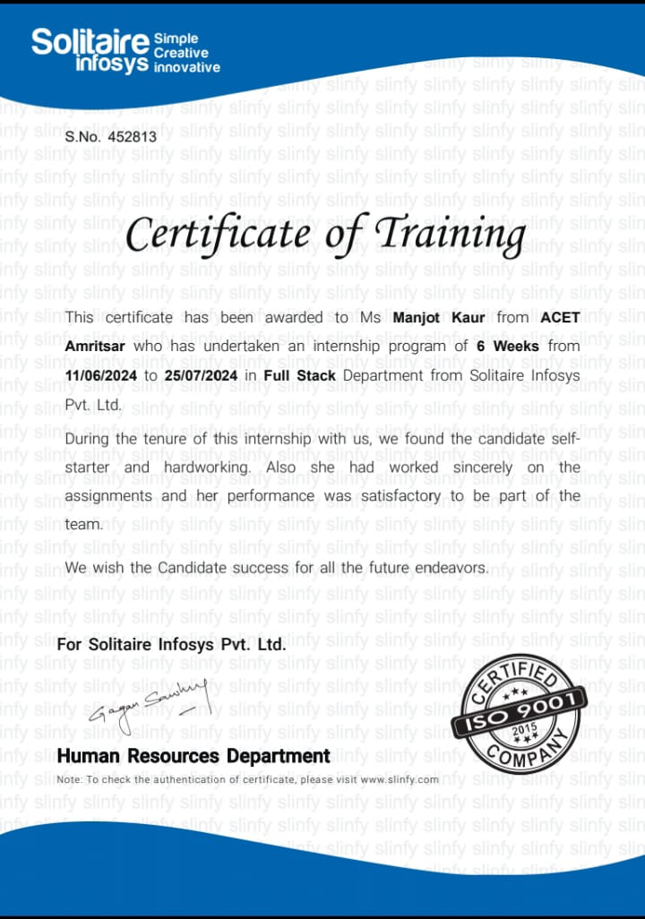

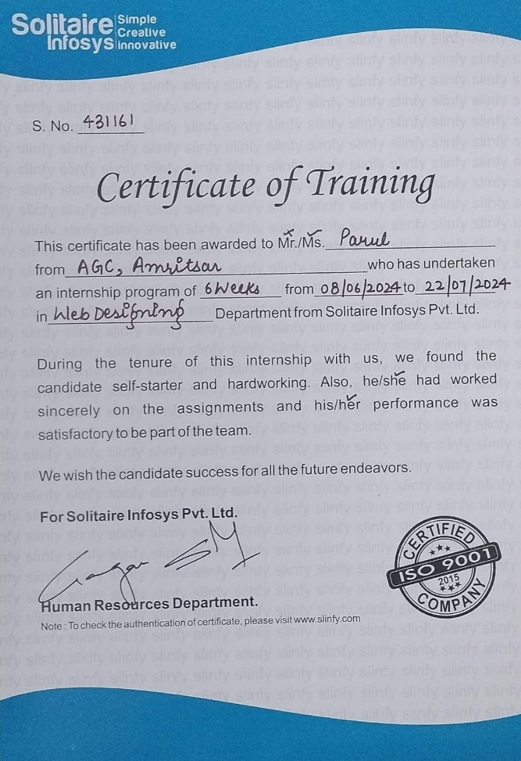

**TRAINING OBJECTIVE**

* **Enhance Skills and Competencies:** Equip employees with specific skills and knowledge required to perform their job effectively, whether these are technical skills, soft skills, or specialized expertise.
* **Improve Performance**: Address performance gaps by providing targeted training to help employees achieve higher levels of productivity and effectiveness in their roles.
* **Ensure Compliance:** Educate employees on legal, regulatory, and organizational standards to ensure adherence to required practices and procedures, reducing the risk of non-compliance.
* **Foster Professional Growth**: Support career development by providing training that prepares employees for advancement opportunities and helps them develop skills for future roles.
* **Facilitate Organizational Change**: Prepare employees for changes within the organization, such as new technologies, processes, or structural shifts, and support them in adapting effectively.
* **Promote Safety and Risk Management**: Train employees on safety protocols, risk management practices, and emergency procedures to maintain a safe work environment and minimize workplace hazards.
* **Enhance Team Collaboration**: Improve teamwork and communication among employees to foster better collaboration and a more cohesive work environment.
* **Boost Employee Engagement and Satisfaction**: Increase employee motivation and job satisfaction by investing in their development, which can lead to higher retention rates and a more positive workplace culture.

**INTRODUCTION TO ORGANIZATION**

* **Solitaire Infosys Pvt Ltd,** located in Chandigarh, is a prominent IT solutions company specializing in delivering comprehensive software development, IT consulting, and digital transformation services.
* Founded with a mission to provide innovative technology solutions, the company is recognized for its expertise in areas such as custom software development, web and mobile application development, and IT infrastructure management.
* Solitaire Infosys Pvt Ltd is committed to fostering a learning environment that bridges academic knowledge with practical industry experience.
* For students seeking industrial training, the company offers a dynamic program designed to immerse trainees in real-world projects and cutting-edge technologies.
* This hands-on training experience helps interns gain valuable skills and insights, preparing them for successful careers in the IT industry.
* By participating in industrial training at Solitaire Infosys Pvt Ltd, interns benefit from working alongside experienced professionals, tackling challenging projects, and gaining exposure to the latest industry practices and technologies.
* Top of Form
* Bottom of Form

**INTRODUCTION TO PROJECT**

Welcome to **'UWON'**, the ultimate online destination for quiz enthusiasts! At UWON, we believe in making learning fun, interactive, and rewarding. Our platform offers a vast array of quizzes across various topics, catering to all ages and interests. Whether you're a student, a professional, or simply someone with a passion for knowledge, UWON has something for you.

Our quizzes cover a wide range of subjects, from general knowledge and current events to specialized topics like science, history, and pop culture. Each quiz is designed to challenge your mind, expand your understanding, and provide a delightful experience. With regularly updated content, there's always something new to explore.

At UWON, we understand the importance of community and competition. Join our vibrant community of quiz lovers, where you can compete with friends, family, and other users from around the world. Track your progress, earn points, and climb the leader board to showcase your knowledge and skills.

We also offer exciting rewards and recognition for top performers. As you progress and achieve high scores, you can unlock badges, certificates, and other exclusive perks. With UWON, every quiz is not just a test of knowledge, but a step towards victory and personal growth. Join us today and start your journey to becoming a quiz champion!

**TECHNOLOGIES USED**

**HTML**



**HTML (Hyper Text Markup Language)** is the fundamental language used to structure and present content on the web. It defines the layout of a webpage by using elements, which are like building blocks that organize and display text, images, multimedia, links, and interactive forms.

**Expanded Features of HTML Structure:** HTML outlines the structure of web content by organizing it into a hierarchical format. This allows for creating headings, paragraphs, lists, and other content types in a clear, organized manner.

**Tags and Elements:** HTML uses tags to define different parts of a webpage. Each tag has a specific function, such as defining text, inserting images, or creating hyperlinks. These tags form the foundation of how web content is presented.

**Attributes:** HTML elements can have attributes that give additional information, like the link destination for a hyperlink or alternative text for an image.

**Media and Interactivity:** HTML supports embedding multimedia such as images, audio, and videos, along with interactive content like buttons, forms, and navigation menus.

**CSS**



**CSS (Cascading Style Sheets)** is a stylesheet language used to describe the visual presentation of a webpage. While HTML provides the structure and content, CSS focuses on how that content is displayed, allowing for a wide range of stylistic and layout options. CSS is what transforms a plain HTML page into an attractive and user friendly interface.

**Expanded Features of CSS:**

**Design and Style Control:** CSS allows developers to apply detailed styles such as colors, fonts, borders, and backgrounds. It provides options to set font styles, text alignment, and manage the aesthetics of a webpage down to the smallest detail.

**Responsive and Adaptive Design:** CSS supports responsive design through features like media queries, which allow web pages to automatically adjust layouts and styles based on screen size, orientation, and device type. This makes websites accessible and visually appealing on desktops, tablets, and mobile devices.

**Layout Management:** CSS offers powerful layout models, such as Flexbox and Grid, that help in creating complex, flexible, and well-organized layouts. These models enable developers to position elements precisely, manage spacing, and create dynamic structures without relying on traditional methods like tables.

**Separation of Content and Style:** By keeping the content (HTML) and style (CSS) separate, CSS makes the code easier to maintain. This separation allows for content updates without needing to adjust the design, and vice versa. It also improves reusability by enabling a single CSS file to style multiple HTML pages consistently.

**JAVASCRIPT**



**JavaScript (JS)** is a versatile programming language primarily used to make web pages interactive and dynamic. It enables behaviours like responding to user inputs, manipulating content in real-time, and integrating complex functionalities, enhancing the overall user experience on websites. JavaScript can be used both on the client-side (in the browser) and server-side (with technologies like Node.js).

**Expanded Features of JavaScript:**

**Interactivity and User Engagement:** JavaScript allows you to create interactive elements such as dropdown menus, modals, sliders, and dynamic forms. It makes web pages more engaging by responding to user actions like clicks, hovers, and keystrokes.

**DOM Manipulation:** The Document Object Model (DOM) represents the structure of a webpage. JavaScript can directly manipulate this structure, allowing developers to update, delete, or create elements dynamically. This is essential for tasks like updating content without reloading the page (e.g., updating a shopping cart).

**Client-Side Validation:** JavaScript handles real-time form validation on the client side before submitting data to the server. This reduces server load and provides immediate feedback to users when they enter incorrect or incomplete data.

**Event Handling:** JavaScript is event-driven, meaning it can listen for and respond to user events like mouse clicks, key presses, or page load. This enables smooth, real time interactions and complex behaviours, such as drag-and-drop interfaces or animations triggered by user actions.

**FIREBASE**



Firebase is a product of Google which helps developers to build, manage, and grow their apps easily. It helps developers to build their apps faster and in a more secure way. No programming is required on the firebase side which makes it easy to use its features more efficiently. It provides services to android, ios, web, and unity. It provides cloud storage. It uses NoSQL for the database for the storage of data.

1. **Real-time Database**:
   * **Description**: Cloud-hosted NoSQL database for real-time data syncing.
   * **Features**: Real-time updates, offline support, secure access.
2. **Cloud Firestore**:
   * **Description**: Scalable NoSQL database with real-time and offline support.
   * **Features**: Powerful querying, seamless integration, offline capabilities.
3. **Authentication**:
   * **Description**: Service for user authentication.
   * **Features**: Social login, email/password, secure and easy integration.
4. **Cloud Functions**:
   * **Description**: Run backend code in response to events.
   * **Features**: Auto-scaling, event-driven execution, serverless architecture.
5. **Cloud Storage**:
   * **Description**: Storage solution for user-generated content.
   * **Features**: Secure, scalable, high-performance file serving.
6. **Firebase Hosting**:
   * **Description**: Fast and secure hosting for web apps and static content.
   * **Features**: Global CDN, SSL, easy deployment.
7. **Firebase Analytics**:
   * **Description**: Analytics for user behavior and app performance.
   * **Features**: Real-time insights, customizable events, integration with other Firebase services.
8. **Firebase Test Lab**:
   * **Description**: Cloud-based testing infrastructure.
   * **Features**: Automated testing on various devices, detailed results.
9. **Firebase Performance Monitoring**:
   * **Description**: Monitors app performance.
   * **Features**: Real-time metrics, performance insights, integration with Firebase services.
10. **Firebase Remote Config**:
    * **Description**: Dynamic app configuration without updates.
    * **Features**: Real-time changes, A/B testing, customizable settings.

**HARDWARE AND SOFTWARE REQUIREMENTS**

**Hardware Requirements:**

* Any PC processor
* 512 MB Ram
* Keyboard Mouse
* Internet Connection

**Software Requirements:**

* Operating system: Windows 11 OS
* Web Browser (Google Chrome, Internet Explorer, Firefox, Microsoft edge, etc.)

**FEATURES OF PROJECT**

* **Competitive Spirit:** "UWON" suggests a focus on winning and competition, appealing to users who enjoy challenges and strive to excel in quizzes.
* **Positive Vibes:** The name "UWON" sounds upbeat and positive, potentially creating a welcoming and encouraging atmosphere for users.
* **Engaging Content:** Users might expect engaging and interactive quiz content that keeps them hooked and motivated to participate.
* **Rewarding Experience:** The name might imply that users can earn rewards or recognition for their achievements in quizzes, adding a gamified element to the platform.
* **Simplicity and Memorability:** The simplicity of the name "UWON" could make it easy to remember and share, which is beneficial for word-of-mouth growth.
* **Global Appeal:** The name could be perceived as universal and appealing across different cultures and languages, enhancing its potential reach.

**OBJECTIVE OF PROJECT**

The objective of the UWON Quiz website is to create an engaging and interactive platform where users can participate in a variety of quizzes on different topics. The website aims to cater to a broad audience interested in challenging themselves, competing with others, and expanding their knowledge in a fun and rewarding way. Through strategic implementation and continuous improvement, UWON aims to become a leading destination for quiz enthusiasts worldwide.

**Key Objectives:-**

1. **User Engagement and Satisfaction:-**

* Foster a vibrant community of quiz enthusiasts by offering diverse and compelling quiz content.
* Ensure a user-friendly interface that enhances accessibility and usability across various devices.
* Implement features such as leader boards, achievements, and social sharing options to encourage interaction and competition among users.

1. **Content Excellence:-**

* Curate high-quality quizzes that cover a wide range of topics including but not limited to general knowledge, pop culture, science, history, and more.
* Regularly update and expand the quiz database to keep content fresh and engaging
* Incorporate feedback mechanisms to gather user input and preferences, ensuring quizzes are relevant and enjoyable.

1. **Differentiation and Value Proposition:-**

* Differentiate UWON from competitors by emphasizing its dynamic and user-centered approach to quizzes.
* Offer unique features such as personalized quiz recommendations based on user preferences and performance history.
* Provide a rewarding experience through virtual badges, certificates of achievement, and possibly tangible rewards for top performers.

1. **Monetization Strategy:-**

* Develop sustainable revenue streams through targeted advertising, sponsored quizzes, and premium membership options.
* Balance monetization efforts with maintaining a positive user experience and ensuring fairness in quiz content and competitions.

1. **Technical Stability and Scalability:-**

* Build a robust and scalable technical infrastructure capable of handling increasing user traffic and data securely.
* Implement rigorous security measures to protect user information and prevent unauthorized access.
* Continuously monitor and optimize website performance to ensure seamless user experience and minimal downtime.

1. **Marketing and Growth:-**

* Execute a comprehensive digital marketing strategy to attract new users and retain existing ones.
* Utilize SEO, social media, content marketing, and partnerships with influencers to increase visibility and engagement.
* Collaborate with educational institutions, corporate entities, and media outlets to promote UWON as a reputable quiz platform.

**FEASIBILITY ANALYSIS**

The feasibility analysis for the UWON Quiz website aims to evaluate its viability and potential for success in the competitive landscape of online quiz platforms. This comprehensive assessment covers various aspects including market research, technical feasibility, content strategy, monetization potential, user acquisition, legal considerations, and risk assessment.

1. **Market Analysis :-** 
   1. **Market Demand :-** 
      * **Target Audience:** The primary audience includes quiz enthusiasts, students, professionals seeking knowledge challenges, and individuals interested in interactive learning.
      * **Trends:** Growing interest in online quizzes due to their educational and entertainment value, especially among younger demographics accustomed to digital engagement.

* 1. **Competitive Landscape :-**
* **Major Competitors:** Identify key players such as Sporcle, Quizlet, and Kahoot!, analyzing their strengths and weaknesses.
  + - **Unique Selling Proposition (USP):** Differentiate UWON by focusing on diverse quiz topics, user engagement features (like leader boards), and personalized quiz recommendations.

1. **Technical Feasibility :-**
   1. **Website Development :-**
      * **Platform:** Evaluate the feasibility of using modern web technologies (HTML5, CSS3, JavaScript) for a responsive and user-friendly interface.

* + - **Scalability:** Plan for scalability to accommodate increasing user traffic and database expansion.

* + - **Security:** Implement robust security measures (SSL encryption, secure user authentication) to protect user data and prevent cyber threats.

* 1. **Hosting and Infrastructure :-**
     + **Hosting Provider**: Select a reliable hosting provider capable of handling bandwidth demands and ensuring minimal downtime.

* + - **Database Management**: Optimize database management systems (e.g., MySQL, MongoDB) for efficient data storage and retrieval.

1. **Content Strategy :-**
   1. **Quiz Content :-**
      * **Diversity**: Develop a content strategy to offer quizzes across various categories (general knowledge, sports, entertainment, etc.) to cater to diverse user interests.

* + - **Quality Assurance**: Implement mechanisms for quality control to ensure accurate and engaging quiz questions, periodically updating content to maintain relevance.

* 1. **User Engagement Features :-**
     + **Gamification**: Incorporate gamification elements (badges, achievements, levels) to enhance user engagement and encourage repeat visits.

* + - **Social Sharing**: Enable users to share quiz results and achievements on social media platforms to foster community interaction.

1. **Monetization Strategy :-**
   1. **Revenue Streams :-**
      * **Advertising**: Utilize targeted advertising placements based on user demographics and quiz content relevance.

* + - **Premium Features**: Offer premium membership options with additional features such as ad-free experience, exclusive quizzes, or advanced analytics.

* + - **Sponsored Content**: Collaborate with brands for sponsored quizzes or promotional campaigns targeting relevant audiences.

1. **User Acquisition and Retention :-**
   1. **Marketing Strategy :-**
      * **Digital Marketing**: Deploy SEO techniques, content marketing, and social media campaigns to increase website visibility and attract new users.

* + - **Partnerships**: Form partnerships with educational institutions, corporate entities, and influencers to expand reach and credibility.

* + - **Retention Strategies**: Implement personalized user experiences, email newsletters, and loyalty programs to retain existing users and encourage frequent engagement.

1. **Legal and Regulatory Considerations :-**
   1. **Data Protection :-**
      * **Compliance**: Ensure compliance with data protection regulations (e.g., GDPR, CCPA) by implementing stringent data handling policies and secure data storage practices.

* + - **Intellectual Property**: Obtain necessary licenses or permissions for quiz content sourced from third parties to avoid copyright infringement issues.

1. **Financial Viability :-**
   1. **Financial Projections :-**
      * **Cost Analysis**: Estimate initial development costs, operational expenses (hosting, maintenance), and marketing expenditures.

* + - **Revenue Forecast**: Project revenue potential based on expected user growth, advertising rates, and premium membership uptake.

1. **Risk Assessment :-**
   1. **Risk Identification :-**
      * **Cybersecurity**: Mitigate risks associated with data breaches or hacking attempts through proactive security measures.

* + - **Market Competition**: Address competitive pressures by continuously innovating content and enhancing user experience.

* + - **Regulatory Changes**: Stay updated with legal requirements and adapt policies accordingly to minimize legal risks.

**EXISTING SYSTEM**

The UWON Quiz website is a platform designed to offer users a diverse array of quizzes across various topics, catering to quiz enthusiasts, students, and anyone interested in challenging themselves intellectually. This analysis provides an overview of the current system, encompassing its architecture, features, user experience, technical infrastructure, security measures, and future considerations for enhancement.

1. **Website Architecture**
   1. **Frontend Architecture**
      * **Technologies Used**: The frontend of UWON utilizes modern web technologies such as HTML5, CSS3, and JavaScript frameworks like React.js for dynamic user interfaces.

* + - **Responsive Design**: The website is designed to be responsive, ensuring a consistent and user-friendly experience across desktops, tablets, and mobile devices.

* + - **UI Design**: The user interface features intuitive navigation, clear layout, and interactive elements to enhance engagement and usability.

* 1. **Backend Architecture**
     + **Server-side Technologies**: Backend operations are powered by Node.js, providing a scalable and efficient server environment for handling user requests and data processing.

* + - **Database Management**: MongoDB is employed as the database management system, facilitating robust storage and retrieval of quiz content, user profiles, and session information.

* + - **API Integration**: Integration with third-party APIs enables functionalities such as user authentication (using OAuth), social media sharing, and analytics tracking.

1. **Features and Functionality**
   1. **User Registration and Authentication**
      * **Registration Process**: Users can register via a straightforward registration form, which includes email verification to ensure authenticity.

* + - **Authentication**: Secure authentication mechanisms allow users to log in using their credentials or via social media accounts for convenience.

* + - **User Profiles**: Each user has a profile where they can manage personal information, track quiz performance, and view achievements.

* 1. **Quiz Management**
     + **Quiz Creation**: The platform provides tools for administrators to create quizzes, including options for multiple-choice questions, true/false statements, and more complex formats.

* + - **Content Management**: An intuitive CMS interface allows content managers to update, categorize, and schedule quizzes based on topics, difficulty levels, and user feedback.

* + - **Quiz Player**: Users engage with quizzes through an interactive player interface, which includes features like timer countdowns, score tracking, and immediate feedback on answers.

* 1. **User Engagement Features**
     + **Leader boards and Rankings**: Leader boards showcase top performers across different quiz categories, motivating users to compete and improve their rankings.

* + - **Achievements and Badges**: Gamification elements reward users with badges and achievements based on quiz completion milestones, fostering engagement and retention.

* + - **Social Sharing**: Integration with social media platforms enables users to share quiz results, achievements, and interesting quiz content with their networks.

1. **Content Management System (CMS)**
   * + **Backend Dashboard**: Administrators access a robust backend dashboard to manage all aspects of the website, including user management, quiz creation, content moderation, and analytics.

* + - **Content Moderation**: Tools and workflows are in place to monitor and moderate user-generated content, ensuring compliance with community guidelines and maintaining a positive user experience.

* + - **Version Control**: Version control mechanisms track revisions made to quiz content and user data, providing transparency and accountability.

1. **Technical Infrastructure**
   1. **Hosting and Server Configuration**
      * **Hosting Provider**: The website is hosted on a reliable cloud hosting platform, offering scalability and high availability to accommodate varying levels of user traffic.

* + - **Load Balancing**: Load balancing techniques are implemented to distribute traffic efficiently across multiple servers, optimizing performance during peak usage periods.

* 1. **Security Measures**
     + **Data Encryption**: Secure Socket Layer (SSL) encryption is employed to protect data transmitted between users and the server, ensuring confidentiality and integrity.

* + - **User Privacy**: GDPR-compliant policies safeguard user privacy rights, with measures in place for data anonymization and user consent management.

* + - **Security Audits**: Regular security audits and vulnerability assessments are conducted to identify and mitigate potential threats, maintaining the integrity of user data and system operations.

1. **Performance Metrics**
   * + **Page Load Speed**: Performance metrics consistently monitor page load times and responsiveness, with ongoing optimization efforts to enhance speed and user experience.

* + - **Scalability**: Scalability tests and capacity planning strategies are employed to handle increasing user growth and maintain seamless performance.

* + - **Uptime and Availability**: Monitoring tools track uptime metrics, ensuring minimal downtime and reliable access to the website for users worldwide.

The existing system analysis of UWON Quiz website highlights its robust architecture, comprehensive features, user-friendly interface, secure infrastructure, and scalable performance. By leveraging modern technologies, effective content management, and strong security measures, UWON provides a compelling platform for quiz enthusiasts to engage, learn, and compete. Future enhancements may focus on further improving user personalization, expanding quiz content diversity, enhancing mobile optimization, and integrating advanced analytics for deeper insights into user behaviour and preferences. Continuous innovation and responsiveness to user feedback will be key to maintaining UWON's position as a leading online quiz platform in the competitive digital landscape.

**LIMITATION OF EXISTING SYSTEM**

The UWON Quiz website, while robust in many aspects, also exhibits several limitations that impact its functionality, user experience, security, and scalability. This analysis identifies and discusses these limitations comprehensively across various dimensions of the platform.

1. **User Interface and Experience**
   * **Limited Customization Options**: The current UI design lacks extensive customization features for users, such as personalized themes or layout preferences.

* + **Complex Navigation**: Users may find navigating between different quiz categories or accessing specific features cumbersome due to the complexity of menu structures.

* + **Device Compatibility**: While responsive, the website may not provide an optimized experience across all devices, especially older mobile devices or browsers.

1. **Technical Infrastructure**
   * **Scalability Challenges**: During peak traffic periods, the website may experience performance issues or slowdowns, indicating potential scalability challenges.

* + **Load Handling**: While load balancing is implemented, occasional spikes in traffic could still affect website performance, impacting user experience negatively.

* + **Dependency on Third-party APIs**: Reliance on thirdparty APIs for certain functionalities introduces risks related to API uptime, changes in API specifications, and data security.

1. **Content Management System (CMS) and Quiz Creation**
   * **Complexity in Quiz Creation**: Administrators may find the current tools for quiz creation limited in terms of flexibility in question types or multimedia integration.

* + **Version Control Limitations**: The lack of comprehensive version control mechanisms for quizzes and content revisions could lead to confusion or errors in content updates.

* + **Content Moderation Challenges**: Manual content moderation processes may be time-consuming and could result in delays in publishing new quizzes or updates.

1. **Security and Privacy**
   * **Data Encryption and Compliance**: While SSL encryption is employed, there may be room for enhancing data encryption protocols to ensure more robust data security.

* + **User Privacy Concerns**: Compliance with global data protection regulations (e.g., GDPR, CCPA) may require stricter adherence to user privacy rights and data anonymization practices.

* + **Vulnerability Management**: Regular security audits are crucial, but there may be a need for more proactive vulnerability management and response strategies.

1. **User Engagement and Gamification**
   * **Limited Gamification Elements**: While badges and achievements are implemented, expanding gamification features (e.g., customizable avatars, virtual rewards) could enhance user engagement.

* + **Social Integration**: Enhancing social sharing options and integration with more platforms could increase user interaction and organic growth through user-generated content.

1. **Performance Metrics and Analytics**
   * **Insufficient Performance Monitoring**: While performance metrics are tracked, there may be a need for more granular insights into page load times, server response rates, and user session analytics.

* + **Analytics for Personalization**: Advanced analytics capabilities for personalized quiz recommendations or targeted advertising could be underutilized or not fully integrated.

The UWON Quiz website, despite its strengths in providing diverse quiz content and engaging user experience, faces several limitations that impact its overall functionality, security, scalability, and user satisfaction. Addressing these limitations through systematic improvements in UI/UX design, technical infrastructure upgrades, enhanced content management capabilities, stricter security measures, and advanced analytics integration will be crucial for maintaining competitiveness and achieving sustained growth in the dynamic online quiz market. By prioritizing these areas of improvement and incorporating user feedback iteratively, UWON can enhance its position as a leading platform for quiz enthusiasts globally.

**ADVANTAGES**

1. **User Interface and Experience:**
   * Intuitive design facilitates easy navigation.
   * User-friendly layout enhances accessibility for all users.
   * Responsive design ensures compatibility across devices.

1. **Quiz Creation and Management:**
   * Easy-to-use interface for creating quizzes. oCustomizable options for question types (multiple choice, true/false, etc.).
   * Ability to set timers, randomize questions, and adjust difficulty levels.

1. **Scalability and Performance:**
   * Capable of handling large numbers of concurrent users.
   * Efficient server management ensures minimal downtime.
2. **Security and Integrity:**
   * Measures in place to prevent cheating and ensure fair play. oSecure storage of user data and quiz results.

1. **Analytics and Reporting:**
   * Detailed insights into user performance and quiz results.
   * Reporting tools for administrators to track progress and identify trends.

1. **Integration and Compatibility:**
   * Integration with learning management systems (LMS) for educational institutions. oCompatibility with various browsers and operating systems.

1. **Customization and Personalization:**
   * Options for branding and custom themes.
   * Personalized user profiles and preferences.

1. **Community and Engagement:**
   * Features for social sharing and competition among users.
   * Discussion forums or comment sections for each quiz.

1. **Accessibility and Inclusivity:**
   * Features for accessibility (e.g., screen reader compatibility).
   * Multilingual support for diverse user bases.

1. **Support and Documentation:**

* Comprehensive help guides and documentation.
* Responsive customer support for technical assistance.

**CODING**

<body>

<nav class="navbar">

<div class="navdiv"> <div class="logo">

<img src="../logo.jpg" alt="" width="180px" height="40px"></div>

<ul>

<li><a href="#">Home</a></li>

<li><a href="cont.html">Contact Us</a></li>

<li><a href="abt.html">About</a></li>

<li><a href="help.html">Help</a></li>

<input type="text" placeholder="Search...">

<button class="bt"><a href="log.html">Login </a></button>

</ul>

</div>

</nav>

<div class="big">

<div class="box">

<div class="img">

<img src="../logo.jpg" alt=""> </div>

<br>

<br>

<h1>Welcome to UWon Quiz !........</h1>

<p>Click here to Start Quiz</p>

<button><a href="log.html"> Start</a></button>

</div>

</div>

</body>

</html>

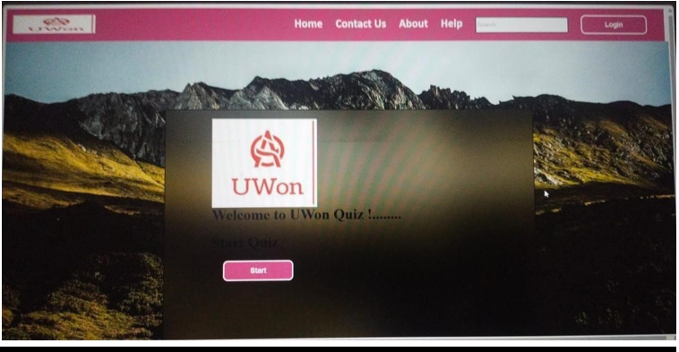

<script>

const questions = [

{

question: "1. ___ river is known as spiritual river in india. ", answers: [

{ text: "Yamuna", correct: false },

{ text: "Ganga", correct: true },

{ text: "sarawati", correct: false },

{ text: "none of these", correct: false }

]

},

{

question: "2. Mata Vaishno Devi ji temple is located in?", answers: [

{ text: "mathura", correct: false },

{ text: "mumbai", correct: false },

{ text: "katra", correct: true },

{ text: "delhi", correct: false }

]

},

{

question: "3. Name the holy book of thr Muslims ?", answers: [

{ text: "Tripitakan", correct: false },

{ text: "Bible", correct: false },

{ text: "Quaran", correct: true },

{ text: "None of these", correct: false }

]

},

{

question: "4. How many Guru's are there in the Sikhism ?", answers: [

{ text: "10", correct: true },

{ text: "11", correct: false },

{ text: "12", correct: false },

{ text: "15", correct: false }

]

},

{

question: "5. The holy book of Hindu's is ?", answers: [

{ text: "Granth", correct: false },

{ text: "Ved", correct: true },

{ text: "Puran", correct: false },

{ text: "None of These ", correct: false }

]

},

// Continue adding questions up to 50

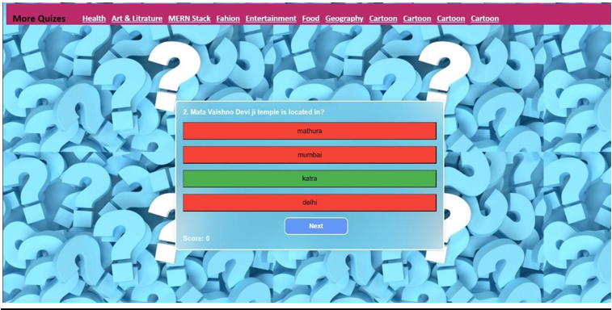

**DFD’s**

Creating a Data Flow Diagram (DFD) for a quiz website like "uwon" involves mapping out how data moves through the system, from inputs like user interactions to outputs like quiz results. Here's a structured approach to designing a DFD for the "uwon" quiz website:

**Level 0 DFD (Context Diagram):-**

The Level 0 DFD provides an overview of the entire system, showing the interaction between the quiz website and external entities.

**Entities:**

* **Users:** Interact with the quiz website by taking quizzes and viewing results.
* **Admin:** Manages quizzes, questions, and user accounts.
* **Database:** Stores quiz data, user profiles, and quiz results.

**Processes:**

* **Manage Quizzes:** Administers quiz creation, editing, and deletion.
* **Take Quiz:** Allows users to answer quiz questions.
* **Evaluate Quiz:** Calculates quiz scores and provides feedback.
* **Manage Users:** Handles user authentication and profile management.

**Data Flows:**

* **User Input:** Answers to quiz questions.

**Quiz Data:** Questions and answers stored in the database.

* **Quiz Results:** Scores and feedback displayed to users.
* **User Authentication:** Validates user login credentials.

**Diagram:**

* Represent the entire system as a single process labeled

"Quiz System."

* Use arrows to indicate data flow between processes, data stores (database), and external entities (Users, Admin).

**Level 1 DFD:-**

The Level 1 DFD breaks down each major process into subprocesses, providing more detail about how data flows within the system.

**Processes:**

1. **Manage Quizzes:**

* Add Quiz
* Edit Quiz
* Delete Quiz

1. **Take Quiz:**
   * Retrieve Quiz Questions

* Record User Responses

1. **Evaluate Quiz:**
   * Calculate Scores
   * Generate Feedback
2. **Manage Users:**
   * Authenticate User
   * Manage User Profiles

**Data Flows:**

**Add/Edit/Delete Quiz:** Update quiz database.

* **Retrieve Quiz Questions:** Fetch questions from the database.
* **Record User Responses:** Store user answers.
* **Calculate Scores:** Compare user answers with correct answers.
* **Generate Feedback:** Provide quiz performance feedback to users.

**Data Stores:**

* **Quiz Database:** Stores quizzes, questions, answers, and results.
* **User Database:** Stores user profiles and authentication data.

**Diagram:**

* Draw separate process boxes for each major function (Manage Quizzes, Take Quiz, Evaluate Quiz, Manage Users).
* Connect these processes with data flows and data stores using labeled arrows. **Detailed DFD Components:- Processes:**
* **Add Quiz:** Define steps for adding quiz details.
* **Edit Quiz:** Specify how existing quizzes are modified.
* **Delete Quiz:** Describe deletion procedures and data updates.
* **Retrieve Quiz Questions:** Detail process of fetching questions.

**Record User Responses:** Explain how user answers are stored.

* **Calculate Scores:** Outline scoring algorithms.
* **Generate Feedback:** Show steps for feedback generation.
* **Authenticate User:** Explain user login and validation process.
* **Manage User Profiles:** Detail profile creation, modification, and deletion.

**Data Flows:**

* Elaborate on specific data elements (e.g., question IDs, user IDs, scores).
* Clarify how data moves between processes and data stores.

**Data Stores:**

* Provide a structured view of database tables and their contents.

**Diagram:**

* Use detailed symbols to represent data flows, processes, data stores, and entities.
* Ensure the diagram is clear and easy to understand, with proper labeling and notation.

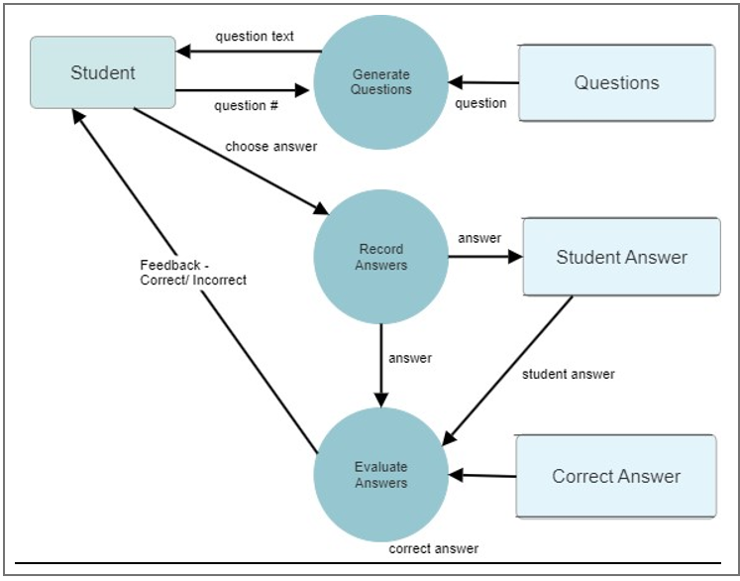

**ER DIAGRAM**

Creating an Entity-Relationship (ER) diagram for the "uwon" quiz website involves identifying the main entities, their attributes, and their relationships within the system. Here’s a structured approach to designing an ER diagram for this scenario:

**Entities in the "uwon" Quiz Website:**

**User:**

* **Attributes:** UserID (Primary Key), Username, Password, Email, Registration Date

**Quiz:**

* **Attributes:** QuizID (Primary Key), QuizName, Description, Created By (Foreign Key referencing UserID of User who created the quiz), Creation Date

**Question:**

* **Attributes:** QuestionID (Primary Key), QuizID (Foreign Key referencing QuizID of Quiz), QuestionText

**Answer:**

* **Attributes:** AnswerID (Primary Key), QuestionID (Foreign Key referencing QuestionID of Question), Answer Text, Is Correct (boolean indicating whether this answer is correct for the associated question)

**Quiz Attempt:**

* **Attributes:** AttemptID (Primary Key), UserID (Foreign Key referencing UserID of User), QuizID (Foreign Key referencing QuizID of Quiz), Attempt Date, Score

**UserAnswer:**

* **Attributes:** UserAnswerID (Primary Key), AttemptID (Foreign Key referencing AttemptID of QuizAttempt), QuestionID (Foreign Key referencing QuestionID of Question), AnswerID (Foreign Key referencing AnswerID of Answer)

**Relationships:**

* **User** and **Quiz**: One-to-Many (One user can create multiple quizzes)

* **Quiz** and **Question**: One-to-Many (One quiz can have multiple questions)

* **Question** and **Answer**: One-to-Many (One question can have multiple answers)

* **User** and **QuizAttempt**: One-to-Many (One user can attempt multiple quizzes)

* **Quiz** and **QuizAttempt**: One-to-Many (One quiz can have multiple attempts)

* **Question** and **UserAnswer**: One-to-Many (One question can have multiple user answers in different attempts)
* 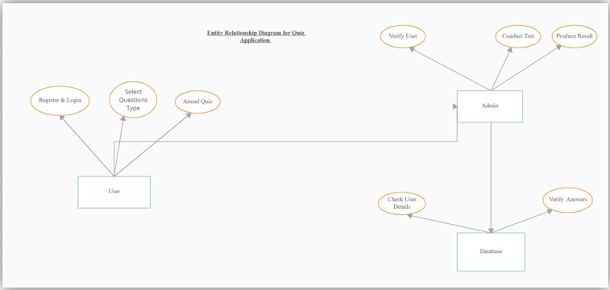

**FUTURE SCOPE**

The "uwon" quiz website has several potential avenues for future development and enhancement to improve user engagement, functionality, and scalability. Here are some future scope ideas:

1. **Enhanced User Experience:** 
   * **Personalization:** Implement user profiles where users can track their quiz history, favorite quizzes, and performance trends.
   * **Customization:** Allow users to customize quiz settings such as difficulty levels, categories, and quiz formats.
   * **Interactive Features:** Introduce interactive elements like leaderboards, badges, and achievements to motivate users.
2. **Advanced Quiz Features:** 
   * **Real-time Quizzing:** Enable live quizzes where multiple users can participate simultaneously, seeing results instantly.
   * **Multi-format Quizzes:** Support various quiz formats such as timed quizzes, image-based questions, and multimedia-rich quizzes.
   * **Collaborative Quizzes:** Allow users to create and share collaborative quizzes with friends or the community.
3. **Learning Management System Integration:** 
   * **Educational Resources:** Expand beyond quizzes to include educational resources such as tutorials, study guides, and reference materials.
   * **Certification Programs:** Introduce certification quizzes with official accreditation upon successful completion.
   * **Analytics and Reporting:** Provide detailed analytics to track user progress and identify areas for improvement.
4. **Social and Community Features:** 
   * **Social Sharing:** Enable users to share quiz results and achievements on social media platforms.
   * **Community Forums:** Introduce discussion forums where users can discuss quiz topics, share insights, and ask questions.
   * **User-generated Content:** Allow users to submit quiz questions and answers, with community voting and moderation.
5. **Mobile App Development:** 
   * **Mobile Compatibility:** Develop a dedicated mobile app for iOS and Android platforms to enhance accessibility and user convenience.
   * **Offline Mode:** Enable offline access to quizzes and results, syncing data when connectivity is restored.
6. **Monetization Strategies:** 
   * **Subscription Models:** Offer premium features such as ad-free experience, exclusive quizzes, and advanced analytics through subscription tiers.
   * **Ad Revenue:** Generate revenue through targeted advertising based on user demographics and quiz content.
   * **Partnerships and Sponsorships:** Collaborate with educational institutions, businesses, or brands for sponsored quizzes and content.
7. **Gamification Elements:** 
   * **Rewards and Incentives:** Introduce virtual rewards, points, or virtual currency for completing quizzes and achieving milestones.
   * **Competitions:** Organize regular quiz competitions with prizes for top performers, fostering a competitive environment.
8. **Accessibility and Localization:** 
   * **Accessibility Features:** Ensure compliance with accessibility standards (e.g., screen readers, color contrast) to cater to diverse user needs.
   * **Localization:** Offer quizzes in multiple languages and adapt content to regional preferences and cultural contexts.
9. **Continuous Improvement:** 
   * **User Feedback:** Implement mechanisms for users to provide feedback on quizzes, features, and overall user experience.
   * **Agile Development:** Adopt agile methodologies to iterate quickly, address user needs promptly, and stay competitive in the market.
10. **Data Security and Privacy:** 
    * **Data Protection:** Strengthen security measures to protect user data, ensuring compliance with data privacy regulations (e.g., GDPR, CCPA).
    * **Transparency:** Provide clear terms of service and privacy policies regarding data collection, storage, and usage practices.

**REFERENCES**

* **Quizlet**: A popular platform for learning tools and flashcards, widely used in education.
* **Kahoot!**: Known for its interactive quizzes and gamified learning experiences, often used in classrooms and corporate training.
* **Sporcle**: Offers a wide range of quizzes and trivia games on various topics.
* **Quizizz**: Similar to Kahoot!, it allows educators to create quizzes that students can engage with in real-time.
* **ProProfs Quiz Maker**: Provides tools to create quizzes, assessments, and surveys for various purposes.
* **Trivia Crack**: A mobile game app that features trivia quizzes in various categories, playable against friends or strangers.

**CONCLUSION**

In conclusion, the "uwon" quiz website has the potential to make a significant impact in the educational and online learning space by providing a versatile platform for quizzes and interactive learning experiences. By focusing on user engagement, community building, and continuous improvement, "uwon" can establish itself as a valuable resource for learners of all ages and backgrounds. With strategic development and attention to user feedback, "uwon" can continue to grow and innovate in the competitive online education market.