1. Open app setting the make entry for DBConnection of slq db as app setting key-value

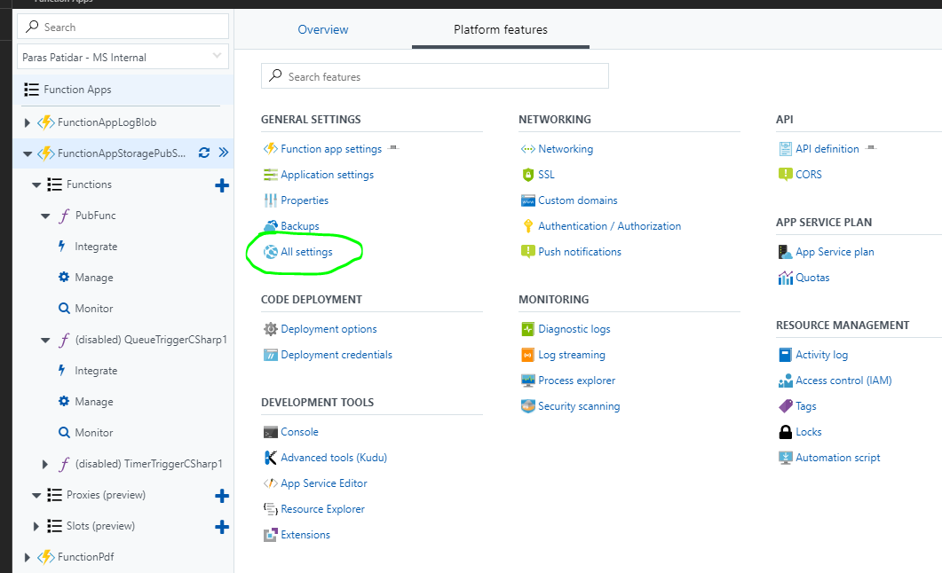

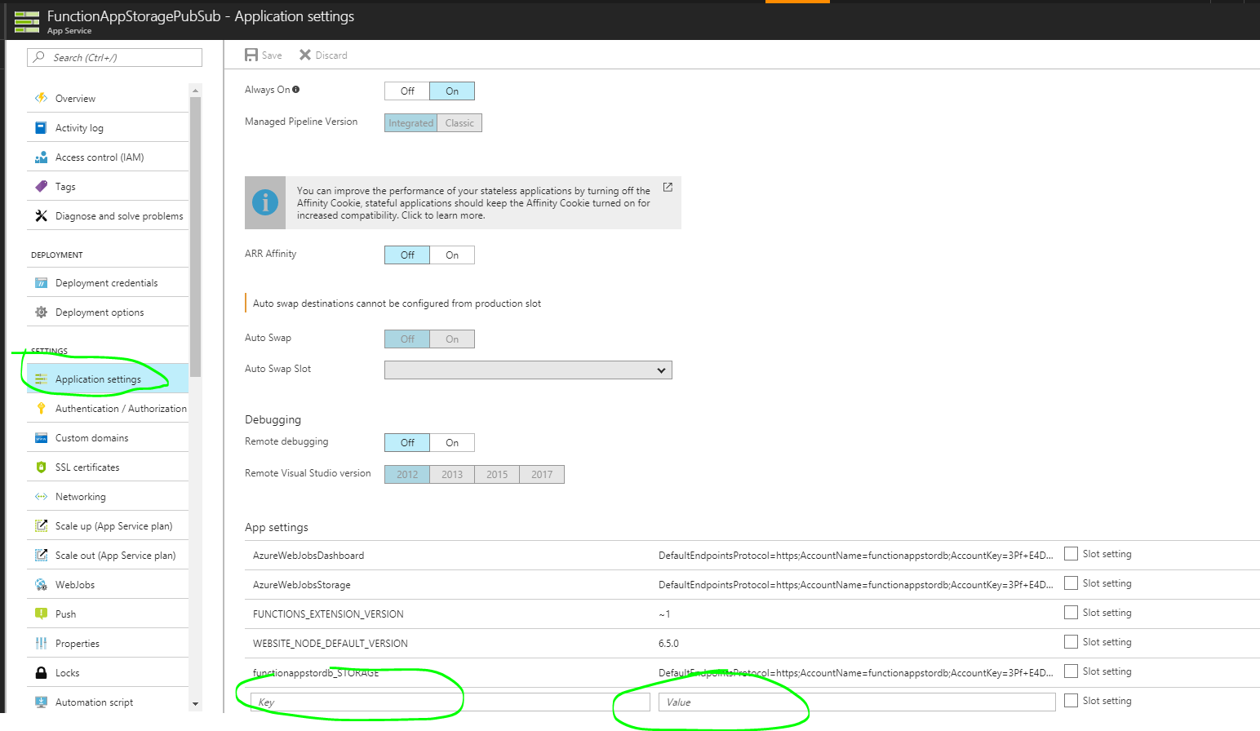

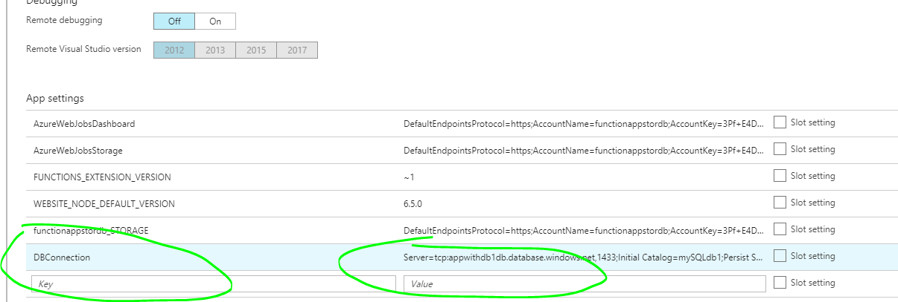

1. Now add some packages in function app by adding project.json and add these lines over there :

|  |
| --- |
| 1. { 2. "frameworks": { 3. "net46":{ 4. "dependencies": { 5. "Dapper": "1.42.0", 6. "System.Data.SqlClient":"4.1.0", 7. "Microsoft.WindowsAzure.ConfigurationManager":"3.2.1" 8. } 9. } 10. } 11. } |

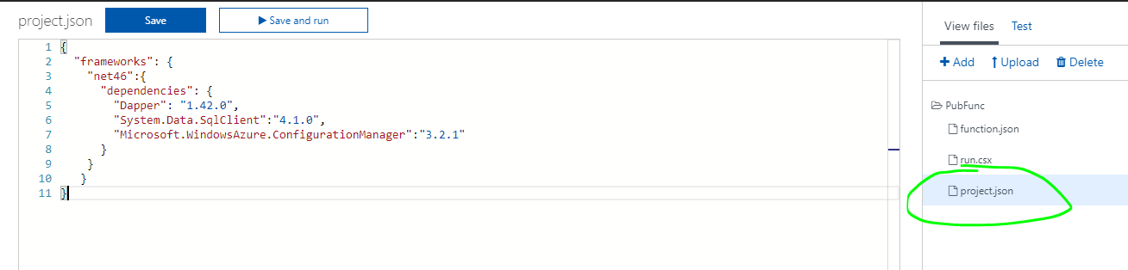

3. Click on Save and it will start downloading some packages from nugget.

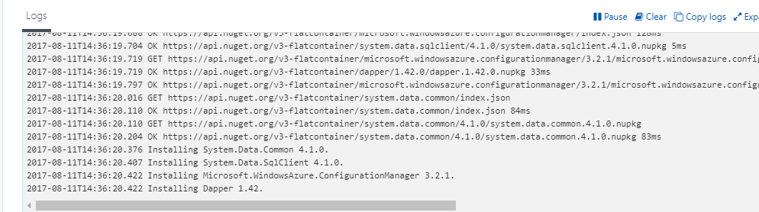

4. Now add some namespaces for sql db and configuration in run.csx (or if you are using VS2017 preview then in your function code )

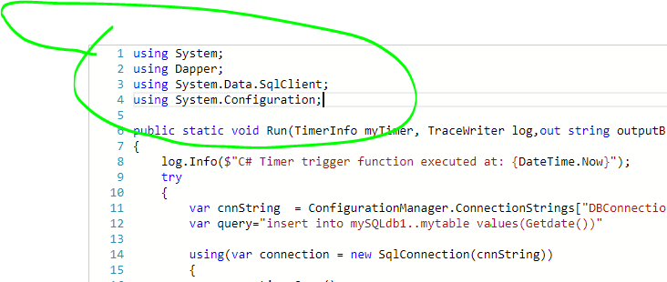

5. Now try to run any sample ADO code like follows :

|  |
| --- |
| var cnnString=ConfigurationManager.AppSettings["DBConnection"];  var query="insert into mySQLdb1..mytable values(Getdate())";  SqlConnection connection= new SqlConnection(cnnString);  connection.Open();  SqlCommand cmd =new SqlCommand(query, connection);  cmd.ExecuteNonQuery();  connection.Close();    log.Info("Log added to database successfully!"); |

