**1Q) what is terraform? what are the advantages?**

Ans) IaaC --> infra as a code

1. Automated infra-CRUD [create, read, update and delete] within minutes, you can create entire infra structure.

2.Version control:

==================

since it is code, we can keep it in Git and track it properly, it is easy to collobarate also with team members, you can maintain versions of infra.

3. Consistent infra:

====================

using terraform code, you can create similar infra in all environments without duplicating the code.

4.inventory management:

=======================

by seeing terraform code we can understand the resources what we are using, you no need to go to console and fetch the report.

5.Cost Optimization:

====================

it can destroy the infra within minutes so that we can reduce cost and other problem forgetting resources to delete.

6.Automatic dependency resolution or management:

==================================

terraform will take care of dependency resolution while creating resources as well as deleting the resources.

7.Moduler infra:

================

Code reuse, you can have terraform modules created, any number of projects can call these modules to create infra instead of writing from the scratch again. you can use these module

some standards

DRY --> Don't repeat yourself.

Project A --> they can simply call central code

Project b --> they can simply call central code

'

'

project N --> they can simply call central code

Central Code --> common terraform code, best standards, security policies.

terraform commands:

=====================

terraform init --> to download the providers and other configuration.

terraform plan --> to will not create the resources, it will give us an idea of what it is going to create

terraform apply --> create the resources

terraform destroy --> deletes the resources.

RDS --> private

RDS --> need some updates

**2Q) what is state file in terraform?**

Ans) Terraform is uses state file to compare the actual infrastructure created and declared infrastructure through .tf files it generally stores

The state into terraforms. tfstate.

State file =Actual infrastructure created by terraform

Desired infrastructure = declared to .tf files

Terraform responsibility is to match desired infrastructure with actual infrastructure.

terraform files .tf = declared configuration = terraform responsibility to create these resources provided you did correct syntax.

actual configuration = tfstate = this is where terraform track the resources it created.

declared configuration == actual configuration

**3Q) what is the remote state in terraform?**

Ans) saving state file locally is not recommended in terraform. Because in a collaborative environment multiple persons would be working on the same infra. So there is a high possibility of duplications and errors if you save the state locally.

Terraform recommends storing the state file in a centralized location, accessible by entire team. And it should be locked so that more people

Can’t do changes in infrastructure at a time

Below are the benefits

Below is the sample code to store the state in s3 and lock it with DynamoDB.

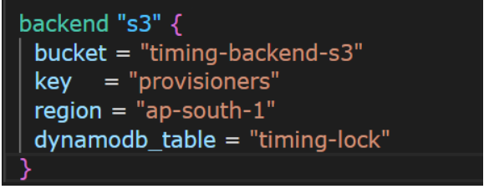

**4Q) explain variables in terraform?**

Ans) variable are used to parameterize the infrastructure. We can provide dynamic values to the configuration through variables.

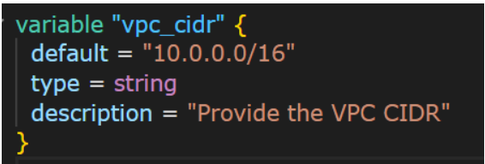

Refer var.[variable-name] wherever you want.

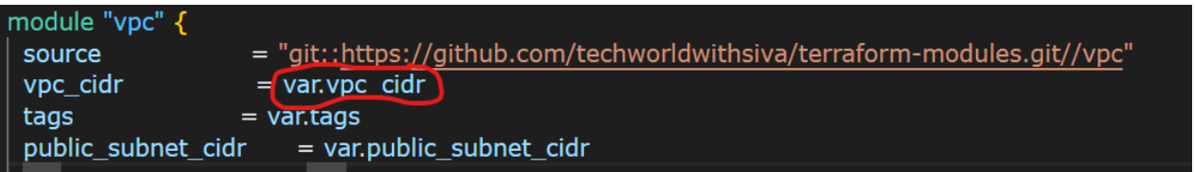

We have below types of variables.

* String
* Number
* Bool
* Map
* List

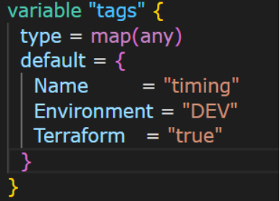

**5Q) what is tfvars in terraform?**

Ans) tfvars is a file which has key, value pairs. It is used to supply the values to terraform variables. If default value is specified in a variables file TFVARS can override those values.

We can use different tfvars files like dev.tfvars and prod.tfvars to provisioning the infrastructure in multiple environments.

We should use -var-file tag to pass tfvars files to the terraform command.

Terraform apply -var-file=dev.tfvars

**6Q) what is count and count index in terraform?**

Ans) in terraform , count parameter used to create multiple instances

Of a resource based on a specified count value.

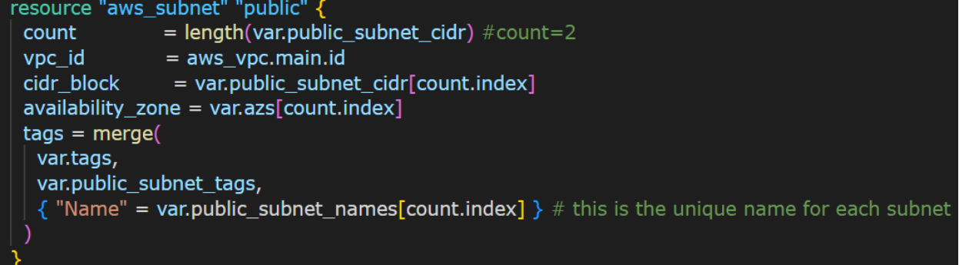

we use count.index to refer to the index from 0. this index is useful to set appropriate values that can be referred from variables.

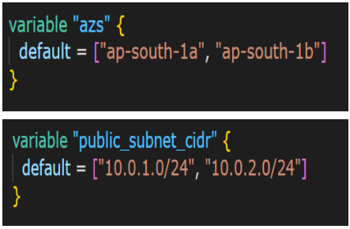

**7Q) what are the outputs in terraform?**

Ans) when we create resources in terraform. It can give us the attributes of the resource it created. These output values useful while creating other resources. Module developers expose the output values, module users can catch and use them to create other resources.

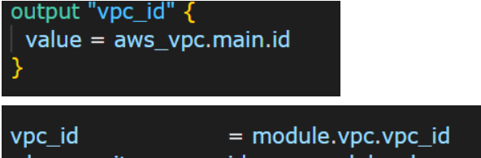

**8Q) what are data sources in terraform?**

Ans) we can query the information from the cloud using datasources. We can retrieve the existing resources details and use them while creating other resources.

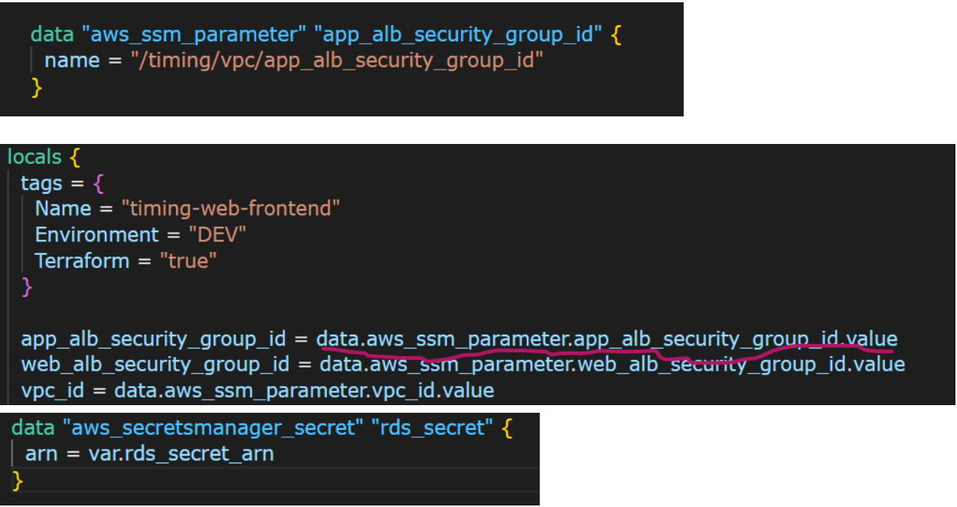

**9Q) what are locals in terraform?**

Ans) locals are like variables in some aspects. We can set key value and use it wherever we want. It has extra capabilities unlike variables, we can assign expressions and functions to locals and refer wherever required. Variable values can be overridden through tfvars and command line, but local values can’t be overridden.

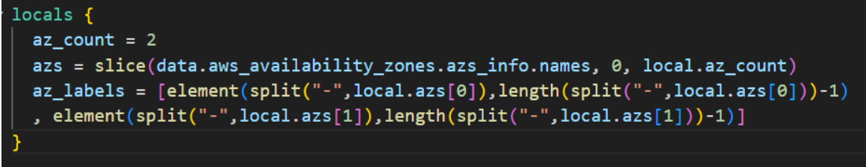

**10Q) what are the functions in terraform? Name a functions you used?**

Ans) functions are to do a unit of work, it can accept inputs and provide the output for us. we have many types of functions like numeric, string,file,netwok functions in terraform. I frequently used

* File function to read the content.
* Split function to split the value based on the separator.
* Slice function to get a part from a list.
* Element function to find out a particular index element.
* Length function to know the size of a list.
* Lookup function to find the value of a key in a map.