Assesment

1. Create database query:

CREATE DATABASE assesment1

1. Create table

-- Bank table

CREATE TABLE Bank (

branch_id INT PRIMARY KEY AUTO_INCREMENT,

branch_name VARCHAR(50),

branch_city VARCHAR(50)

);

-- Loan table

CREATE TABLE Loan (

loan_no INT PRIMARY KEY AUTO_INCREMENT,

branch_id INT UNIQUE KEY,

account_holder_id INT UNIQUE KEY,

loan_amount bigint,

loan_type VARCHAR(50),

FOREIGN KEY (branch_id) REFERENCES Bank(branch_id)

-- Account holder table

CREATE TABLE AccountHolder (

account_holder_id INT PRIMARY KEY AUTO_INCREMENT,

account_no INT UNIQUE KEY,

account_holder_name VARCHAR(100),

city VARCHAR(50),

contact VARCHAR(20) UNIQUE KEY,

date_created DATE,

account_status VARCHAR(20),

account_type VARCHAR(50),

balance bigint

);

Account holder table

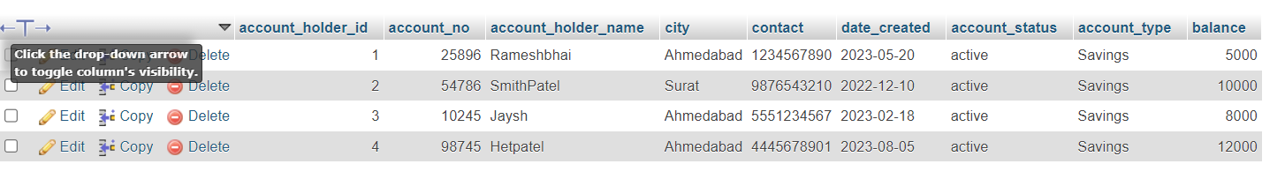

Bank table

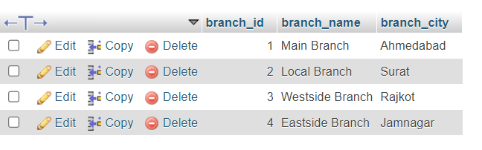

Loan table

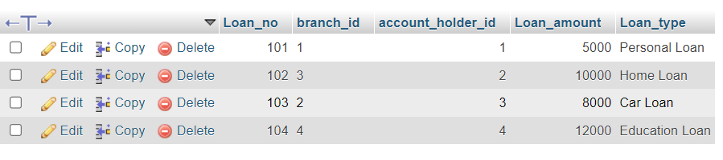

1. account A is trying to transfer $100 to account B.

UPDATE account_holder SET balance = balance - 100 WHERE account_holder_id = 1;

UPDATE account_holder SET balance = balance + 100 WHERE account_holder_id = 2;

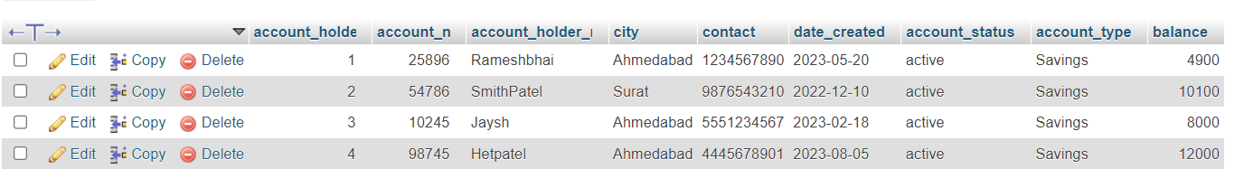

1. Also fetch the details of the account holder who are related from the same city

SELECT * FROM account_holder WHERE city = ‘Ahemedabad’;

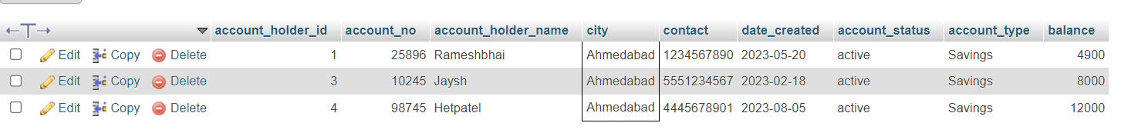

1. Write a query to fetch account number and account holder name, whose accounts were created after 15th of any month

SELECT account_no,account_holder_name FROM account_holder WHERE DAY(date_created) > 15

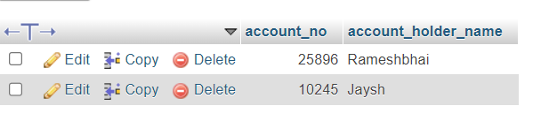

1. Write a query to display the city name and count the branches in that city. Give the count of branches an alias name of Count_Branch.

SELECT branch_city,COUNT(branch_city) AS branch_name FROM banktable GROUP BY branch_city;

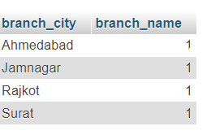

1. Write a query to display the account holder’s id, account holder’s name, branch id, and loan amount for people who have taken loans. (NOTE : use sql join concept to solve the query)

SELECT account_holder.account_holder_id,account_holder.account_holder_name,loan.branch_id,loan.Loan_amount

FROM account_holder JOIN loan ON

account_holder.account_holder_id = loan.account_holder_id;

