[1] Create Table Name: Student and Exam

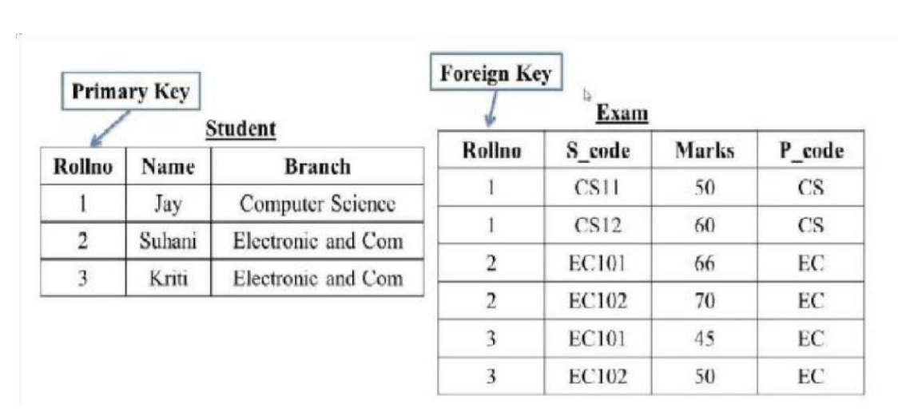

CREATE TABLE student(

Rollno int PRIMARY KEY,

Name varchar(50),

Branch varchar(50)

);

INSERT INTO student(

Rollno ,Name,Branch)VALUES

(1,"Jay","Computer Science"),

(2,"Suhani","Electronic and Computer"),

(3,"Kriti","Electronic and Computer");

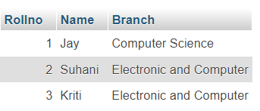

CREATE TABLE Exam (

Rollno int,

S_code varchar (50),

Marks int,

P_code varchar(50),

FOREIGN KEY(Rollno) REFERENCES student(Rollno)

);

INSERT INTO exam(Rollno,S_code,Marks,P_code)VALUES

(1,"CS11",50,"CS"),

(1,"CS12",60,"CS"),

(2,"EC101",66,"EC"),

(2,"EC102",70,"EC"),

(3,"EC101",45,"EC"),

(3,"EC102",50,"EC");

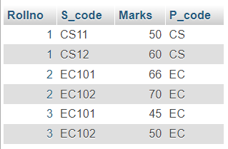

[2] Create table given below:

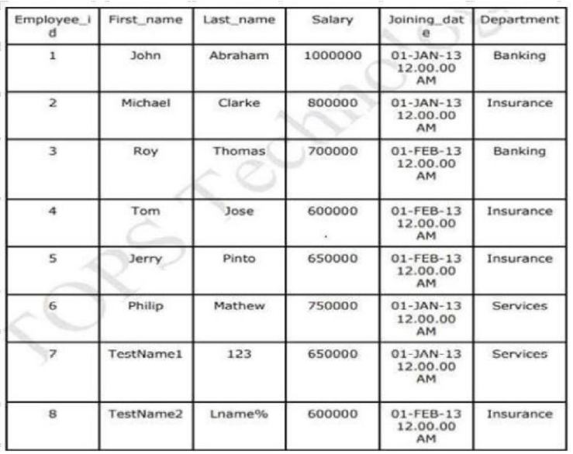

Create table: Employee

CREATE TABLE Employee(

Employee_id int PRIMARY KEY AUTO_INCREMENT,

First_name varchar(50),

Last_name varchar(50),

Salary int,

Joining_date DATETIME,

Department varchar(50)

);

Insert Data into table

INSERT INTO employee( Employee_id,First_name,Last_name,Salary,Joining_date,Department)VALUES

(1,"John","Abraham",1000000,” 2013-01-01” ,"Banking");



INSERT INTO employee (First_name,Last_name,Salary,Joining_date,Department)VALUES

("Michael","Clarke",800000,"2013-01-01","Insurance"),

("Roy","Thomas",700000,"2013-02-01","Banking"),

("Tom","Jose",600000,"2013-02-01","Insurance"),

("Jerry","Pinto",650000,"2013-02-01","Insurance"),

("Philips","Mathew",750000,"2013-01-01","Services"),

("TestName1","123",650000,"2013-01-01","Services"),

("TestName2","Lname%",600000,"2013-02-01","Insurance");

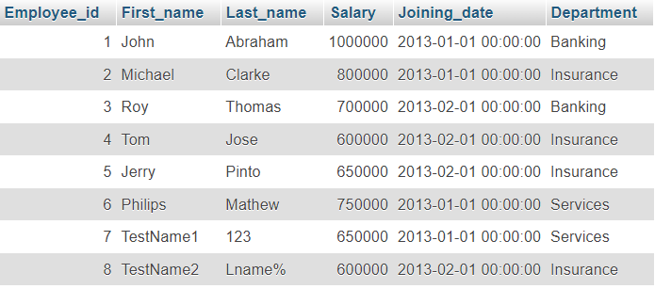

Create table: Incentive

CREATE TABLE Incentive(

Employee_ref_id int,

Incentive_date DATE,

Incentive_amount int,

FOREIGN KEY(Employee_ref_id) REFERENCES employee(Employee_id)

);

Insert data into table

INSERT INTO incentive(Employee_ref_id,Incentive_date,Incentive_amount)VALUES

(1,"2013-02-01",5000),

(2,"2013-02-01",3000),

(3,"2013-02-01",4000),

(1,"2013-01-01",4500),

(2,"2013-01-01",3500);

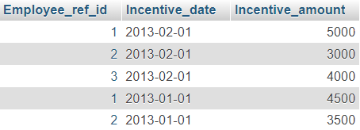

1. Get First_Name from employee table using Tomname “Employee Name”.

SELECT First_name AS Employee_Name FROM employee;

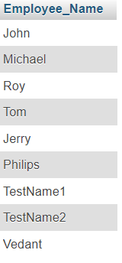

1. Get FIRST_NAME, Joining Date, and Salary from employee table.

SELECT First_name,Joining_date,Salary FROM employee;

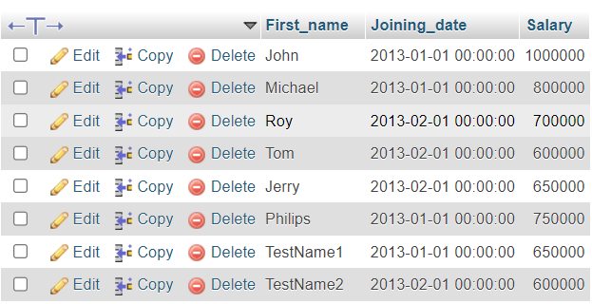

1. Get all employee details from the employee table order by First_Name Ascending and salary descending?

First_name Ascending:

SELECT * FROM employee ORDER BY First_name ASC;

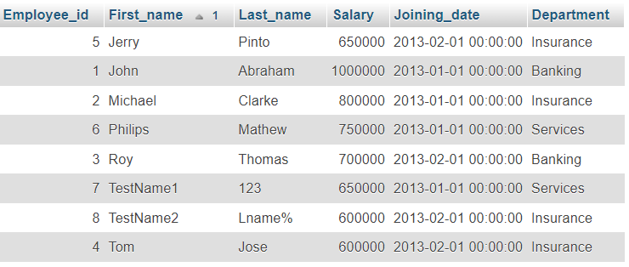

Salary descending:

SELECT * FROM employee ORDER BY Salary DESC;

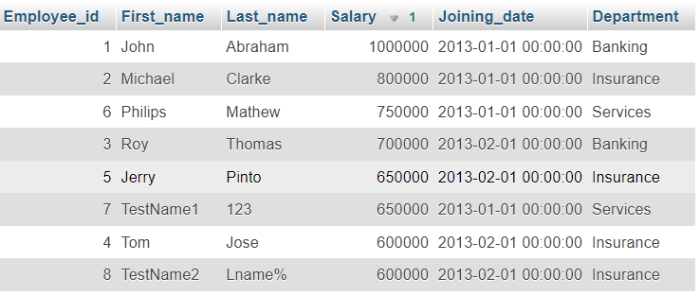

1. Get employee details fromemployee table whose first name contains ‘J’.

SELECT * FROM employee WHERE First_name LIKE '%J%';

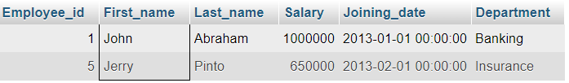

1. Get department wise maximum salary from employee table order by salary ascending?

SELECT * FROM employee WHERE (Department,Salary) IN (SELECT Department,MAX(Salary) FROM employee GROUP BY Department) ORDER BY Salary ASC;

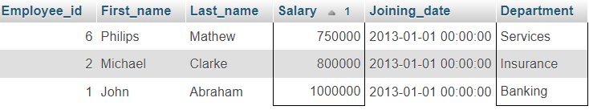

SELECT Department,MAX(Salary) FROM employee GROUP BY Department ORDER BY Salary ASC;

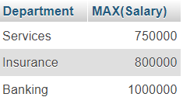

(F) Select first_name, incentive amount from employee and incentives table for those employees who have incentives and incentive amount greater than 3000.

SELECT employee.First_name,incentive.Incentive_amount FROM employee INNER JOIN incentive ON employee.Employee_id = incentive.Employee_ref_id WHERE incentive.Incentive_amount > 3000;

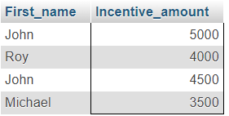

(G) Create After Insert trigger on Employee table which insert records in viewtable.

CREATE TABLE Employee_trigger(

Id int,

F_name varchar(50),

L_name varchar(50),

T_salary int,

Join_date datetime,

Dept varchar(50),

FETCH_Time TIMESTAMP,

ACTION varchar(50)

);



Create Trigger:

CREATE TRIGGER trigger_ins AFTER INSERT ON employee FOR EACH ROW INSERT INTO employee_trigger(Id,F_name,L_name,T_salary,Join_date,Dept,ACTION)

VALUES(NEW.Employee_id, NEW.First_Name, NEW.Last_Name, NEW.Salary, NEW.Joining_date, NEW.Department,"Data Insert !!");

Perform and check:

INSERT INTO employee(First_name,Last_name,Salary,Joining_date,Department)

VALUES

("Vedant","Patel",45023,"2015-05-09","Finance");



[3] Create table given below: Salesperson and Customer.

Table – 1: Salesperson table

CREATE TABLE Sales_Person(

SNo int PRIMARY KEY NOT null,

SNAME varchar(50),

CITY varchar(50),

COMM float(2)

);

INSERT INTO sales_person(SNo,SNAME,CITY,COMM)VALUES

(1001,"Peel","London",.12),

(1002,"Serres","San Jose",.13),

(1004,"Motika","London",.11),

(1007,"Rafkin","Barcelona",.15),

(1003,"Axelrod","New York",.1);

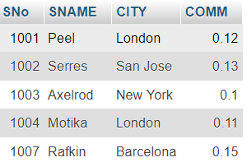

Tabel – 2: Customer Table

CREATE TABLE Customer(

CNM int,

CNAME varchar(50),

CITY varchar(50),

RATING int,

SNo int,

FOREIGN KEY (SNo) REFERENCES sales_person (SNo)

);

INSERT INTO customer(CNM,CNAME,CITY,RATING,SNo)VALUES

(201,"Hoffman","London",100,1001),

(202,"Giovanne","Roe",200,1003),

(203,"Liu","San Jose",300,1002),

(204,"Grass","Barcelona",100,1002),

(206,"Clemens","London",300,1007),

(207,"Pereira","Roe",100,1004);

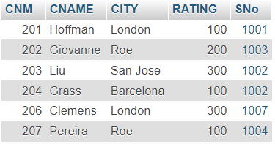

Retrieve the below data from above table

(A) All Customer name whose rating is more than 100.

SELECT CNAME FROM customer WHERE RATING > 100;

(B) Names and cities of all salespeople in London with commission above 0.12.

SELECT SNAME,CITY FROM sales_person WHERE CITY = "London" AND COMM > 0.12;



(C) All salespeople either in Barcelona or in London.

SELECT * FROM sales_person WHERE CITY = "London" OR CITY = "Barcelona";

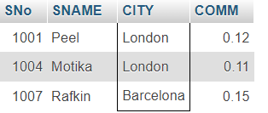

(D) All salespeople with commission between 0.10 and 0.12. (Boundary values should be excluded).

SELECT * FROM sales_person WHERE COMM > 0.10 AND COMM < 0.12;

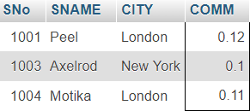

(E) All customers excluding those with rating <= 100 unless they are located in Roe.

SELECT * FROM customer WHERE (RATING > 100 AND CITY != "Roe") OR CITY = "Roe";

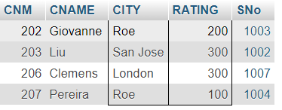

(F) Write a SQL statement that displays all the information about all salespeople.

(G) From the following table, write a SQL query to find orders that are delivered by a salesperson with ID. 5001. Return ord_no, ord_date, purch_amt.

Sample table: orders

[4] From the following table, write a SQL query to select a range of products whose price is in the range Rs.200 to Rs.600. Begin and end values are included. Return pro_id, pro_name, pro_price, and pro_com.

🡪CREATE TABLE item_mast(

PRO_ID int AUTO_INCREMENT PRIMARY KEY,

PRO_NAME varchar(100),

PRO_PRICE FLOAT(2),

PRO_COM int

);

🡪INSERT INTO item_mast(PRO_ID,PRO_NAME,PRO_PRICE,PRO_COM)VALUES

(101,"Mother Board",3200.,15);

🡪INSERT INTO item_mast(PRO_NAME,PRO_PRICE,PRO_COM)VALUES

("Key Board",450.00,16),

("ZIP drive",250.00,14),

("Speaker",550.00,16),

("Monitor",5000.00,11),

("DVD drive",900.00,12),

("CD drive",800.00,12),

("Printer",2600.00,13),

("Refill cartridge",350.00,13),

("Mouse",250.00,12);

🡪Write a SQL query to select a range of products whose price is in the range Rs.200 to Rs.600. Begin and end values are included. Return pro_id, pro_name, pro_price, and pro_com.

SELECT PRO_ID, PRO_NAME, PRO_PRICE, PRO_COM

FROM item_mast

WHERE PRO_PRICE BETWEEN 200 AND 600;

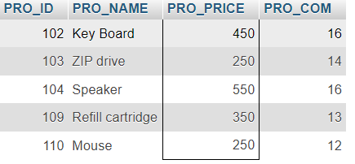

🡪Write a SQL query to calculate the average price for a manufacturer code of 16. Return avg.

SELECT AVG(PRO_PRICE) AS avg_price

FROM item_mast

WHERE PRO_COM = 16;



🡪Write a SQL query to display the pro_name as 'Item Name' and pro_priceas 'Price in Rs.'

SELECT PRO_NAME AS "Item Name", PRO_PRICE AS "Price in Rs."

FROM item_mast;

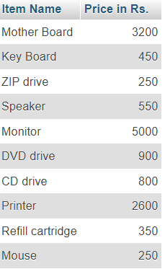

🡪Write a SQL query to find the items whose prices are higher than or equal to $250. Order the result by product price in descending, then product name in ascending. Return pro_name and pro_price.

SELECT PRO_NAME, PRO_PRICE

FROM item_mast WHERE PRO_PRICE >= 250

ORDER BY PRO_PRICE DESC, PRO_NAME ASC;

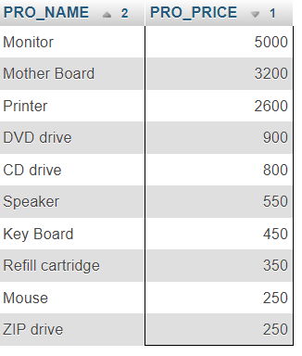

🡪Write a SQL query to calculate average price of the items for each company. Return average price and companycode.

SELECT PRO_COM AS company_code, AVG(PRO_PRICE) AS average_price

FROM item_mast GROUP BY PRO_COM;

