(1)Define the terms: Website, Webpage, Web browser, Web server, HTML,CSS

Ans:

1. Website: A website is a collection of related web pages, multimedia content, and other digital resources that are accessible through a unique domain name and hosted on one or more web servers. Websites can be used for a variety of purposes, such as personal or business marketing, e-commerce, entertainment, education, and more.

2. Webpage: A webpage is a single document or resource that forms part of a website. It is written in HTML and is accessed through a web browser. Web pages can include text, images, video, audio, and other interactive elements.

3. Web browser: A web browser is a software application that allows users to access and navigate the World Wide Web. Examples of popular web browsers include Google Chrome, Mozilla Firefox, Microsoft Edge, and Safari. Web browsers interpret and display web pages, and allow users to interact with them through the use of hyperlinks, forms, and other elements.

4. Web server: A web server is a computer system that stores and serves web content to clients that request it, typically using the HTTP protocol. Web servers can be used to host websites, web applications, and other digital resources. Popular web servers include Apache, and Microsoft IIS.

5. HTML: HTML (Hypertext Markup Language) is a markup language used to create web pages and other digital content. It consists of a set of tags and attributes that define the structure and content of a web page. HTML is interpreted by web browsers to display text, images, and other media on a web page.

6. CSS: CSS (Cascading Style Sheets) is a style sheet language used to define the visual appearance and layout of HTML and XML documents. CSS allows web developers to separate the presentation of a web page from its content, making it easier to maintain and update. CSS is used to define colors, fonts, layouts, and other visual elements of a web page.

(2) Create a webpage to show “This is my first HTML page”

Ans:

<!DOCTYPE html>

<html>

<head>

<title>My First HTML Page</title>

</head>

<body>

<h1>This is my first HTML page</h1>

</body>

</html>

Output:



(3) Display top 10 IT companies list in html webpage

Ans:

<!DOCTYPE html>

<html lang="en">

<head>

<title>Top 10 IT Companies</title>

</head>

<body>

<h1>Top 10 IT Companies</h1>

<ol>

<li>Microsoft</li>

<li>Apple</li>

<li>Amazon</li>

<li>Alphabet</li>

<li>Facebook</li>

<li>Tencent</li>

<li>Alibaba</li>

<li>IBM</li>

<li>Intel</li>

<li>Samsung Electronics</li>

</ol>

</body>

</html>

Output:



(4)Create a dropdown list

Ans:

<!DOCTYPE html>

<html lang="en">

<head>

<title>Dropdown list</title>

</head>

<body>

<select>

<option value="option1">Option 1</option>

<option value="option2">Option 2</option>

<option value="option3">Option 3</option>

</select>

</body>

</html>

Output:

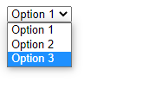

(5) Create a Table Of college Management system using row span & col span.

Ans:

<!DOCTYPE html>

<html lang="en">

<head>

<title>Document</title>

</head>

<body>

<table border="1">

<tr>

<td>Day/Period</td>

<td>I9:30</td>

<td>II10:20-11:10</td>

<td>III11:10-12:00</td>

<td>12:00-12:40</td>

<td>IV12:40-1:30</td>

<td>V1:30-2:20</td>

<td>VI2:30-3:10</td>

<td>VII3:10-4:00</td>

</tr>

<tr>

<td>Monday</td>

<td>Eng</td>

<td>Mat</td>

<td>Che</td>

<td rowspan="6">

<pre>

<b> L

U

N

C

H</b>

</pre>

</td>

<td colspan="3" align="center">LAB</td>

<td>Phy</td>

<!-- <td></td>

<td></td> -->

</tr>

<tr>

<td>Tuesday</td>

<td colspan="3" align="center">LAB</td>

<td>Eng</td>

<td>Che</td>

<td>Mat</td>

<td>Sports</td>

<!-- <td></td>

<td></td>

<td></td> -->

</tr>

<tr>

<td>Wednesday</td>

<td>Mat</td>

<td>Phy</td>

<td>Eng</td>

<td>Che</td>

<td colspan="3" align="center">Library</td>

<!-- <td></td>

<td></td>

<td></td> -->

</tr>

<tr>

<td>Thursday</td>

<td>Phy</td>

<td>Eng</td>

<td>Che</td>

<td colspan="3" align="center">Lab</td>

<td>Mat</td>

<!-- <td></td>

<td></td>

<td></td> -->

</tr>

<tr>

<td>Friday</td>

<td colspan="3" align="center">Lab</td>

<td>Mat</td>

<td>Che</td>

<td>Eng</td>

<td>Phy</td>

<!-- <td></td>

<td></td>

<td></td> -->

</tr>

<tr>

<td>Saturday</td>

<td>Eng</td>

<td>Che</td>

<td>Mat</td>

<td colspan="3">Seminar</td>

<td>sports</td>

<!-- <td></td>

<td></td>

<td></td> -->

</tr>

</table>

</body>

</html>

Output:

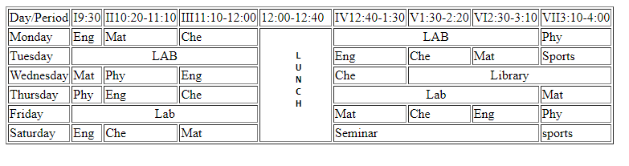

(6) Create below table using HTML table tags

Ans:

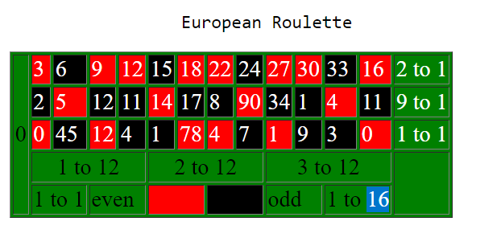

Code:

<body>

<table border="1" bgcolor="green" cellpadding="">

<pre> European Roulette </pre>

<tr>

<td rowspan="5" bgcolor="green">0</td>

<td bgcolor="red"><font color="white">3</font></td>

<td bgcolor="black"><font color="white">6</font></td>

<td bgcolor="red"><font color="white">9</font></td>

<td bgcolor="red"><font color="white">12</font></td>

<td bgcolor="black"><font color="white">15</font></td>

<td bgcolor="red"><font color="white">18</font></td>

<td bgcolor="red"><font color="white">22</font></td>

<td bgcolor="black"><font color="white">24</font></td>

<td bgcolor="red"><font color="white">27</font></td>

<td bgcolor="red"><font color="white">30</font></td>

<td bgcolor="black"><font color="white">33</font></td>

<td bgcolor="red"><font color="white">16</font></td>

<td bgcolor="green"><font color="white">2 to 1</font></td>

</tr>

<tr>

<!-- <td></td> -->

<td bgcolor="black"><font color="white">2</font></td>

<td bgcolor="red"><font color="white">5</font></td>

<td bgcolor="black"><font color="white">12</font></td>

<td bgcolor="black"><font color="white">11</font></td>

<td bgcolor="red"><font color="white">14</font></td>

<td bgcolor="black"><font color="white">17</font></td>

<td bgcolor="black"><font color="white">8</font></td>

<td bgcolor="red"><font color="white">90</font></td>

<td bgcolor="black"><font color="white">34</font></td>

<td bgcolor="black"><font color="white">1</font></td>

<td bgcolor="red"><font color="white">4</font></td>

<td bgcolor="black"><font color="white">11</font></td>

<td bgcolor="green"><font color="white">9 to 1</font></td>

</tr>

<tr>

<!-- <td></td> -->

<td bgcolor="red"><font color="white" >0</font></td>

<td bgcolor="black"><font color="white">45</font></td>

<td bgcolor="red"><font color="white">12</font></td>

<td bgcolor="black"><font color="white">4</font></td>

<td bgcolor="black"><font color="white">1</font></td>

<td bgcolor="red"><font color="white">78</font></td>

<td bgcolor="red"><font color="white">4</font></td>

<td bgcolor="black"><font color="white">7</font></td>

<td bgcolor="red"><font color="white">1</font></td>

<td bgcolor="black"><font color="white">9</font></td>

<td bgcolor="black"><font color="white">3</font></td>

<td bgcolor="red"><font color="white">0</font></td>

<td bgcolor="green"><font color="white">1 to 1</font></td>

</tr>

<tr>

<!-- <td></td> -->

<td colspan="4" align="center" bgcolor="green">1 to 12</td>

<td colspan="4" align="center" bgcolor="green">2 to 12</td>

<td colspan="4" align="center" bgcolor="green">3 to 12</td>

<!-- <td></td>

<td></td>

<td></td>

<td></td>

<td></td>

<td></td>

<td></td>

<td></td>

<td></td> -->

<td rowspan="2"></td>

</tr>

<tr>

<!-- <td></td> -->

<td colspan="2" bgcolor="green">1 to 1</td>

<td colspan="2" bgcolor="green">even</td>

<td bgcolor="red" colspan="2"></td>

<td bgcolor="black" colspan="2"></td>

<td colspan="2" bgcolor="green">odd</td>

<td colspan="2" bgcolor="green">1 to 16</td>

<!-- <td></td>

<td></td>

<td></td>

<td></td>

<td></td>

<td></td>

<td></td> -->

</tr>

</table>

</body>

</html>

(7) Create Registration form using HTML, CSS

Ans:

<style>

form {

margin: auto;

width: 50%;

padding: 20px;

border: 1px solid #ccc;

border-radius: 10px;

background-color: #f2f2f2;

font-family: Arial, sans-serif;

}

label {

display: block;

margin-bottom: 10px;

font-weight: bold;

}

input[type=text], input[type=email], input[type=password] {

width: 100%;

padding: 10px;

margin-bottom: 20px;

border: 1px solid #ccc;

border-radius: 5px;

box-sizing: border-box;

font-size: 16px;

font-family: Arial, sans-serif;

}

button {

background-color: #4CAF50;

color: white;

padding: 10px 20px;

border: none;

border-radius: 5px;

cursor: pointer;

font-size: 16px;

font-family: Arial, sans-serif;

}

</style>

</head>

<body>

<form>

<label for="fname">First Name</label>

<input type="text" id="fname" required>

<label for="lname">Last Name</label>

<input type="text" id="lname" required>

<label for="email">Email Address</label>

<input type="email" id="email" required>

<label for="password">Password</label>

<input type="password" id="password" name="password" required>

<button>Register</button>

</form>

</body>

</html>

Output:

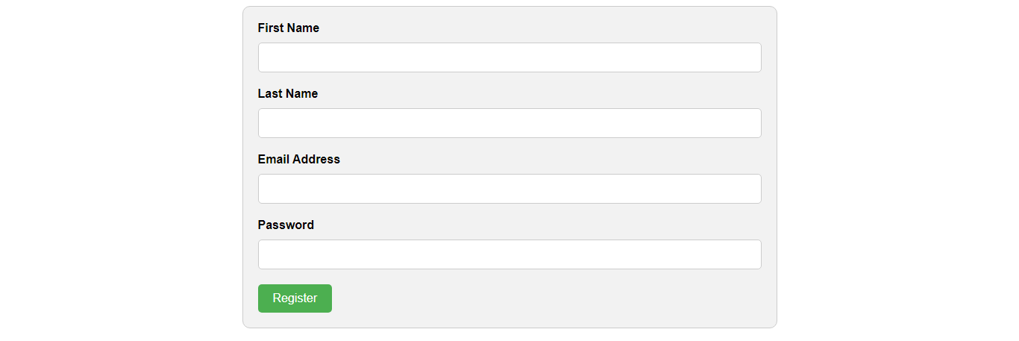

(8) In how many ways can a CSS be integrated as a web page?

Ans:

Internal CSS: This involves placing CSS code within the head section of an HTML document using the <style> tag. This method is useful for small-scale projects or when you only need to style a single page.

Ex: <style>

body {

background-color: lightblue;

color: red;

text-align: center;

}

</style>

External CSS: This involves creating a separate CSS file and linking it to the HTML document using the <link> tag. This method is useful for larger projects with multiple pages, as it allows you to apply the same styles across multiple pages.

Ex: <head>

<title>External CSS Example</title>

<link rel="stylesheet" href="styles.css">

</head>

Inline CSS: This involves placing CSS code directly within the HTML elements using the style attribute. This method is useful for making small, quick changes to specific elements on a page.

Ex: <body>

<h1 style="color: red; text-align: center;">Welcome to my website!</h1>

</body>

(9) Create simple three pages using External CSS, Internal CSS, and Inline CSS.

Ans:

[1]External CSS example:

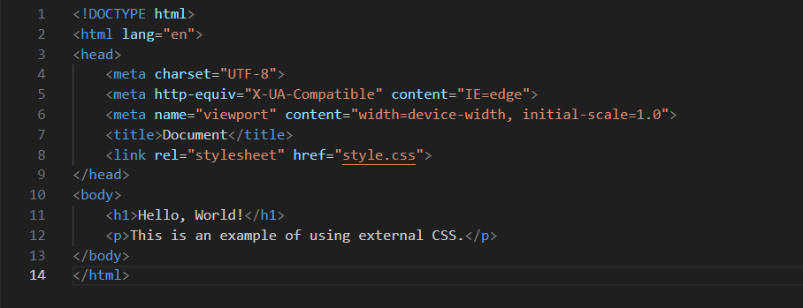

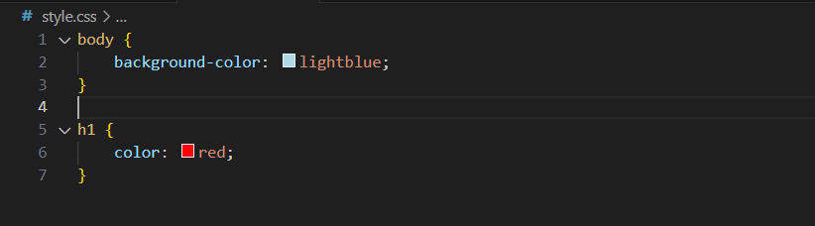

Output:



[2]Internal CSS:

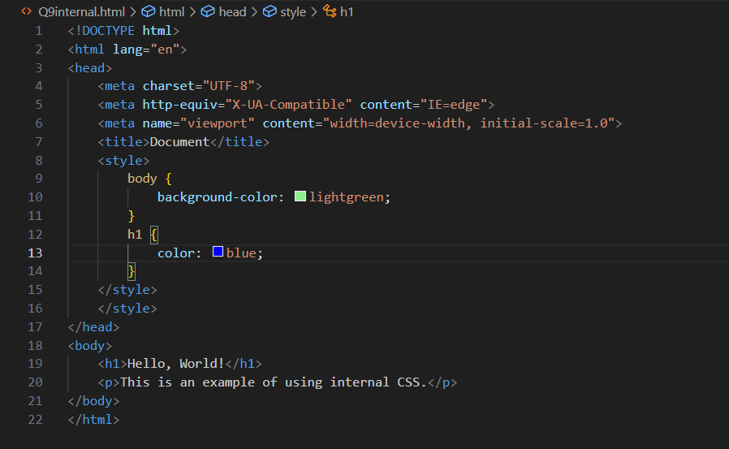

Output:



[3]Inline CSS:

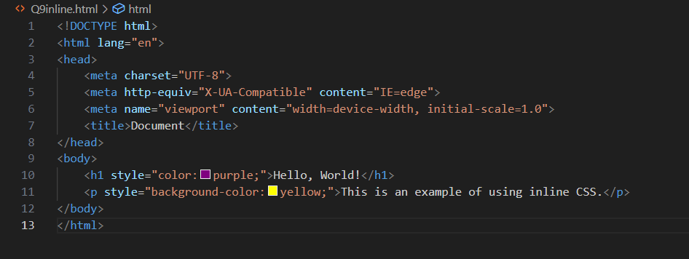

Output:

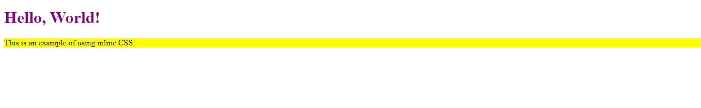

(10) Create below page using HTML CSS

<!DOCTYPE html>

<html lang="en">

<head>

<meta charset="UTF-8">

<meta http-equiv="X-UA-Compatible" content="IE=edge">

<meta name="viewport" content="width=device-width, initial-scale=1.0">

<title>Document</title>

<style>

h3 {

background: rgb(20, 149, 149);

text-align: center;

padding: 5px;

color: brown;

font-size: 28px;

}

form {

background: aqua;

}

#userparticulars {

margin: auto;

}

#personalparticulars {

margin: auto;

}

#accountparticulars {

margin: auto;

}

.one {

color: brown;

font-weight: bold;

font-family: Verdana, Geneva, Tahoma, sans-serif;

}

.btn {

background: rgb(20, 149, 149);

color: white;

/\* margin: auto; \*/

margin: 5px;

}

.button{

text-align: center;

}

</style>

</head>

<body>

<h3>Individual Registration</h3>

<form>

<!-- User Particulars -->

<table>

<tr class="one">

<td>User Particulars</td>

</tr>

</table>

<table id="userparticulars">

<tr>

<td>Login ID</td>

<td><input type="text"></td>

</tr>

<tr>

<td>Password</td>

<td><input type="password"></td>

</tr>

<tr>

<td>Confirm Password</td>

<td><input type="text"></td>

</tr>

</table>

<!-- Personal Particulars -->

<table>

<tr class="one">

<td>Personal Particulars</td>

</tr>

</table>

<table id="personalparticulars">

<tr>

<td>Salutation</td>

<td><select>

<option value="">select</option>

<option value="">option2</option>

<option value="">option3</option>

<option value="">option4</option>

</select></td>

<td>First Name</td>

<td><input type="text"></td>

</tr>

<tr>

<td>Middle Name</td>

<td><input type="text"></td>

<td>Last Name</td>

<td><input type="text"></td>

</tr>

<tr>

<td>Resident Status</td>

<td><select>

<option value="">select</option>

<option value="">option2</option>

<option value="">option3</option>

<option value="">option4</option>

</select></td>

<td>Country</td>

<td><select>

<option value="">select</option>

<option value="">option2</option>

<option value="">option3</option>

<option value="">option4</option>

</select></td>

</tr>

<tr>

<td>Email-Id</td>

<td><input type="text"></td>

<td>Mobile Number</td>

<td><input type="tel"></td>

</tr>

</table>

<!-- Account Particulars -->

<table>

<tr class="one">

<td>Account Particulars</td>

</tr>

</table>

<table id="accountparticulars">

<tr>

<td>15 Digit Account No</td>

<td><input type="text"></td>

<td>Nick Name</td>

<td><input type="text"></td>

</tr>

<tr>

<td>Fund Transfer</td>

<td><select>

<option value="">select</option>

<option value="">option2</option>

<option value="">option3</option>

<option value="">option4</option>

</select></td>

</tr>

</table>

<!-- DECLARATION -->

<table>

<tr class="one">

<td>DECLARATION</td>

</tr>

</table>

<table>

<tr>

<td>I have read understood and hereby agree to the Terms and Conditions in respect of all products and

channels.</td>

</tr>

<tr>

<td>I understand that any changes in the terms and conditions applicable to this relationship would be

made available to me on request at any job branches.I confirm that all accounts under this login

name are operated singly and in case of joint account operated by either or survivor(s)under his/her

joint name respectively.I do hereby declare that information furnished in this form is true to the

best of my knowledge and belief. </td>

</tr>

</table>

<div class="button">

<tr>

<input type="submit" value="Submit" class="btn">

<input type="reset" value="Reset" class="btn">

</tr>

</div>

</table>

</form>

</body>

</html>

Output:

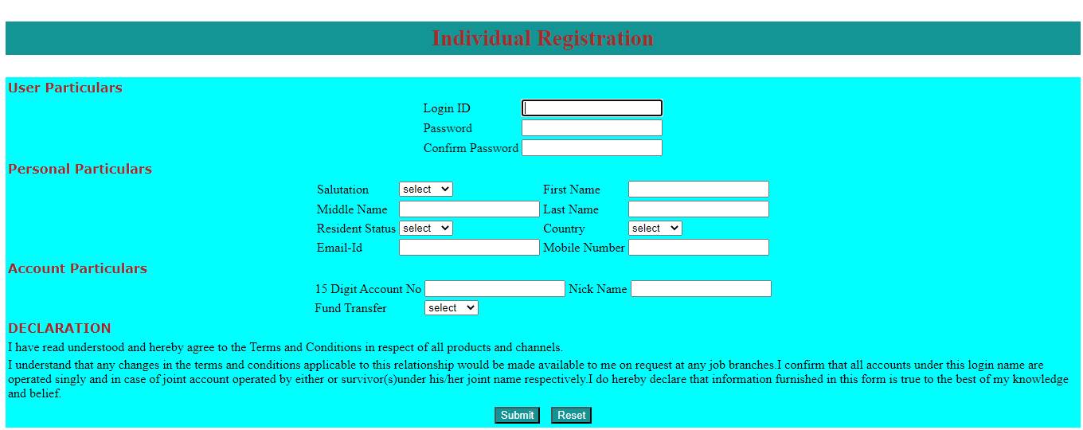

(11) Create link-pseudo classes using external css, to format links on the pages

Ans:

HTML:

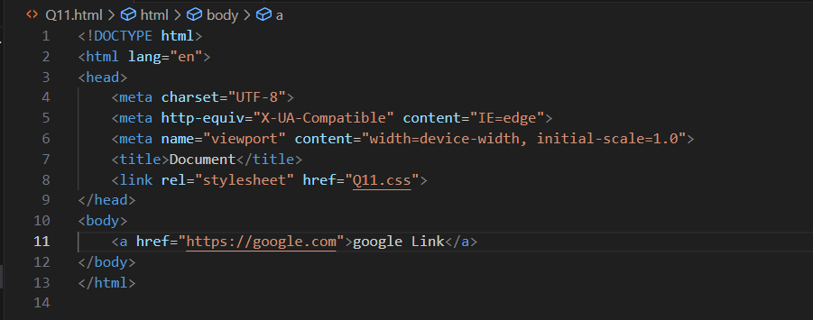

CSS:

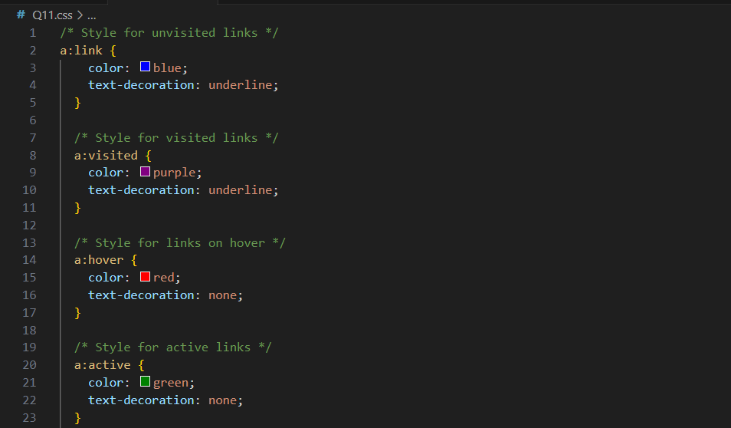



(12) Create a dynamic pseudo class using HTML, CSS

Ans:

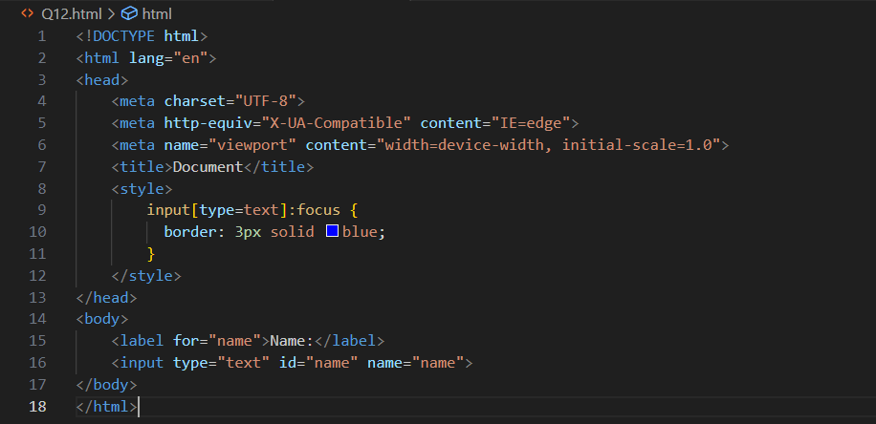

Output:

