Traffic Management System

**Index.html:**

<!DOCTYPE html>

<html lang=”en”>

<head>

<meta charset=”UTF-8”>

<meta name=”viewport” content=”width=device-width, initial-scale=1.0”>

<title>Traffic Management</title>

<link href=<https://cdn.jsdelivr.net/npm/bootstrap@5.3.2/dist/css/bootstrap.min.css> rel=”stylesheet”>

<script src=<https://cdn.jsdelivr.net/npm/bootstrap@5.3.2/dist/js/bootstrap.bundle.min.js>></script>

<link rel=”stylesheet” href=”./style.css”>

<script src=”./script.js”></script>

</head>

<body>

<div class=”container-fluid text-center bg-danger” style=”min-height:15vh;”>

<h2 class=”text-white py-4 px-5 “ >TRAFFIC MANAGEMENT SYSTEM</h2>

</div>

<div class=”container”>

<h2 class=”text-center mt-5” >Traffic Light Simulation</h2><br><br>

<div class=”row mt-3”>

<div class=”col-md-3”><h4>Lane 1</h4>

<h5>Vehicle Count = <span id=”ph-level”>12</span></h5>

<div id=”traffic-light”>

<input type=”radio” name=”traffic-light-color” id=”color1” value=”color1” />

<input type=”radio” name=”traffic-light-color” id=”color2” value=”color2”/>

<input type=”radio” name=”traffic-light-color” id=”color3” value=”colo3” />

</div>

</div>

<div class=”col-md-3”><h4> Lane 2</h4>

<h5>Vehicle Count =<span id=”conductivity”>42</span></h5>

<div id=”traffic-light”>

<input type=”radio” name=”traffic-light-color” id=”color1” value=”color1” />

<input type=”radio” name=”traffic-light-color” id=”color2” value=”color2”/>

<input type=”radio” name=”traffic-light-color” id=”color3” value=”colo3” />

</div>

</div>

<div class=”col-md-3”><h4>Lane 3</h4>

<h5>Vehicle Count = <span id=”temperature”>18</span></h5>

<div id=”traffic-light”>

<input type=”radio” name=”traffic-light-color” id=”color1” value=”color1” />

<input type=”radio” name=”traffic-light-color” id=”color2” value=”color2”/>

<input type=”radio” name=”traffic-light-color” id=”color3” value=”colo3” />

</div>

</div>

<div class=”col-md-3”><h4>Lane 4</h4>

<h5>Vehicle Count = <span id=”temperature1”>1</span></h5>

<div id=”traffic-light”>

<input type=”radio” name=”traffic-light-color” id=”color1” value=”color1” />

Hi <input type=”radio” name=”traffic-light-color” id=”color2” value=”color2”/>

<input type=”radio” name=”traffic-light-color” id=”color3” value=”colo3” />

</div>

</div>

</div>

</div>

</body>

</html>

**Style.css:**

#traffic-light {

Margin-left: 20px;

Margin-top: 40px;

Background-color:#333;

Width:120px;

Height:320px;

Border-radius:30px;

}

Input {

Appearance: none;

Position: relative;

Left: 50%;

Width:80px;

Height:80px;

Margin-top: 30px;

Margin-left:-40px;

Background-color: grey;

Border-radius: 100%;

Display: block;

&#color1 {

Background-color: darken( #FF0000,15%);

&:hover {

Animation: blink1 1.1s step-end infinite;

}

&:checked {

Background-color: #FF0000;

Box-shadow: 0 0 6em lighten( #FF0000,10%);

}

}

&#color2 {

Background-color: darken(#FFFF00,15%);

&:hover {

Animation: blink2 1s step-end infinite;

}

&:checked {

Background-color: #FFFF00;

Box-shadow: 0 0 6em lighten(#FFFF00,10%);

}

}

&#color3 {

Background-color: darken(#00FF00,15%);

&:hover {

Animation: blink3 1s step-end infinite;

}

&:checked {

Background-color:#00FF00;

Box-shadow: 0 0 6em lighten(#00FF00,10%);

}

}

}

@keyframes blink1 {

0% {

Background-color:#FF0000;

Box-shadow: 0 0 6em lighten(#FF0000,10%);

}

50% {

Background-color: darken(#FF0000,15%);

Box-shadow: 0 0 0em transparent;

}

}

@keyframes blink2 {

0% {

Background-color: #FFFF00;

Box-shadow: 0 0 6em lighten(#FFFF00,10%);

}

50% {

Background-color: darken(#FFFF00,15%);

Box-shadow: 0 0 0em transparent;

}

}

@keyframes blink3 {

0% {

Background-color: #00FF00;

Box-shadow: 0 0 6em lighten(#00FF00,10%);

}

50% {

Background-color: darken(#00FF00,15%);

Box-shadow: 0 0 0em transparent;

}

}

**Script.js:**

Function updateData() {

// Simulated data (replace with actual data retrieval logic)

Const phValue = (Math.random() * 14).toFixed(2);

Const conductivityValue = (Math.random() * 50).toFixed(2);

Const temperatureValue = (Math.random() * 30).toFixed(2);

Const temperature1Value = (Math.random() * 30).toFixed(2);

// Update the HTML elements with the new data

Document.getElementById(“ph-level”).textContent = phValue;

Document.getElementById(“conductivity”).textContent = conductivityValue;

Document.getElementById(“temperature1”).textContent = temperature1Value;

Document.getElementById(“temperature”).textContent = temperature1Value;

}

// Poll for updates every 5 seconds (adjust as needed)

setInterval(updateData, 11000);

**Output:**

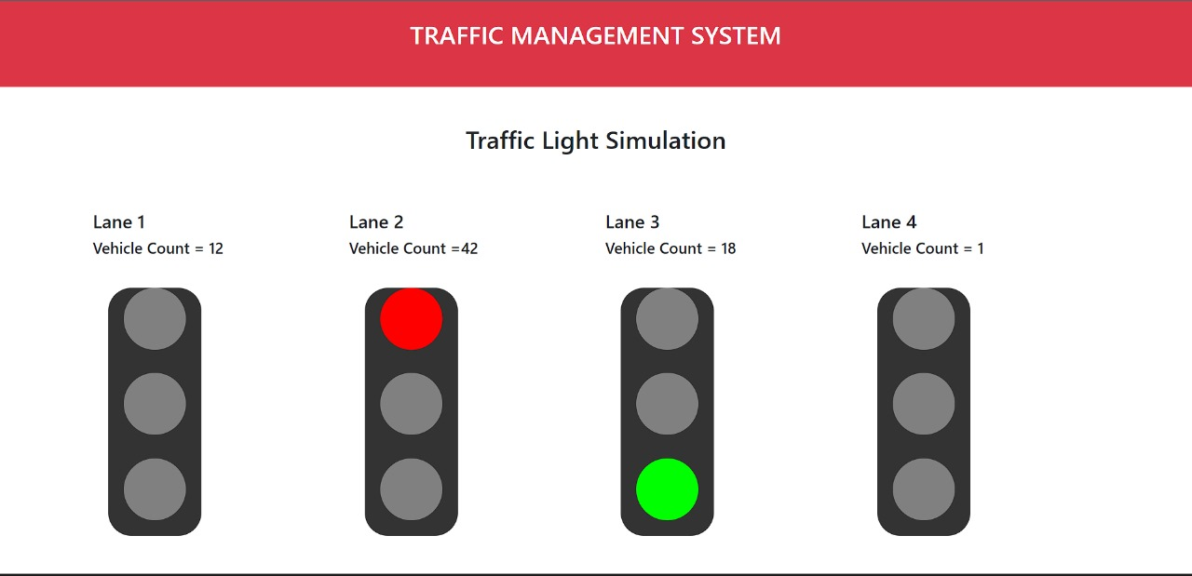

**Mobile Application:**

