REPORT

On

MINI PROJECT WORK

APUML: An Efficient Approach to Detect Mobile Phishing Webpages using Machine Learning

Submitted in
partial fulfilment of the requirements
to award
Bachelor of Technology
in
Information Technology

BY

P. Bharath Kumar (B21IT034)
B. Akshaya (B21IT053)
P. Sai Rohanth (B21IT033)
P. Rohan (B21IT040)

Under the Guidance of
Sri Gautam Rampalli
Assistant Professor

Department of Information Technology
KAKATIYA INSTITUTE OF TECHNOLOGY & SCIENCE, WARANGAL-15
(An Autonomous Institute under Kakatiya University)
2023 – 2024



C E R T I F I C A T E

This is to certify that P. Bharath Kumar (B21IT034), B. Akshaya (B21IT053), P. Sai Rohanth (B21IT033), P. Rohan (B21IT040) of VI- Semester B.Tech. Information Technology has satisfactorily completed the Mini Project entitled “TITLE OF MINI PROJECT” in the partial fulfillment of the requirement of B.Tech degree during this academic year 2023-24.

SUPERVISOR CHAIRMAN, DMPEC

Sri Gautam Rampalli Dr. T. SENTHIL MURUGAN
Assistant Professor Professor & Head, Dept. of I.T.

ACKNOWLEDGEMENT

I wish to take this opportunity to express my deep gratitude to all the people who have extended their cooperation in various ways during my Mini project. It is my pleasure to acknowledge the help of all those individuals.
I thank Dr. K. ASHOKA REDDY, Principal of Kakatiya Institute of Technology & Science, Warangal, for his strong support.
I thank Dr. T. SENTHIL MURUGAN, Professor & Head, Department of Information Technology for his constant support in bringing shape to this Mini project.
I would like to thank my supervisor Sri Gautam Rampalli, Assistant Professor of Information Technology for his guidance and help throughout the Mini project.
In completing this Mini project successfully all our faculty members have given an excellent cooperation by guiding us in every aspect. All your guidance helped me a lot and I am very grateful to you.

P.BharathKumar(B21IT034)
B. Akshaya (B21IT053)
Sai Rohanth (B21IT033)
P. Rohan (B21IT040)

ABSTRACT

The phishing websites have evolved as a major cybersecurity threat in recent times. The phishing websites host spam, malware, ransomware, drive-by exploits, etc. A phishing website many a time look- alike a very popular website and lure an unsuspecting user to fall victim to the trap. The victim of the scams incurs a monetary loss, loss of private information and loss of reputation. Hence, it is imperative to find a solution that could mitigate such security threats in a timely manner. Traditionally, the detection of phishing websites is done using blacklists. There are many popular websites which host a list of blacklisted websites, e. g. Phish Tank. The blacklisting technique lack in two aspects, blacklists might not be exhaustive and do not detect a newly generated phishing website. In recent times machine learning techniques have been used in the classification and detection of phishing websites. By studying different types of websites, we make our smart system learn how to tell the good ones from the bad ones. We test various ways the smart system can work, and it shows good results in accuracy.

ACRONYMS

RF | : | Random Forest
ML | : | Machine Learning
SVM | : | Support Vector Machine
DB | : | Data Base

TABLE OF CONTENTS
 |  |  |  | Page No.
ABSTRACT |  |  |  | i
ACRONYMS |  |  |  | ii
TABLE OF CONTENTS |  |  |  | iii
LIST OF FIGURES |  |  |  | iv
CHAPTER 1 | INTRODUCTION |  |  | 01
 | 1.1 | INTRODUCTION |  | 01
 | 1.2 | OBJECTIVES |  | 02
 | 1.3 | METHODOLOGY |  | 02
CHAPTER 2 | LITERATURE REVIEW |  |  | 03
CHAPTER 3 | IMPLEMENTATION |  |  | 05
 | 3.1 | DATA COLLECTION |  | 05
 |  | 3.1.1  3.1.2  3.1.3 | DATA COLLECTION  PREPROCESSING FEATURE EXTRACTION | 05  05  06
 | 3.2 | TRAINING THE MODELS |  | 08
NAIVE BAYES
SUPPORT VECTOR MACHINE DECISION TREE
RANDOM FOREST
 | 3.3 | FLOWCHART |  | 11
CHAPTER 4 | EXPERIMENTATION AND RESULTS |  |  | 13
 | 4.1 | EXPERIMENTAL WORK |  | 13
 |  | 4.1.1 | CODE IMPLEMENTATION | 14
 | 4.2 | GRAPHICAL USER INTERFACE |  | 20
 | 4.3 | RESULTS |  | 21
CHAPTER 5 | CONCLUSION AND FUTURE SCOPE |  |  | 22
 | 5.1 | CONCLUSIONS |  | 22
 | 5.2 | FUTURE SCOPE |  | 23
REFERENCES |  |  |  | 24

LIST OF FIGURES

Fig. No. | Title | Page No.
3.1 | List of Features of the URL | 07
3.2 | Procedure | 09
3.3 | Flowchart | 11
3.4 | Division of train and test data | 11
3.5 | Architecture for Prediction Algorithms | 12
3.6 | Interface | 24
3.7 | Accuracies of the model | 25

CHAPTER 1 INTRODUCTION

INTRODUCTION

In the present carefully interconnected world, the danger of phishing assaults poses a potential threat, presenting huge dangers to people, organizations, and associations the same. Phishing, a type of cybercrime wherein malevolent entertainers imitate genuine substances to trick clients into revealing delicate data like passwords, monetary subtleties, or individual information, stays an unavoidable test in the internet. As customary phishing location strategies battle to stay up with the developing complexity of malevolent strategies, there emerges a squeezing need for creative methodologies equipped for proactively recognizing and frustrating such dangers.
Utilizing the force of AI calculations, specialists and online protection experts are endeavoring to foster vigorous and proficient systems for distinguishing phishing sites continuously. By dissecting assorted highlights removed from site designs, content, and ways of behaving, AI models can recognize inconspicuous examples demonstrative of vindictive purpose, along these lines sustaining safeguards against phishing assaults. This paper investigates the perplexing scene of phishing site location from the perspective of AI. It clarifies the key standards supporting the location cycle, outlines the key advances associated with building viable recognition models, and explains the critical job of information in preparing and approving these models.
The paper dives into the different strategies and calculations utilized in the component extraction, preprocessing, and demonstrating stages, revealing insight into their separate assets and restrictions. By orchestrating bits of knowledge from research tries and useful executions, this paper means to give an exhaustive outline of the cutting-edge strategies and best practices in phishing site recognition utilizing AI. Additionally, it tries to highlight the meaning of progressing development and joint effort in the domain of network safety, underscoring the basic of remaining in front of enemies in the ceaseless waiting round of

cyber safeguard. In the ensuing segments, we dive into the complexities of each stage in the discovery pipeline, clarifying the strategies, challenges, and arising patterns molding the scene of AI driven phishing site identification. Through a thorough assessment of different methodologies and contextual investigations, we try to furnish perusers with the information and bits of knowledge important to explore this powerful space and contribute definitively to the continuous mission for digital versatility.

OBJECTIVES
    - Model Development: Design and implement a machine learning model for phishing website detection.
    - Feature Engineering: Identify relevant features from URLs, content to create a comprehensive feature set.
    - Dataset Preparation: Collect a diverse dataset with labelled examples of phishing and legitimate websites.
    - Real-Time Detection: Develop a system for real-time phishing website detection using the trained model.
    - Continuous Monitoring

METHODOLOGY
    - Data Collection: Gather a diverse dataset containing both legitimate and phishing websites.
    - Feature Extraction: Identify and extract relevant features from website data, such as URL characteristics and content-based attributes.
    - Data Preprocessing: Clean and preprocess the dataset, handling missing values and normalizing features.
    - Model Selection: Choose appropriate machine learning algorithms suited for binary classification tasks.
    - Training: Train the selected machine learning models on the preprocessed dataset.
    - Evaluation: Evaluate the trained models using metrics like accuracy, precision, and recall.
      - Monitoring and Maintenance: Continuously monitor the model's performance and update it periodically to adapt to evolving threats.

CHAPTER 2 LITERATURE REVIEW

Research in the field of phishing website detection using machine learning has focused on various aspects to improve the accuracy and efficacy of detection systems. One key area of investigation is feature selection, where studies have analyzed the effectiveness of different features in distinguishing between legitimate and phishing websites. For instance, Singh et al. (2019) conducted an extensive analysis of URL-based features and their relevance in phishing detection. Additionally, researchers have explored the performance of different machine learning algorithms for classification tasks. Comparative studies have evaluated algorithms such as logistic regression, decision trees, random forests, support vector machines, and neural networks.
Chen et al. (2020), in a comparative study, found that ensemble methods like random forests achieved superior accuracy in phishing website detection. Furthermore, there is a growing interest in leveraging ensemble methods and deep learning architectures, such as convolutional neural networks (CNNs) and recurrent neural networks (RNNs), for feature extraction and classification in phishing detection tasks. Li et al. (2021) proposed a deep learning-based approach combining CNNs and LSTM networks for detecting phishing websites. Feature engineering and preprocessing techniques have also been explored to enhance model performance.
Khonji et al. (2017) investigated the impact of feature selection and engineering on detection models and found that carefully crafted features significantly improve classification accuracy. Additionally, addressing class imbalance in datasets is a common challenge, with researchers proposing oversampling, undersampling, and cost-sensitive learning techniques to mitigate its effects.
Bhattacharyya et al. (2018) proposed a hybrid oversampling technique combined with SMOTE to improve detection in imbalanced datasets. Real-time detection and deployment of phishing detection systems have also been emphasized, with researchers developing lightweight and efficient models suitable for deployment in real-time systems.

Shah et al. (2020) proposed a lightweight machine learning model for real-time phishing detection, designed to operate efficiently on resource-constrained devices. Finally, evaluation metrics and benchmarking efforts play a crucial role in assessing model performance and providing insights into the strengths and limitations of different approaches.
Alazab et al. (2018) conducted a comparative evaluation of machine learning algorithms using benchmark datasets, highlighting the importance of selecting appropriate metrics based on detection task requirements. Overall, these studies contribute to advancing phishing website detection through machine learning, offering insights into effective methodologies, algorithm selection, feature engineering, and real-world deployment considerations.

CHAPTER 3 IMPLEMENTATION
In this chapter, a detailed description of algorithm, software requirements, flowchart of framework of system is given.

DATA COLLECTION

    - DATA COLLECTION
- Distinguishing phishing sites includes gathering and investigating different sorts of information to recognize dubious examples and ways of behaving.
- Normally, the phishing site information is gathered from Phish Tank or OpenPhish. PhishTank.com is a site where phishing URLs are recognized and can be gotten to through Programming interface call.
- There are openly accessible datasets like the UCI AI store dataset, Kaggle datasets in which there are many records each having URL, type (genuine/phishing) as qualities of that URL.

PREPROCESSING
During the time spent planning AI models for phishing site identification, include extraction from URLs is central. This extraction includes arranging highlights into four primary gatherings.
"Address, right off the bat, Bar Based Highlights" envelop measurements like URL length, the count of subdomains, and the presence of extraordinary characters, as phishing URLs will generally be extended, have various subdomains, and may incorporate exceptional characters to imitate authentic URLs.
"Unusual Based Elements" involve distinguishing anomalies, for example, the presence of IP addresses, sidetracks, or URL shorteners, as these are generally taken advantage of strategies in phishing assaults to muddle the genuine objective of the URL.
Thirdly, "HTML and JavaScript Based Elements" dive into the investigation of page content and JavaScript code, zeroing in on the distinguishing proof of structures, spring up triggers, and jumbled code, which are all characteristic of phishing endeavors meaning to catch client qualifications or sidestep identification.

Finally, "Space Based Elements" include assessing area related credits like age, notoriety, and comparability to known authentic spaces, as phishing sites frequently utilize recently enrolled areas with unfortunate notorieties or misleading similitudes to respectable destinations.
By fastidiously extricating highlights from these classes, AI models can perceive designs recognizing genuine from phishing URLs, consequently improving the precision of recognition frameworks in shielding clients against digital dangers.

FEATURE EXTRACTION
Address Bar Based Features:
URL Length: Determine the length of the URL and represent it as a binary value, where 1 indicates a long URL and 0 indicates a short URL.
Number of Subdomains: Count the number of subdomains in the URL and encode it using three values (low, medium, high) based on predefined thresholds.
Use of Special Characters: Identify the presence of special characters in the URL (such as '@', '-', '_', etc.) and represent it with a binary value indicating its presence or absence.
Abnormal Based Features:
Presence of IP Address: Check if the URL contains an IP address instead of a domain name and encode it as a binary value.
Use of Redirects: Determine if the URL redirects to another page and encode it using three values (low, medium, high) based on the number of redirects.
Use of URL Shorteners: Detect the presence of URL shortening services and represent it with a binary value indicating its presence or absence.
HTML and JavaScript Based Features:
Presence of Forms: Analyze the HTML content to identify the presence of login or submission forms and represent it with a binary value.
Use of Pop-ups: Check for JavaScript code triggering pop-up windows and encode it with a binary value.
Use of Obfuscated Code: Examine JavaScript code for obfuscation techniques and represent it with a binary value indicating its presence or absence.

Result Label:
Assign a label to each URL indicating its true nature. Use -1 to represent phishing sites and 1 to represent legitimate sites.
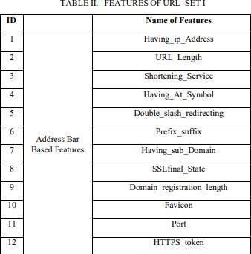
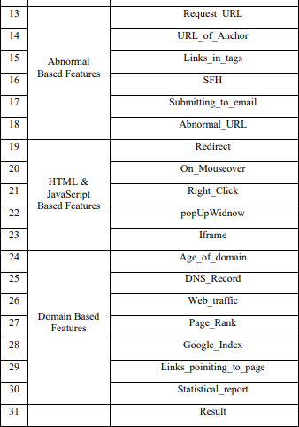

2.1 Features

TRAINING THE MODELS

Information Readiness: Guarantee that the dataset containing the removed highlights is appropriately preprocessed, with missing qualities took care of, unmitigated factors encoded, and includes scaled if essential.
Dividing Information: Gap the preprocessed dataset into preparing and testing sets. A typical split is 70-30 or 80-20, with most information utilized for preparing and the rest for testing.
Preparing SVM: Introduce a SVM classifier, choosing fitting boundaries, for example, the portion type (direct, polynomial, spiral premise capability) and regularization boundary
(C). Train the SVM classifier on the preparation information, where the highlights are utilized to foresee the relating class names (phishing or genuine). SVM learns the ideal hyperplane that best isolates the two classes in the element space.
Preparing Choice Tree (DT): Make a choice tree classifier, indicating boundaries, for example, the most extreme profundity of the tree and the base number of tests expected to part a hub. Train the choice tree classifier on the preparation information, where the elements are utilized to recursively segment the component space considering limit esteems that limit contamination. Choice tree learns an order of if-else conditions to group occurrences into various classes.
Preparing Random Forest (RF): Introduce an irregular woods classifier, determining boundaries like the quantity of trees in the woodland, the greatest profundity of each tree, and the quantity of highlights to consider at each split. Train the arbitrary woodland classifier on the preparation information. Each tree in the woods is prepared on a bootstrap test of the first dataset, and highlights are haphazardly chosen at every hub to decide the best parted. It consolidates the forecasts of numerous choice trees to deliver a more powerful and precise classifier.
Preparing Naïve bayes (NB): Make an Innocent Bayes classifier, expecting freedom among highlights given the class. Train the Guileless Bayes classifier on the preparation information, where the probability of each component given the class is assessed utilizing greatest probability assessment. Gullible Bayes registers the back likelihood of each class given the elements and chooses the class with the most elevated likelihood as the expectation.

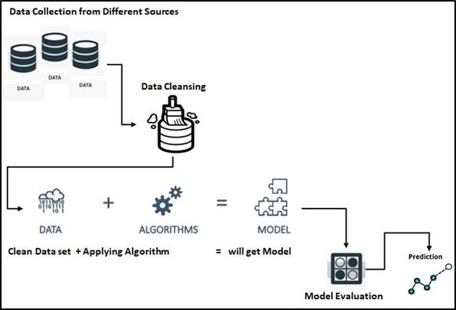
Model Assessment: Assess the prepared classifiers utilizing the testing set to evaluate their presentation. Normal assessment measurements incorporate exactness, accuracy, review, F1-score, and region under the ROC bend. Analyze the exhibition of SVM, DT, RF, and NB classifiers in view of these measurements to figure out which classifier performs best for the undertaking of phishing site location.

Fig. 3.2 Procedure

PROCEDURE:

HTML Form for Input:
Create an HTML form using <form> tag to collect user input. Include an input field using
<input> tag where users can enter URL they want to analyze. Utilize appropriate attributes such as type="text" for text input and name attribute to identify the input field.

Styling with CSS:
Apply CSS to enhance the visual appearance and layout of the input form. Use CSS selectors to target HTML elements and apply styles such as colors, fonts, padding, and margins. Apply CSS rules to improve user experience, including responsive design for different screen sizes.

Flask Integration:
Use Flask, a Python web framework, to handle the backend logic of the web application. Define routes using decorators (@app.route) in a Python script to specify the URLs that the application should respond to. Create a route to handle the form submission, typically using the POST method. Access the input URL from the form submission using Flask's request object (request.form['input_name']).

URL Validation:
Validate the input URL to ensure it follows the correct format and does not contain any malicious characters or patterns. Implement validation logic in the Flask route to check if the URL is valid before processing further.

Processing and Analysis:
Once the input URL is validated, perform any necessary preprocessing or analysis on the URL. This may involve extracting features from the URL, such as domain name, length, and presence of special characters, which can be used for further analysis.

Displaying Results:
Present the results of the URL analysis back to the user in the HTML template. Use Flask's template engine to render dynamic content by passing data from the backend to the HTML template. Display relevant information about the URL analysis, such as whether it is classified as phishing or legitimate, along with any additional details or insights.

Testing and Optimization:
Test the web application thoroughly to ensure functionality and usability across different browsers and devices. Optimize the application for performance by minimizing load times and optimizing resource usage. Iterate on the design and functionality based on user feedback to continuously improve the user experience.

How to run a Flask app?
To test Flask installation, type the following code in the editor as Hello.py. from flask import Flask app = Flask(name) @app.route('/')
def hello_world(): return 'Hello World’ ifname == 'main':
app.run()
The above given Python script is executed from Python shell. Python Hello.py A message in Python shell informs you that
* Running on http://127.0.0.1:5000/ (Press CTRL+C to quit)

FLOW CHART
The following steps are to be followed for the data to be passed from one top level to the bottom level that is shown in Figure 3.5.
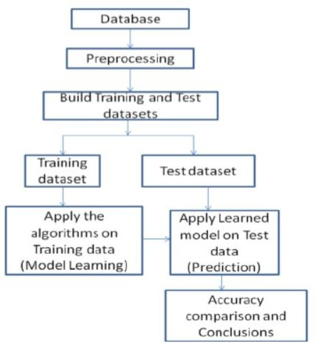
Fig. 3.3 Flow chart for prediction

Design for Train and Test data
In any Machine Learning techniques the data sets that are being used for the prediction has to be divided into training and testing that is shown in the Fig. 3.6.
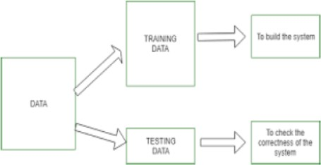

Fig. 3.4 Division of train and test data

s

Architecture for Prediction Algorithms
For all the algorithms to perform its task has to have some specific architecture. The Architecture of all the Machine Learning prediction Algorithms is shown in the Fig. 3.7.
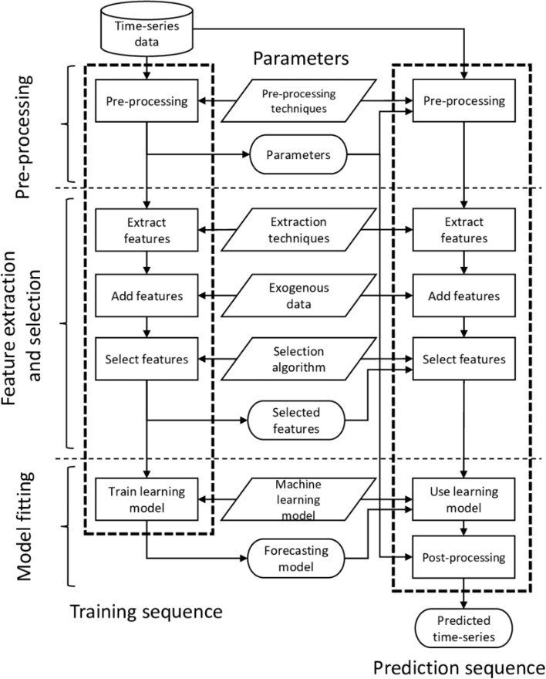
Fig. 3.5Architecture for Prediction Algorithms

CHAPTER 4 EXPERIMENTATION AND RESULTS
In this chapter, implementation of algorithm or frame work is described. Results will be explained in terms of tables and graphs etc.
  - Experimental Work
In our project, Analysis of algorithms is done based on the data sets collected from PhishTank, other websites and features of those URLs are extracted which are saved in CSV files. The Algorithms used in our project are:
- Naive bayes
- Decision Tree
- Random Forest
- SVM

    - CODE IMPLEMENTATION.

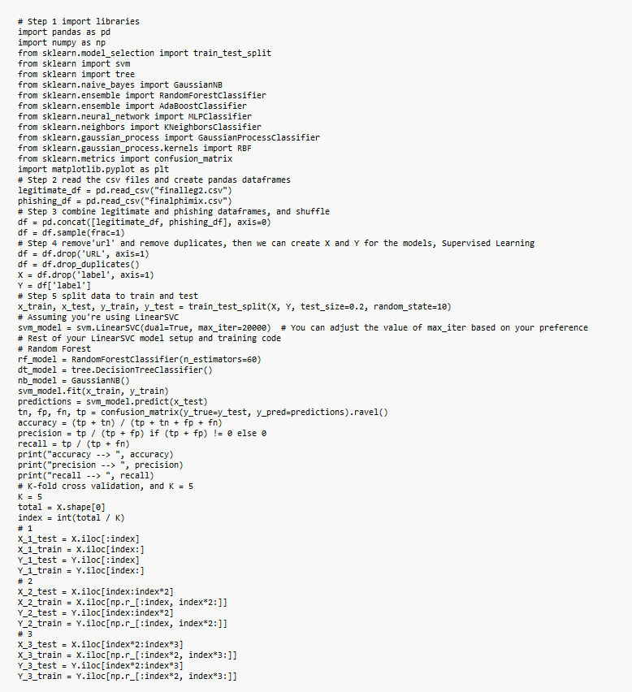

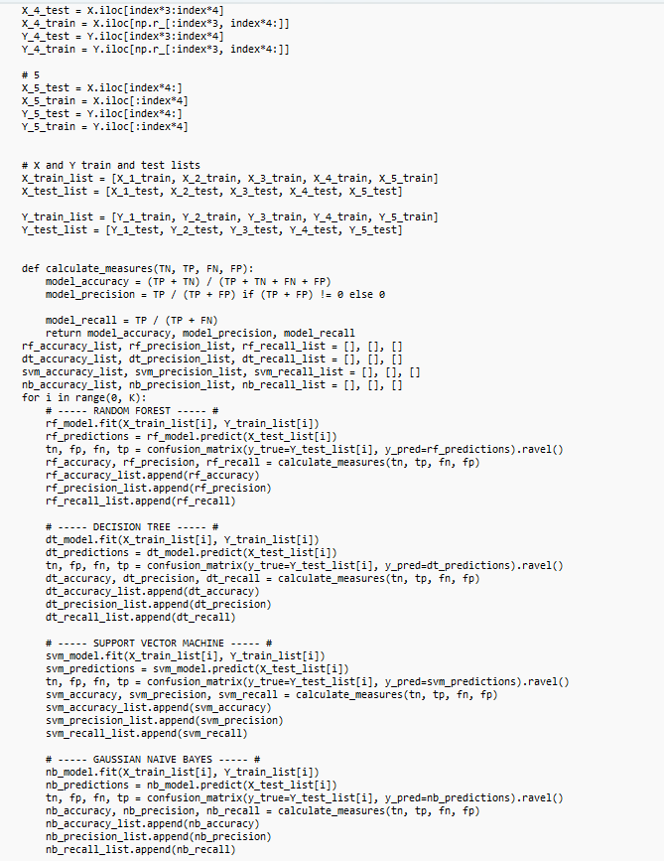

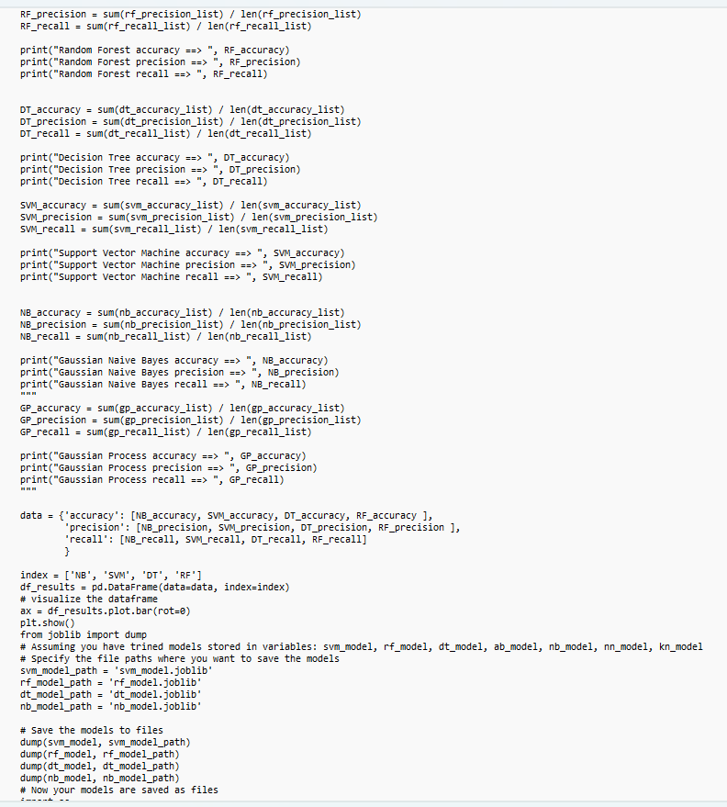

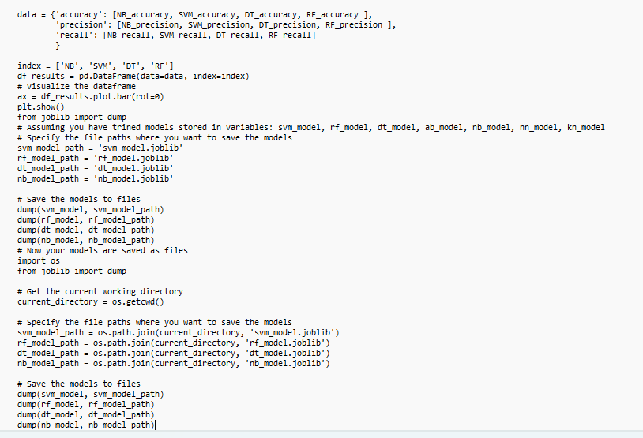

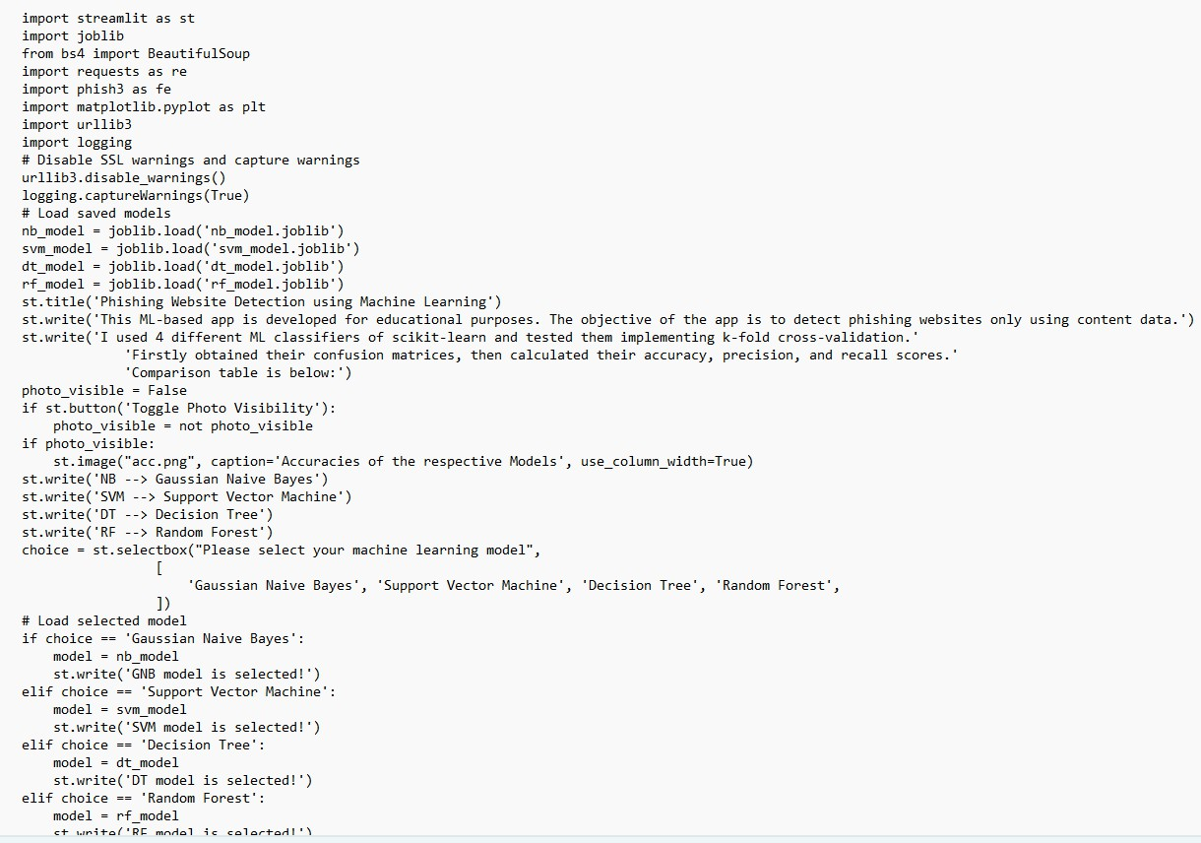

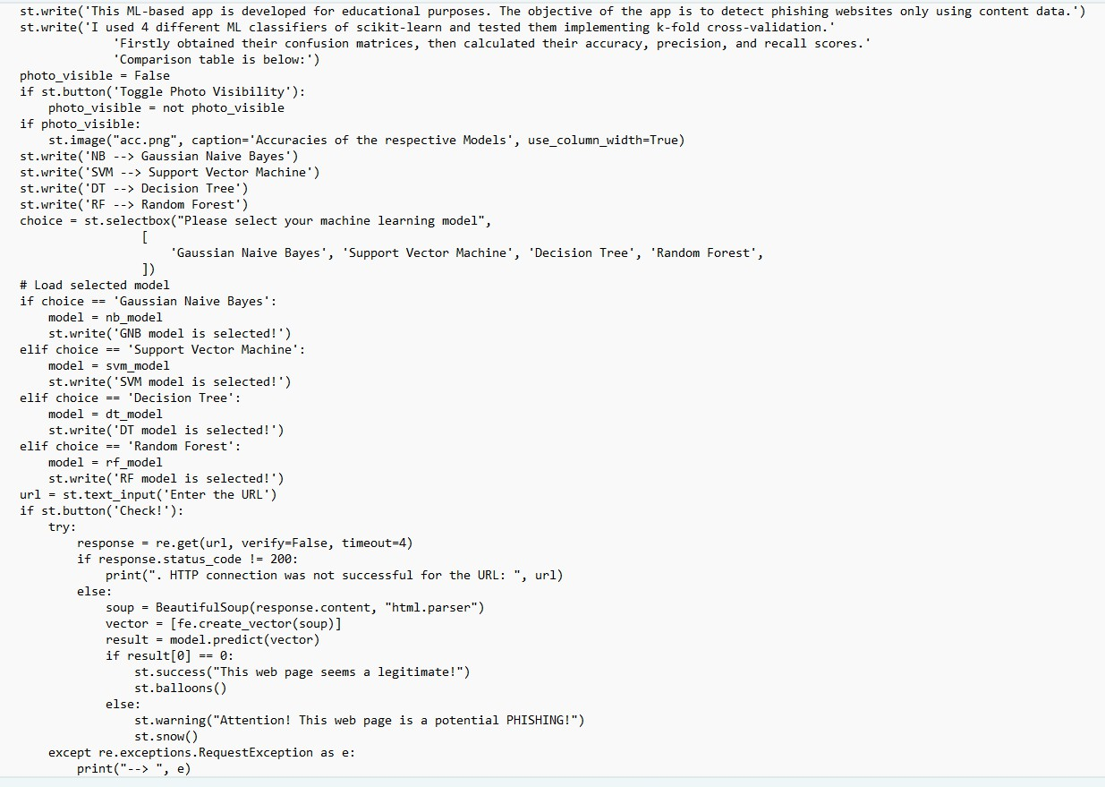

4.2. GRAPHICAL USER INTERFACE
Making a UI (UI) for phishing site location utilizing AI includes planning a framework that permits clients to connect with the basic model. We can fabricate a UI utilizing HTML/CSS and jar or Online stages.
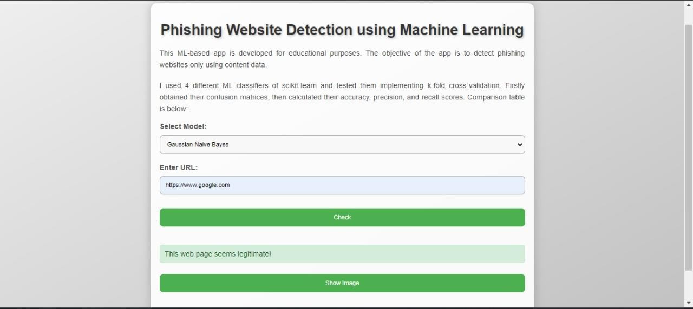
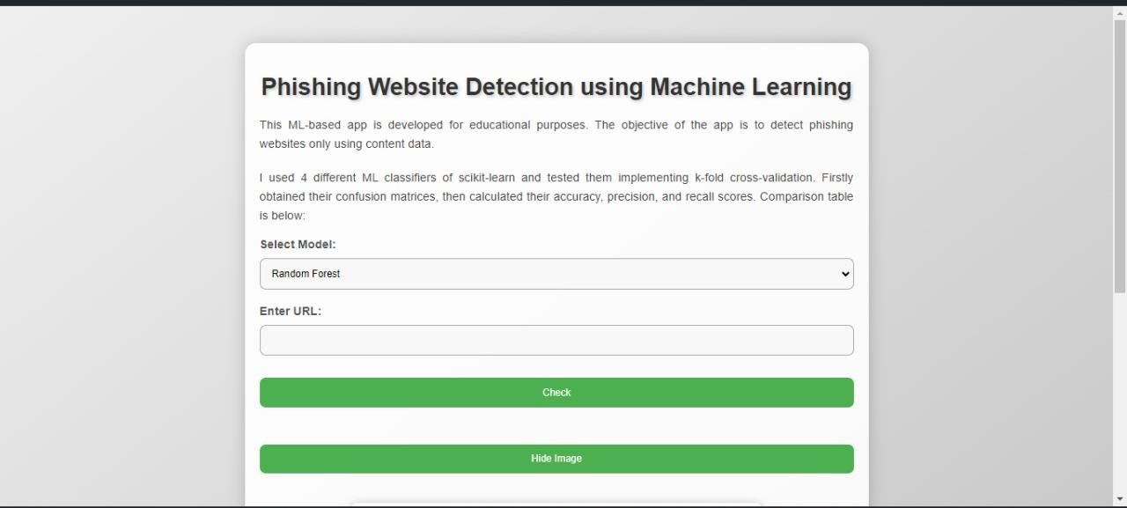

4.3. RESULTS AND DISCUSSION
In this chapter, detailed output analysis of an algorithm is described.

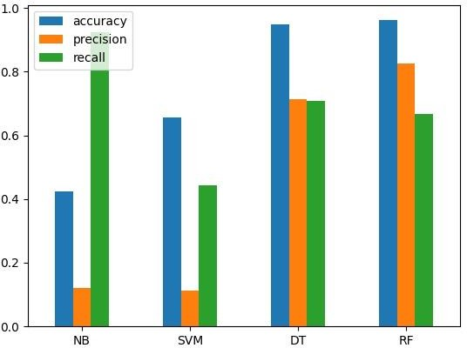

Random Forest works efficiently with the accuracy of 0.966. Random Forest accuracy ==> 0.9663
Random Forest precision ==> 0.8661 Random Forest recall ==> 0.6996

CHAPTER 5 CONCLUSION AND FUTURE SCOPE

CONCLUSIONS

In once-over, involving simulated intelligence for phishing webpage recognizable proof has shown crucial for further developing online security. This proposed approach is a client-side game plan and relies upon no untouchable organizations. The mix of state of the art models, URL-based assessment, and part assurance systems has chipped away at the accuracy. Incorporate decision and dimensionality decline systems smooth out data, and different artificial intelligence estimations show strong gathering. The possible destiny of man-made intelligence in phishing area integrates further creating precision, ceaseless acknowledgment, and merging behavior assessment. Attempts will focus on keeping an eye on opposing attacks, organizing with the organization security natural frameworks. Compliment on client tutoring, security insurance, and adaptability to propelling perils will add to areas of strength for more convincing recognizable proof structures.

FUTURE SCOPE

Undeniable level Examination Techniques: The horizon appeals towards integrating more complicated assessment systems, for instance, simulated intelligence models ready on clearing datasets, to transcend the space of principal URL characteristics and improve phishing acknowledgment precision.
Consistent Watchfulness: The execution of progressing noticing capacities, maybe through getting together with unique risk information takes care of or using web crawlers, can ensure relentless evaluation of URL security status, appropriating likely risks before they arise.
Client driven Cycles: Combining instruments for clients to give analysis on examination results and report questionable URLs will not simply support a helpful procedure towards structure refinement yet furthermore grow client responsibility and trust.
Compact Transparency: Loosening up the application's convenience to flexible stages through the improvement of nearby or hybrid convenient applications will take exceptional consideration of the creating tendencies of clients who logically rely upon phones or tablets for their web based joint efforts.
Multilingual Assistance: Offering total assistance for separating URLs in various vernaculars, worked with by harsh speech disclosure and taking care of techniques, will feature the application's commitment to inclusivity and overall accessibility.
Neighborhood Advancement: By empowering joint exertion with online security organizations and researchers, perhaps through openly delivering the endeavor or participating in helpful drives, the application can harness total knowledge to stay up with the latest with progressing phishing examples and revelation systems.

REFERENCES

- P. Zhang, A. Oest, H. Cho, Z. Sun, R. Johnson, B. Wardman, S. Sarker, A. Kapravelos, T. Bao, R. Wang, Y. Shoshitaishvili, A. Doupé, and G.-J. Ahn, ‘‘CrawlPhish: Large-scale analysis of client-side cloaking techniques in phishing,’’ in Proc. IEEE Symp. Secur.

- ENISA. (2021). Cybersecurity for SMEs—Challenges and Recommendations. [Online]. Available: https://www.enisa.europa.eu/publications/ enisa-report-cybersecurity-for-smes

- Cisco. (2021). Cyber Security Threat Trends: Phishing, Crypto Top the List. [Online]. Available:https://umbrella.cisco.com/info/2021-cybersecurity-threat-trends-phishing-crypto- top-the-list

- M. Alsharnouby, F. Alaca, and S. Chiasson, ‘‘Why phishing still works: User strategies for combating phishing attacks,’’ Int. J. Hum.-Comput. Stud., vol. 82, pp. 69–82, Oct. 2015.

- Anti-Phishing Working Group—APWG. (2022). Phishing Activity Trends Report-1Q. [Online]. Available: https://docs.apwg.org/reports/ apwg_trends_report_q1_2022.p
1

