Night at the Museum

During the night of the museum event, I was able to see the projects of my classmates and students from other periods, even though my time at the museum event that night was only for 30 minutes. Due to the fact that our project was not entirely finished, my group received a lot of comments and tips from other students. We drew more influence from other projects to alter the project's looks and add new features, like a comment section where users could discuss the various teams we offered. One parent in particular asked us questions regarding the site's mechanics and general programming, which we were able to satisfactorily respond to. They also suggested that we change the site's colors to match the theme of basketball more. I really enjoyed getting to know people from different classes and interacting with those who weren't involved in CSP and are thinking about joining.

CollegeBoard APCSP Multiple Choice Final

As we had to take the APCSP CollegeBoard final, I felt confident knowing I have truly learned a lot from this class and taking advantage of my resources. I have been working with my team and using external resources such as the CollegeBoard videos. Creating multiple pages from fastpages templates throughout the year helped me understand how to code with ease for both the front end and back end. I had completed the CollegeBoard MC Final and received a 45/50.

The 5 questions I got incorrect are below:

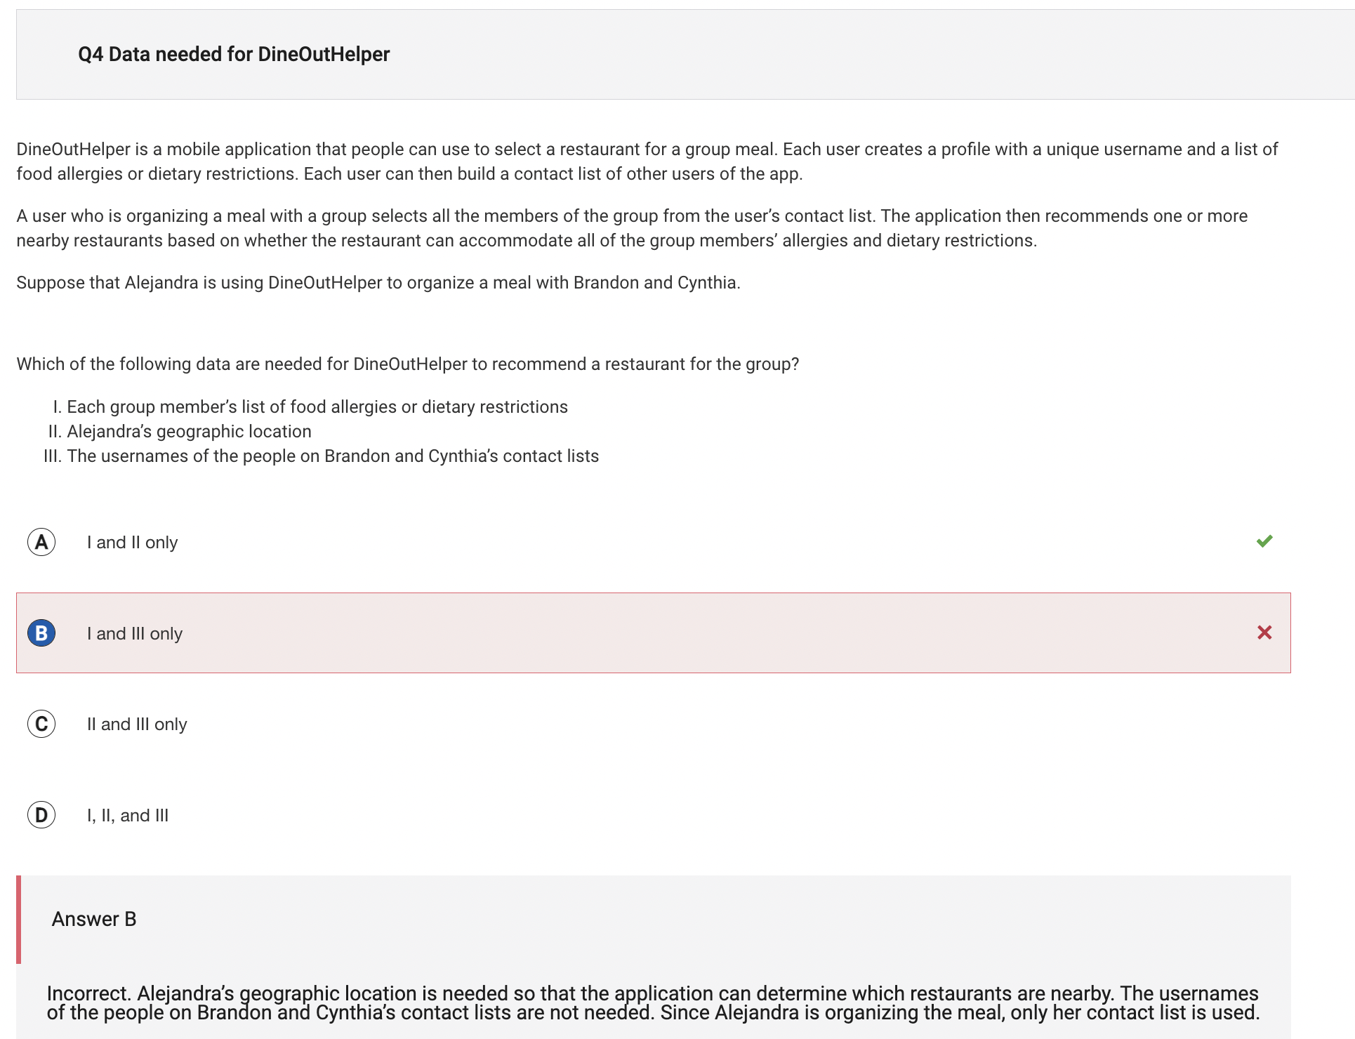

A1. The correct answer to this question above was option A: I and II only. This is correct because the usernames of the people on Brandon and Cynthia’s contact lists are irrelevant to which restaurant to eat yet, although knowing the geographical location is relevant because it is looking to find restaurants near by.

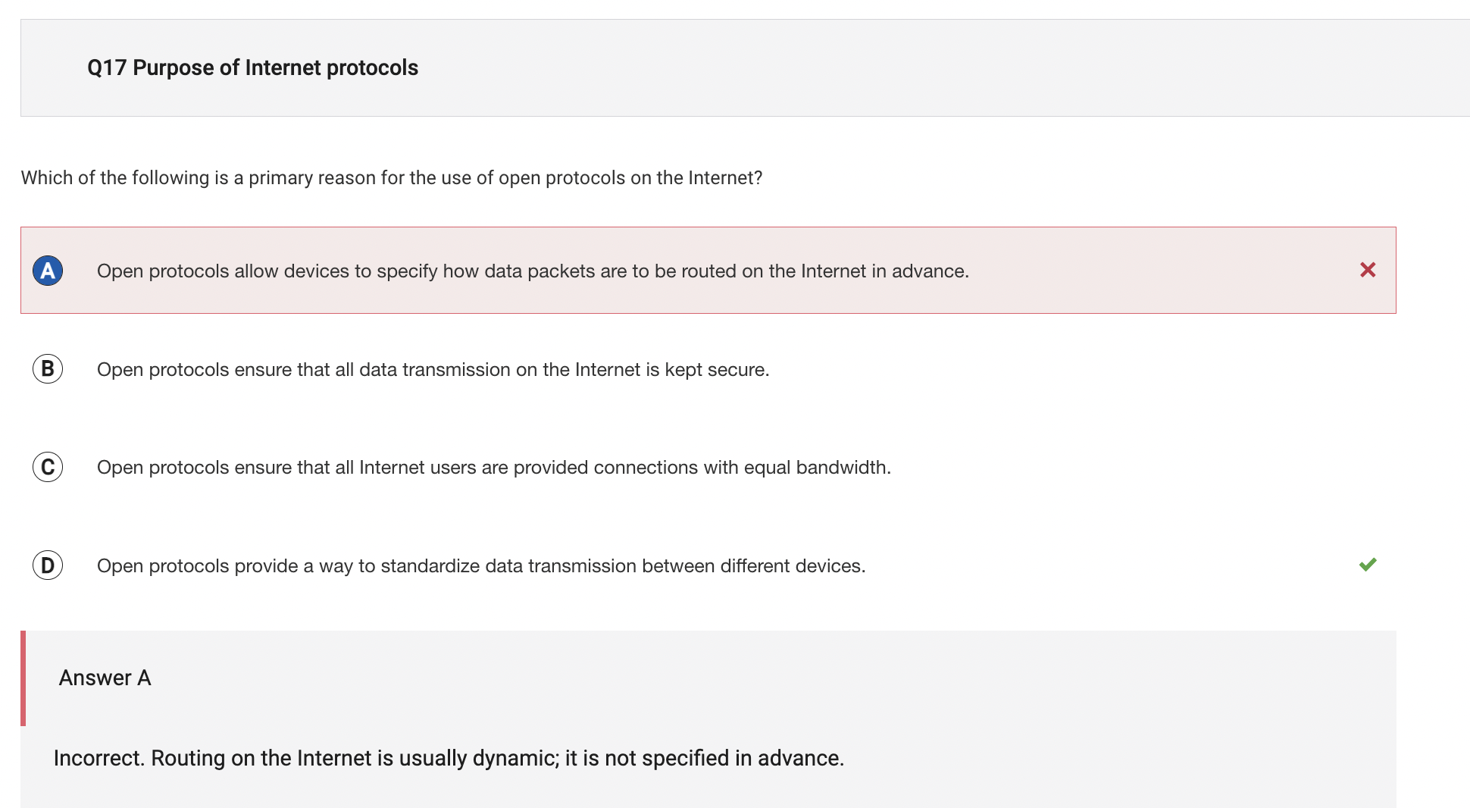

A2. The correct answer to this is option D: Open protocols provide a way to standardize data transmission between different devices. This is because protocols used on the Internet enable devices from different manufacturers to communicate in a standard way.

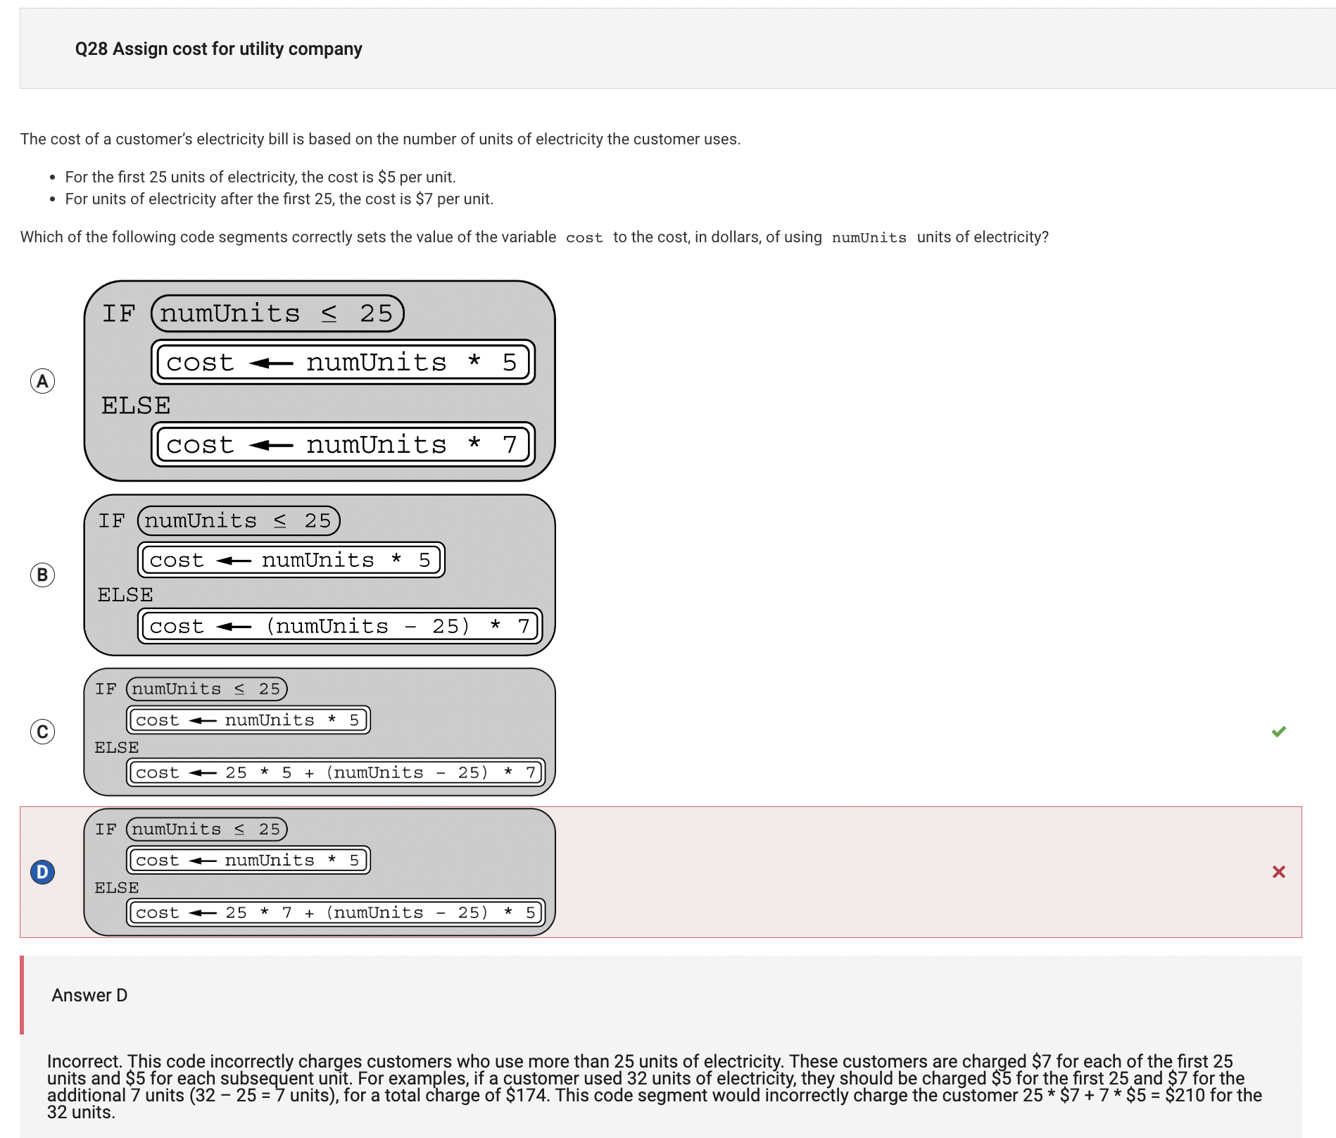

A3. The correct answer to this is option C. This is because protocols used on the Internet enable devices from different manufacturers to communicate in a standard way. This is because if the number of units of electricity used is 25 or less, the cost is 5 times the number of units. Otherwise, the cost is 5 times the first 25 units plus 7 times the number of units above 25.

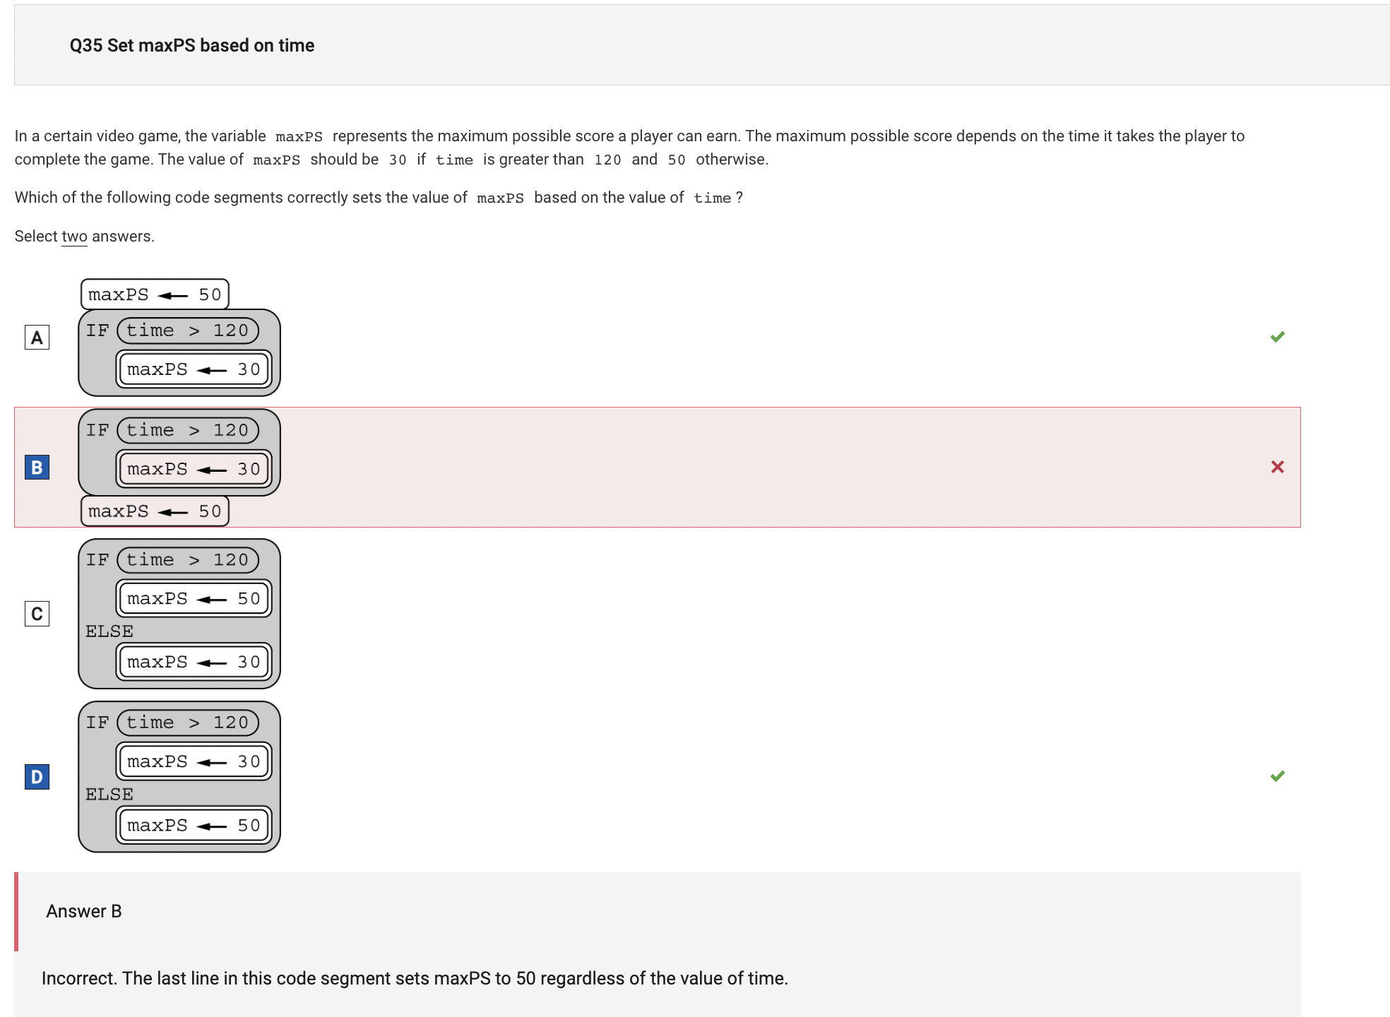

A4. The correct answer to this is option A and D. This is because for option A, the code segment sets maxPS to 50 by default, then uses the IF statement to set maxPS to 30 when time > 120.

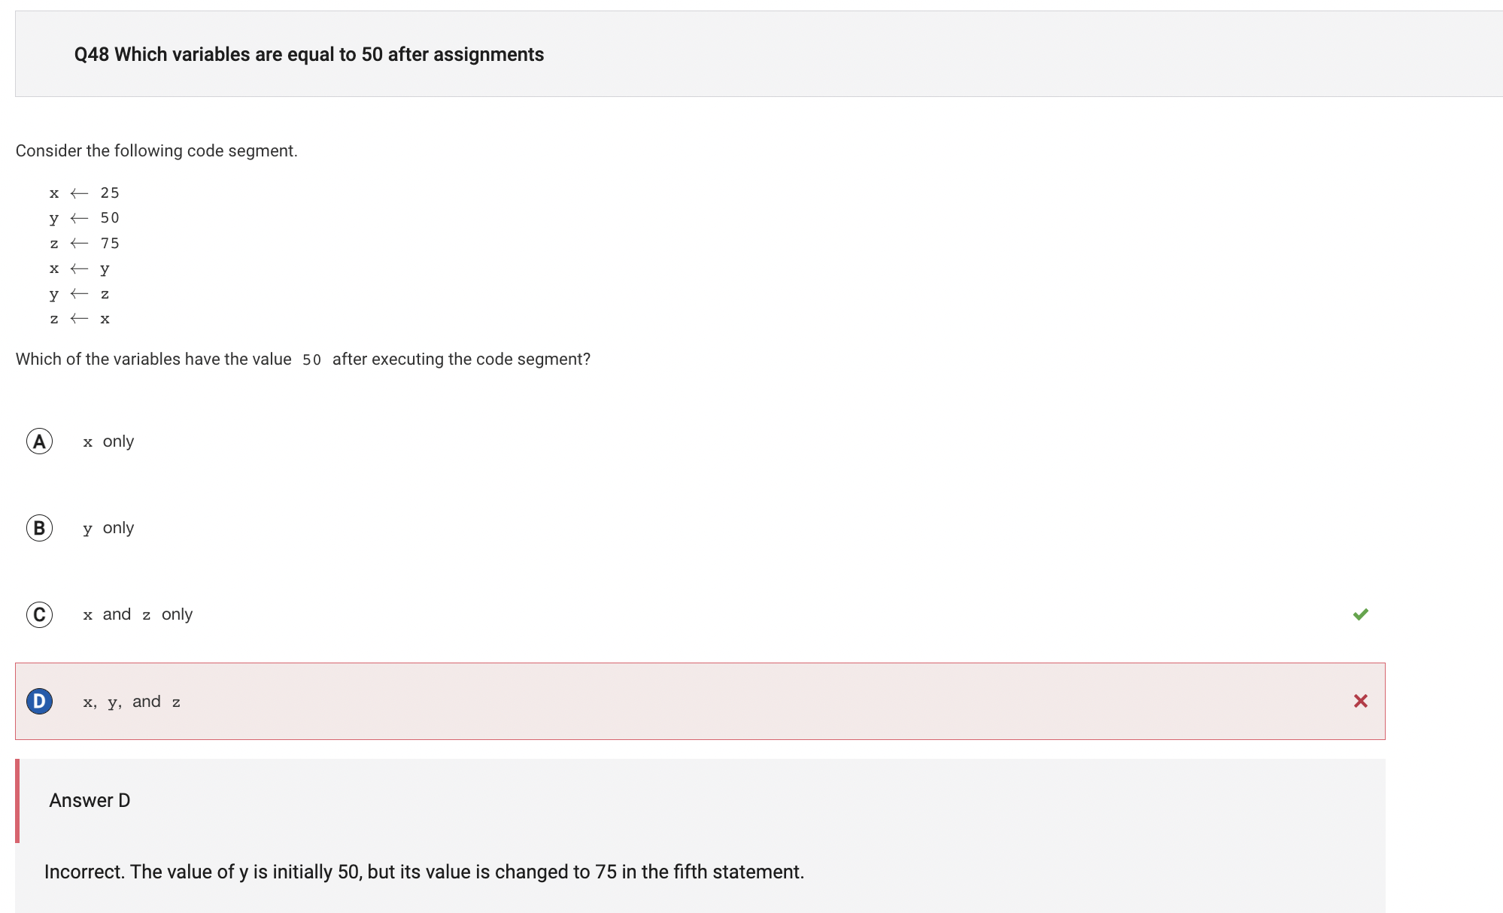

A5. The correct answer to this is option C. This is because the first three statements assign values to the variables. The fourth statement assigns the value of y (which is 50) to x. The fifth statement assigns the value of z (which is 75) to y. The sixth statement assigns the value of x (which is 50) to z. Therefore, x and z both have the value 50.