

**Microprocessor and Microcontroller Lab**

**Lab Report: 1**

Name: **Md. Abdullah al Numan**

ID: **182015101**

**Lab Report Name:** Introduction to Assembly Language and EMU 8086.

**Assembly Language:** In computer programming, Assembly Language is a low-level programming language. Assembly code can be converted to machine code using an assembler.

**EMU 8086:** This program is extremely helpful for those who just begin to study assembly language. First, we write a source code and then we compile it. After compiling we run this program.

Here we a calculator and a convertor. In this convertor we convert Binary, Hexa-Decimal, Decimal and octal.

**Interface of EMU 8086:**

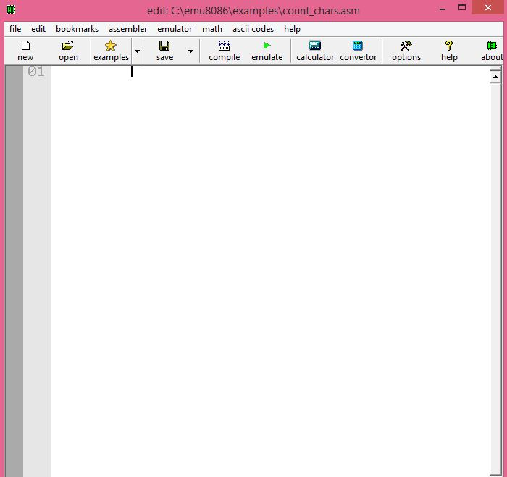

After compile we get an interface. In this editor there have 16 REG, 4 Segment Reg.

The Registor are:

AX, AH, AL

BX, BH, BL

CX, CH, CL

DX, DH, DL

DI

SI

DP

SP

SREG are

DS, ES, SS, CS

In EMU 8086 we can run our program single step.

**Output interface:**

