Key Characteristics of TCP/IP
How should I design a network protocol to transmit data quickly while keeping the data order without any data loss? TCP/IP has been designed with this consideration. The following are the key characteristics of TCP/IP required to understand the concept of the stack.
TCP and IP
Technically, since TCP and IP have different layer structures, it would be correct to describe them separately. However, here we will describe them as one.

1. Connection-oriented
First, a connection is made between two endpoints (local and remote) and then data is transferred. Here, the "TCP connection identifier" is a combination of addresses of the two endpoints, having <local IP address, local port number, remote IP address, remote port number> type.

2. Bidirectional Byte Stream
Bidirectional data communication is made by using byte stream.

3. In-order Delivery
A receiver receives data in the order of sending data from a sender. For that, the order of data is required. To mark the order, 32-bit integer data type is used.

4. Reliability through ACK
When a sender did not receive ACK (acknowledgement) from a receiver after sending data to the receiver, the sender TCP re-sends the data to the receiver. Therefore, the sender TCP buffers unacknowledged data from the receiver.

5. Flow Control
A sender sends as much data as a receiver can afford. A receiver sends the maximum number of bytes that it can receive (unused buffer size, receive window) to the sender. The sender sends as much data as the size of bytes that the receiver's receive window allows.

6. Congestion Control
The congestion window is used separately from the receive window to prevent network congestion by limiting the volume of data flowing in the network. Like the receive window, the sender sends as much data as the size of bytes that the receiver's congestion window allows by using a variety of algorithms such as TCP Vegas, Westwood, BIC, and CUBIC. Different from flow control, congestion control is implemented by the sender only.

Data Transmission
As indicated by its name, a network stack has many layers. The following Figure 1 shows the layer types.
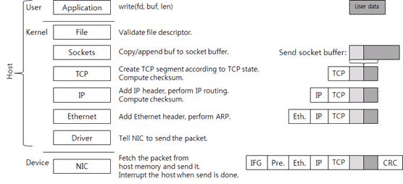
Figure 1: Operation Process by Each Layer of TCP/IP Network Stack for Data Transmission.
The kernel socket has two buffers.
- One is the send socket buffer for sending;
- And the other is the receive socket buffer for receiving.
When the write system call is called, the data in the user area is copied to the kernel memory and then added to the end of the send socket buffer.

Data Receiving
Now, let's take a look at how data is received. Data receiving is a procedure for how the network stack handles a packet coming in. Figure 3 shows how the network stack handles a packet received.
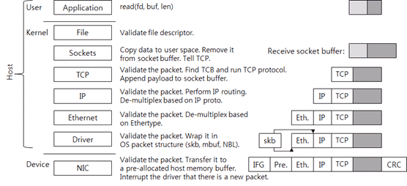
Figure 2: Operation Process by Each Layer of TCP/IP Network Stack for Handling Data Received.

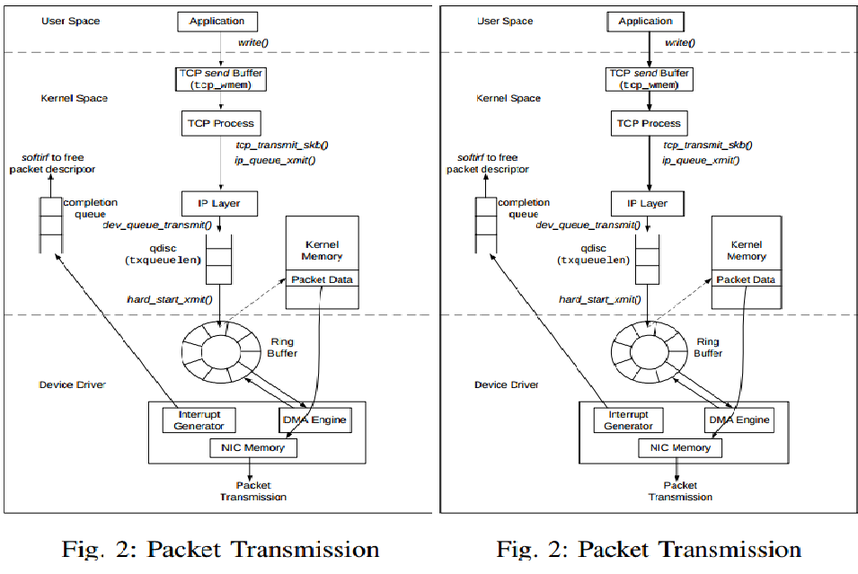

Network Device Driver Hardware Interface:

Driver allocates Ring Buffers.
Driver resets descriptors to initial state.
Driver puts packet to be sent in Tx buffers.
Device puts received packet in Rx buffers.
Driver/Device update descriptors to indicate state.
Device indicates Rx and end of Tx with interrupt,unless interrupt mitigation techniques are applied.

Network device registration:
Each network device is represented by a struct net_device
These are allocated using: struct net_device * alloc_netdev (size, mask,setup_func);
size – size of our priv data
partmask – a naming pattern (e.g. “eth%d”)
setup_func – A functionthat set ups the rest of net_device.
And is registered via a call to: int register_netdev (struct net_device *dev);

Network device intilization:
The net_device structure is initalized with numerous methodsand flags by the setup function:
open – request resources, register interrupts, start queues.
Stop – deallocates resources, unregister irq, stop queue.
get_stats – report statistics
set_multicast_list – configure device for multicast
hard_start_xmit – called by the stack to initiate Tx.
IFF_MULTICAST – Device support multicast
IFF_NOARP – Device does not support ARP protocol

Packet Representation :
struct sk_buff

Socket buffer operation:
skb_put : add data to a buffer.
skb_push : add data to the start of a buffer.
skb_pull : remove data from the start of a buffer.
skb_headroom : returns free bytes at buffer head.
skb_tailroom : returns free bytes at buffer end.
skb_reserve : adjust headroom.
skb_trim : remove end from a buffer.

CPUs often take a performance hit when accessing unalignedmemory locations.Since an Ethernet header is 14 bytes network drivers oftenend up with the IP header at an unaligned offset.
IP header can be aligned by shifting the start of thepacket by 2 bytes. Drivers should do this with:
skb_reserve(NET_IP_ALIGN);
The downside is that the DMA is now unaligned. On somearchitectures the cost of an unaligned DMA outweighs thegains so NET_IP_ALIGN is set on a per arch basis.

Socket buffer allocation:
dev_alloc_skb : allocate an skbuff for Rx
netdev_alloc_skb : allocate an skbuff for Rx, on aspecific device.
Allocate a new sk_buff and assign it a usage count of one.The buffer has unspecified headroom built in. Users should allocatethe headroom they think they need without accounting for the builtin space. The built in space is used for optimizationsNULL is returned if there is no free memory.Although these functions allocates memory it can be called from an interrupt.

Softnet:

Network stack is implemented as a pair of softirqs forparallelize packet handling on SMP machines:
NET_TX_SOFTIRQ: Feeds packets from network stack to driver.
NET_RX_SOFTIRQ: Feeds packets from driver to network stack.
Like any other softirq, these are called on return frominterrupt or via the low priority ksoftirqd kernel thread.Transmit/receive queues are stored in per-cpu softnet_data.

Packet Reception:
The driver allocates an skb and sets up a descriptor in thering buffers for the hardware.
The driver Rx interrupt handler calls netif_rx(skb).
netif_rx deposits the sk_buff in the per-cpu input queue. andmarks the NET_RX_SOFTIRQ to run.
At SoftIRQ processing time, net_rx_action() is called byNET_RX_SOFTIRQ, which calls the driver poll() method tofeed the
packet up.
Normally poll() is set toproccess_backlog() by net_dev_init().

Packet Reception overview:

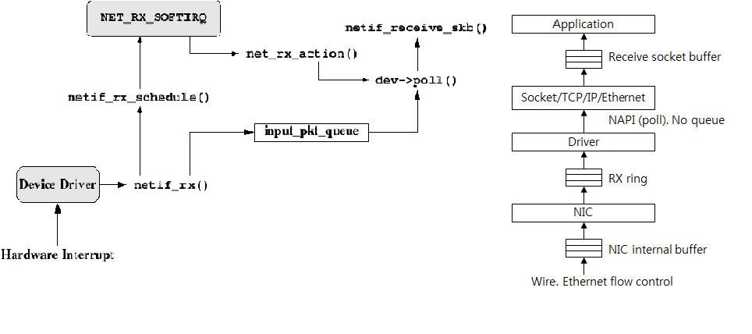
Packet transmission:
Each network device defines a method:
int (*hard_start_xmit) (struct sk_buff *skb, structnet_device *dev);
This function is indirectly called from the NET_TX_SOFTIRQ.
Call are serialized via the lock dev->xmit_lock_owner.
The driver manages the transmit queue during interface upand downs or to signal back pressure using the followingfunctions:
void netif_start_queue (struct net_device *net);
void netif_stop_queue (struct net_device *net);
void netif_wake_queue (struct net_device *net);

Packet transmit overview:

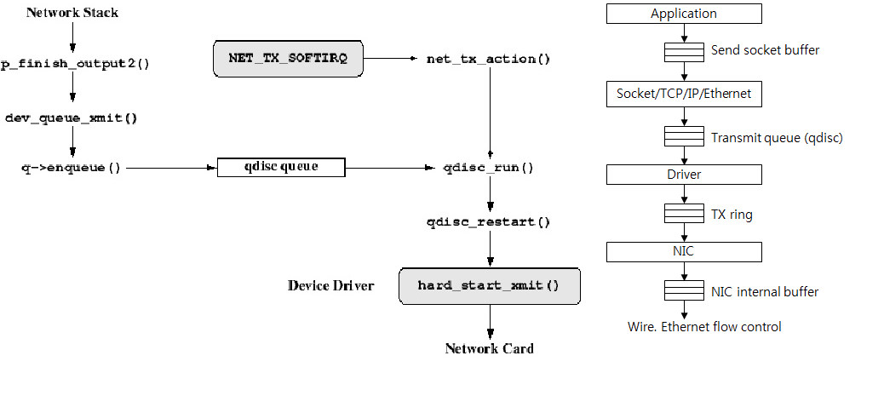

NAPI: Network “New API”
Provides interrupt mitigation
Requirements:
A DMA ring buffer.
Ability to turn off receive interrupts or events.
It is used by defining a new method:
int (*poll) (struct net_device *dev, int * budget);
which is called by the network stack periodically whensignaled by the driver to do so.

NAPI cont:
When a receive interrupt occurs, driver:
Turns off receive interrupts.
Calls netif_rx_schedule (dev) to get stack to startcalling it's poll method.
The Poll method
Scans receive ring buffers, feeding packets to the stack via: netif_receive_skb (skb).
If work finished within budget parameter, re-enables interruptsand calls netif_rx_complete(dev)
Else, stack will call poll method again.

Routing:
After the socket buffer is delivered to a protocol handler thehandler may decide to route the packet.
The default routing uses the normal destination based routingwith single table and a FIB destination cache.
For each packet the routintg destination is looked up in theFIB cache.
If found, the packet is sent to that interface driver.
Otherwise a more costly routing decision based on rules occursand the result is stored in the FIB.

What is netfilter:
Netfilter is a framework for packet mangling
Each protocol defines "hooks" (IPv4 defines 5) which arewell-defined points in a packet's traversal of that protocol stack.
At each of these points, the protocol will call the netfilterframework with the packet and the hook number.
Parts of the kernel can register to listen to the different hooksfor each protocol.
When a packet is passed to the netfilter framework, it willcall all registered callbacks for that hook and protocol.

Netfilter Hooks:
Kernel code can register a call back function to be calledwhen a packet arrives at each hook. and are free tomanipulate the packet.
The callback can then tell netfilter to do one of five things:
NF_ACCEPT : continue traversal as normal.
NF_DROP : drop the packet; don't continue traversal.
NF_STOLEN : I've taken over the packet; stop traversal.
NF_QUEUE : queue the packet (usually for userspace handling).
NF_REPEAT : call this hook again.

IP Tables:
A packet selection system called IP Tables has been builtover the netfilter framework.
It is a direct descendant of ipchains (that came fromipfwadm, that came from BSD's ipfw IIRC), withextensibility.
Kernel modules can register a new table, and ask for a packetto traverse a given table.
This packet selection method is used for packet filtering (the`filter' table), Network Address Translation (the `nat' table)and general pre-route packet mangling (the `mangle' table).
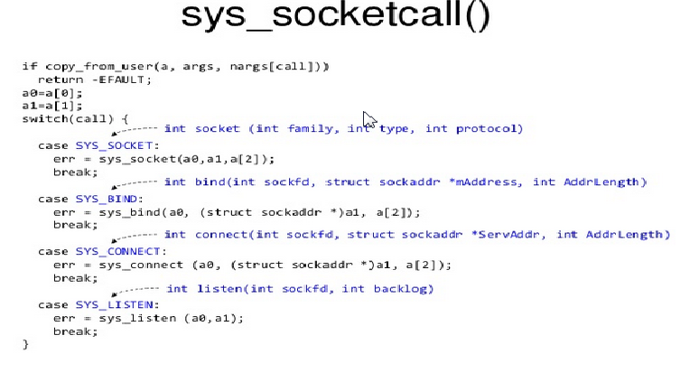

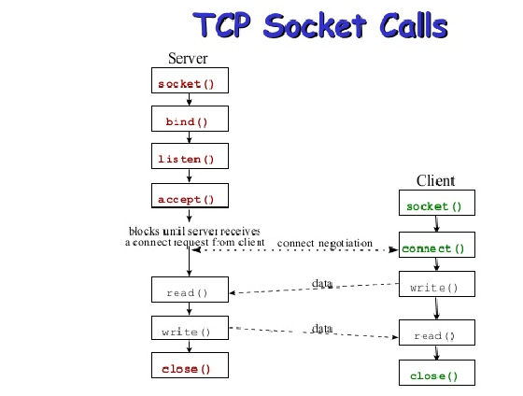
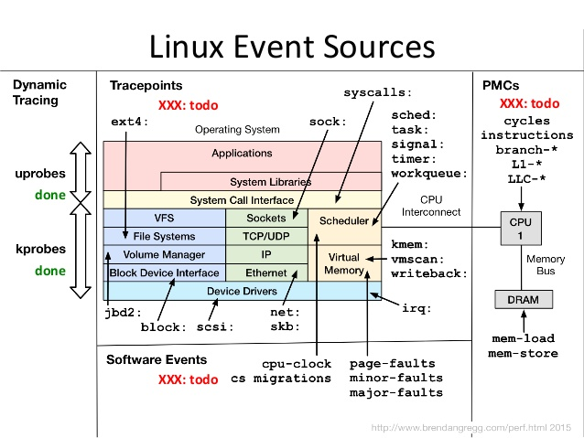
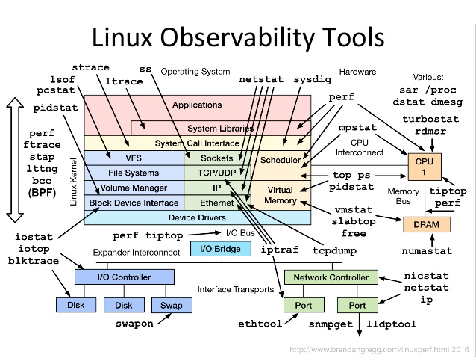
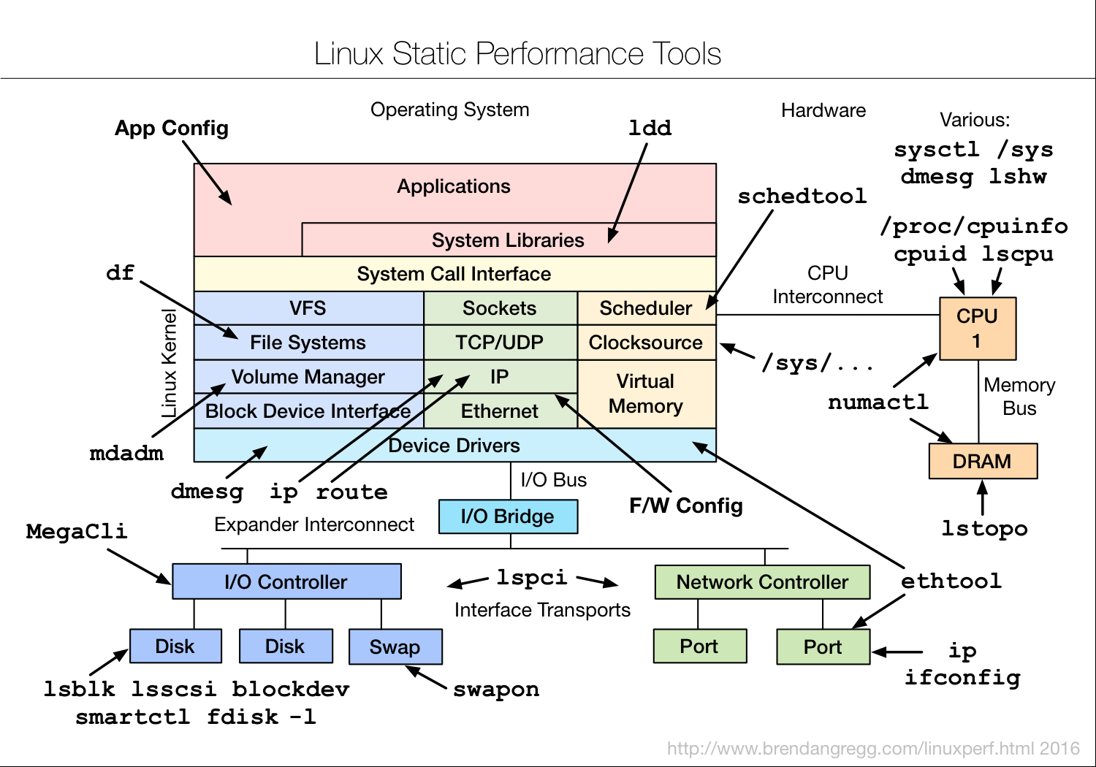
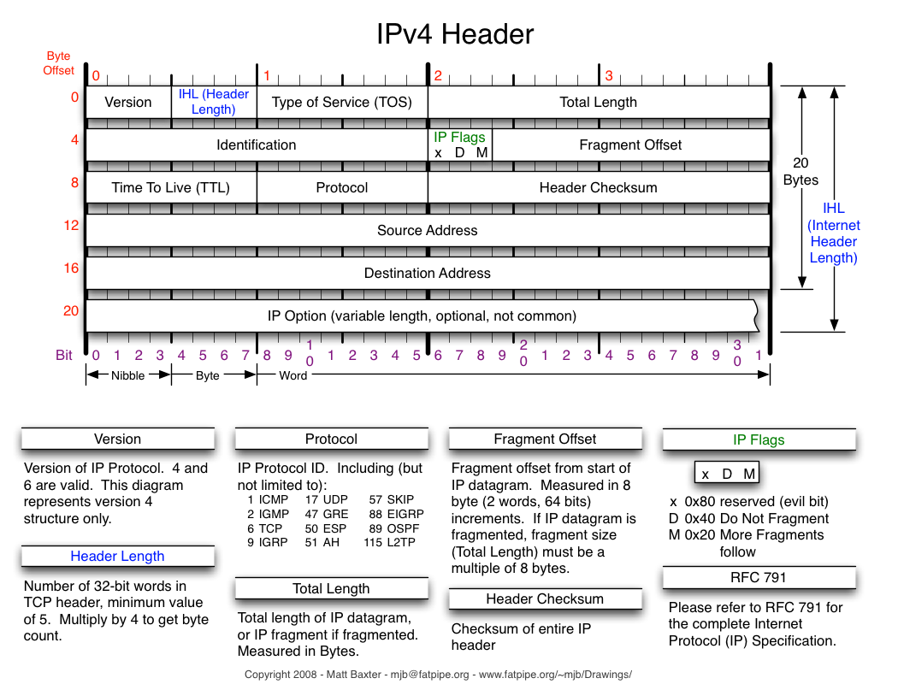

struct ipheader {
unsigned char iph_ihl:4, ip_ver:4;
unsigned char iph_tos;
unsigned short int iph_len;
unsigned short int iph_ident;
unsigned char iph_flags;
unsigned short int iph_offset;
unsigned char iph_ttl;
unsigned char iph_protocol;
unsigned short int iph_chksum;
unsigned int iph_source;
unsigned int iph_dest;
};
/* total tcp header length: 24 bytes */
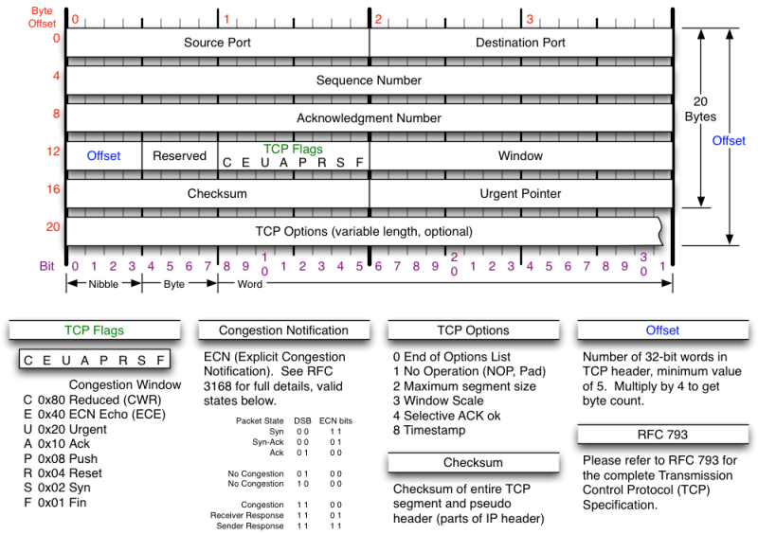
TCP Header

struct tcpheader {
unsigned short int tcph_srcport;
unsigned short int tcph_destport;
unsigned int tcph_seqnum;
unsigned int tcph_acknum;
unsigned char tcph_reserved:4, tcph_offset:4;
unsigned char tcph_flags;
unsigned short int tcph_win;
unsigned short int tcph_chksum;
unsigned short int tcph_urgptr;
};
/* total tcp header length: 20 bytes (= 160 bits) */
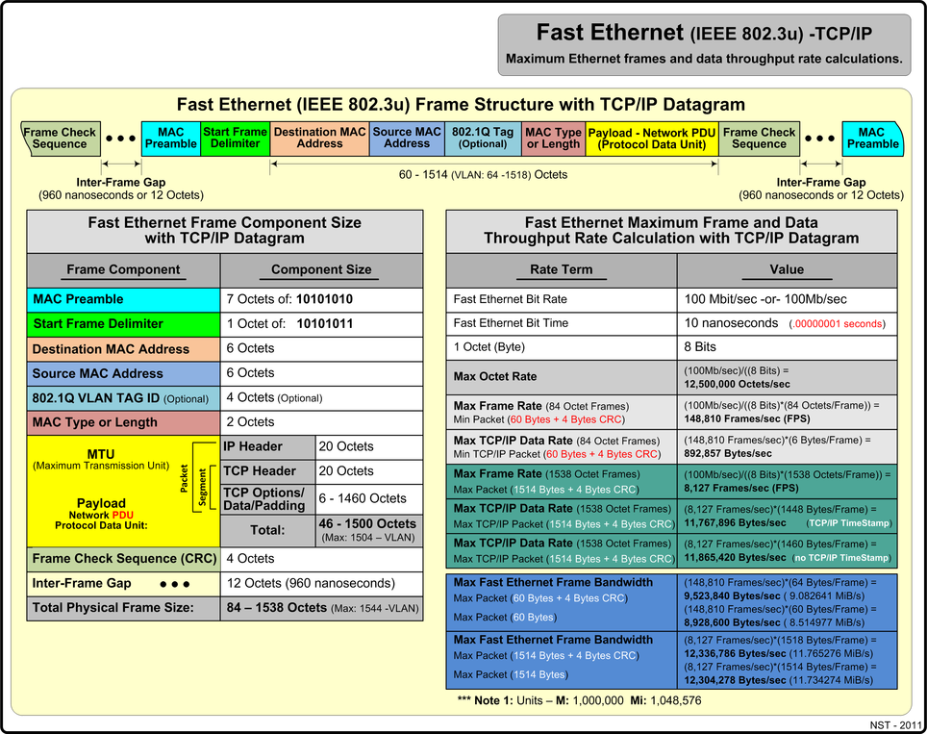

Device layer vs device driver:
https://01.org/linuxgraphics/gfx-docs/drm/networking/kapi.html#linux-networking
http://www.cubrid.org/blog/understanding-tcp-ip-network-stack
http://www.cnblogs.com/ggjucheng/archive/2012/11/01/2750217.html
http://www.tenouk.com/Module43.html
http://amsekharkernel.blogspot.in/2012/01/what-are-ways-of-communication-bw-user.html
http://liuluheng.github.io/wiki/public_html/Linux/Networks/nework-access-layer.html
