PARALLEL WIRELESS · RCT — STUDY GUIDE
Module 10
Lab & Measurement Practice

Mentor's note: Where it all meets the bench: instruments, the FHGW platform bring-up, IQ playback, and the pitfalls that catch every new engineer.

1. The instruments
Instrument | Role
Vector Signal Generator (VSG) | plays IQ waveforms into the radio (Rx tests)
Vector Signal Analyzer / Spectrum Analyzer | measures the transmitted signal (Tx tests)
Keysight EXM (E6640A) | combined VSG + VSA, software-toggled — your workhorse
Power meter | accurate absolute power reference
VNA | return loss / VSWR (Module 2) and cable-loss characterization

2. The bench
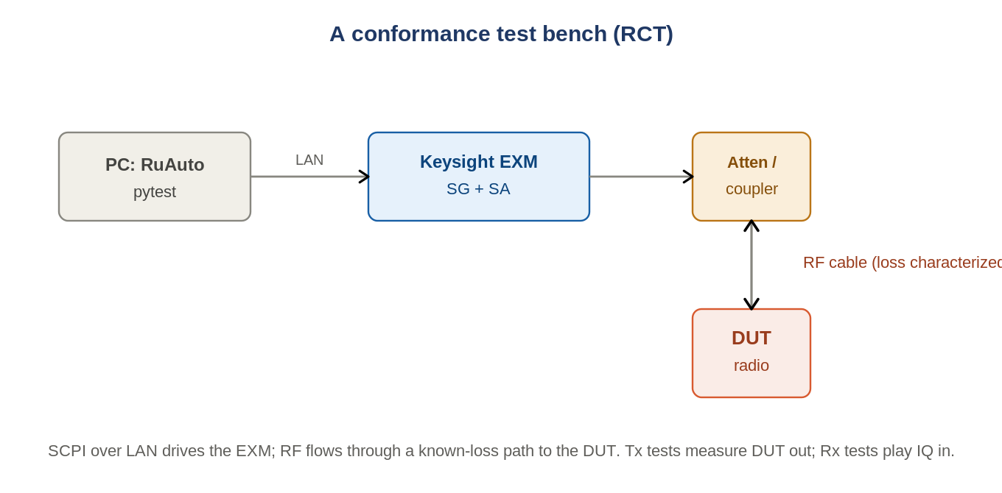
Figure: PC drives the EXM over LAN; RF flows through a known-loss path to the DUT.
The PC runs RuAuto and drives the EXM by SCPI over LAN; RF flows through a characterized, matched path to the DUT. Tx tests measure DUT output; Rx tests play IQ in.

3. IQ capture and playback
Playback (Rx): load waveform into the VSG, set power/freq/sample-rate, set trigger (TDD: external trigger delay to align to the frame), enable ARB + modulation + RF. Capture (debug): the VSA records live IQ to inspect EVM/spectrum/timing.

4. The platform you actually bring up
Element | Notes
DU | baseband unit driving the radio
FHGW | fronthaul gateway 'in a box' = the radio (Xilinx ZU67 RFSoC, 8 TX/8 RX)
NETCONF / EEPROM personality | radio configured via NETCONF (netopeer2); EEPROM holds model/flavour
Grandmaster (Falcon) | timing: PTP / IEEE-1588v2, GNSS, 10 MHz / 1PPS (LLS-C1)
RF switch (Mini-Circuits) | HTTP-controlled path routing between DUT and instruments
APC | remote power control / cycling
OTA chamber / rotator | TRP/EIRP over-the-air

5. Putting the whole course together
When you... | You are using...
read a power or RSSI number | M1 (dB), M4
check VSWR / return loss | M2
reason about sensitivity / noise | M3, M4
look at a constellation / EVM | M5
debug ACLR / spectral regrowth | M6 (chain/CFR/DPD), M7
work on PA power / Vdd | M11
run a PRACH test | M8
work on the AAU / calibration | M9
set up the bench / platform | M10 + RuAuto Field Guide + Validation ref

6. The pitfalls that catch everyone
- Forgetting cable-loss / de-embedding.
- Overloading the analyzer (reference level too low).
- Wrong RBW, or no TDD gating.
- Loose/dirty connectors — torque to spec.
- Keying a PA into an open/short (Module 2).

7. Self-check
- Which instrument both generates and analyzes?
- Before trusting a power number, what correction applies?
- For a TDD Tx measurement, what feature is essential?
Answers
1. The Keysight EXM (VSG + VSA).
2. Cable-loss / path de-embedding.
3. Gating to the transmit slot.

You have the full picture
Language (1-2), chain (3), metrics (4), signal (5), the Tx chain and its cleanup (6-7), PA efficiency (11), the two big test areas and the platform (8-9), tied to the bench (10) and to RuAuto + the references. Re-read in order, do the self-checks, and open the real configs and match each test to its module.

