PARALLEL WIRELESS · RCT — STUDY GUIDE
Module 11
PA Efficiency & Power Optimization

Mentor's note: Module 6 made the PA clean; this makes it cheap to run. Dynamic Vdd, gate bias, and bias sequencing are how a modern AAU cuts its biggest energy cost. Built from your PA Efficiency Test Plan.

1. Linearity is not the whole story — efficiency is the other half
Module 6 was about making the PA linear (CFR + DPD). This module is about making it cheap to run. A macro PA can burn hundreds of watts; most of a base station's energy bill is the PA. The lever is simple to state: only feed the PA as much DC power as the current traffic needs.

2. Drain efficiency and back-off
Drain efficiency = RF power out / DC power in. A PA is most efficient near saturation and least efficient when backed off — but we MUST back off for OFDM's high PAPR (Module 6). So at low traffic the PA sits deep in back-off, wasting power.
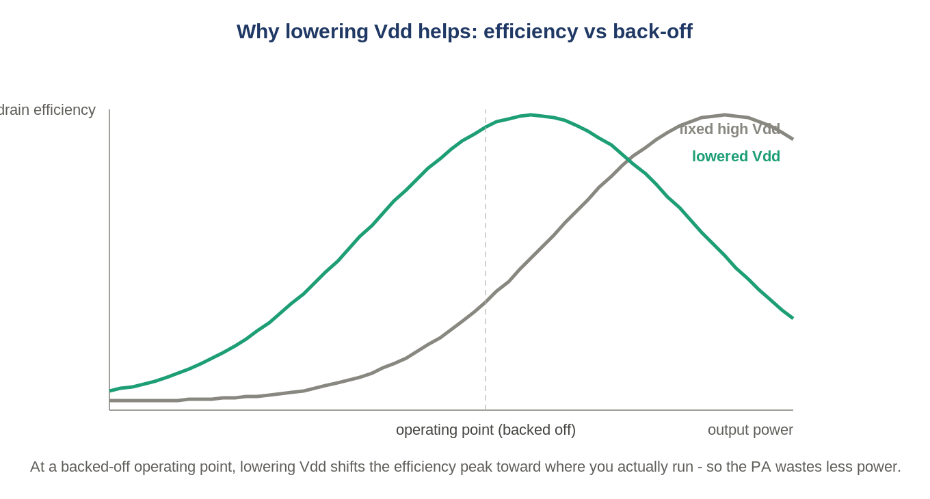
Figure: Lowering the drain voltage shifts the efficiency peak toward the backed-off operating point.

3. Dynamic Vdd — the core idea
Instead of one fixed drain voltage (Vdd) for all conditions, lower Vdd as traffic (the occupancy of data resource blocks) falls. Less Vdd at low load = the efficiency peak moves to where you are actually operating = less wasted power.
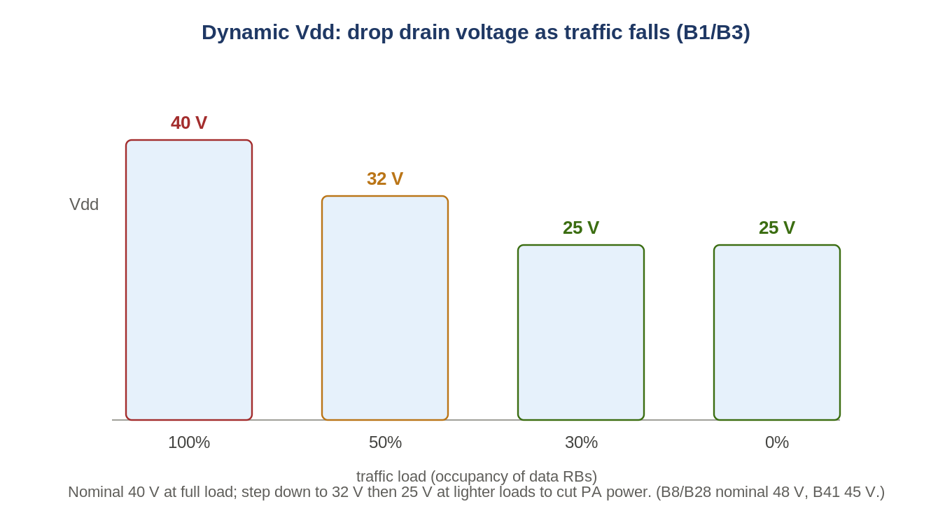
Figure: Vdd stepped down with traffic load (B1/B3 example).
Load (occupancy) | B1 / B3 Vdd | Note
100% (full) | 40 V (nominal) | reference
50% (busy hour) | 32 V (Vdd_Low1)
30% (medium) | 25 V (Vdd_Low2)
0% (no data RBs) | 25 V | low/idle
Other bands carry their own nominal: B8/B28 ~48 V, B41 ~45 V.

4. You can't just drop Vdd — you re-tune CFR and Tx power
Lowering Vdd changes the PA's behaviour, so the plan compensates: re-set the CFR working point (pre-CFR gain register 0xb0290000: 0xD7 for occupancy > 50%, 0x128 for <= 50%) and re-adjust output power via the DAC current so the radiated power and the spectrum (ACLR, EVM) stay within spec at the lower voltage. This is why Modules 6 and 11 are joined at the hip.

5. Gate bias (Vgg) — a second lever
Beyond the drain voltage, the gate bias Vgg3_p (tested at -6.5 V datasheet, -5.5 V, -4.5 V) trades quiescent current for linearity and adds further savings, especially when Vdd is already below nominal.

6. Turning the PA on and off, safely
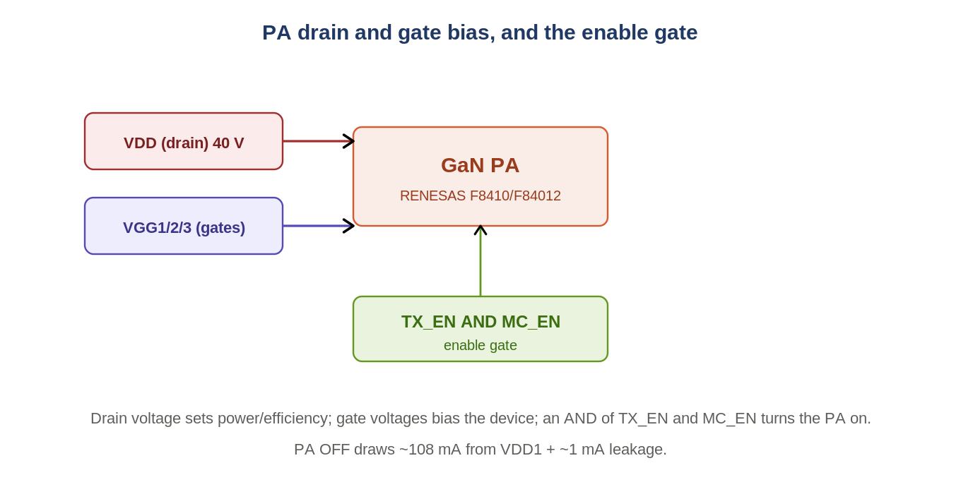
Figure: Drain rail, gate rails, and the TX_EN AND MC_EN enable gate.
A GaN PA (RENESAS F8410 / F84012) has a drain rail (VDD) and several gate rails (VGG1/2/3). It is enabled by an AND of TX_EN and MC_EN. Bias must be sequenced in a defined order (the RENESAS bias sequence) to avoid damaging the device. Even fully OFF it draws about 108 mA from VDD1 plus ~1 mA leakage.

7. Transition timing and sequencing
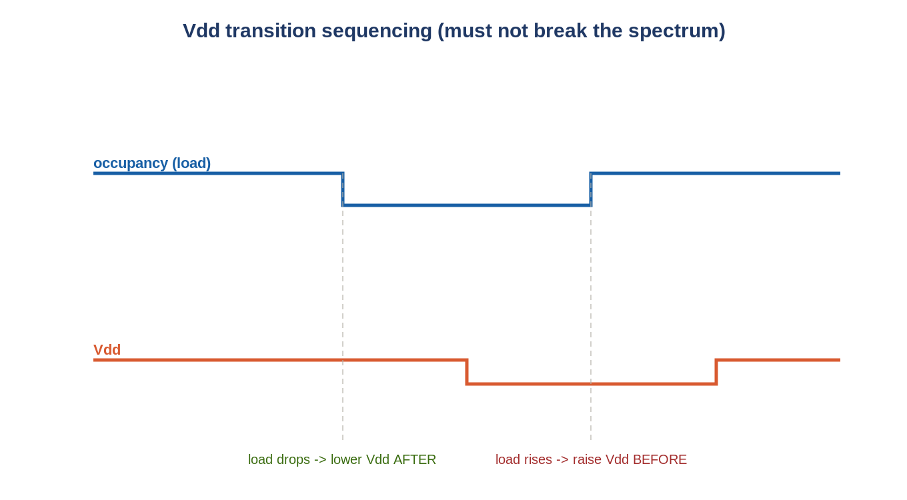
Figure: Lower Vdd only AFTER load drops; raise Vdd BEFORE load rises.
Switching Vdd live is delicate: the order matters. When load drops, lower Vdd only after the new (lower) occupancy is in effect; when load rises, raise Vdd before the occupancy increases. The transition time must meet bounds, and the transmitted spectrum must stay 3GPP-compliant throughout the change.

8. Measuring efficiency — the DC side
To prove savings you measure DC power in: the -48 V main PSU feeds PSU#1-3 and three DC-DC converters, all read through the Common-Board MCU (currents and voltages), with temperature sensors on the FHGW/RFFE/common board. Efficiency = RF out (per PA / TRP, including beamforming gain of about +12 dB for B1/B3/B41 or +6 dB for B8/B28) divided by DC in.

9. Self-check
- Why does a fixed Vdd waste power at low traffic?
- When traffic drops, do you lower Vdd before or after the occupancy change? Why?
- Name two things you must re-tune after lowering Vdd to stay in spec.
- Where does the DC-power measurement come from?
Answers
1. The PA sits deep in back-off where efficiency is poor, but still runs at full drain voltage.
2. After — lowering Vdd before the load drops could push the (still-high) signal into clipping / spec failure.
3. CFR working point (pre-CFR gain register) and output power via DAC current (and possibly Vgg).
4. Common-Board MCU reading the -48 V PSU, PSU#1-3 and DC-DC converter currents/voltages.

Takeaways
- Efficiency, not just linearity, drives PA design. Drain efficiency = RF out / DC in.
- Dynamic Vdd lowers drain voltage with traffic (40->32->25 V on B1/B3) to recover efficiency in back-off.
- Lowering Vdd forces re-tuning CFR + DAC current (and Vgg); transitions must be sequenced and stay in spec.
This pairs with Module 6 (the Tx chain) and the PA Efficiency Test Plan in your folder.

