PARALLEL WIRELESS · RCT — STUDY GUIDE
Module 13
RU Features & Operations

Mentor's note: The operational feature set of the radio: power saving (uSleep, reduced carrier power, PA shutdown), protection, capabilities, tilt, and the measurement features (RSSI accuracy, IQ playback/recording, variable-load DPD, dynamic range). What each is, why it exists, and how to use/test it.
Scope note: These are real RU features/tests. Where the value is in your repo (dynamic range, RSSI, IQ playback, PA protection) it is quoted verbatim. For features whose exact CLI lives in the gated FHGW User Guide and the IQ Playback/Recording Commands wiki (uSleep, reduced carrier power, RU capabilities, tilt, PA shutdown sequence), the what/why/how is taught here and the command source is flagged so you can fill in the exact syntax.

A. Power-saving features

1. uSleep (micro-sleep)
What: the PA (and parts of the Tx path) are switched off during OFDM symbols/slots that carry no data, then woken for the next active symbol.
Why: the PA is the biggest energy consumer; at low/idle load many symbols are empty, so sleeping through them saves significant power - a finer-grained version of the dynamic-Vdd idea in Module 11.
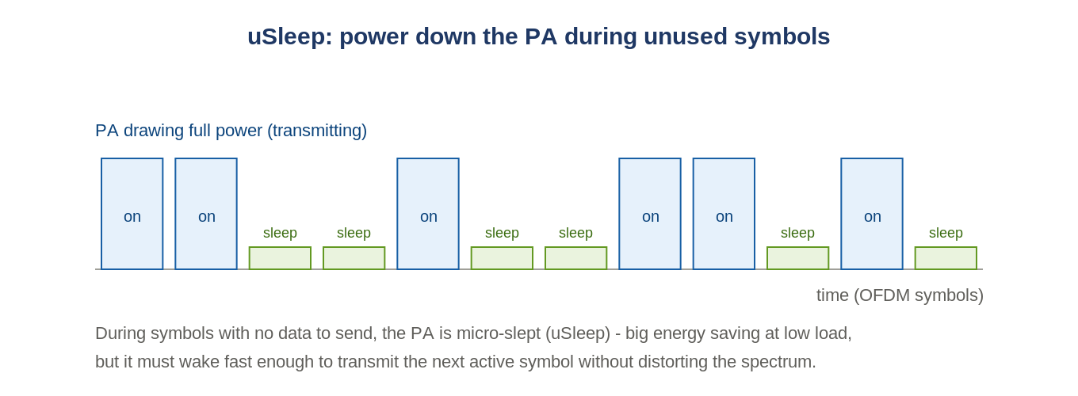
Figure: uSleep powers the PA down on empty symbols and wakes it for active ones.
How to use / test: enabled by an RU feature flag/CLI (FHGW User Guide). The critical test is that the PA wakes fast enough that the first active symbol is not distorted - so you verify EVM/ACLR and the transient at the sleep-to-active boundary, and confirm the power saving on the DC side (Module 11's measurement chain).

2. Reduced Carrier Output Power
What: deliberately transmitting a carrier below its nominal maximum power (e.g. for a small cell, coverage shaping, coexistence, or thermal/power limits).
Why: not every deployment needs full power; lower power reduces interference to neighbours, saves energy, and manages heat.
How: set digitally in the DL chain (Module 6) - via DL power scaling and the DAC output current, the same knobs the PA-efficiency plan uses to hold target power at lower Vdd. When you reduce carrier power you re-verify that ACLR/EVM/OBUE still pass at the new level (the spectrum must stay compliant at reduced power).
Ties to what you know
Reduced carrier power is the same DL-scaling / DAC-current lever from Modules 6 and 11 - just used as a deployment setting rather than an efficiency step.

3. PA Shutdown process
What: the ordered sequence to turn a PA off (and on) safely, toggling the drain and gate rails in the correct order.
Why: a GaN PA can be damaged if drain and gate voltages are applied/removed out of order; a defined sequence protects the device and avoids transient spikes on the air.
How (from Module 11 + FHGW User Guide): enable is an AND of TX_EN and MC_EN; the RENESAS bias sequence defines the order (gates then drain on the way up, reverse on the way down). Even fully OFF the PA draws about 108 mA from VDD1 plus ~1 mA leakage - useful to know when reading DC current. PA on/off is one of the automations the PA-efficiency plan calls out as needed.

B. Protection

4. PA Protection
What: hardware/firmware that shuts down or backs off the PA when it sees a dangerous condition - high reflected power (bad VSWR / open or short port, Module 2), over-temperature, over-current, or over-drive.
Why: reflected power and heat destroy PAs; protection saves the (expensive) hardware.
How to test: your setups run test_Tx_Pa_Protection (listed in the RCT-4G-GR-FHGW / AAU cadences). The test deliberately drives a protection condition and verifies the PA trips and recovers correctly. Conceptually it is the VSWR-trip protection from Module 2 made testable.

C. Capability & configuration

5. RU Capabilities
What: the set of features/parameters the RU advertises or can be queried for - supported bands, bandwidths, number of Tx/Rx ports, power classes, DPD/CFR support, uSleep support, etc.
Why: the DU/management plane needs to know what the RU can do to configure it correctly; test automation reads capabilities to decide which tests apply.
How: queried over the management plane (NETCONF/EEPROM personality, Module 10) - the FHGW is a Xilinx RFSoC with 8 TX + 8 RX and a per-band flavour stored in EEPROM. In RuAuto the setup's fdd/tdd_test_setup.json encodes the RU's real ports/bands/antenna mapping, which is the capability set the tests run against.

6. Tilt (electrical downtilt)
What: steering the antenna beam's elevation angle downward electronically (no mechanical movement).
Why: controls cell coverage/overlap and interference - more downtilt shrinks the cell and reduces interference to neighbours.
How: on an AAU, tilt is done by beamforming - applying a progressive phase across the vertical antenna elements (Module 9), the same mechanism as beam steering but in elevation. Set via the management plane; verify with OTA pattern measurement in the chamber (Module 10).

D. Measurement & test features

7. RSSI accuracy
What: how closely the RU's reported RSSI matches the true received power at its input.
Why: the network uses reported RSSI/measurements for scheduling and power control - if the RU's readback is off, those decisions are wrong.
How to test: your setups run test_Rx_RSSI (frequency fm). A known power is injected (via the calibrated, cable-loss-corrected path) and the RU's reported RSSI is compared to it; the delta is the accuracy. This is the RSSI readback calibration mentioned in the conformance methodology.

8. IQ playback and recording
What: playback = the RU (or generator) transmits a pre-stored IQ waveform; recording = the RU captures live IQ samples off the air/chain to a file for analysis.
Why: playback gives an exact, repeatable stimulus (Module 5); recording lets you capture what the RU actually sees/sends to debug EVM, spectrum, or timing without external instruments.
How (repo + IQ Playback/Recording wiki): your setups define an iq_playback_ant_map that maps each band/carrier to the physical antenna indices, e.g.:
"iq_playback_ant_map": {
"b0307": { "3": [1, 0], "7": [4, 5] },
"b0407": { "4": [1, 0], "7": [4, 5] } }
Read it: for band group b0307, band 3 plays back on antenna indices [1,0], band 7 on [4,5]. The exact playback/record CLI commands (start/stop, file, sample rate, duration) are in the IQ Playback and Recording Commands wiki page - drop that page's text into the folder and I will add the precise commands here.

9. Variable load tests (DPD)
What: running the transmitter at different traffic loads (occupancy of data RBs: 100%, 50%, 30%, 0%) and confirming DPD/CFR keep ACLR and EVM in spec at each.
Why: DPD is trained/adapted for the signal statistics; as load changes, PAPR and the PA operating point change, so linearization must hold across loads - this is exactly the occupancy sweep in the PA-efficiency plan (Module 11).
How: set the DU to generate each occupancy, then measure ACLR/EVM (Module 7). It pairs with dynamic Vdd (Module 11): at each load you also re-tune the CFR working point (0xD7 vs 0x128) and DAC current.

10. Dynamic range
What: Tx: the ratio between maximum (full RB) and minimum (1 RB) output power the transmitter can produce. Rx: the ability to receive a wanted signal in the presence of a strong in-band interferer (Module 4).
Why: the radio must handle both very light and very heavy loading (Tx) and both weak and strong signals (Rx).
How (real limits from your threshold file):
"test_Tx_dynamic_range": { // 3gpp 6.3.2, total power dynamic range
"tolerance": 0.4,
"limits": { "5": {"min_limit": 13.9}, // per BW (MHz): min dB
"10": {"min_limit": 16.9},
"15": {"min_limit": 18.7},
"20": {"min_limit": 20.0} } }
Tx: measured DR (full-RB power minus 1-RB power) must be >= the per-BW min. The 5G Rx dynamic range (DynamicRange_7_3) uses FRC A2-5 with a power sweep to a BLER crossing, KPI about -85 dBm - the same search pattern as sensitivity (Module 12).

Summary: where each lives now
Feature | Module / test
uSleep | this module (A.1) + FHGW User Guide for CLI
Reduced carrier output power | this module (A.2) + Modules 6/11 (the lever)
PA shutdown process | this module (A.3) + Module 11 (bias sequence)
PA protection | this module (B.4); test_Tx_Pa_Protection; Module 2 (VSWR)
RU capabilities | this module (C.5) + Module 10 (NETCONF/EEPROM)
Tilt | this module (C.6) + Module 9 (beamforming)
RSSI accuracy | this module (D.7); test_Rx_RSSI; Module 4
IQ playback & recording | this module (D.8); Modules 5/12; IQ wiki for CLI
Variable load (DPD) | this module (D.9); Modules 6/11
Dynamic range | this module (D.10); Module 4; tests 6.3.2 / 7.3
To make 'how to use' exact
Drop the FHGW User Guide and the IQ Playback/Recording Commands wiki page into D:\Learning (paste text or save the file), and I will add the precise CLI commands for uSleep, reduced carrier power, tilt, RU-capability queries, PA shutdown, and IQ playback/record into this module.

Self-check
- uSleep saves power how, and what must you verify when it wakes?
- Reduced carrier power uses which existing lever?
- What condition typically triggers PA protection?
- How is electrical tilt achieved on an AAU?
Answers
1. By powering the PA down on empty symbols; verify EVM/ACLR and the wake transient on the next active symbol.
2. DL power scaling / DAC current (Modules 6 and 11).
3. High reflected power (bad VSWR / open port), over-temperature, or over-current/over-drive.
4. Beamforming - a progressive phase across the vertical antenna elements.

