PARALLEL WIRELESS · RCT — STUDY GUIDE
Module 14
RSSI & the Receive Chain (RSSA)

Mentor's note: The RSSI/RSSA topic in full: the uplink path antenna->LNA->ADC->FFT->DU, why RSSI is read in dBFS and offset to dBm, the real ADC calibration method and results from your deck, and receiver dynamic range.

1. The uplink signal path (what the RSSA call walked through)
RSSI is measured on the receive path, so you have to know that path cold. Here it is, antenna to DU:
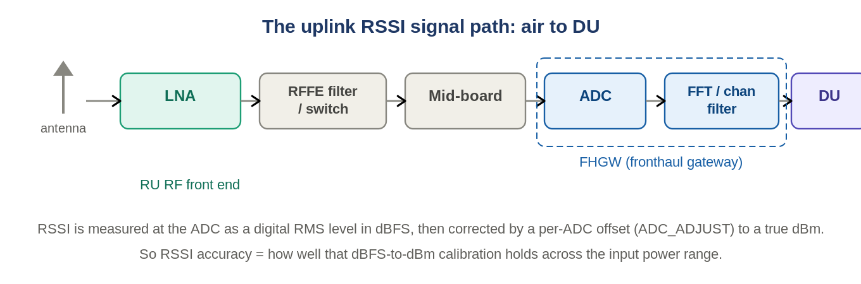
Figure: The UL path: antenna -> LNA -> RFFE filter/switch -> mid-board -> FHGW (ADC -> FFT) -> DU.
Over the air the signal hits the antenna, then the LNA (first and most important stage - it sets the noise figure, Module 3), through the RFFE filters/switches and the mid-board combiner, into the FHGW where the ADC digitizes it, the FFT / channel filter splits it into subcarriers, and finally the IQ goes over fronthaul to the DU for higher-PHY/MAC. RSSI is read at the ADC.

2. Two ways to read RSSI - and the real feature goal
From David on the call: RSSI can be obtained two independent ways, and the RSSI feature is about making the two agree.
Method | How it works
Via the DU | After the ADC, the FHGW LowPHY does the FFT and signal processing and sends the IQ to the DU. The DU does the heavy lifting - measures the received data and calculates BLER and RSSI (in dBm and dBFS).
Via the CLI (get_rssi) | Read the power directly after the ADC on the RU with the get_rssi command. It returns a value for each of the 8 ADCs (0-7); which one matters depends on the band, the flavor, and which antenna is receiving.
The RSSI feature = your task
Goal: compare the RSSI from the CLI (FHGW get_rssi) against the RSSI reported by the DU, for each flavor and each band. There used to be a GAP between the two; it was closed by adding a software feature on the DU side.
David's ask to you: FIRST measure the sensitivity point and RSSI manually with a basic uplink test; THEN build the automation that runs the CLI-vs-DU comparison across all flavors and bands (it was done manually before - now automate it).

3. What RSSI is (and is not)
RSSI (Received Signal Strength Indicator) is the total wideband power at the receiver input, in dBm. It sums wanted signal + noise + interference across the measured band. It is NOT the same as:
Metric | Difference from RSSI
RSRP | power of the reference signals only (per resource element) - a clean per-signal measure
RSRQ | a quality ratio (RSRP relative to RSSI)
SINR | wanted signal vs noise+interference - quality, not raw power
Because RSSI includes everything, a high RSSI does not mean a good signal - it could be mostly interference.

4. dBFS at the ADC vs dBm at the antenna
This is the crux. The ADC reports a digital RMS level in dBFS (Module 1 appendix) - relative to the converter's full scale. To turn that into a real dBm at the port you must add a per-ADC offset. If that offset is wrong, the reported RSSI is wrong. So RSSI accuracy is really 'how good is the dBFS-to-dBm calibration.'
Two more distinctions from the call: the ADC has ~11-bit resolution (2^11 steps), which quantizes the analog signal; and the two units answer different questions - dBm is absolute power referenced to the bandwidth (Hz), while dBFS is power referenced to the ADC full-scale dynamic range.

5. RSSI accuracy calibration (the deck's actual method)
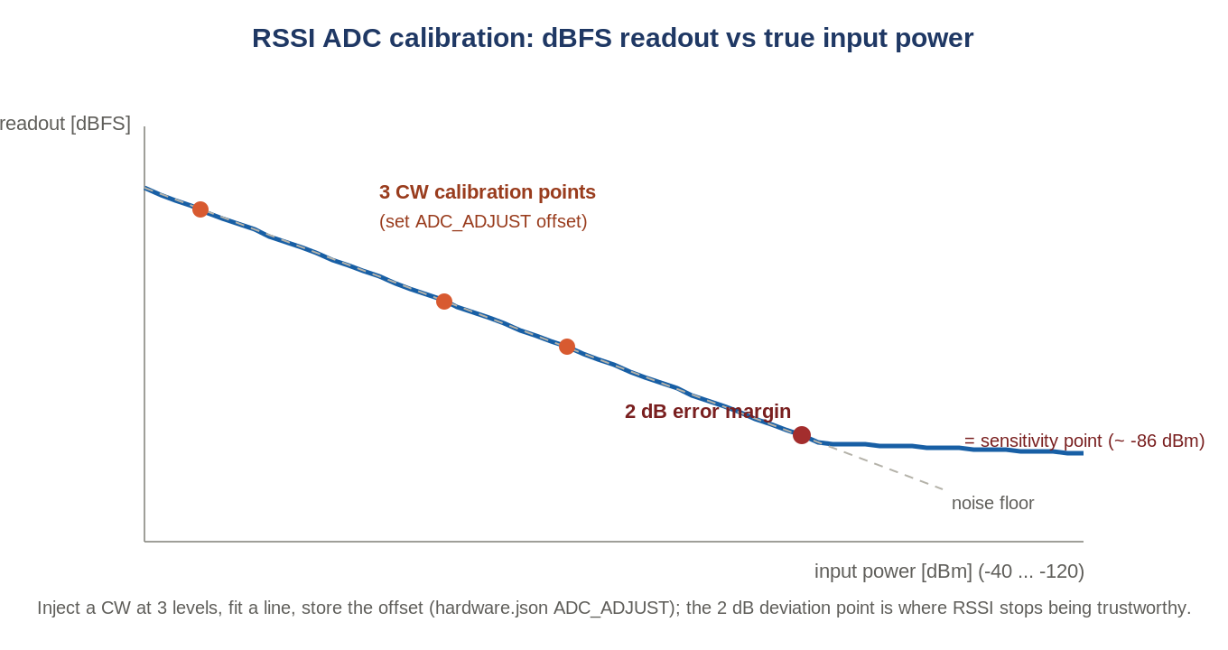
Figure: Fit a line through 3 CW points, store the ADC offset; the 2 dB deviation is the sensitivity point.
From the RSSI Results deck: inject a CW tone at the band centre at 3 known power levels (-40.5, -60.5, -70.5 dBm), read the RSSI at each, fit an approximate straight line, and compute the average offset. That offset is written per-ADC into /etc/configs/hardware.json (the ADC_ADJUST vector - one entry per ADC 0-7). Then automation sweeps the input over [-40 dBm : 1 dB : -120 dBm] and records the corrected RSSI.
The band-to-ADC mapping (real)
B1 uses ADCs 0, 1, 4, 5. B3 uses ADCs 2, 3, 6, 7. Each ADC is calibrated separately (its own ADC_ADJUST offset).

6. The results: the 1/2/3 dB error margins
The key output is the power level at which the RSSI readout deviates from the fitted line by a set amount - the lower the power, the more the reading drifts as it approaches the noise floor:
- 3 dB point - the level just above the ADC noise floor (the deepest it can still 'see').
- 2 dB error margin - the sensitivity point of the RSSI measurement: below this, the RSSI reading is no longer trustworthy.
Real numbers from the newer AAU (all RFFEs summed on antenna 0):
ADC | Band | ADC RMS at sens. point [dBFS] | 2 dB error margin [dBm]
0 | B1 | -44.9 | -95.5
2 | B3 | -43.3 | -93.5
Per-antenna results ranged roughly -76 to -90 dBm for the 2 dB margin, showing some spread across ADCs/antennas - which is exactly why each ADC gets its own offset.

7. Receiver dynamic range (the wider picture)
RSSI accuracy lives inside the receiver's dynamic range: the span from the noise floor (weakest detectable signal at acceptable SNR) up to the overload / 1 dB compression point (strongest signal before distortion). A related figure is Spurious-Free Dynamic Range (SFDR): the range over which no spurious/intermod product rises above the noise floor. Typical RSSI usable range is about -40 dBm down to around -120 dBm - matching the sweep the calibration uses.

8. How you read RSSI on the box
On the RU the power monitor reports the digital level: power-monitor 0<n> ul (dBFS). In the test framework, test_Rx_RSSI injects a known, cable-loss-corrected power and compares the RU's reported RSSI to it - the delta is the accuracy (the readback calibration).

9. Self-check
- Which stage in the UL path sets the receiver noise figure, and why does it matter for RSSI?
- Why must the ADC's dBFS reading be offset-corrected to give RSSI in dBm?
- What is the '2 dB error margin' point?
- Which ADCs serve B1 vs B3?
Answers
1. The LNA (first stage, Friis) - it sets how weak a signal the receiver can measure at all.
2. dBFS is relative to the ADC full scale; the offset maps it to absolute power (dBm) at the port.
3. The input power where the RSSI readout deviates 2 dB from the fitted line - the sensitivity point below which RSSI is untrustworthy.
4. B1 = ADCs 0,1,4,5; B3 = ADCs 2,3,6,7.

Takeaways
- RSSI = total wideband power (dBm), read at the ADC as dBFS and offset-corrected.
- Accuracy = quality of the dBFS->dBm calibration (3 CW points -> ADC_ADJUST in hardware.json).
- The 2 dB error margin is the RSSI sensitivity point; it sits inside the receiver dynamic range (~-40 to -120 dBm).
Note: this module is built from the RSSI Results deck and your signal-path summary of the David Bekker call. If you paste the call transcript I will add anything the deck did not capture.

