PARALLEL WIRELESS · RCT — STUDY GUIDE
Module 15
UL RCT Embedded & the Dynamic Test

Mentor's note: The on-RU receiver test: the ul-rct-test CLI, the four-stage pipeline, the sensitivity/dynamic sweep and its range, real results, and the FHGW IQ-playback and power-monitor commands.

1. What UL RCT (embedded) is and why it exists
UL RCT validates the entire uplink receive path - antenna to BLER - against 3GPP fixed reference channels. 'Embedded' means it runs entirely on the FHGW: no DU, no external test PC, one CLI command. A signal generator still injects the FRC waveform; everything else is on the RU.
Why: it catches receive-chain regressions at the box level, fast, before DU integration - a multi-box lab setup becomes a single command.

2. The four-stage pipeline
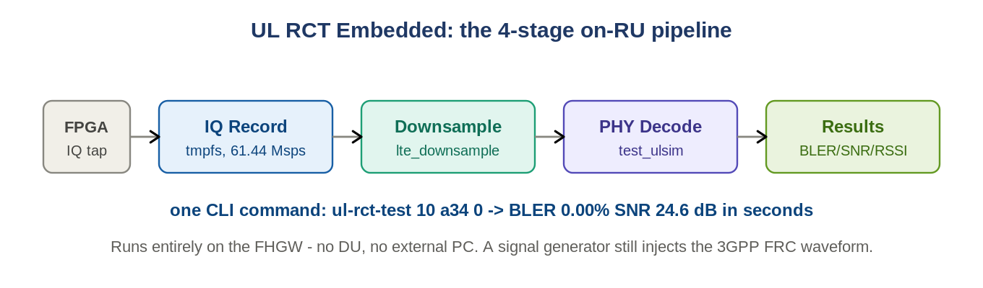
Figure: IQ record -> downsample -> PHY decode -> results, all on the FHGW.
Stage | What it does
1. IQ Record | captures raw IQ from an FPGA channel-filter tap into tmpfs (~2.5 MB/frame at 61.44 Msps)
2. Downsample | converts the FHGW rate down to what the PHY decoder accepts (lte_downsample)
3. PHY Decode | O-RAN 7.2x low-PHY: FFT, channel estimation, demap, decode, CRC (test_ulsim)
4. Results | BLER, SNR and RSSI to the shell and per-run log files

3. The CLI
ul-rct-test 35 a13 10 0 100 --debug # full run, all params
ul-rct-test -sc 4 2 # shortcut, positional
ul-rct-test -l # list supported scenarios
ul-rct-test 10 a34 0 # -> BLER 0.00% SNR 24.6 dB
Two modes: Normal (summary only - BLER, SNR, RSSI - built for Python automation) and Debug (per-stage timing + full PHY logs).

4. Supported test cases (18)
Sensitivity (A1-3, QPSK) and PUSCH performance (A3-x QPSK, A5-x 64QAM), across LTE B1/B3 from 5 to 20 MHz - 18 scenarios total. A1 = Rx sensitivity; A3/A5 = PUSCH performance. The framework is band-agnostic (extensible to NR FRCs).

5. The dynamic / sensitivity sweep
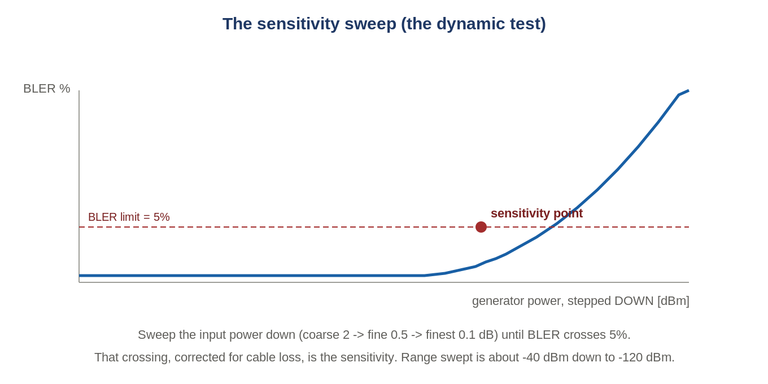
Figure: Step the input power down until BLER crosses 5% - that crossing is the sensitivity.
This is the 'dynamic test' you asked about. The tool sweeps the generator power down in stages (coarse 2 -> fine 0.5 -> finest 0.1 dB) and watches BLER; the power at which BLER crosses 5% (cable-loss corrected) is the sensitivity point. QPSK (A1-3) sensitivity cases take about 11 steps each; 64QAM cases fewer (4-8). The swept range spans roughly -40 dBm down to -120 dBm - the 'maximum range' of the measurement.
What '2x11' means (confirmed from the call)
David meant the ADC digital resolution: 2^11 - an 11-bit ADC (~2048 quantization steps). He first said 12 bits then corrected to 11. It is NOT the number of sweep steps.
The ADC resolution plus its dynamic range set how weak a signal it can resolve above the noise floor and how strong before it clips. The swept power range (~-40 to -120 dBm) is the maximum range the sensitivity test characterizes.

6. Real results (from the deck)
Embedded (RU) vs DU sensitivity, antenna 0, all 8 cases PASS, max delta 1.25 dB:
FRC / BW | DU [dBm] | RU [dBm] | delta
A1-3 QPSK, 5-20 MHz | -111.9 | -112.1 | 0.20
A5 64QAM, 5 MHz | -92.80 | -92.85 | 0.05
A5 64QAM, 10 MHz | -89.30 | -89.85 | 0.55
A5 64QAM, 20 MHz | -83.6 | -84.85 | 1.25 (review)
FHGW BOB 4-antenna sweep: Band 1, DSA = 5, cable loss ~5.7 dB, 32 cases (4 BW x 2 mod x 4 ant), 32/32 PASS. Timing: ~33 s per sensitivity step (PHY decode ~49%, IQ record ~25%, downsample ~24%).

7. FHGW CLI: IQ playback, power monitor, limits
IQ playback (DL simulation instead of PHY) - real commands from the FHGW User Guide:
cd /srv/iq_samples/ # waveform folder
/usr/bin/cli-manager & # open the IQ-playback manager
telnet localhost 8888 # connect (user root / pass root)
iq_playback /srv/iq_samples/<file.bin> 0 0 0

# read the digital power monitor:
for i in {0..3}; do power-monitor 0$i dl; done
The FHGW power/sensitivity limits you validate against:
Band | Max output [dBm] | Sensitivity [dBm] | Power monitor
B1 | -16.7 | -69 | -16.7 dBFS, -8.8 dBFS [dpd_i]
B3 | -15.7 | -69 | (as above)
B41 (TDD) | -23 | - | -16.7 dBFS, -8.8 dBFS [dpd_i]

8. Resources
The FHGW has only 2 GB RAM: 768 MB pre-reserved as 2 MB hugepages for the PHY decoder, a 1 GB tmpfs at boot for binaries + IQ, a pre-flight RAM check, and auto-cleanup that deletes the oldest IQ recordings first (keeps the 5 most recent runs).

9. Self-check
- What are the four pipeline stages, in order?
- What defines the sensitivity point in the sweep?
- Does UL RCT Embedded need a DU? What does it still need?
- What is the real IQ-playback command to run a waveform?
Answers
1. IQ record -> downsample -> PHY decode -> results.
2. The input power where BLER crosses 5% (cable-loss corrected).
3. No DU; it still needs a signal generator to inject the FRC waveform.
4. iq_playback /srv/iq_samples/<file.bin> 0 0 0 (via cli-manager + telnet localhost 8888).

Takeaways
- UL RCT Embedded runs the whole Rx-chain test on the FHGW with one CLI command (ul-rct-test).
- The dynamic test = a power sweep (coarse/fine/finest) to the 5% BLER crossing; range ~-40 to -120 dBm.
- IQ playback: cli-manager + telnet 8888 + iq_playback; read levels with power-monitor.
Built from FHGW_Embedded_RCT.pptx and the FHGW User Guide. The UL RCT Test wiki user guide is gated - paste it and I will add any extra CLI options.

