PARALLEL WIRELESS · RCT — STUDY GUIDE
Module 16
TDD LTE & PHY DU Impact

Mentor's note: How TDD differs from FDD and what it forces to change: the frame and special subframe, PRACH format 4, HARQ/PUCCH, PSS/SSS positions, RF off-power/timing, and the PHY DU impact.

1. TDD vs FDD
Time-Division Duplex (TDD) puts downlink and uplink in different, non-overlapping time slots on the SAME frequency, so it works in unpaired spectrum (FDD needs paired UL/DL frequencies). B41 is your TDD band; B1/B3/B8/etc are FDD.

2. The frame and the special subframe
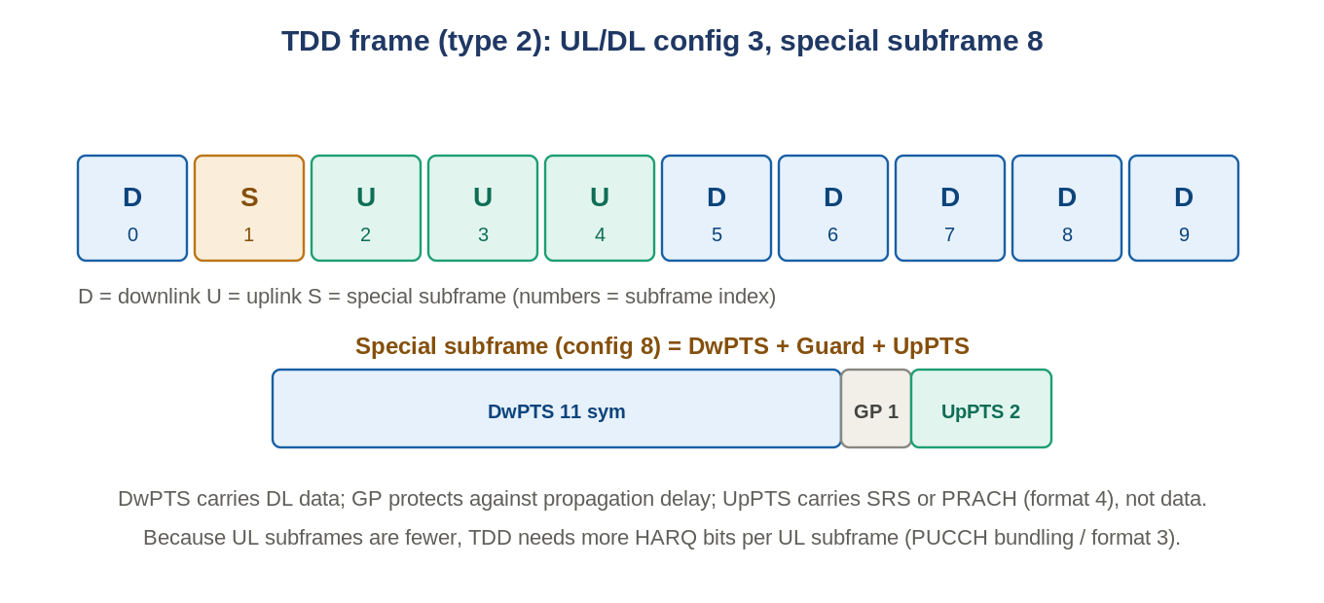
Figure: TDD frame type 2 (UL/DL config 3) with a special subframe (config 8).
A radio frame is 10 subframes in two half-frames of 5. A TDD frame mixes Downlink (D), Uplink (U), and Special (S) subframes. PW products use two combinations: (2,7) and (3,8) - meaning (UL/DL configuration, special-subframe configuration). The special subframe splits into DwPTS (downlink data), a Guard Period (protects against propagation delay during the DL->UL turnaround), and UpPTS (too short for data - used for SRS or PRACH, or left as extra guard). Config 8 = DwPTS 11 sym, GP 1, UpPTS 2; config 7 = DwPTS 10, GP 2, UpPTS 2.

3. PRACH in TDD
TDD has fewer UL subframes, so to keep random-access capacity it can put multiple PRACH regions in one subframe (frequency-domain multiplexing). Format 4 is TDD-only: the preamble rides in the short UpPTS field (very small cells only), freeing the normal UL subframes for throughput. Note the FHGW limitation: only PRACH config index 4 is supported, and only Frame Config 2 / Special Subframe Config 6.

4. UCI and HARQ - the bit-count problem
With fewer UL subframes, each one must carry the ACK/NACKs for several DL subframes, so HARQ bit counts per UL subframe grow (worst case M=4 DL slots per UL slot). Consequences: PUCCH format 1b with channel selection covers up to 4 HARQ bits; beyond that (multiple carriers/codewords) you need format 3; bundling (logical AND of ACKs) reduces the count (e.g. 16 ACKs/frame down to 8). The scheduler must allocate more resources to keep the coding rate.

5. PSS/SSS and control channels move
Signal | FDD position | TDD position
PSS | last symbol of slots 0 and 10 | 3rd symbol of the special subframes (sf 1 and 6)
SSS | 2nd-to-last symbol of slots 0/10 | last symbol of slot 1 (sf 0) and slot 11 (sf 5)
PDCCH | up to 3 OFDM symbols | <=2 symbols in sf 1 and 6 (PSS occupies the 3rd)
The PSS/SSS offset even lets a UE detect whether a carrier is FDD or TDD.

6. RF and system aspects
- Off-power mask: TDD defines the transmitter OFF power during UL subframes and the maximum ON<->OFF transient time (Module 7's gated measurement).
- PA stress: the DL/UL discontinuity means the PA switches on and off, which can degrade its performance - a reason CFR/DPD and bias sequencing matter.
- Tighter timing: TDD needs stringent time synchronization (grandmaster/PTP) to avoid UL/DL interference between neighbouring cells (cross-slot interference).
- Reciprocity: because UL and DL share the frequency, SRS measurements can drive DL beamforming - a big TDD advantage for massive MIMO (Module 9).

7. What changes in the PHY DU
Component | TDD change
PRACH | format 4 support; frequency-domain multiplexing; config-index constraints
PUCCH | support format 3 and 1b-with-channel-selection tables for more HARQ bits
UCI over PUSCH | handle the increased HARQ bit count
Slot length | PDSCH/PUSCH must handle special-slot lengths (11/12 sym, not 14)
PSS/SSS | place them at the TDD positions
PDCCH | restrict control region in sf 1/6; TDD-appropriate DCI sizes
Timing / SRS | more accurate TA loop; implement SRS receiver; mitigate cross-slot interference

8. Self-check
- Why can TDD use unpaired spectrum but FDD cannot?
- What are the three parts of the special subframe, and what is the guard period for?
- Why does TDD need more HARQ bits per UL subframe?
- What TDD-only advantage helps DL beamforming?
Answers
1. TDD separates UL and DL in time on one frequency; FDD separates them in frequency, needing a pair.
2. DwPTS (DL data), Guard Period (covers propagation delay in the DL->UL switch), UpPTS (SRS/PRACH).
3. Fewer UL subframes must acknowledge more DL subframes.
4. Channel reciprocity - UL SRS measurements apply to the DL because both share the frequency.

Takeaways
- TDD = UL and DL time-shared on one frequency; frame type 2 with a special subframe (DwPTS/GP/UpPTS).
- Consequences ripple through PRACH (format 4), HARQ/PUCCH (more bits), PSS/SSS positions, and timing.
- Reciprocity is the upside: SRS drives DL beamforming. FHGW supports frame config 2 / SSF 6, PRACH index 4.
Built from your TDD LTE Impact on PHY DU deck. This complements Module 7 (TDD gating) and Module 8 (PRACH).

