RF ENGINEERING — STUDY GUIDE
Module 1
The Decibel & RF Power

Mentor's note: This is the one module you must not skim. Every number on your bench — RSSI, output power, ACLR, gain, return loss, noise figure, EIRP — is in dB or dBm. Get this rock-solid and everything downstream becomes addition and subtraction.

1. Why RF lives in logarithms
A base station may transmit 40 W; the signal it receives from a phone at the cell edge can be around 10^-13 W — a ratio of ~100,000,000,000,000 to 1. You cannot reason about that range in linear watts.
So RF uses a logarithmic scale, the decibel. It compresses that range into a tidy band and turns multiplication into addition.

2. dB — the decibel is a RATIO
dB = 10 x log10 ( P_out / P_in )
Memorize the toolkit: +3 dB = x2, -3 dB = /2, +10 dB = x10, -10 dB = /10, 0 dB = x1. Build everything else by adding these (logs turn multiply into add):
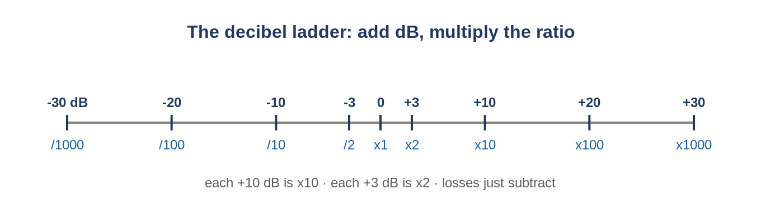
Figure: The dB ladder — adding decibels multiplies the ratio.
- +6 dB = +3 +3 = x4 · +13 dB = +10 +3 = x20 · +20 dB = x100 · +30 dB = x1000
Worked: why 30 dB coupling = 1/1000th
A coupler's coupling factor is a LOSS to the tapped port: -30 dB = /10 /10 /10 = /1000. So the sample is 1/1000th of the main line. (Note: pure +30 dB = x1000 — three tens, no x2; a x2 only appears when there is a +3 in the number.)

3. dBm — absolute power
Fix the reference at 1 milliwatt (the "m") and the ratio becomes an absolute power:
dBm = 10 x log10 ( Power_in_mW / 1 mW )
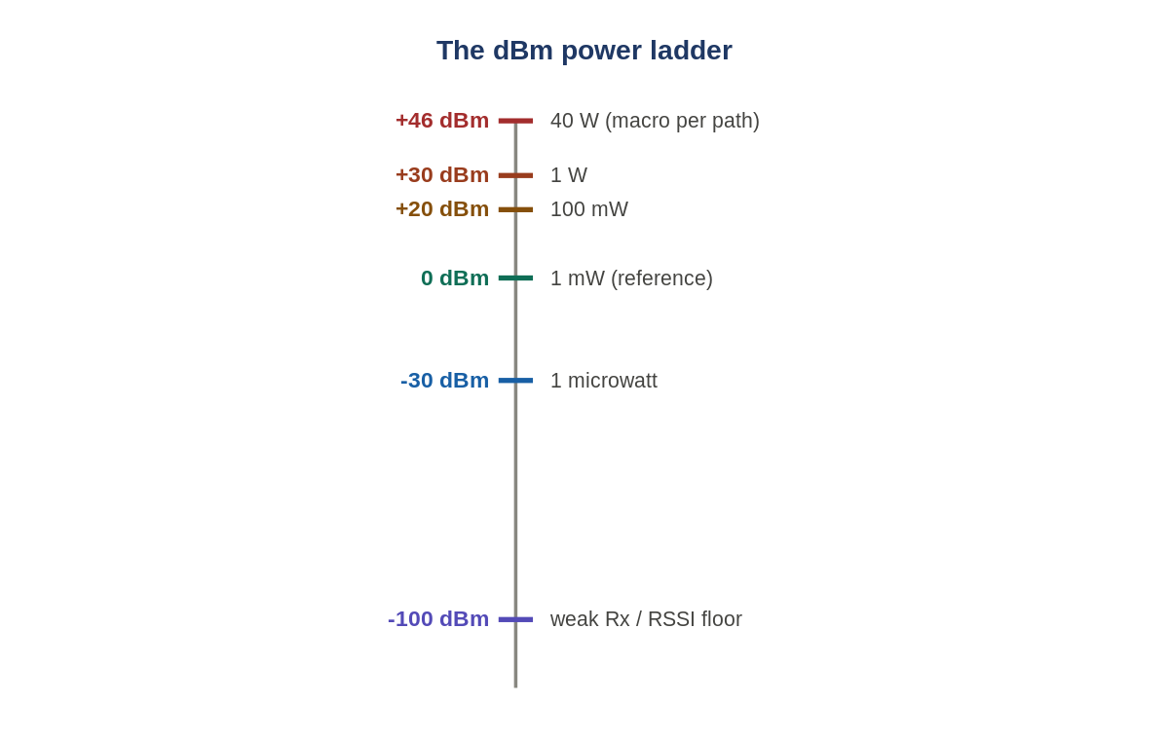
Figure: The dBm ladder. Anchor on 0 dBm = 1 mW and +30 dBm = 1 W.
Two anchors + the rules place any power
0 dBm = 1 mW and +30 dBm = 1 W. Example: +43 dBm = +30 (1 W) +10 (10 W) +3 (20 W) = 20 W.
dBm is a POWER; dB is a RATIO. Add/subtract dB to a dBm; never add two dBm. +30 dBm through a +13 dB amp = +43 dBm.

4. The link budget — why the industry lives in dB
A whole chain is addition and subtraction: gains add, losses subtract.
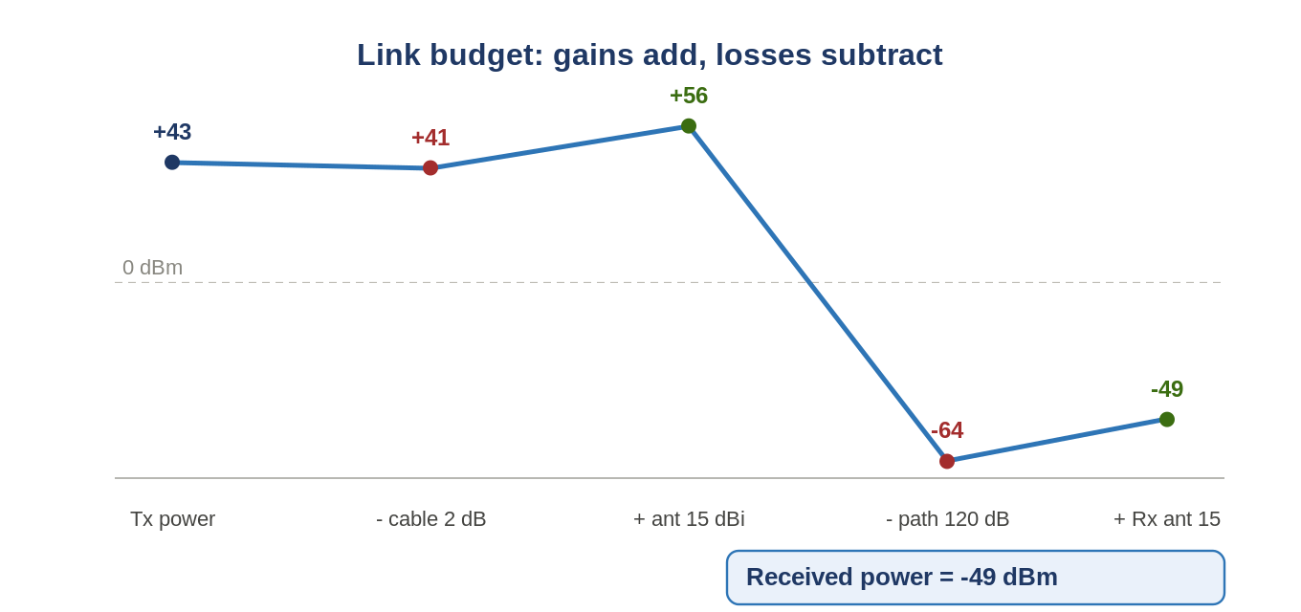
Figure: A link budget: start at Tx power and add the column down to received power.
Tx +43 - cable 2 + ant 15 - path 120 + Rx ant 15 = -49 dBm

5. The flavored dB units
Unit | Reference | Use
dBm | 1 mW | absolute power — your daily unit
dBW | 1 W | dBW + 30 = dBm
dBc | the carrier | ACLR, spurs, harmonics: how far below the main signal
dBi | isotropic radiator | antenna gain; feeds EIRP
dBd | a dipole | dBi = dBd + 2.15
Connecting your glossary
RSSI = received power in dBm. EIRP = Tx (dBm) + antenna gain (dBi) - losses. TRP = total power radiated over the sphere, in dBm. All are power in dBm at different points.

6. Worked example from your world
At analyzer = 37 - 2.5 - 30 = +4.5 dBm
True output = +4.5 + 2.5 + 30 = +37 dBm (de-embedding)
Adding back the path loss is cable-loss correction / de-embedding — the #1 rookie error to avoid. Covered fully in Module 7.

7. Self-check
- An amplifier turns -10 dBm into +20 dBm. Gain in dB?
- Express 4 W in dBm.
- Signal +43 dBm, spur -7 dBm: how many dBc down?
- Why is 'this antenna outputs 15 dBm of gain' wrong?
Answers
1. +30 dB.
2. +36 dBm.
3. 50 -> -50 dBc.
4. Gain is a ratio (dBi), not a power (dBm); antennas focus, not create, power.

Takeaways
- dB = ratio; dBm = absolute power (ref 1 mW). Never add two dBm.
- +3 dB = x2, +10 dB = x10, 0 dBm = 1 mW, +30 dBm = 1 W.
- A whole RF chain is addition/subtraction in dB — the link budget.
Next — Module 2: the 50-ohm world (impedance, reflection, VSWR, return loss).

