RF ENGINEERING — STUDY GUIDE
Module 2
The 50-Ohm World: Impedance, Reflection, VSWR & Return Loss

Mentor's note: Module 1 was the language; this is the plumbing. Everything is joined by 50-ohm lines, and when impedance does not match, power bounces back. Return loss and VSWR tell you how leak-free your plumbing is.

1. Why 50 ohms?
At RF a cable is a transmission line with a characteristic impedance Z0 set by its geometry, not its length. The industry standardized on 50 ohm: coax handles max power near 30 ohm and has minimum loss near 77 ohm, and 50 is the compromise. Rule: keep the path 50 ohm end to end.

2. What happens at a mismatch: reflection
Into exactly 50 ohm: all power absorbed. Into anything else: some reflects back. The reflection coefficient Gamma:
G = (ZL - Z0) / (ZL + Z0)
matched -> 0 · open -> +1 · short -> -1

3. The two numbers you live by: Return Loss & VSWR
Return Loss (dB) = -20 log10|G| — how far below incident the reflection is. Bigger = better. VSWR = (1+|G|)/(1-|G|), the ratio of standing-wave max to min voltage. Near 1 = better.
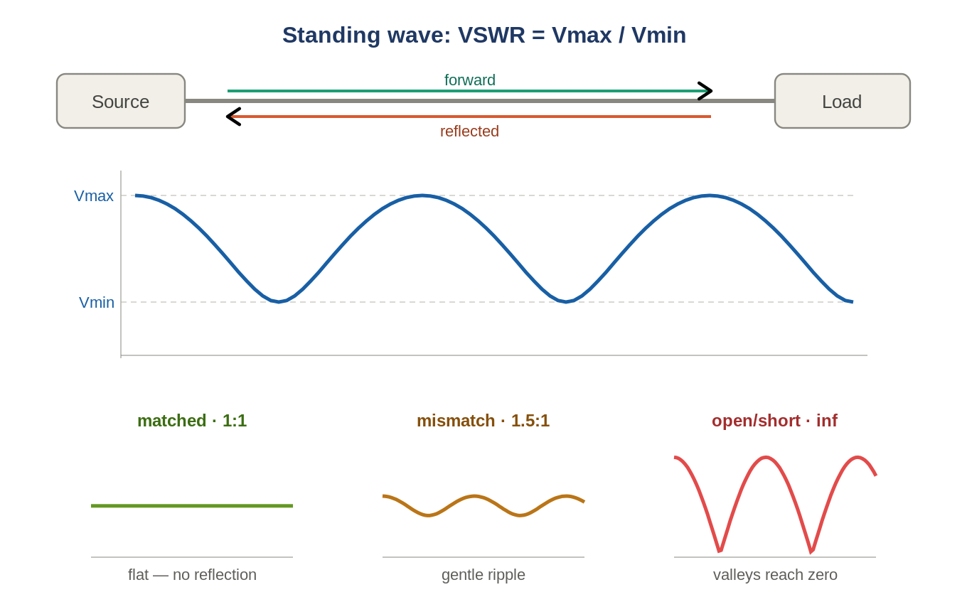
Figure: Forward + reflected combine into a standing wave; VSWR is its peak-to-valley ratio.

4. Translating VSWR and Return Loss
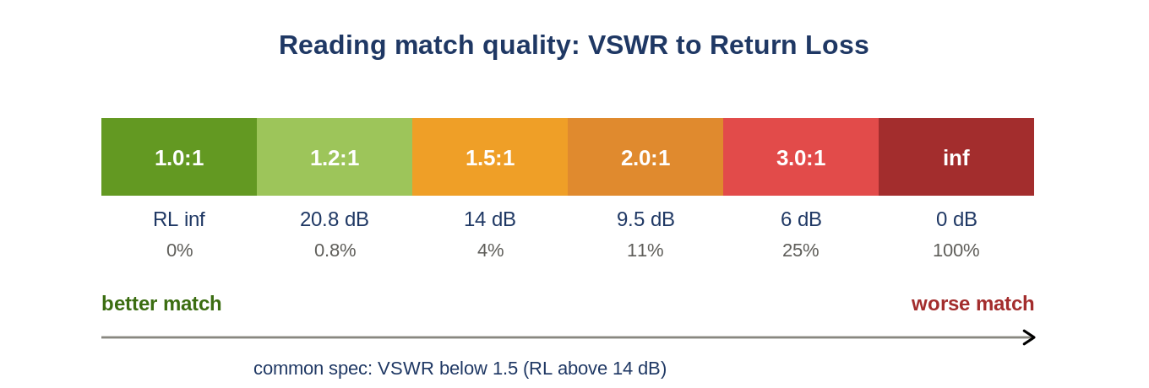
Figure: The same match quality, read as VSWR, return loss, and percent power reflected.
VSWR | Return Loss | % reflected | Verdict
1.0:1 | infinite | 0% | perfect
1.5:1 | 14 dB | 4% | good (typical spec)
2.0:1 | 9.5 dB | 11% | marginal
3.0:1 | 6 dB | 25% | bad
inf | 0 dB | 100% | open/short
Read instantly
RL and VSWR are two views of |G|. A common spec is VSWR < 1.5 (RL > 14 dB). Measure RL 8 dB and the port is out of spec, reflecting ~16% of its power.

5. Why mismatch hurts
- Lost power: reflected power never reaches the antenna.
- PA stress: reflection returns to the amplifier — a bad/open port can damage the PA. Hence VSWR-trip protection.
- Measurement error: a mismatched test path adds ripple, shifting ACLR/power numbers.

6. In your RCT world
- Connectors: most bad VSWR is a loose/dirty connection. Torque to spec, keep clean.
- cable_loss.json: exists because the path is not lossless; a matched, characterized path makes Module-1 de-embedding valid.
- Open/Short/Load: VNA cal standards — Load = perfect 50 ohm (G=0), Open/Short = perfect reflectors (G=+/-1).

7. Self-check
- Return loss 20 dB: % reflected, good or bad?
- Key TX into an open port: Gamma? why dangerous?
- VSWR 1.5:1 is about what return loss?
- Why 50 ohm and not 30 or 77?
Answers
1. 1% reflected — good.
2. G=+1, 100% reflected into the PA — can damage it.
3. ~14 dB.
4. Compromise between max power (30) and min loss (77).

Takeaways
- Keep everything 50 ohm. G=(ZL-Z0)/(ZL+Z0).
- RL = -20log|G| (big = good). VSWR=(1+|G|)/(1-|G|) (near 1 = good).
- Mismatch = lost power + PA stress + measurement error. Spec VSWR<1.5 (RL>14 dB).
Next — Module 3: the RF chain (the main RF flow), DAC to PA and back, with gain and noise-figure cascade math.

