RF ENGINEERING — STUDY GUIDE
Module 3
The RF Chain — the Main RF Flow

Mentor's note: Modules 1-2 gave you the language (dB) and the plumbing (50 ohm). This module is the radio itself. Every block here appears in your AAU block diagram, at every power_monitor tap, and as the thing each conformance test measures. Learn the chain once and the rest of the course is just zooming into individual blocks.

1. The whole chain at a glance
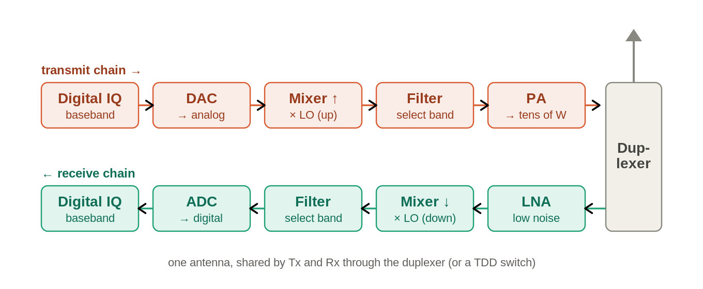
Figure: The transmit and receive chains, sharing one antenna through the duplexer.
A radio is two signal paths sharing one antenna. Trace the transmit path left-to-right along the top, and the receive path right-to-left along the bottom.

2. Transmit side — building the signal up
Stage | What it does
Digital IQ | The waveform as numbers (baseband), measured in dBFS. This is what IQ playback injects.
DAC | Digital-to-analog: turns the IQ samples into an analog baseband signal.
Mixer + LO | Up-conversion. Multiplies baseband by the Local Oscillator to land on the carrier: f_RF = f_LO + f_baseband.
Filter | Removes the unwanted mixer image and out-of-band products, leaving a clean band.
PA | Power amplifier: lifts a milliwatt-level signal to tens of watts. The hottest, most non-linear block — the reason DPD exists (Module 6).
Duplexer / TDD switch | Routes Tx to the shared antenna (FDD: frequency-split duplexer; TDD: time switch).

3. Receive side — pulling a whisper out of the noise
Stage | What it does
LNA | Low-noise amplifier: the FIRST thing the weak (~ -100 dBm) signal hits. High gain, very low noise — it sets the whole receiver's noise figure.
Mixer + LO | Down-conversion back to baseband: f_baseband = f_RF - f_LO.
Filter | Selects the wanted channel, rejects neighbours.
ADC | Analog-to-digital: samples the signal into IQ for the modem.

4. Equation 1 — gain cascades by addition
This is just the Module-1 link budget applied inside the radio. Total chain gain (dB) = the sum of every stage's gain and loss. Add the column:
DAC drive +5 dB
filter loss -2 dB
PA gain +40 dB
-------------------
net +43 dB

5. Equation 2 — noise figure, and why the LNA is first
Every stage adds a little noise and degrades the signal-to-noise ratio (SNR). Crucially, WHERE the noise is added matters. Friis's cascade formula:
F_total = F1 + (F2-1)/G1 + (F3-1)/(G1*G2) + ...
The first stage's noise passes through undivided; every later stage's noise is divided by all the gain ahead of it. So a high-gain, low-noise first stage swamps everything downstream. That is the whole reason the LNA is first.
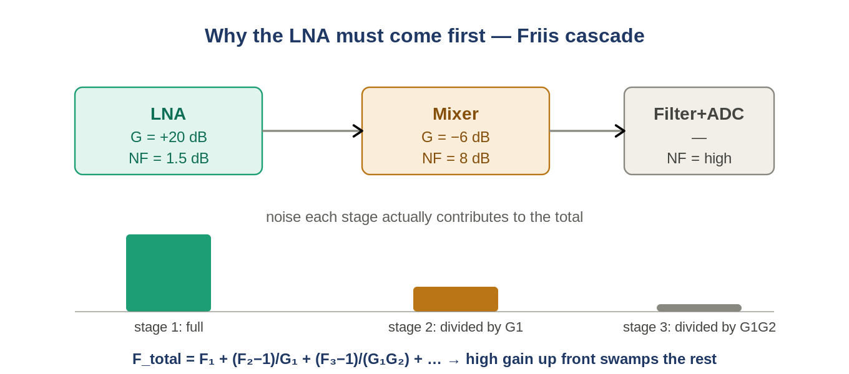
Figure: The first stage dominates the total noise figure; later stages are divided down by the gain ahead of them.

6. Noise floor and sensitivity — where the chain meets the test
The receiver noise floor and reference sensitivity are built straight from this chain's noise figure:
Noise floor (dBm) = -174 + 10*log10(BW in Hz) + NF
Sensitivity = -174 + 10*log10(BW) + NF + required_SNR
-174 dBm/Hz is thermal noise at room temperature, a physical constant. Stack the contributions and you arrive at the spec number your RCT sensitivity test (7.2) checks:
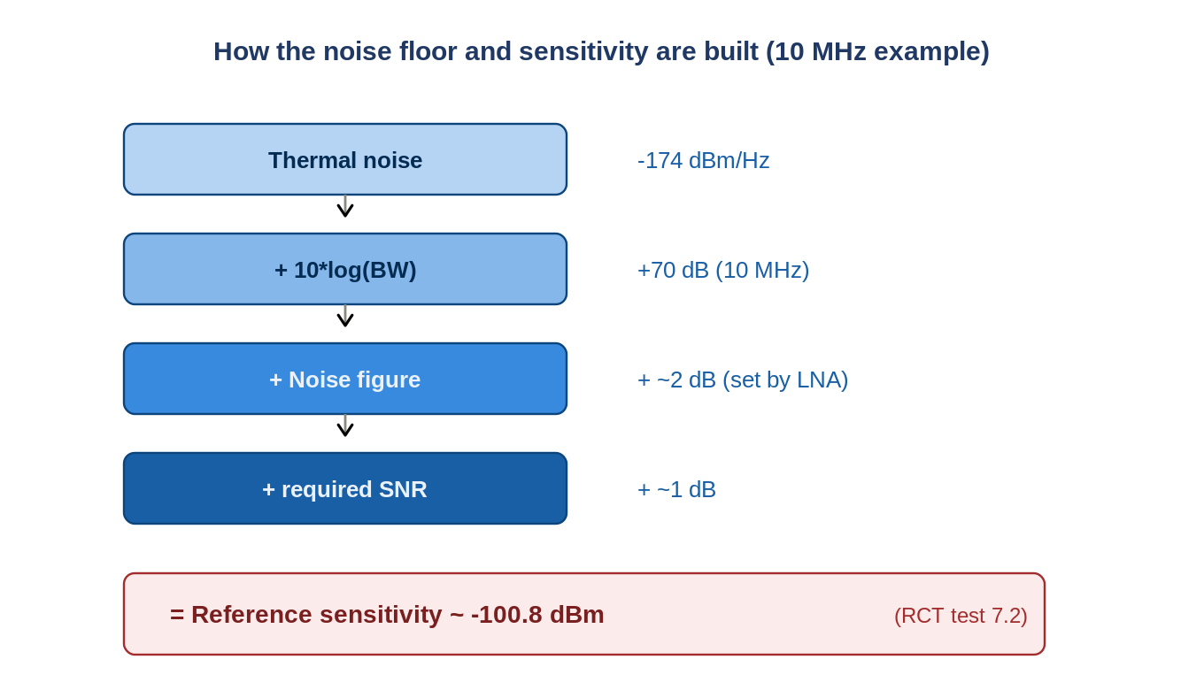
Figure: Reference sensitivity is the thermal floor plus bandwidth, noise figure, and required SNR.
The cascade is the pass/fail
A bad LNA -> worse noise figure -> higher noise floor -> worse sensitivity -> a FAILED test 7.2. When a radio hears down to -100.8 dBm, that number was set by this chain. Nothing 'abstract' here — Friis decides whether the unit ships.

7. How this maps to your world
- Your AAU block diagram is this chain replicated per branch (and per band). Modules 6 and 9 zoom into the PA and the multi-branch layout.
- power_monitor reads dBFS at points along the digital end of this chain (DL near the DAC input, UL near the ADC output).
- Conformance tests measure the two ends: Tx tests check what comes OUT of the PA (power, ACLR, EVM); Rx tests check what the chain can HEAR (sensitivity, blocking).

8. Self-check
- In which order does a received signal hit these: ADC, LNA, mixer, filter?
- Why is the LNA placed first and made both low-noise AND high-gain?
- A receiver has BW = 10 MHz (10*log = 70 dB), NF = 3 dB, required SNR = 2 dB. What is its sensitivity?
- If f_LO = 2000 MHz and baseband = 10 MHz, what is the transmit carrier frequency?
Answers
1. LNA -> mixer -> filter -> ADC (amplify the weak signal BEFORE doing anything noisy to it).
2. Friis: the first stage's noise is undivided and its high gain divides down all later noise, so it sets the receiver's NF.
3. -174 + 70 + 3 + 2 = -99 dBm.
4. f_RF = f_LO + f_baseband = 2010 MHz.

Takeaways
- A radio = Tx chain (DAC->mixer->filter->PA) and Rx chain (LNA->mixer->filter->ADC) sharing one antenna.
- Gain cascades by addition (the link budget, inside the box).
- Noise figure is set by the first stage (Friis) — hence the low-noise, high-gain LNA up front.
- Sensitivity = -174 + 10log(BW) + NF + SNR. The chain decides the pass/fail of test 7.2.
Next — Module 4: Key radio metrics. We turn your floating glossary (RSSI, sensitivity, TRP, EIRP, dynamic range) into precise, measurable definitions anchored on this chain.

