PARALLEL WIRELESS · RCT — STUDY GUIDE
Module 4
Key Radio Metrics

Mentor's note: RSSI, sensitivity, dynamic range, the full receiver test family, TRP/EIRP — pinned to the chain from Module 3.

1. RSSI — received signal strength indicator
Total power in the receive band at the radio's input, in dBm. Wideband: it sums wanted signal + noise + interference, so high RSSI alone does not mean good signal. Used for coverage and AGC. (Note: conformance includes an RSSI readback calibration test — the radio's reported RSSI must match the true input power.)

2. Sensitivity
Sensitivity = -174 + 10*log10(BW) + NF + required_SNR
Minimum input power still meeting BLER <= 5% (RCT test 7.2). Set by the chain's noise figure (Module 3).

3. Dynamic range and the broader receiver tests
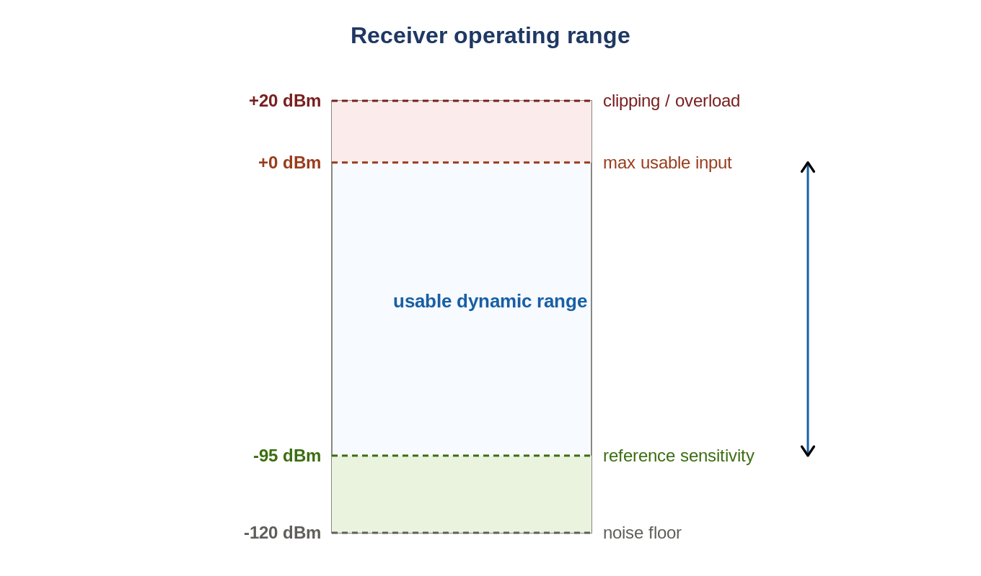
Figure: From noise floor up to overload — the usable receiver window.
Real receiver conformance is much wider than sensitivity. Each of these is a distinct measurement of behaviour under impairment:
Test | Proves
Dynamic range | decode wanted signal with in-band AWGN present
Adjacent channel selectivity (ACS) | reject an interferer just outside the channel
In-channel selectivity (ICS) | decode beside a stronger in-band signal
Narrowband / wideband blocking | reject 1-RB / wideband / out-of-band interferers
Receiver intermodulation | reject IM products of two interferers

4. TRP and EIRP
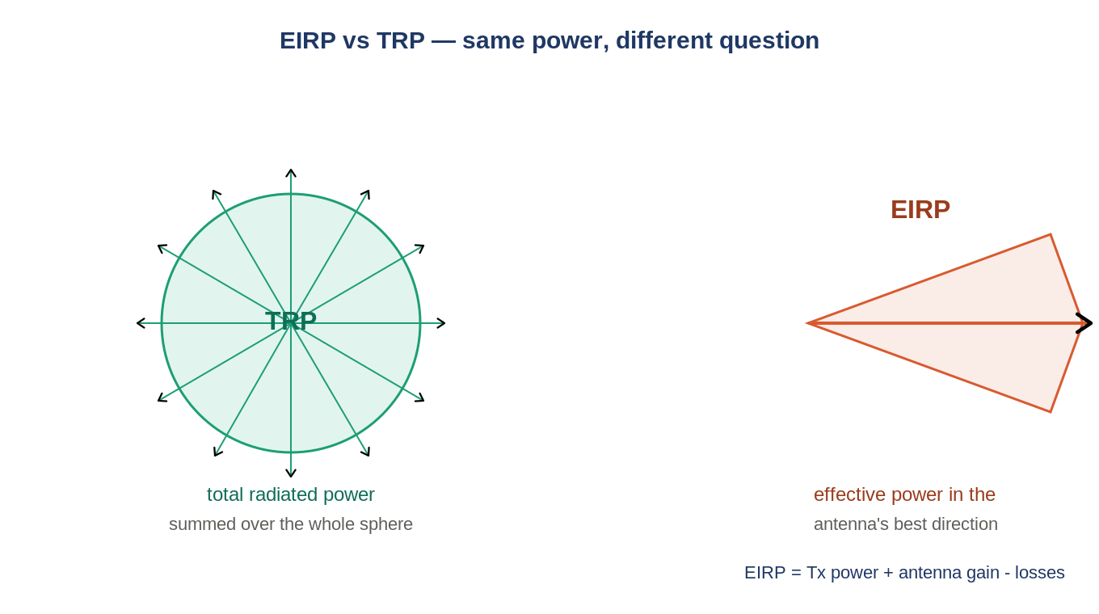
Figure: EIRP is best-direction power; TRP is the whole-sphere total.
EIRP = Tx power + antenna gain - losses (best direction). TRP integrates radiated power over the whole sphere. Both measured over-the-air for the AAU.
Three power numbers, don't confuse them
The PA deck quotes power at three levels: per-PA antenna power (e.g. 38.4 dBm), TRP (e.g. 44.4 dBm), and Tx power including beamforming gain (e.g. 50.4 dBm). Beamforming gain is roughly +12 dB (B1/B3/B41) or +6 dB (B8/B28).

5. The supporting cast
Metric | Meaning
SNR / SINR | signal vs noise (and interference); drives achievable modulation
RSRP / RSRQ | LTE reference-signal power/quality, used by the UE for cell selection
Throughput / BLER | the performance pass criterion (ch.8 tests)

6. Self-check
- Two cells both read RSSI -60 dBm. Equal quality? Why/why not?
- BW 10 MHz (10log=70), NF 4, SNR 1. Sensitivity?
- Name three receiver tests beyond reference sensitivity.
- Antenna gain 16 dBi, Tx 43 dBm, 3 dB loss. EIRP?
Answers
1. No — RSSI includes noise/interference; one could be mostly interference (low SINR).
2. -174+70+4+1 = -99 dBm.
3. ACS, ICS, blocking, receiver intermodulation (any three).
4. 43+16-3 = 56 dBm.

Takeaways
- RSSI = total in-band power; sensitivity = quietest decodable (set by NF).
- Rx conformance = sensitivity + dynamic range + ACS/ICS/blocking/IM + RSSI readback cal.
- Per-PA power vs TRP vs Tx-with-BF-gain are three different numbers.
Next — Module 5: modulation and the IQ world.

