PARALLEL WIRELESS · RCT — STUDY GUIDE
Module 5
Modulation & the IQ World

Mentor's note: IQ, constellations, EVM and IQ playback — the bridge from the digital signal (dBFS) to the modulated RF your tests measure.

1. Why IQ?
A signal has amplitude and phase. The clean way to carry both is two numbers: I (in-phase) and Q (quadrature, 90 deg). Any modulated signal is I + jQ; the DAC/ADC and all digital processing work in IQ — the signal as a point on a 2D plane.

2. Constellations
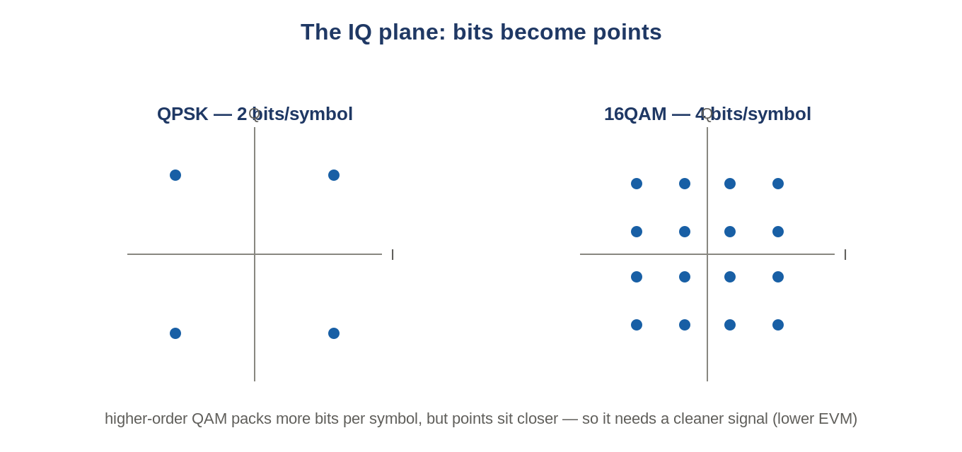
Figure: Each constellation point is a symbol carrying several bits.
QPSK = 2 bits/symbol; 16QAM = 4; 64QAM = 6; 256QAM = 8. Higher order = more data, but points sit closer, demanding a cleaner signal.

3. OFDM and the resource grid
LTE/5G split the channel into many narrow subcarriers, each a low-rate QAM symbol, grouped in time into OFDM symbols. One subcarrier x one symbol = a Resource Element; 12 subcarriers = a Resource Block (the unit behind '25 RBs', '273 PRB').

4. EVM
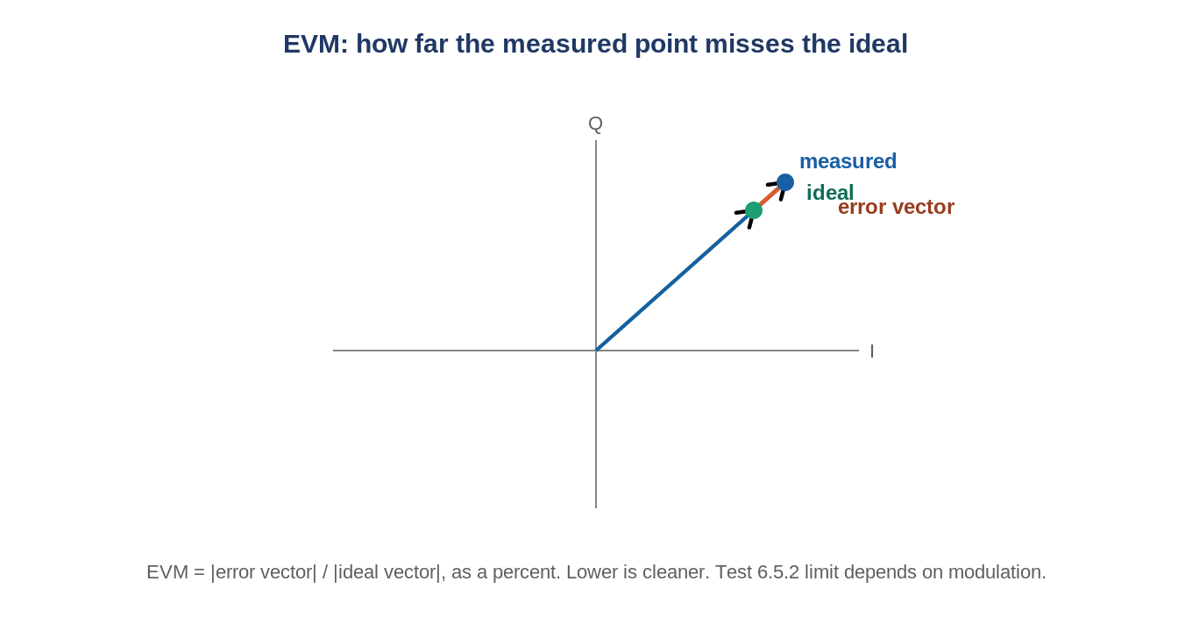
Figure: EVM is the distance from where a symbol should be to where it landed.
Error Vector Magnitude = how far measured symbols miss ideal, as a percent. RCT test 6.5.2. A PA driven too hard (Module 6) raises EVM.

5. IQ playback
Receiver tests need a known, repeatable uplink signal, so a waveform is pre-computed as an IQ file (.bin/.wfm) and a signal generator plays it into the radio. Exact and repeatable — why conformance uses it instead of a live phone (e.g. PRACH_idx158_100MHZ.wfm in RuAuto).

6. Self-check
- Bits per symbol for 64QAM?
- Why does 256QAM need lower EVM than QPSK?
- One Resource Block = how many subcarriers?
Answers
1. 6.
2. Points are packed closer, so less error is tolerable.
3. 12.

Takeaways
- IQ = signal as (I,Q) points; modulation maps bits to constellation points.
- EVM = how far symbols miss ideal (6.5.2); IQ playback feeds Rx tests a known waveform.
Next — Module 6: the DL Tx chain, CFR and DPD.

