PARALLEL WIRELESS · RCT — STUDY GUIDE
Module 6
The DL Tx Chain: Power Scaling, CFR, DPD

Mentor's note: DPD is one link in a chain. This now covers the real FHGW path — DL power scaling, CFR (with your registers), DPD and DAC scale — the heart of your AAU transmitter.

1. The whole downlink transmit chain
DPD is one block in a chain. Here is the real FHGW downlink path, with the actual block order and register values from your hardware:
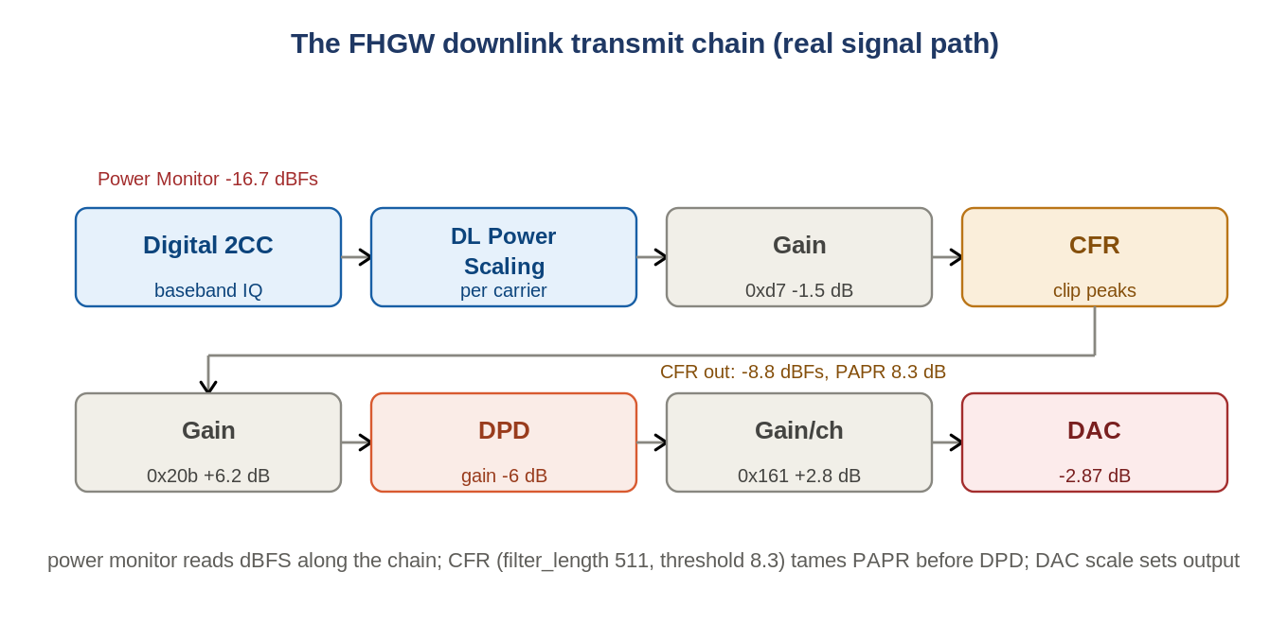
Figure: The real FHGW DL chain: DUC/scaling -> Gain -> CFR -> Gain -> DPD -> Gain/ch -> DAC.
Digital 2CC (two carriers) -> DL power scaling (per-carrier level) -> digital gain -> CFR -> gain -> DPD -> per-channel gain -> DAC output scale. The power monitor reads dBFS at taps along the way (Module 1's appendix).

2. The PA's problem: compression
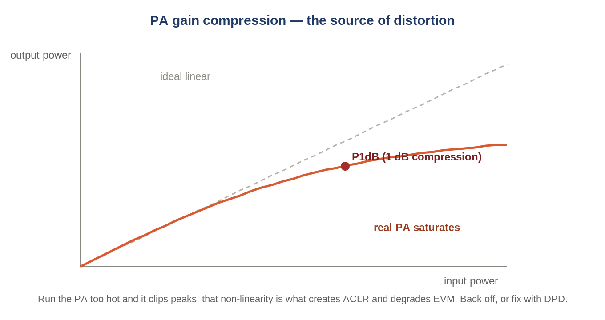
Figure: Output stops tracking input — P1dB marks the 1 dB compression knee.
Amplifiers are linear only up to a point; past P1dB they compress and saturate, generating distortion.

3. PAPR and why we must back off
OFDM sums hundreds of subcarriers, so peaks run ~10 dB above average (high PAPR). To keep peaks out of compression the average runs well below saturation — which is why power_monitor shows DL around -21 dBFS, leaving headroom.

4. CFR — Crest Factor Reduction
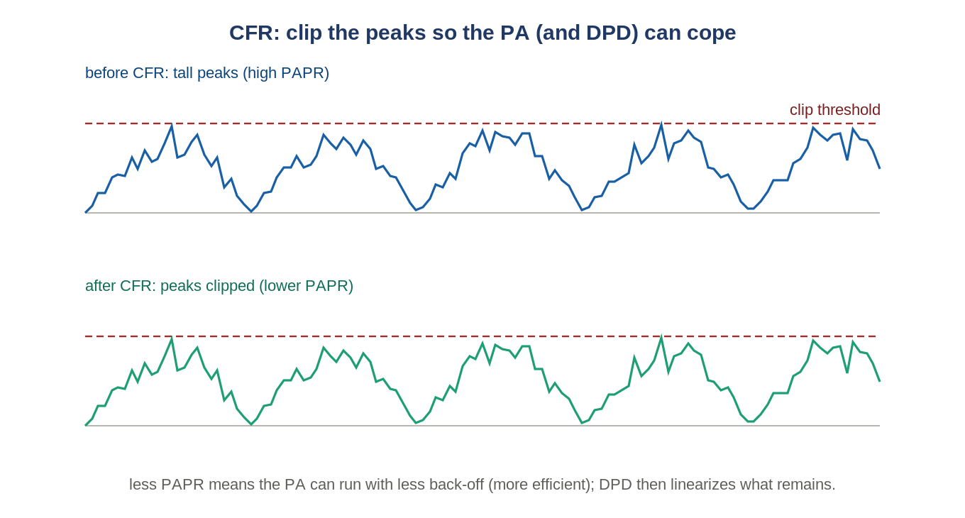
Figure: CFR clips the peaks down to a threshold, lowering PAPR before DPD.
CFR deliberately clips the signal peaks (with a filter so it doesn't splatter) to reduce PAPR before the PA. On your FHGW it is register 0xb0290000 with parameters like filter_length 511, threshold 8.3, and two working points — 0xD7 for occupancy > 50% and 0x128 for <= 50%. Less PAPR lets the PA run with less back-off (more efficient), at the cost of a little EVM/ACLR that DPD then cleans up.

5. Intermodulation and spectral regrowth
A non-linear PA on a wideband signal creates intermodulation products that spill outside the channel (spectral regrowth) — exactly what ACLR measures (Module 7) — and smears the constellation (raises EVM).

6. DPD — Digital Pre-Distortion
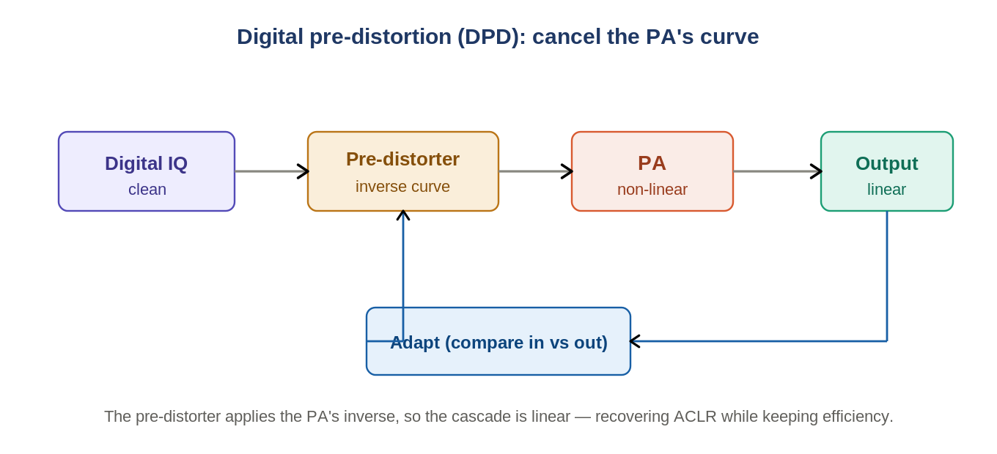
Figure: Pre-distortion applies the PA's inverse so the cascade is linear.
DPD pre-warps the signal with the PA's inverse so PA + pre-distorter behave linearly; a feedback path adapts the model. CFR + DPD together let you run the PA hot (efficient) while passing ACLR/EVM. Your AAU uses a single shared DPD (the next module shows how).
The chain, summarized
DUC/scaling sets the level -> CFR cuts the peaks -> DPD linearizes -> DAC scale sets output. CFR and DPD are partners: CFR reduces how hard DPD must work; DPD fixes the distortion CFR and the PA introduce.

7. Self-check
- Put these in order: DPD, CFR, DAC, DL power scaling.
- What does CFR do, and why before the PA?
- Why must an OFDM PA run backed off?
- What does DPD do in one line?
Answers
1. DL power scaling -> CFR -> DPD -> DAC.
2. Clips peaks to lower PAPR so the PA needs less back-off; done digitally before the PA.
3. High PAPR — peaks would clip and distort.
4. Applies the PA's inverse so the cascade is linear.

Takeaways
- The DL chain: DUC/scaling -> CFR -> DPD -> DAC scale. CFR and DPD are partners.
- CFR cuts PAPR (registers/working points); DPD linearizes; both let the PA run efficiently in spec.
Next — Module 7: ACLR and spectrum analysis (how you measure all of this).

