PARALLEL WIRELESS · RCT — STUDY GUIDE
Module 7
ACLR & Spectrum Analysis

Mentor's note: The spectrum analyzer is your main Tx instrument. ACLR, SEM, cable-loss correction, and the TDD gating that B41 demands.

1. The spectrum analyzer
Shows power vs frequency. Resolution Bandwidth (RBW) sets how finely it resolves frequency and the noise floor; Video Bandwidth (VBW) smooths the trace; averaging steadies noise. Wrong settings, wrong numbers.

2. ACLR
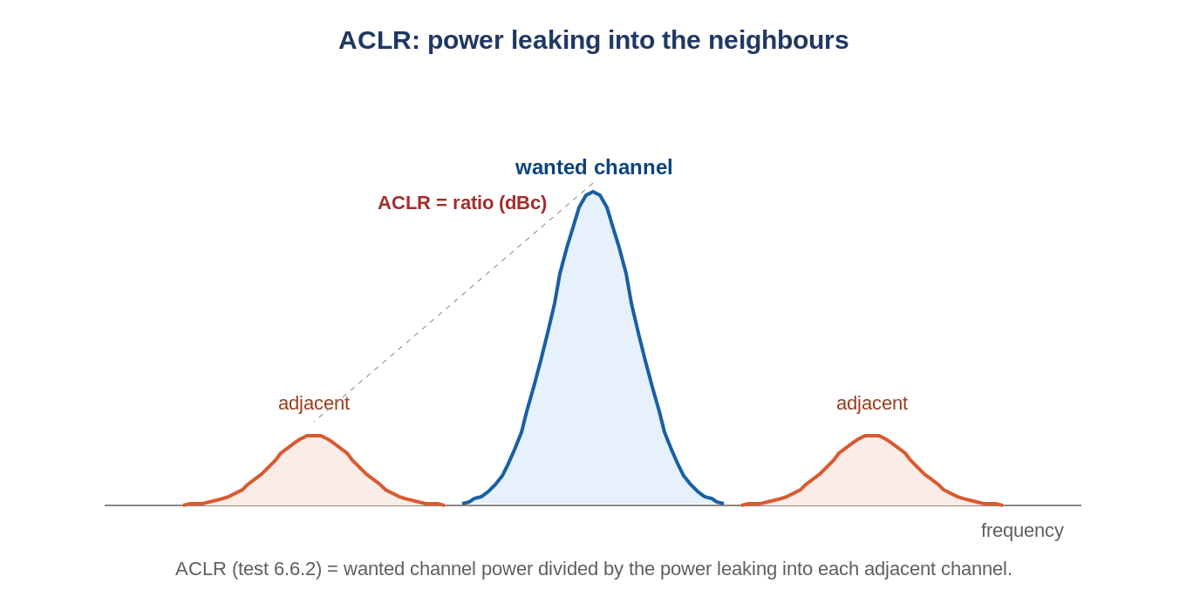
Figure: ACLR compares wanted-channel power to adjacent-channel leakage.
Adjacent Channel Leakage Ratio (RCT test 6.6.2) = wanted-channel power / adjacent-channel power, in dBc — the direct measure of spectral regrowth (Module 6). In RuAuto: sa_set_ACP_mode.

3. SEM, OBUE, spurious
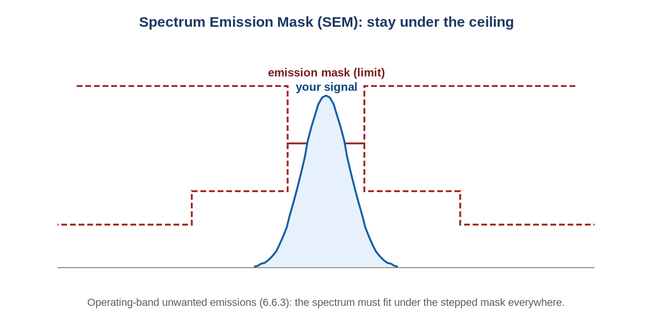
Figure: The transmitted spectrum must sit under a stepped emission mask.
OBUE / spectrum emission mask (6.6.3) requires the whole spectrum under a stepped ceiling; spurious (6.6.4) checks specific far frequencies.

4. Cable-loss de-embedding
Every cable/connector steals power; characterize the loss vs frequency and add it back, or every reading is wrong. RuAuto stores it in cable_loss.json and applies it (extract_cable_loss / :CORR:BTS:GAIN).

5. TDD measurements need gating
On a TDD band (B41) the radio transmits only in some slots. The analyzer must be gated to measure only the transmit slot — e.g. standard preset config 3, special-subframe config 8 (SSFR 8), gate delay ~3.1 ms, gate length ~2.8 ms. Without gating you average in the silent receive slots and read low.
Rookie-error checklist
Forgot cable-loss correction. Wrong RBW. No TDD gating. Reference level too low (analyzer overloads, compresses your reading). Too little averaging.

6. Self-check
- ACLR in one sentence?
- Why must RBW be set correctly?
- Why de-embed cable loss?
- Why gate the analyzer on B41?
Answers
1. Wanted-channel power / adjacent-channel leakage.
2. It sets frequency resolution and the noise floor.
3. To report power at the connector, not after the cable.
4. To measure only the transmit slot, not the silent Rx slot.

Takeaways
- Spectrum analyzer = power vs freq; RBW/VBW/averaging decide correctness.
- ACLR (6.6.2), SEM (6.6.3); always de-embed cable loss; gate TDD measurements.
Next — Module 8: PRACH.

