PARALLEL WIRELESS · RCT — STUDY GUIDE
Module 8
PRACH Deep Dive

Mentor's note: Now with the real detector: Ncs/ZCZ/K math, baseband generation, and the FlexRAN noise-estimator/peak-multiplier decision from your PRACH ALGO deck.

1. What PRACH is for
PRACH (Physical Random Access Channel) is how a UE first reaches the network with no uplink timing — at power-on or to re-sync. The UE sends a random-access preamble (a 'signature'); the base station detects it and replies with a timing-advance command.

2. Preamble structure and baseband generation
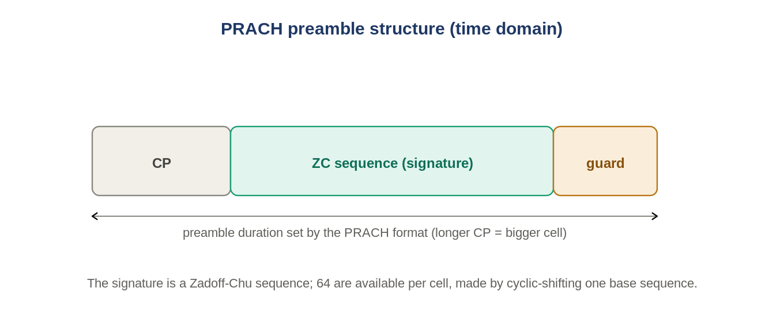
Figure: CP + Zadoff-Chu sequence + guard; format sets the lengths (cell size).
Preamble = cyclic prefix + Zadoff-Chu sequence + guard. The base sequence is built by: DFT, then IDFT + frequency shift + CP addition, power scaling (ramp-up), a half-bin shift, and a configurable frequency shift from SIB2 (in units of 15 kHz subcarriers, with a resampling factor K). Bin distance is 1.25 kHz for formats 0-3.

3. Zadoff-Chu, roots and cyclic shifts
The signature is a Zadoff-Chu (ZC) sequence — constant amplitude, with a single sharp autocorrelation peak and low cross-correlation. The cell broadcasts a root; 64 signatures (preamble index 0-63) are made by choosing a root u and a cyclic shift v. The shift granularity is set by Ncs, which defines the Zero-Correlation Zone (ZCZ).

4. The ZCZ / Ncs / K trade-off
Setting | Effect
ZCZ = 1 -> K = 64, 1 root | small allowable delay, NO inter-root noise
ZCZ = 12 -> K = 6/7, ~10 roots | larger allowable delay, HIGHER inter-root noise
K = number of preambles per root. Allowable delay per UE = Ncs * FFT_size / 839. Bigger cells need a larger allowable delay (more cyclic-shift room), which forces more roots and so more inter-root noise — a real design trade.

5. The detector
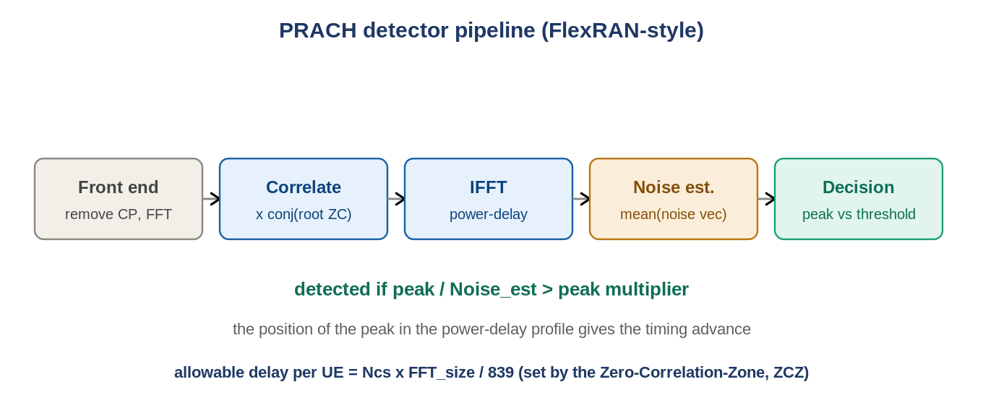
Figure: Front end -> correlate with root ZC -> IFFT -> noise estimate -> peak/threshold decision.
The FlexRAN-style detector: a front end removes the CP and FFTs and extracts the PRACH subcarriers; it multiplies by the conjugate of the root ZC (correlation); an IFFT gives a power-delay profile. A noise estimator takes the correlation after IFFT, forms a noise vector, and computes Noise_est = mean(noise vector). A peak multiplier defines what counts as a peak vs noise: detected if peak / Noise_est exceeds it. The peak's position gives the timing advance. Two error rates matter: missed detection and false alarm (RCT test 8.4).

6. UE behaviour (the 5 steps)
1) Obtain system information (RLC config). 2) Choose preamble index x -> {root u, shift v} at random. 3) Generate the PRACH signal per RLC info and preamble. 4) Send at the RLC-configured time (PRACH configuration index). 5) Wait for the response.
In RuAuto
test_Rx_PRACH plays a PRACH IQ waveform and sweeps input power down (binary or stepped 'sensitivity' search) to find the detection threshold against PRACH_KPI. This is your PRACH ALGO deck made executable.

7. Self-check
- Why does a UE send PRACH at power-on?
- What is the allowable-delay formula, and what sets it?
- What does the noise estimator + peak multiplier decide?
- ZCZ=1 vs ZCZ=12: which gives more roots and more inter-root noise?
Answers
1. No uplink timing yet — PRACH requests access and gets timing advance.
2. Ncs*FFT_size/839, set by the ZCZ (via Ncs).
3. Whether a correlation peak qualifies as a detected preamble vs noise.
4. ZCZ=12 — more roots, higher inter-root noise (but larger allowable delay).

Takeaways
- PRACH = first uplink contact; preamble = CP + ZC + guard, built via DFT/IDFT + shifts.
- Ncs->ZCZ->K->roots->allowable delay is the core trade. Detector = correlate, IFFT, noise-estimate, peak/threshold; peak position = timing advance.
Next — Module 9: AAU architecture and the calibration loop.

