PARALLEL WIRELESS · RCT — STUDY GUIDE
Module 9
AAU Architecture

Mentor's note: Your 6-band single-DPD AAU: the board split, the calibration/observation loop that makes one shared DPD work, and beamforming.

1. From RRH to AAU
An RRH cables to separate antennas; an AAU integrates the radio chains and the antenna array in one unit — shorter feeders, lower loss, per-element control. This is your 6-band B1B3 single-DPD platform.

2. The block diagram
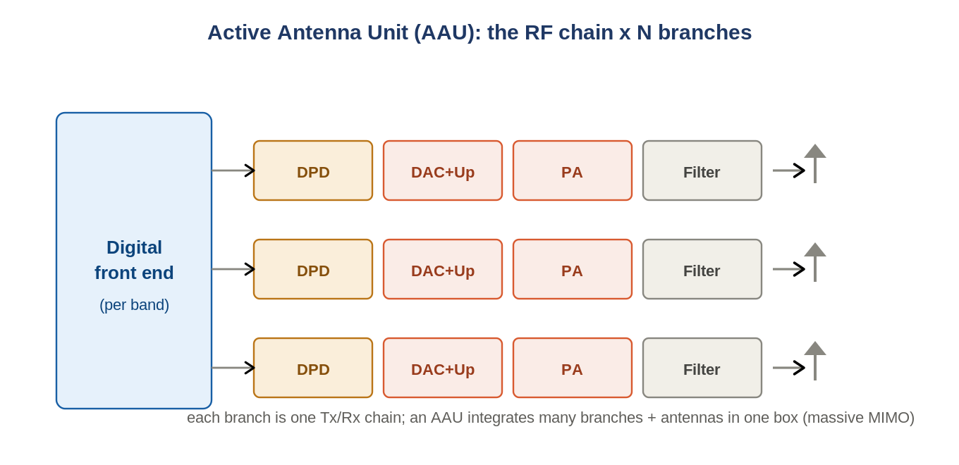
Figure: An AAU = the Module-3 chain replicated per branch, per band, into an antenna array.
Each branch is one Tx/Rx chain (Module 3) feeding one antenna element. A digital front end (the FHGW RFSoC) fans the signal to all branches per band. The board split is FHGW (digital) -> Mid-board (filter/split/cal coupling) -> RFFE (PAs, LNAs, switches, antenna).

3. The calibration / observation loop — how single DPD works
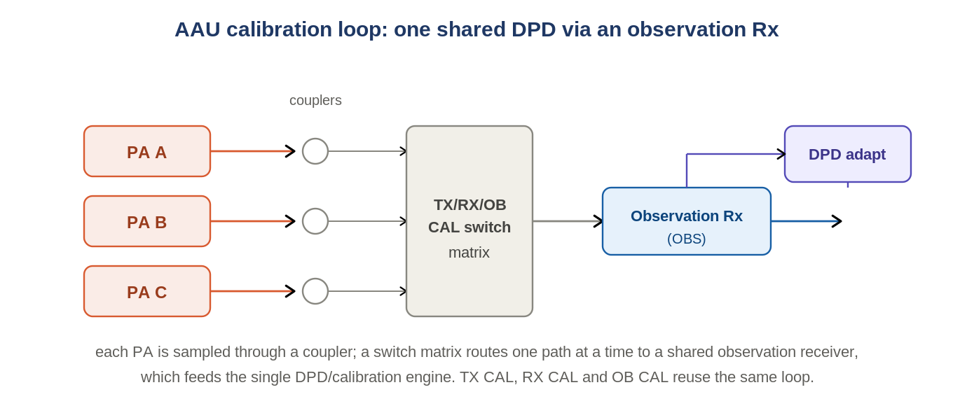
Figure: Couplers sample each PA; a switch matrix routes one path to a shared observation Rx feeding the DPD.
Your diagram is really about calibration. A single shared DPD (the filename says "single DPD") cannot watch every PA at once, so couplers tap each branch and a switch matrix (the SW1..SW25 array) routes ONE path at a time to a shared observation receiver (OBS); that feeds the DPD/calibration engine. The same loop runs TX CAL, RX CAL and OB CAL. The switches must be absorptive (50 ohm at all ports, isolation > 40 dB at 2.7 GHz).

4. Beamforming and massive MIMO
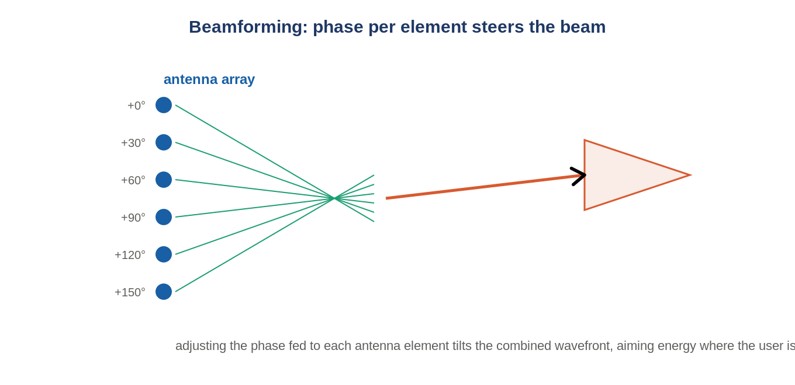
Figure: Phasing each element steers the combined beam toward the user.
Adjusting the phase fed to each element steers the combined wavefront toward a user (beamforming); many branches doing this is massive MIMO. Beamforming gain is ~+12 dB (B1/B3/B41, 12-element arrays) or ~+6 dB (B8/B28, 6-element).

5. Calibration and TDD
Beamforming needs the branches phase/amplitude aligned — hence the calibration loop above. Mid-band AAUs are mostly TDD (the duplexer becomes a switch), so timing and gated measurement matter.

6. Self-check
- What does an AAU integrate that an RRH does not?
- How does one DPD linearize many PAs?
- Why must the CAL switches be absorptive with high isolation?
- Beamforming gain: B1/B3 vs B8/B28?
Answers
1. The antenna array + per-element chains in one unit.
2. Couplers + a switch matrix route one branch at a time to a shared observation Rx feeding the DPD.
3. So unused paths are cleanly terminated and don't leak/reflect into the measurement.
4. ~+12 dB vs ~+6 dB (12- vs 6-element arrays).

Takeaways
- AAU = FHGW (digital) + Mid-board + RFFE; many Module-3 chains + antenna array.
- A single shared DPD works via couplers + switch matrix + one observation receiver (TX/RX/OB CAL).
Next — Module 10: lab and measurement practice.

