PARALLEL WIRELESS · RCT — STUDY GUIDE
Reference
Band Plan & Front-End Components

Mentor's note: Every module talks about 'the PA', 'the filter', 'the switch'. This names the real parts in your AAU and the bands they serve, from the schematics you shared.
Grounds the whole course in the real hardware: which bands the AAU serves, and the actual front-end parts that implement each chain.

1. The band plan
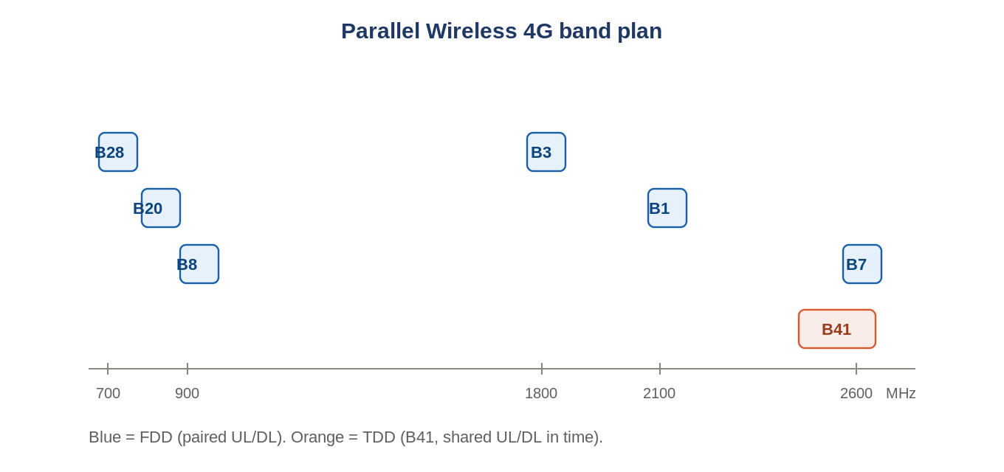
Figure: The bands the platform serves; B41 is TDD, the rest FDD.
Band | Rough freq | Duplex
B28 | ~700 MHz | FDD
B20 | ~800 MHz | FDD
B8 | ~900 MHz | FDD
B3 | ~1800 MHz | FDD
B1 / B4 | ~2100 MHz | FDD
B7 | ~2600 MHz | FDD
B41 | 2496-2690 MHz | TDD
FDD bands use paired uplink/downlink frequencies (a duplexer separates them). B41 is TDD: uplink and downlink share the frequency in alternating time slots (a switch, and gated measurements).

2. The board split
Block | Role
FHGW (RFSoC) | digital: DUC/DDC, power scaling, CFR, DPD, DAC/ADC; the brains
Mid-board | filtering, splitting/combining, calibration coupling between FHGW and RFFE
RFFE (RF front end) | the high-power analog: PAs, LNAs, switches, circulators, antenna feed

3. Front-end components you will meet
Component | What it does
Doherty PA (carrier + peaking) | high-efficiency PA: a main amplifier plus a peaking amplifier that engages on peaks
Driver / MMIC | pre-amplifier stages feeding the PA
Circulator | routes Tx out to the antenna and Rx in to the LNA; isolates reflections
SAW / BPF filters | band selection and rejection (F0180, F1490, BFCN-xxxx, etc.)
Phase shifter (PE44820DS) | 0-360 deg phase control per element - the knob for beamforming
PIN-diode switches (SPDT/SP4T) | route paths (BGS12P2L6, PE42420, PE42445); must be absorptive, >40 dB isolation
Directional couplers (10/20/25 dB) | tap a small sample for power detection and DPD observation
RF power detector (LT5581) | measures power for monitoring/leveling
Balun / pads / V-ATT / term | single-to-differential, fixed/variable attenuation, 50 ohm termination
Why Doherty matters
A Doherty PA keeps efficiency high across a wide power range by adding a 'peaking' amplifier only when the signal peaks demand it - directly relevant to the efficiency work in Module 11.

4. Antenna arrays
Sub-array layouts differ by band group: a 4-2-2-4 element arrangement (12 elements, 4 columns) for B1/B3/B41, and 3-3 (6 elements, 2 columns) for B8/B20/B28 - which is why beamforming gain is higher (~+12 dB) on the former.

