**IBM Netezza Use Case**

Team Name: Code Breakers

Sadhana Edukulla Class ID: 17

Pardha Saradhi Koye Class ID: 40

Koushik Nallani Class ID: 48

Nithin Sai Peram Class ID: 50

|  |  |  |  |  |  |  |
| --- | --- | --- | --- | --- | --- | --- |
| **Improving Performance of Big Data Queries** | | | | | | |
|  |  |  |  |  |  |  |
| **Setup** |  |  |  |  |  |  |
| Choose your favorite Database Management System (e.g. mySQL) | | | | | | |
| Create a database with several tables containing various table relations. | | | | | | |
| Insert a significant amount of data into the tables. | | | | | | |
|  |  |  |  |  |  |  |
| **Challenge** |  |  |  |  |  |  |
| Write queries involving multiple tables (i.e. using JOINs) to retrieve filtered rows and aggregated data from the tables. | | | | | | |
| Show how table design and predicate criteria can impact performance. | | | | | | |
| i.e. |  |  |  |  |  |  |
| Modify attributes so that query results are the same, but query performance is different. | | | | | | |
| Show timings comparing better/worse performance depending on implemention of different attributes. | | | | | | |
| Examples of attributes that affect query performance: | | | | | | |
| - Table definition (e.g. PK/FK, data types, column sizes) | | | | | | |
| - Query predicates (WHERE clause criteria) | | | | | | |
| - JOIN order | | | | | | |
| - Table distribution or indexing or partitioning (if the product allows) | | | | | | |

**Solution:**

We have created four tables EMPLOYEE, DEPARTMENTS, JOBS and JOB_HISTORY to run different queries on individual tables and multiple tables. We are using oracle database to store data.

**Creation of Employees Table:**

CREATE TABLE "EMPLOYEES"

( "EMPLOYEE_ID" NUMBER(6,0),

"FIRST_NAME" VARCHAR2(20),

"LAST_NAME" VARCHAR2(25) CONSTRAINT "EMP_LAST_NAME_NN" NOT NULL ENABLE,

"EMAIL" VARCHAR2(25) CONSTRAINT "EMP_EMAIL_NN" NOT NULL ENABLE,

"PHONE_NUMBER" VARCHAR2(20),

"HIRE_DATE" DATE CONSTRAINT "EMP_HIRE_DATE_NN" NOT NULL ENABLE,

"JOB_ID" VARCHAR2(10) CONSTRAINT "EMP_JOB_NN" NOT NULL ENABLE,

"SALARY" NUMBER(8,2),

"COMMISSION_PCT" NUMBER(2,2),

"MANAGER_ID" NUMBER(6,0),

"DEPARTMENT_ID" NUMBER(4,0),

CONSTRAINT "EMP_SALARY_MIN" CHECK (salary > 0) ENABLE,

CONSTRAINT "EMP_EMAIL_UK" UNIQUE ("EMAIL") ENABLE,

CONSTRAINT "EMP_EMP_ID_PK" PRIMARY KEY ("EMPLOYEE_ID") ENABLE,

CONSTRAINT "EMP_DEPT_FK" FOREIGN KEY ("DEPARTMENT_ID")

REFERENCES "DEPARTMENTS" ("DEPARTMENT_ID") ENABLE,

CONSTRAINT "EMP_JOB_FK" FOREIGN KEY ("JOB_ID")

REFERENCES "JOBS" ("JOB_ID") ENABLE,

CONSTRAINT "EMP_MANAGER_FK" FOREIGN KEY ("MANAGER_ID")

REFERENCES "EMPLOYEES" ("EMPLOYEE_ID") ENABLE

);

**Employees Schema:**

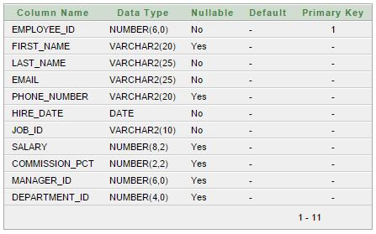

**Creation of Departments Table:**

CREATE TABLE "DEPARTMENTS"

( "DEPARTMENT_ID" NUMBER(4,0),

"DEPARTMENT_NAME" VARCHAR2(30) CONSTRAINT "DEPT_NAME_NN" NOT NULL ENABLE,

"MANAGER_ID" NUMBER(6,0),

"LOCATION_ID" NUMBER(4,0),

CONSTRAINT "DEPT_ID_PK" PRIMARY KEY ("DEPARTMENT_ID") ENABLE,

CONSTRAINT "DEPT_LOC_FK" FOREIGN KEY ("LOCATION_ID")

REFERENCES "LOCATIONS" ("LOCATION_ID") ENABLE,

CONSTRAINT "DEPT_MGR_FK" FOREIGN KEY ("MANAGER_ID")

REFERENCES "EMPLOYEES" ("EMPLOYEE_ID") ENABLE

);

**Departments Schema:**

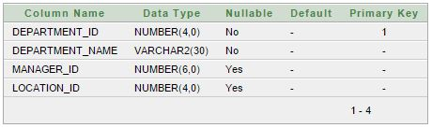

**Creation of Jobs Table:**

CREATE TABLE "JOBS"

( "JOB_ID" VARCHAR2(10),

"JOB_TITLE" VARCHAR2(35) CONSTRAINT "JOB_TITLE_NN" NOT NULL ENABLE,

"MIN_SALARY" NUMBER(6,0),

"MAX_SALARY" NUMBER(6,0),

CONSTRAINT "JOB_ID_PK" PRIMARY KEY ("JOB_ID") ENABLE

);

**Jobs Schema:**

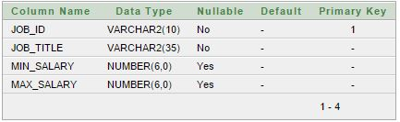

**Creation of Job_History Table:**

CREATE TABLE "JOB_HISTORY"

( "EMPLOYEE_ID" NUMBER(6,0) CONSTRAINT "JHIST_EMPLOYEE_NN" NOT NULL ENABLE,

"START_DATE" DATE CONSTRAINT "JHIST_START_DATE_NN" NOT NULL ENABLE,

"END_DATE" DATE CONSTRAINT "JHIST_END_DATE_NN" NOT NULL ENABLE,

"JOB_ID" VARCHAR2(10) CONSTRAINT "JHIST_JOB_NN" NOT NULL ENABLE,

"DEPARTMENT_ID" NUMBER(4,0),

CONSTRAINT "JHIST_DATE_INTERVAL" CHECK (end_date > start_date) ENABLE,

CONSTRAINT "JHIST_EMP_ID_ST_DATE_PK" PRIMARY KEY ("EMPLOYEE_ID", "START_DATE") ENABLE,

CONSTRAINT "JHIST_JOB_FK" FOREIGN KEY ("JOB_ID")

REFERENCES "JOBS" ("JOB_ID") ENABLE,

CONSTRAINT "JHIST_EMP_FK" FOREIGN KEY ("EMPLOYEE_ID")

REFERENCES "EMPLOYEES" ("EMPLOYEE_ID") ENABLE,

CONSTRAINT "JHIST_DEPT_FK" FOREIGN KEY ("DEPARTMENT_ID")

REFERENCES "DEPARTMENTS" ("DEPARTMENT_ID") ENABLE

);

**Jobs_History Schema:**

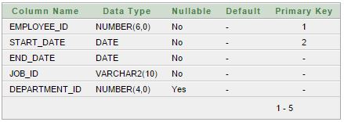

**Queries:**

Below are some of the normal and optimized queries that have different execution times

1. Get department id and name which contains at least one employee using join

**Normal query**

SELECT DISTINCT D.DEPARTMENT_ID,D.DEPARTMENT_NAME FROM DEPARTMENTS D,EMPLOYEES E WHERE E.DEPARTMENT_ID = D.DEPARTMENT_ID ORDER BY D.DEPARTMENT_ID;

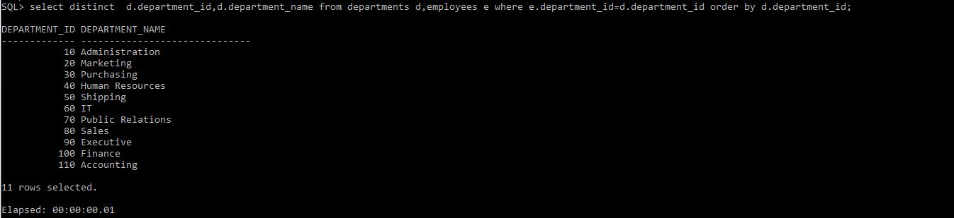

Above query takes 1ms to output result.

**Optimized query**

SELECT D.DEPARTMENT_ID, D.DEPARTMENT_NAME FROM DEPARTMENTS D WHERE EXISTS (SELECT 1 FROM EMPLOYEES E WHERE E.DEPARTMENT_ID = D.DEPARTMENT_ID) ORDER BY D.DEPARTMENT_ID;

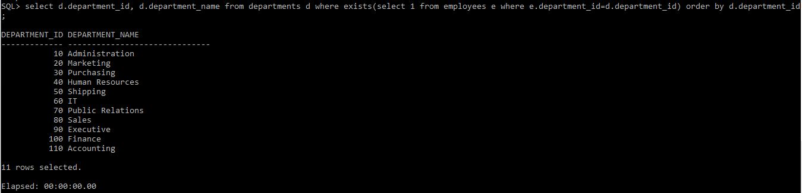

Above query takes 0ms to output result.

1. Optimizing by using different join orders:

**Normal query**

SELECT E.FIRST_NAME, E.LAST_NAME, J.START_DATE, J.END_DATE FROM JOB_HISTORY J LEFT OUTER JOIN EMPLOYEES E ON E.EMPLOYEE_ID = J.EMPLOYEE_ID;

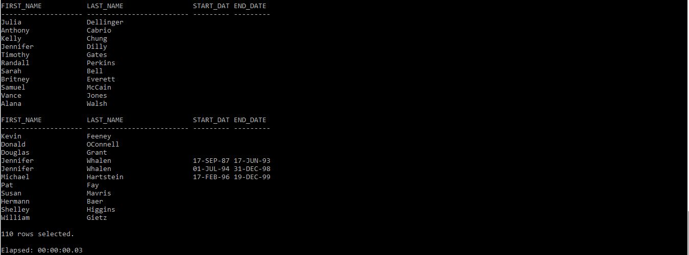

**Optimized query:**

SELECT E.FIRST_NAME, E.LAST_NAME, J.START_DATE, J.END_DATE FROM EMPLOYEES E LEFT OUTER JOIN JOB_HISTORY J ON E.EMPLOYEE_ID = J.EMPLOYEE_ID;

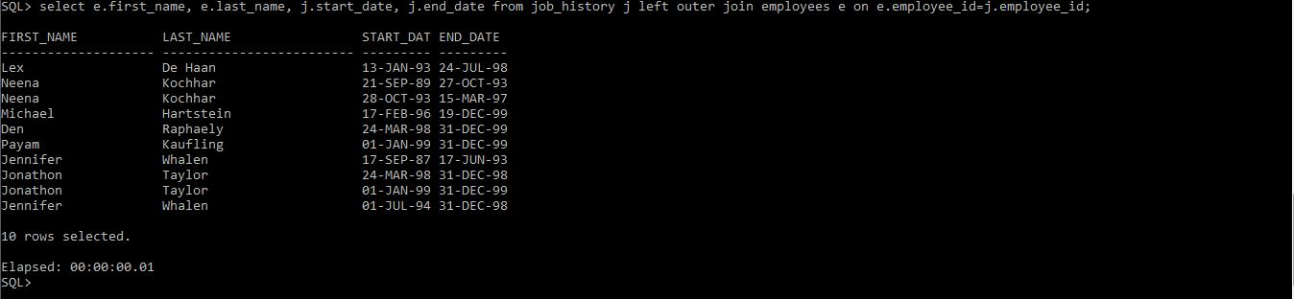

1. Executing all in one query:

**Normal query**

SELECT COUNT (*) FROM employees WHERE salary < 5000;

SELECT COUNT (*) FROM employees WHERE salary BETWEEN 5000 AND 15000;

SELECT COUNT (*) FROM employees WHERE salary < 15000;

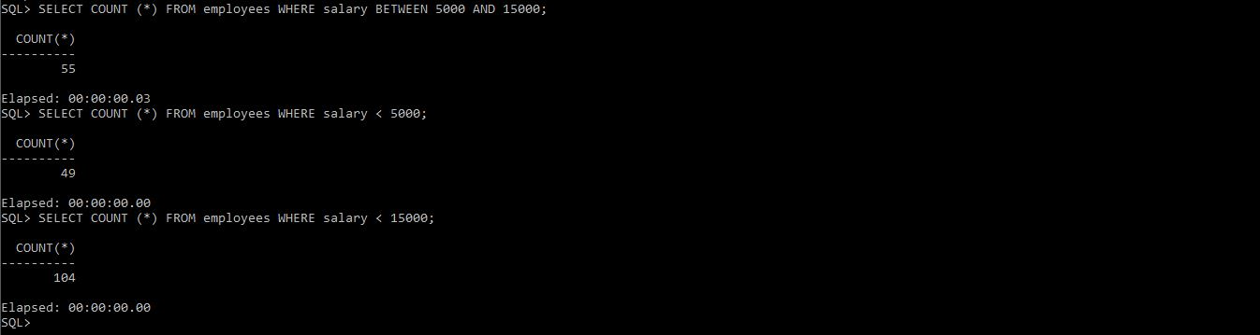

**Advanced query**

SELECT COUNT (CASE WHEN salary < 5000

THEN 1 ELSE null END) count1,

COUNT (CASE WHEN salary BETWEEN 5001 AND 15000

THEN 1 ELSE null END) count2,

COUNT (CASE WHEN salary > 15000

THEN 1 ELSE null END) count3

FROM employees;

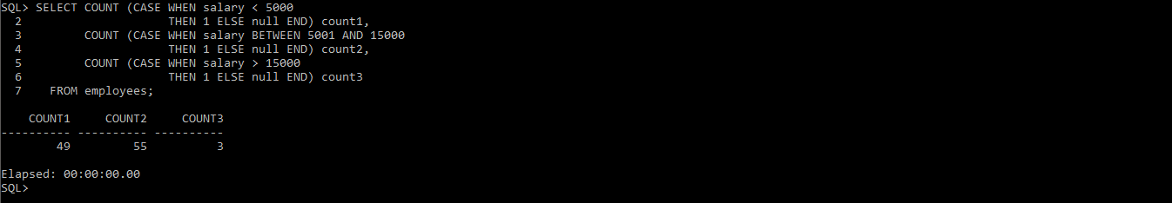

1. Get second highest salary from employees table

Normal query

SELECT DISTINCT(SALARY) FROM EMPLOYEES E1 WHERE (1) = (SELECT COUNT (DISTINCT(E2.SALARY))FROM EMPLOYEES E2 WHERE E2.SALARY > E1.SALARY);



Optimized query

SELECT MAX(SALARY) FROM EMPLOYEES WHERE SALARY NOT IN (SELECT MAX(SALARY) FROM EMPLOYEES);



1. Aggregate Functions

**Normal Query**

SELECT COUNT(*) NUM_OF_EMP FROM JOBS;

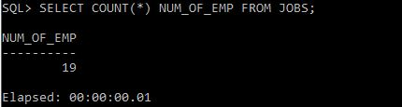

**Optimized Query**

SELECT COUNT(JOB_ID) FROM JOBS;

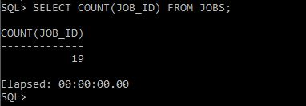

1. Unions example

SELECT job_id FROM jobs UNION SELECT job_id FROM jobs;

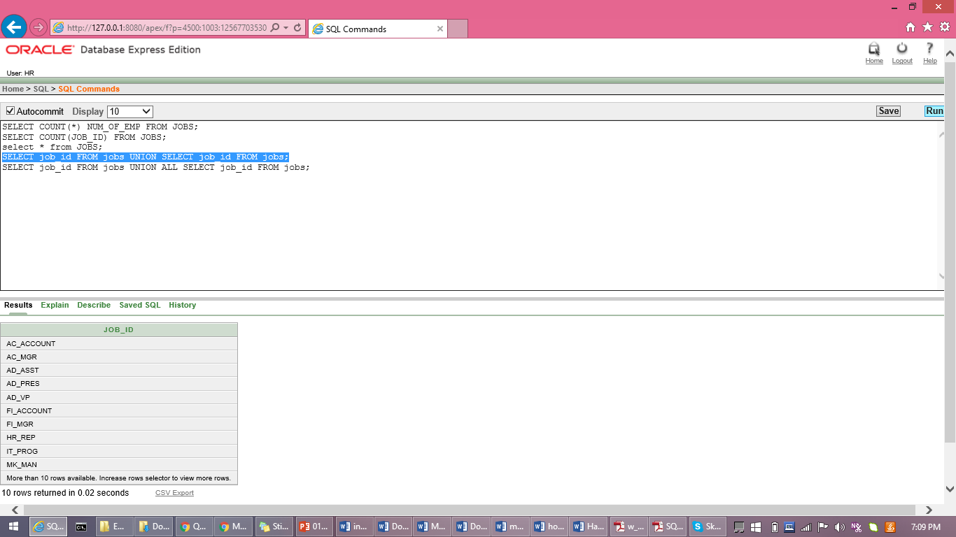

**Optimized query**

SELECT JOB_ID FROM JOBS UNION ALL SELECT JOB_ID FROM JOBS;

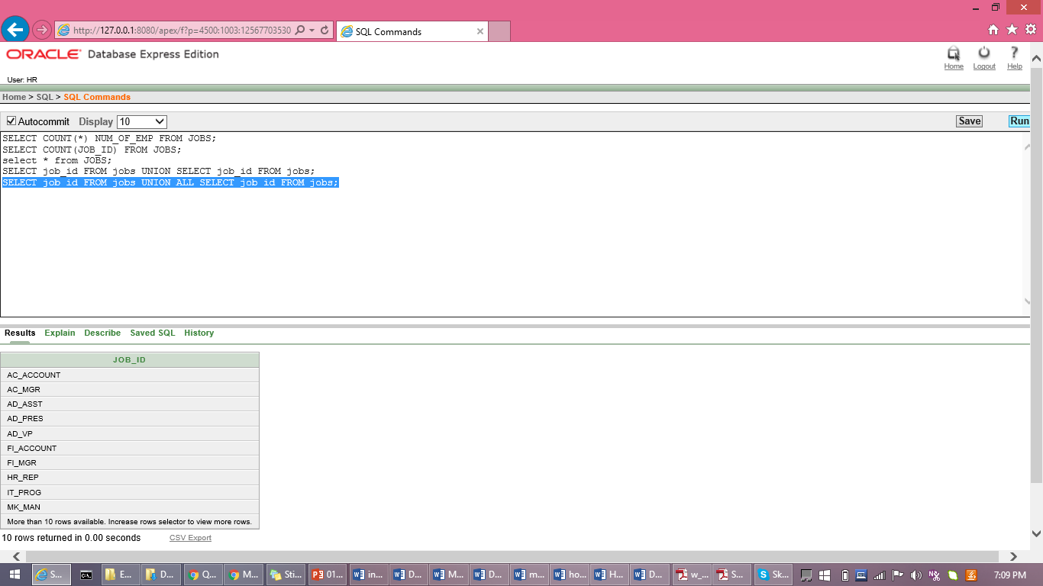

1. Group by command

**Normal query**

SELECT manager_id,job_id,COUNT(*) FROM employees GROUP BY manager_id,job_id;

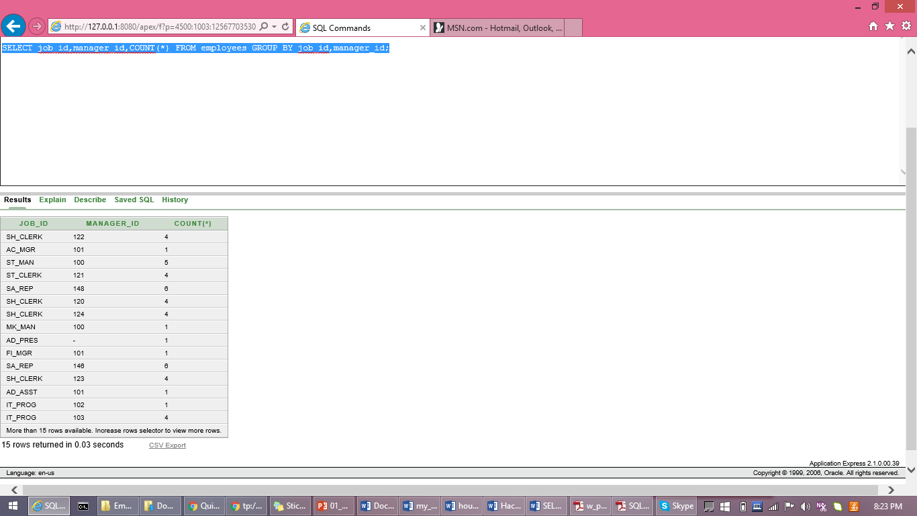

**Optimized query**

SELECT job_id,manager_id,COUNT(*) FROM employees GROUP BY job_id,manager_id;

