GITFLOW LAB - 5
Git | GitHub | VS Code | Branches | Merge | Conflict | Conflict Resolution

Before You Start
Read one step at a time. Each step below follows the supplied Gitflow Lab 5 document and includes the command, purpose, and a screenshot captured from the student's actual Git repository.

Five Simple Words
Repository: Your project stored in Git.
Branch: A separate line of work.
Commit: A saved change in Git.
Push: Send local changes to GitHub.
Merge: Bring changes from one branch into another branch.

Gitflow Used in This Lab
main
|-- develop
|-- feature/login
|-- feature/conflict

Part A - Screenshot-Based Practical (Steps 1-58)
Each step below records the work completed in the student's GitHub repository.

Step 1. Create the GitHub Repository
What you see: GitHub repository: pardheev-dev/ASE-2420090145.
Command: git remote -v
Purpose: GitHub repository: pardheev-dev/ASE-2420090145.
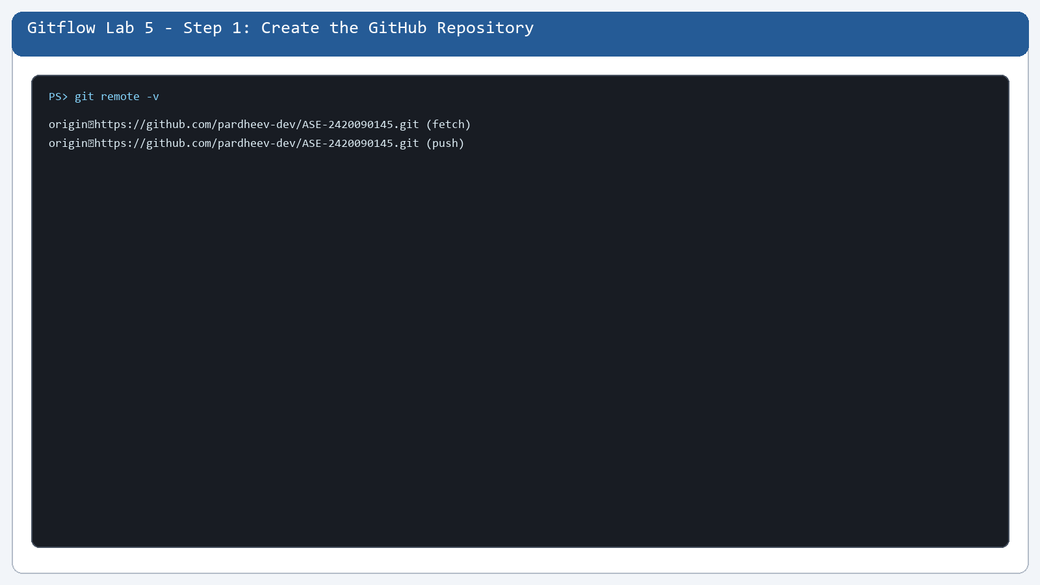

Step 2. Open the New Repository
What you see: HTTPS remote address is visible.
Command: git remote -v
Purpose: HTTPS remote address is visible.
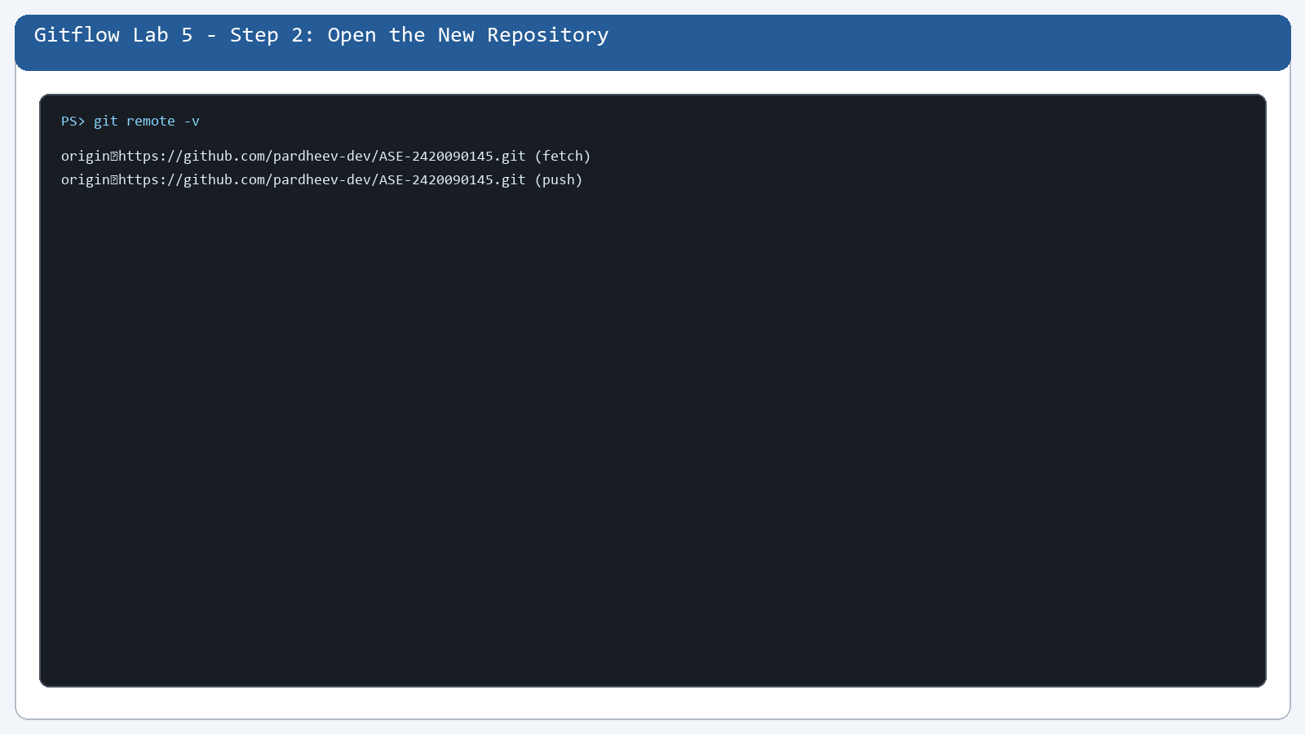

Step 3. Understand the Clone Command
What you see: A clone command copies a GitHub repository.
Command: git remote -v
Purpose: A clone command copies a GitHub repository.
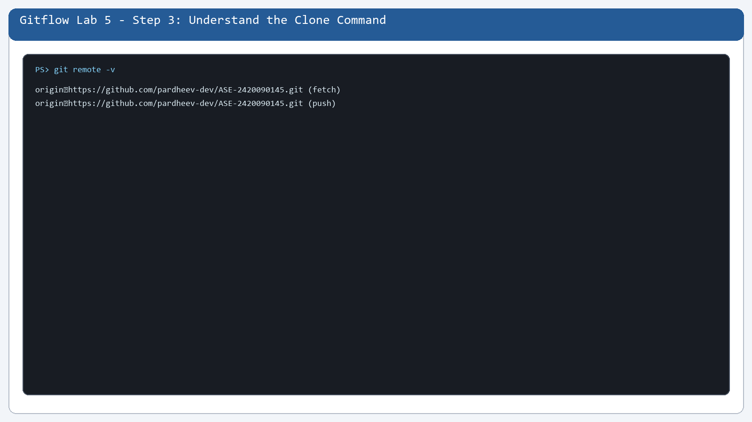

Step 4. Open the Project in VS Code
What you see: The local AES workspace is open.
Command: git status --short --branch
Purpose: The local AES workspace is open.
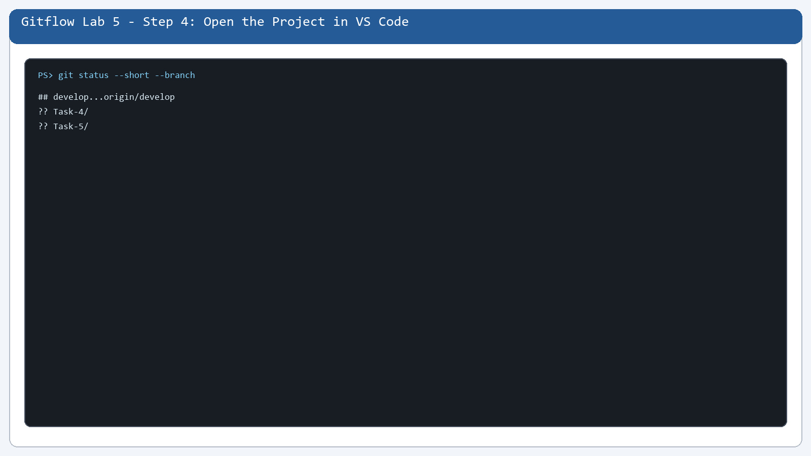

Step 5. Move to the Project Folder
What you see: Git commands run from the project folder.
Command: git status --short --branch
Purpose: Git commands run from the project folder.
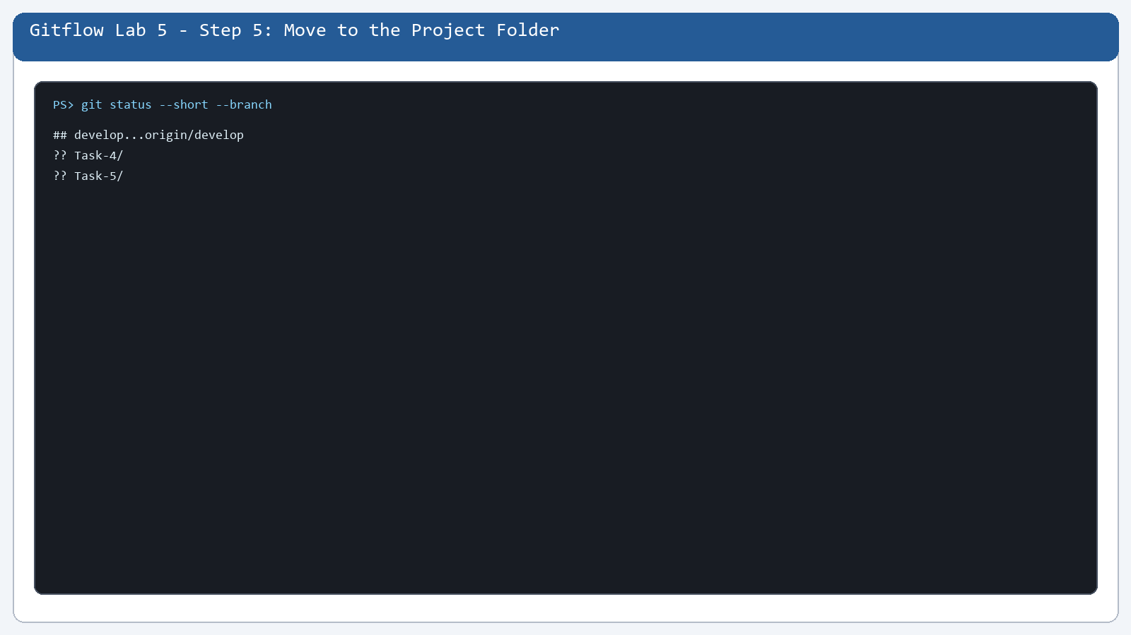

Step 6. Create README.md
What you see: README.md is tracked in the initial commit.
Command: git status
Purpose: README.md is tracked in the initial commit.
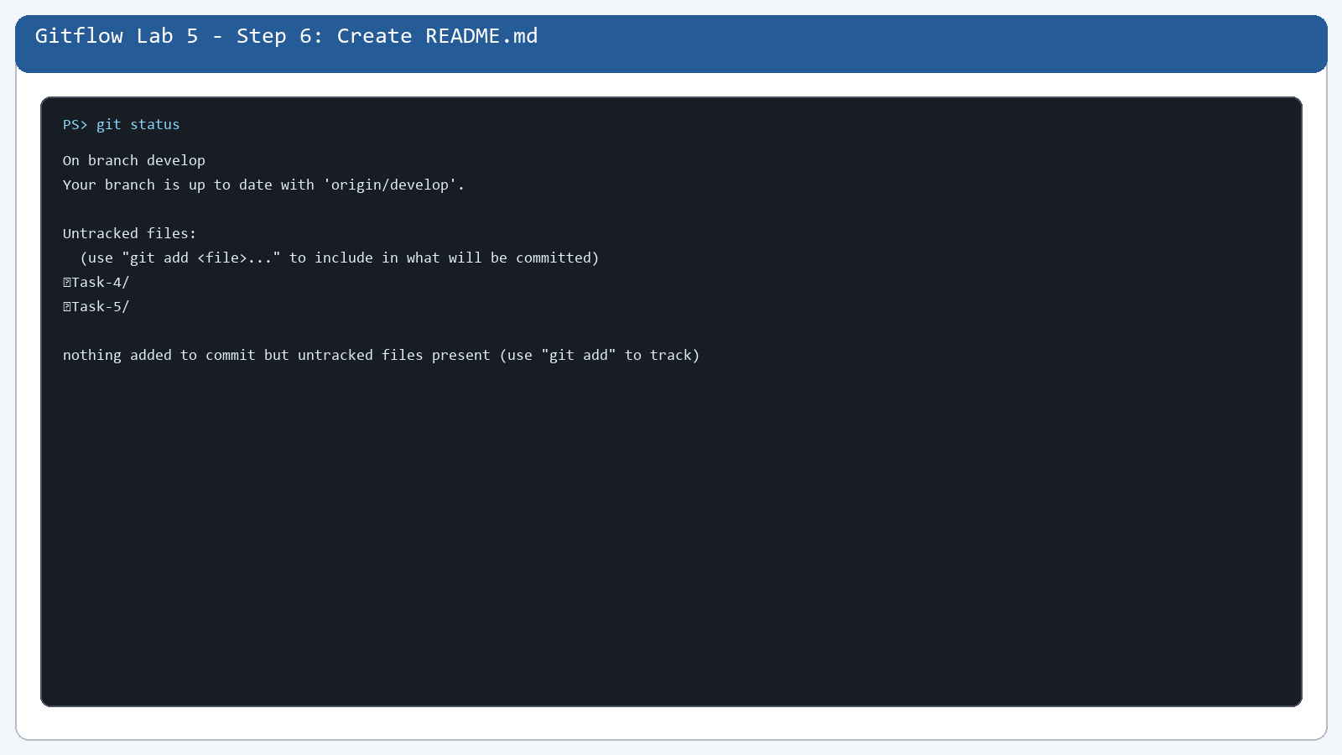

Step 7. Stage README.md
What you see: README.md is staged before the initial commit.
Command: git show --stat --oneline 8e8b558
Purpose: README.md is staged before the initial commit.
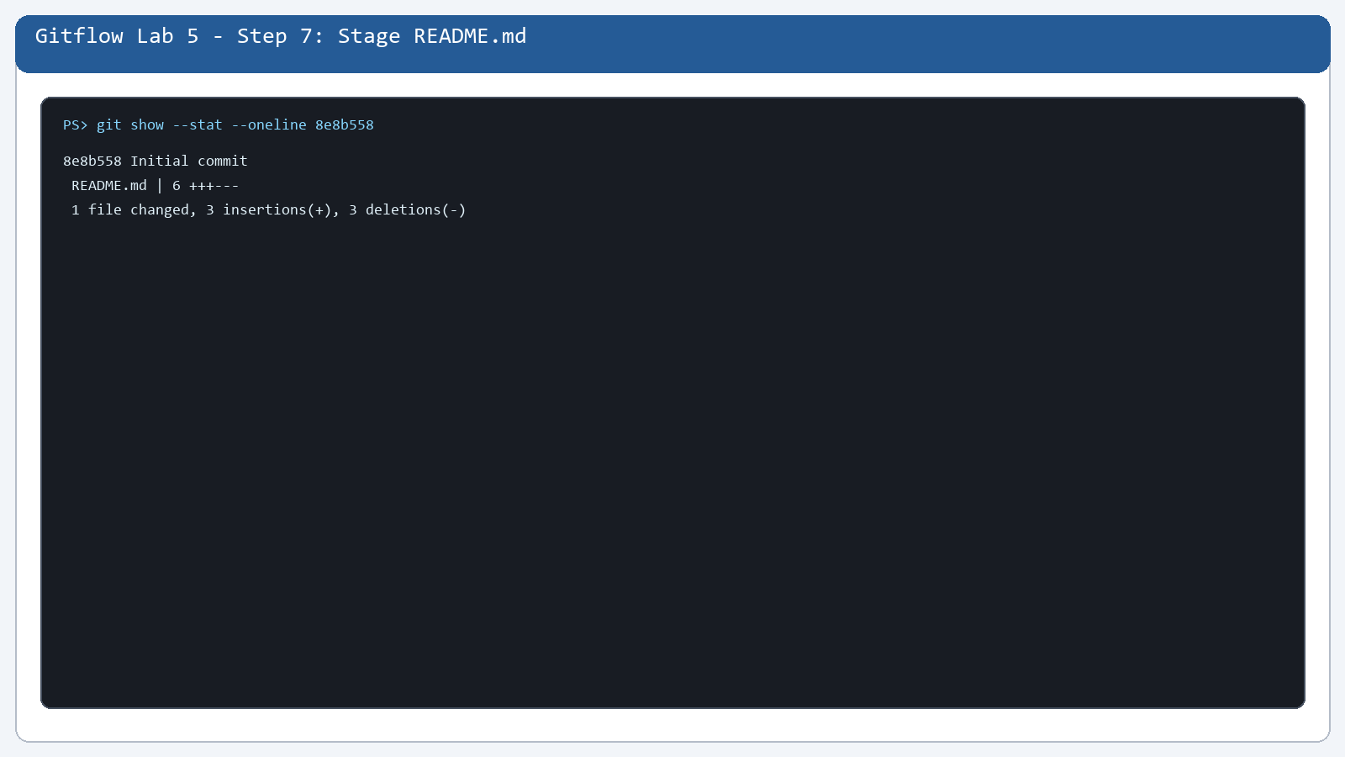

Step 8. Check the Staged File
What you see: The initial README commit is present.
Command: git log --oneline
Purpose: The initial README commit is present.
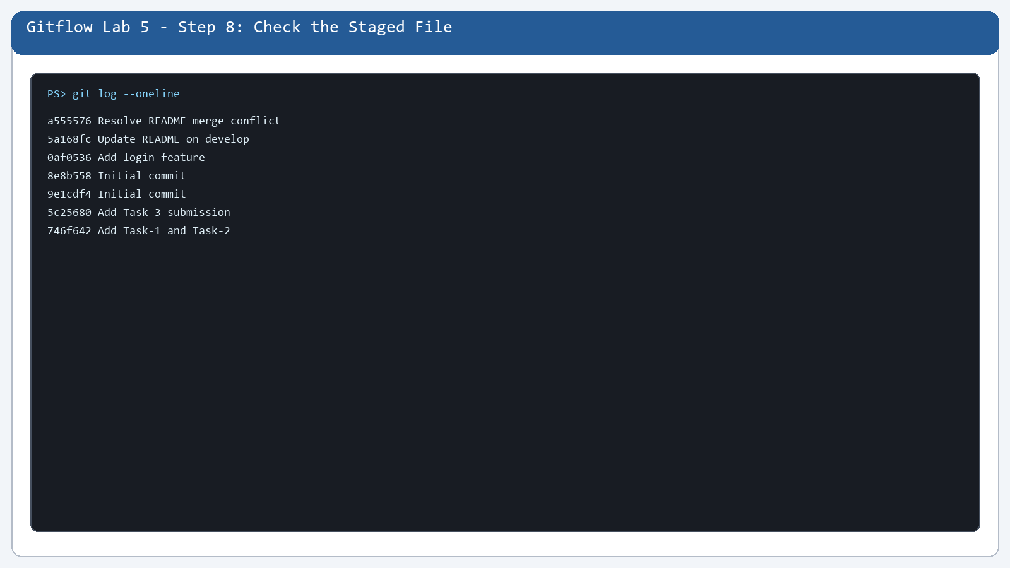

Step 9. Make the Initial Commit
What you see: The first project version is saved.
Command: git show --stat --oneline 8e8b558
Purpose: The first project version is saved.
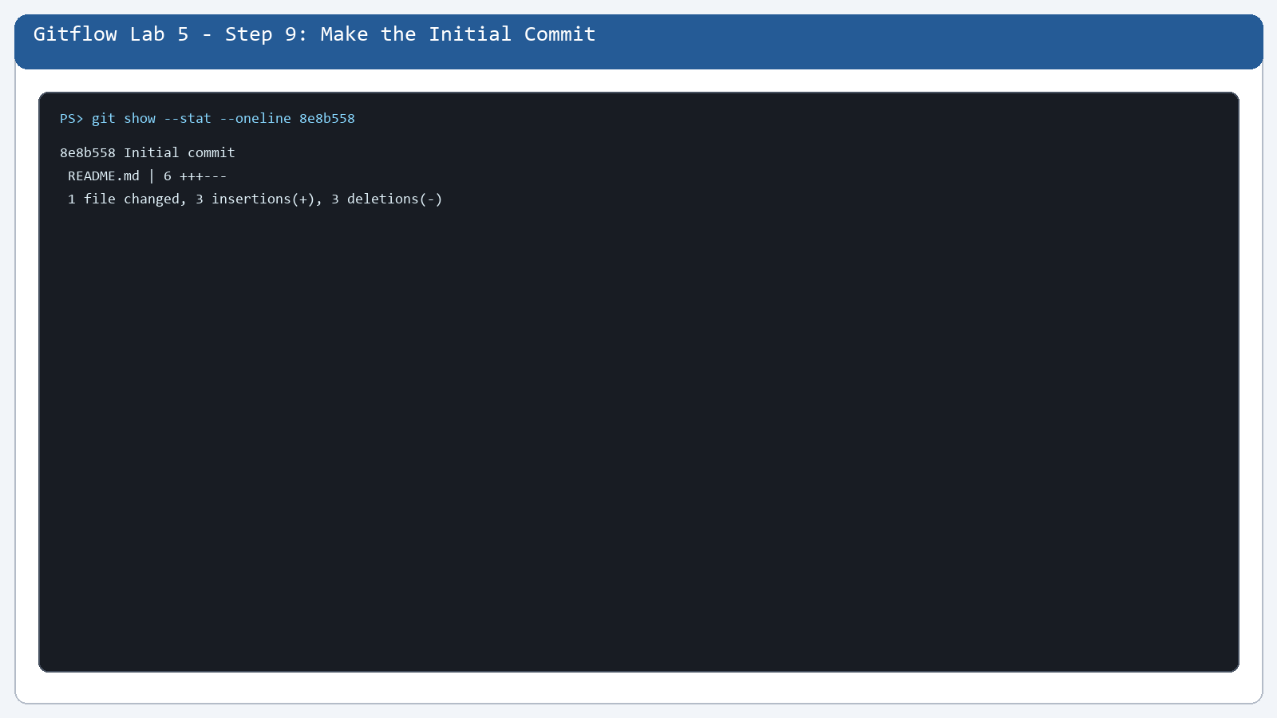

Step 10. Check the Remote Command
What you see: The Git remote configuration is checked.
Command: git remote -v
Purpose: The Git remote configuration is checked.
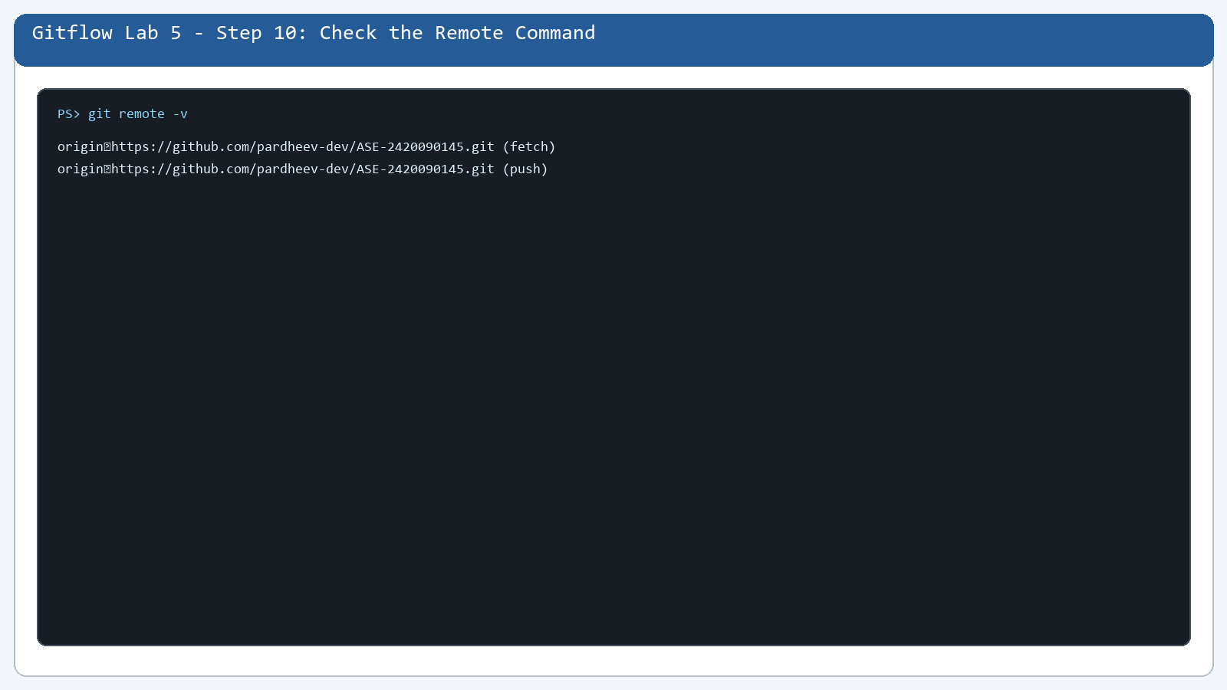

Step 11. Check the GitHub Remote
What you see: origin points to the student's GitHub repository.
Command: git remote -v
Purpose: origin points to the student's GitHub repository.
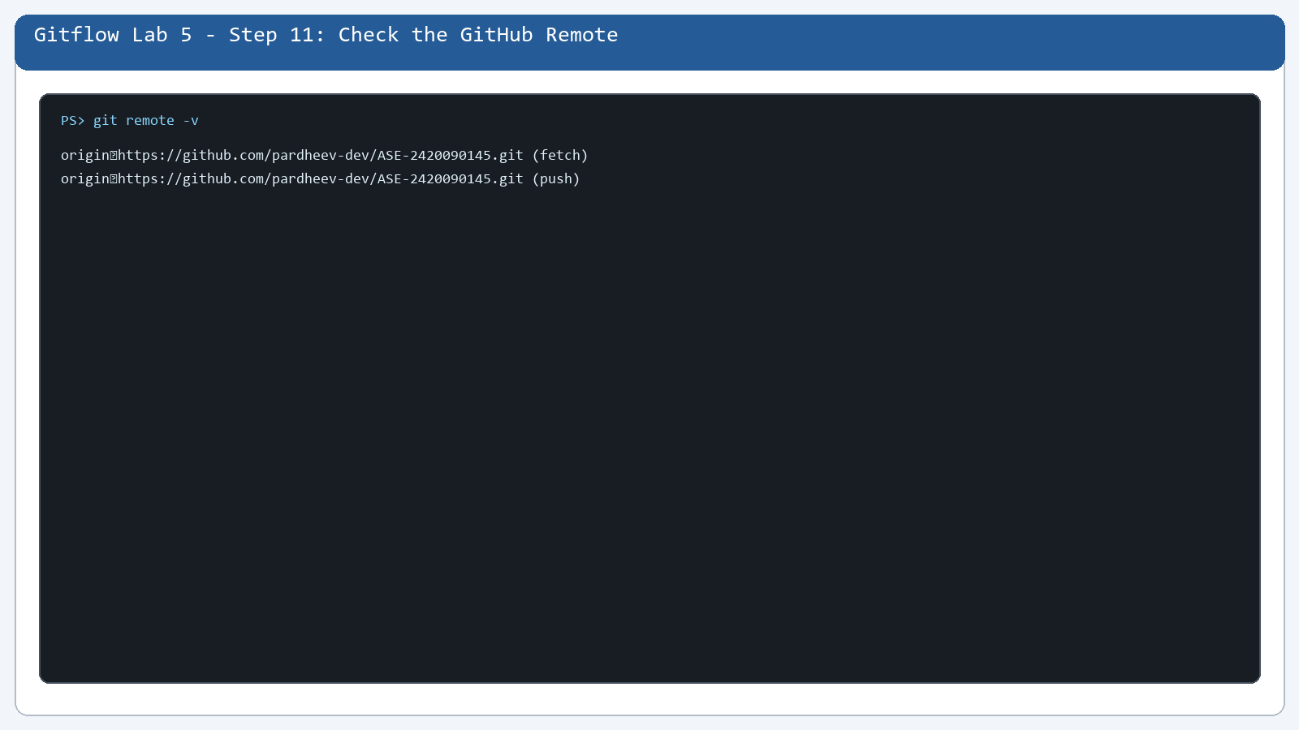

Step 12. Check the Commit History
What you see: The short history is visible.
Command: git log --oneline
Purpose: The short history is visible.
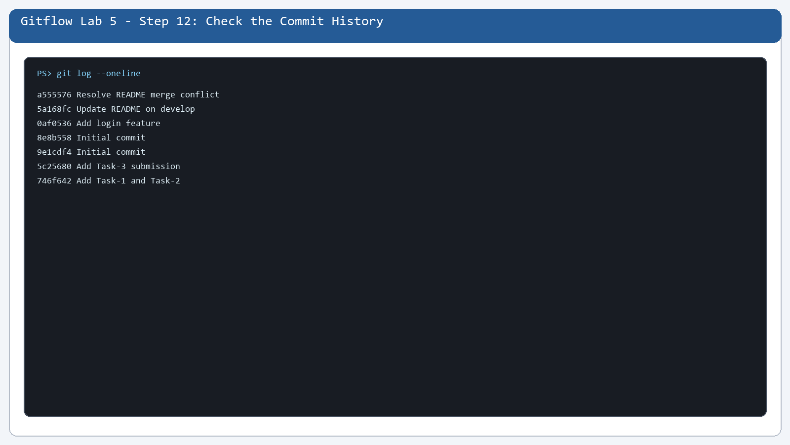

Step 13. Check the Repository on GitHub
What you see: The main branch contains the initial project.
Command: git branch -a
Purpose: The main branch contains the initial project.
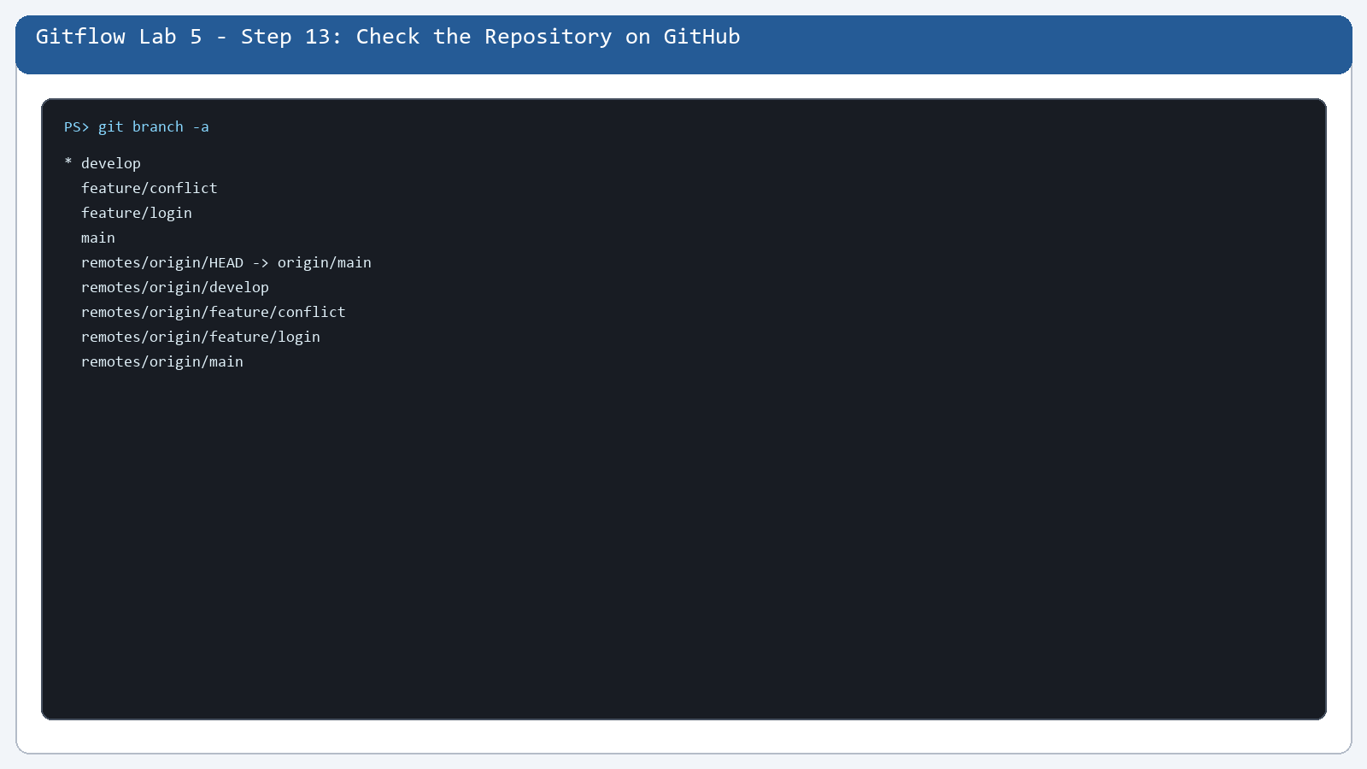

Step 14. Check Git Remote Carefully
What you see: The remote is verified again.
Command: git remote -v
Purpose: The remote is verified again.
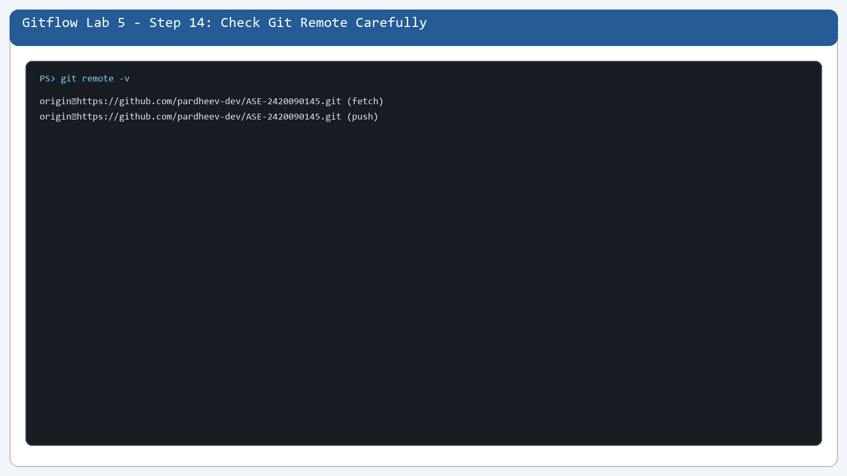

Step 15. Create the develop Branch
What you see: develop is the integration branch.
Command: git branch -avv
Purpose: develop is the integration branch.
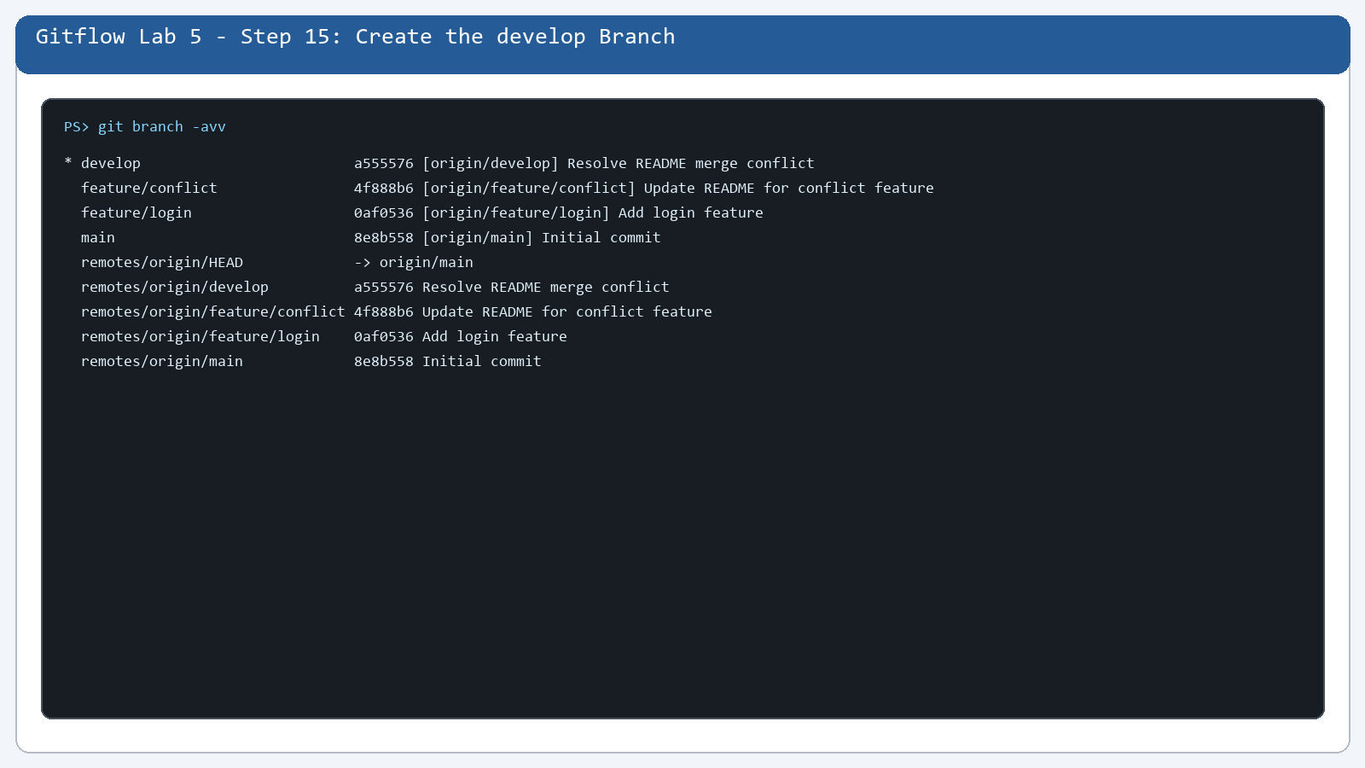

Step 16. Push develop to GitHub
What you see: develop exists on the remote.
Command: git branch -avv
Purpose: develop exists on the remote.
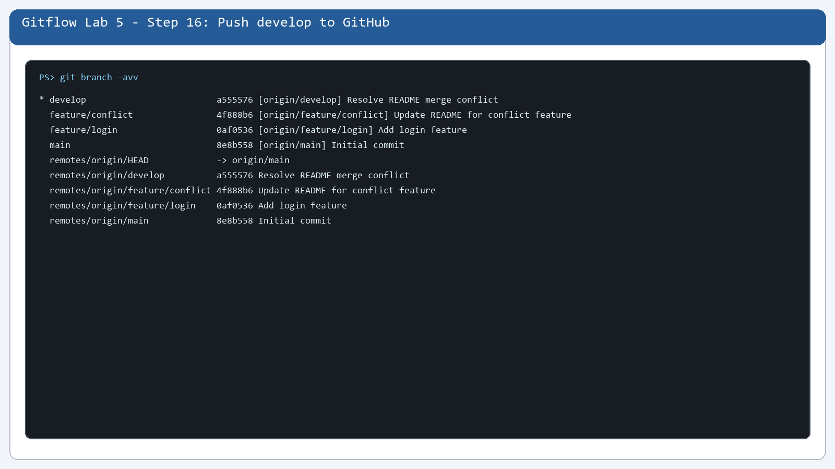

Step 17. Create feature/login
What you see: The login feature branch is created.
Command: git branch -avv
Purpose: The login feature branch is created.
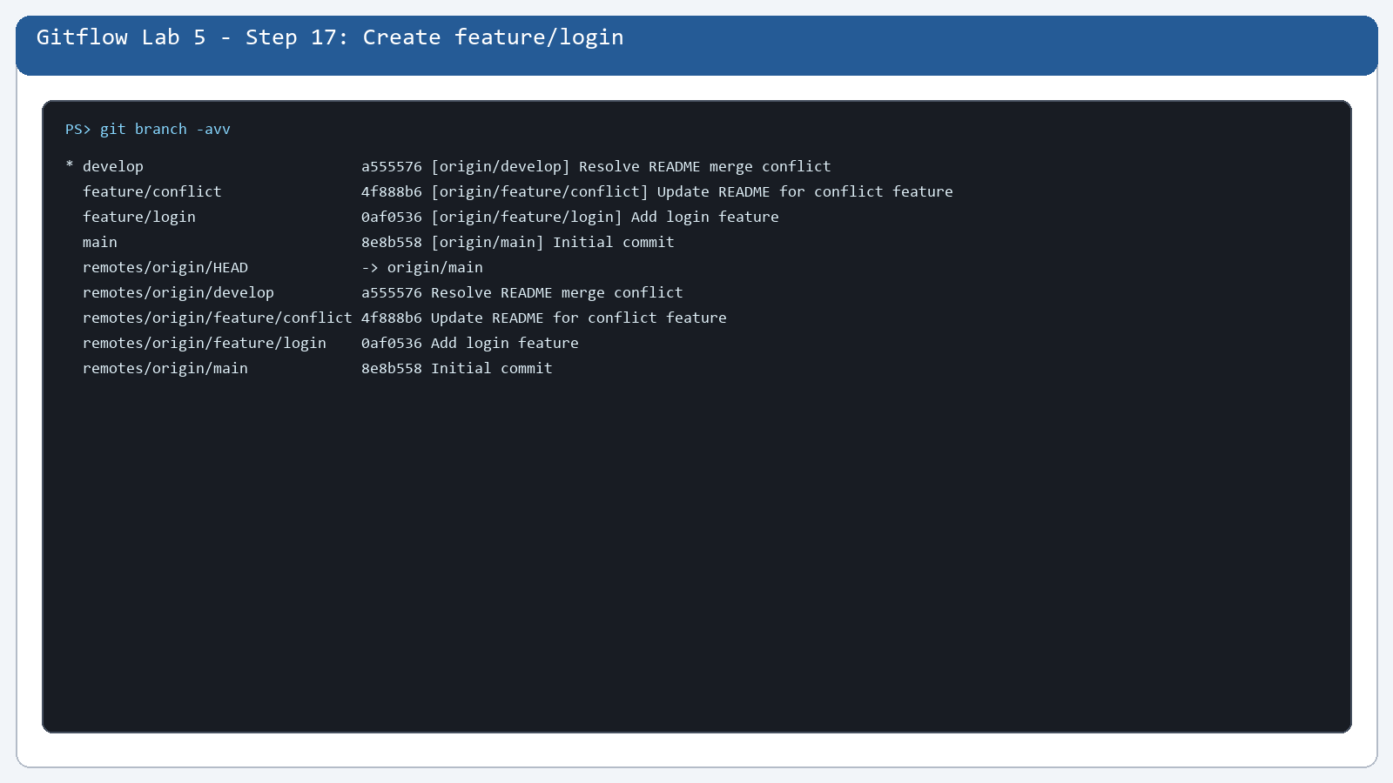

Step 18. Create app.py
What you see: app.py contains the login program.
Command: git show --stat --oneline 0af0536
Purpose: app.py contains the login program.
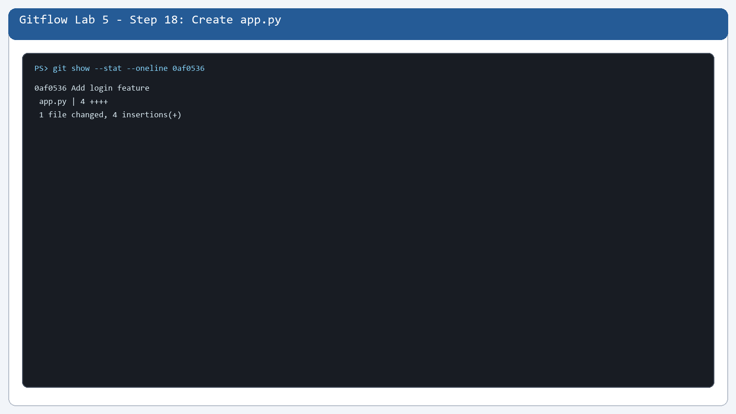

Step 19. Write the Login Program
What you see: The program receives a username.
Command: git show 0af0536:app.py
Purpose: The program receives a username.
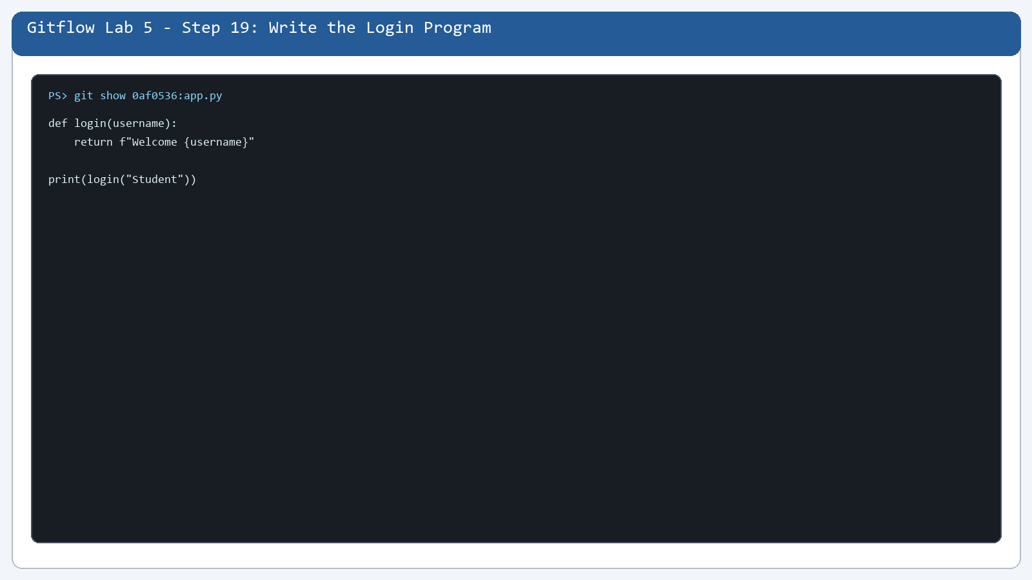

Step 20. Check the Python Command
What you see: Python is used to run the file.
Command: python app.py
Purpose: Python is used to run the file.
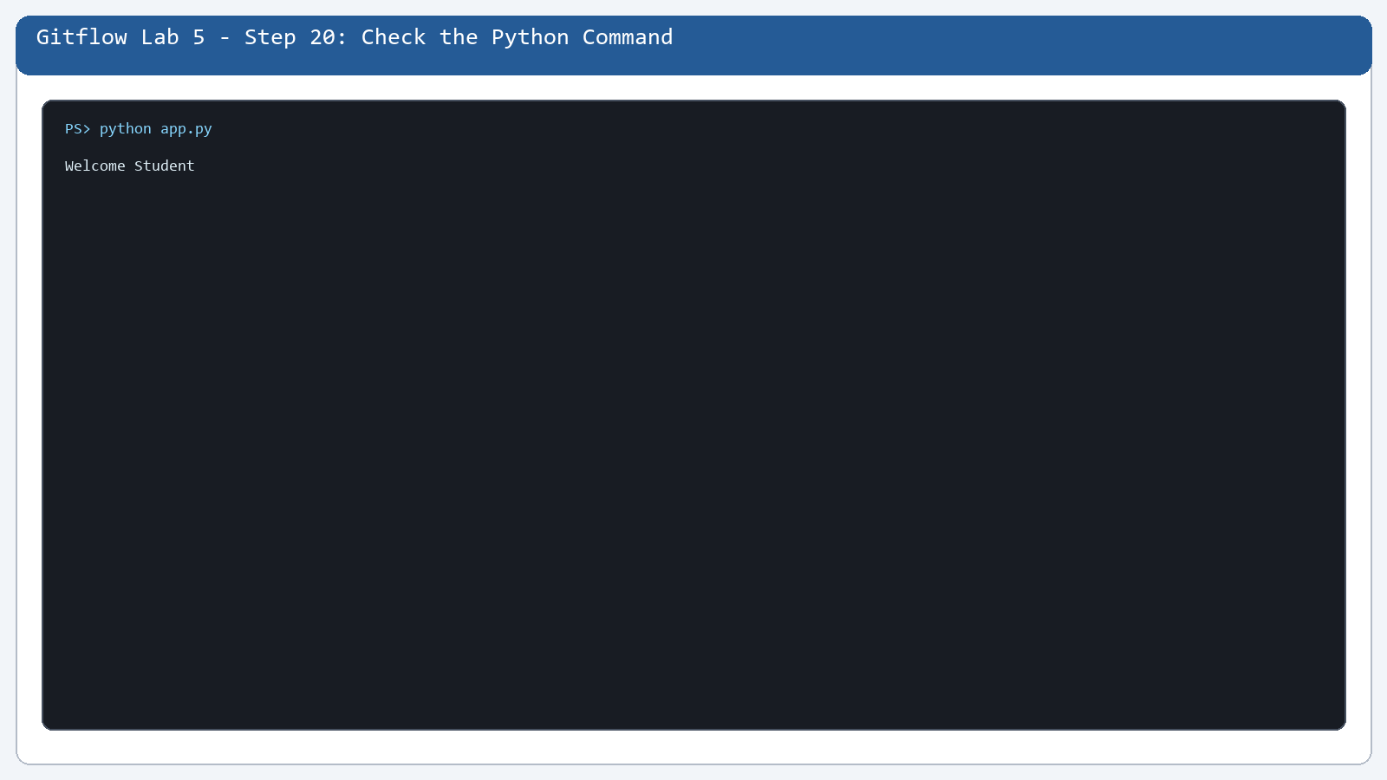

Step 21. Run app.py
What you see: The program prints Welcome Student.
Command: python app.py
Purpose: The program prints Welcome Student.
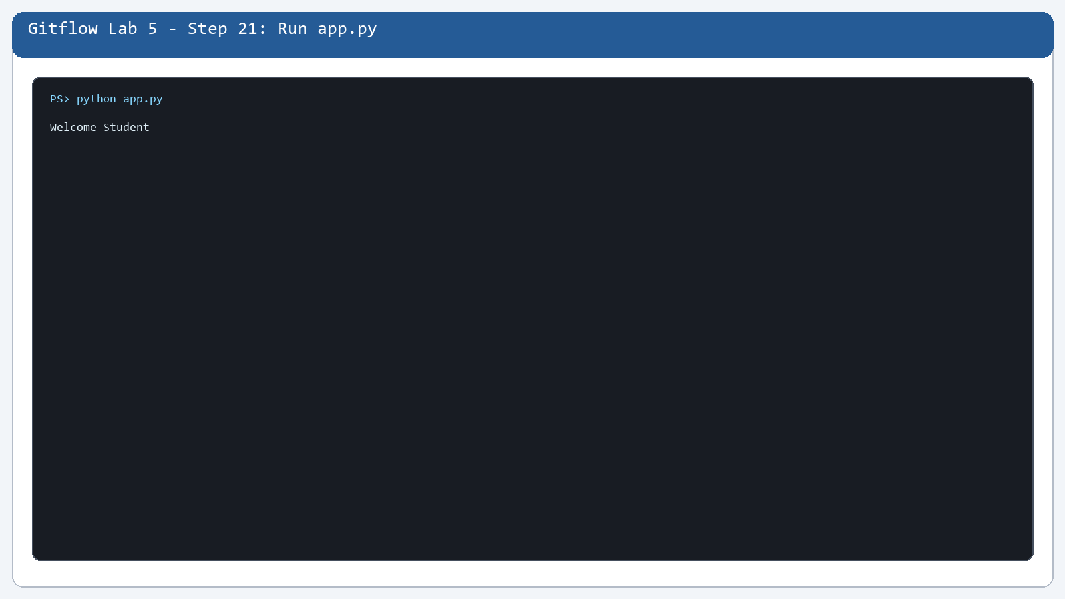

Step 22. Check the New File Again
What you see: The program output and Git state are checked.
Command: git status --short
Purpose: The program output and Git state are checked.
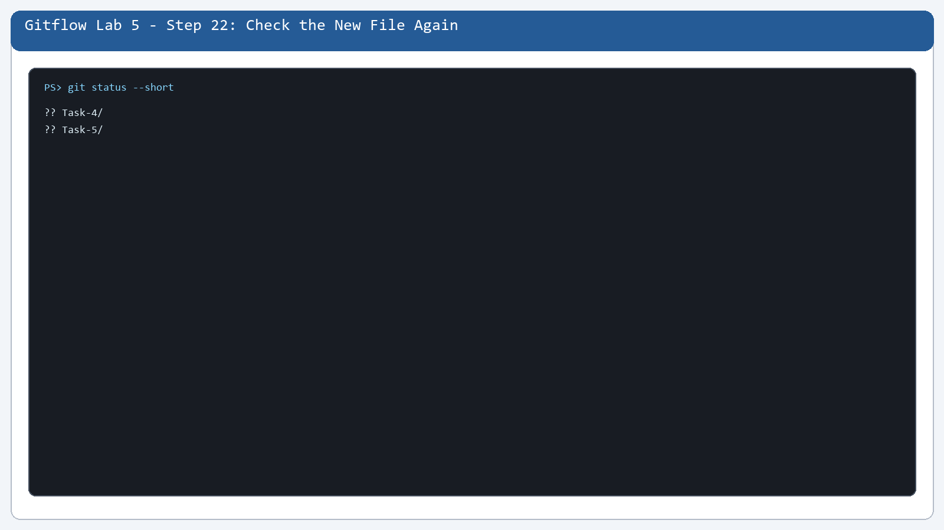

Step 23. Commit the Login Feature
What you see: The login feature is saved.
Command: git show --stat --oneline 0af0536
Purpose: The login feature is saved.
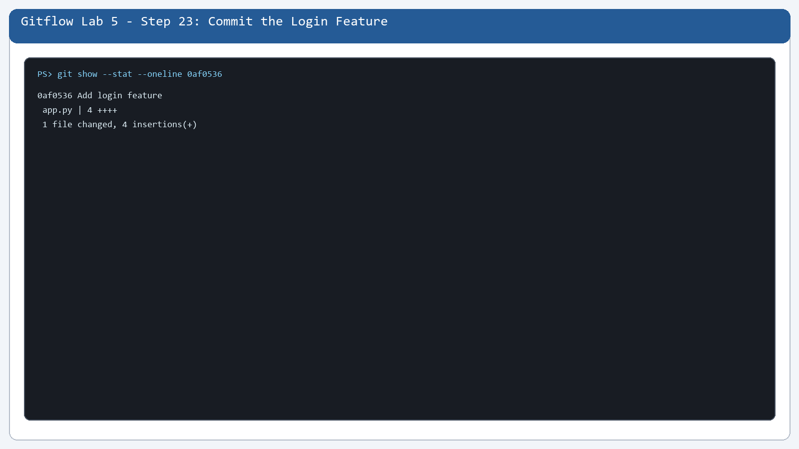

Step 24. Stage app.py
What you see: app.py is included in the feature commit.
Command: git show --stat --oneline 0af0536
Purpose: app.py is included in the feature commit.
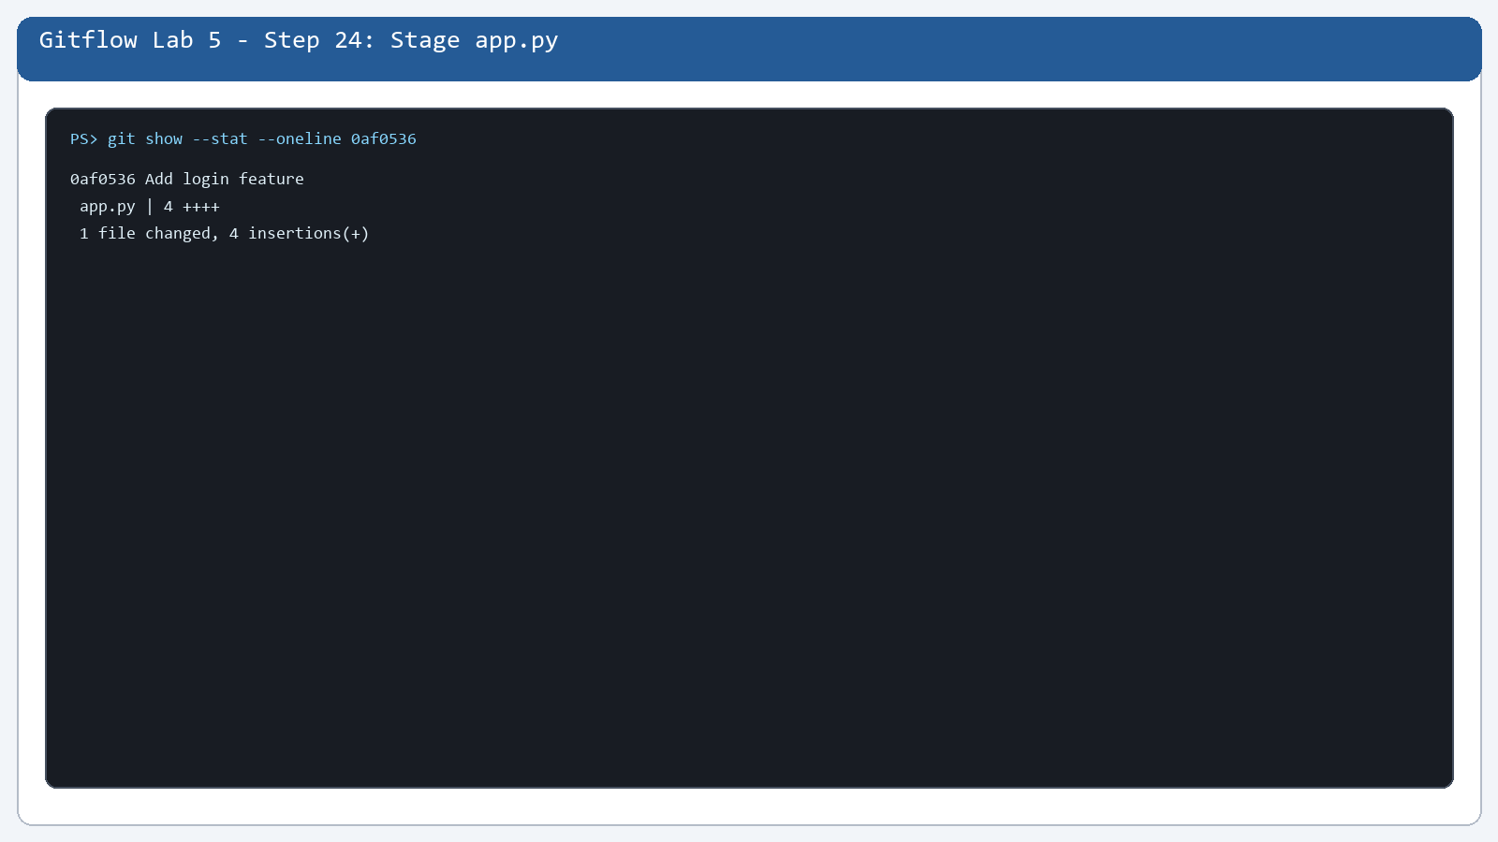

Step 25. Check and Push feature/login
What you see: feature/login is available on GitHub.
Command: git branch -avv
Purpose: feature/login is available on GitHub.
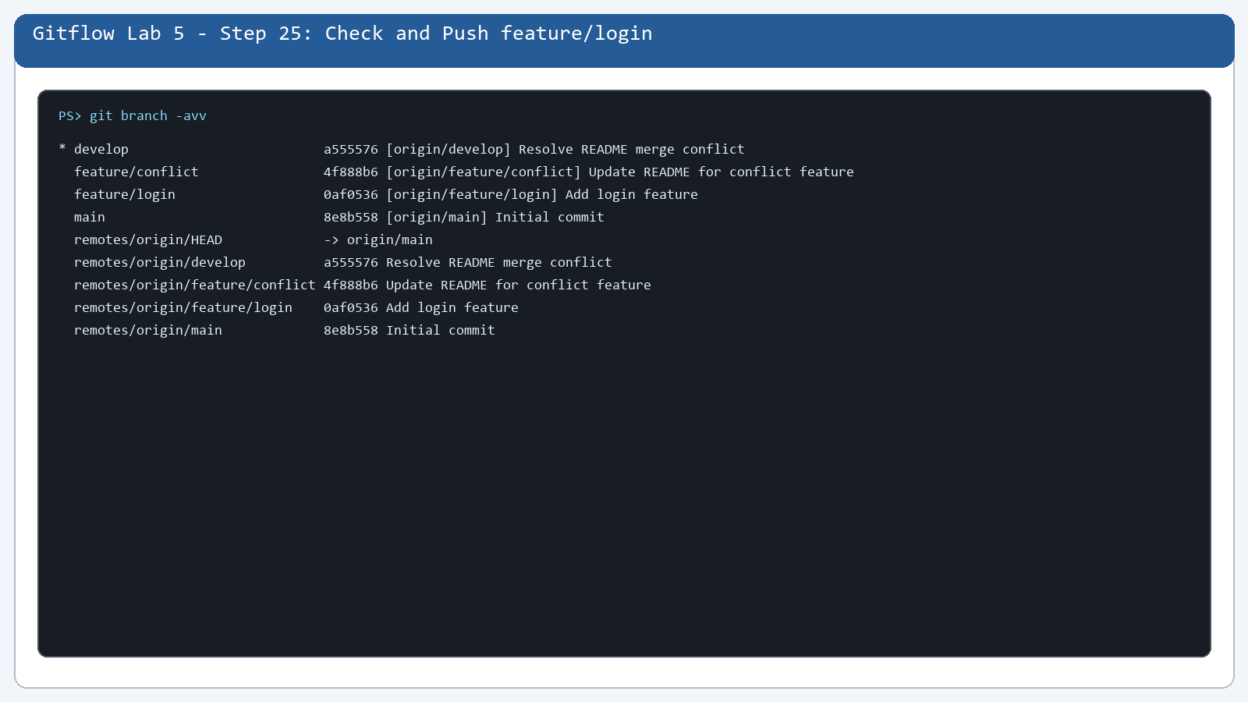

Step 26. See feature/login on GitHub
What you see: The remote feature branch is visible.
Command: git branch -a
Purpose: The remote feature branch is visible.
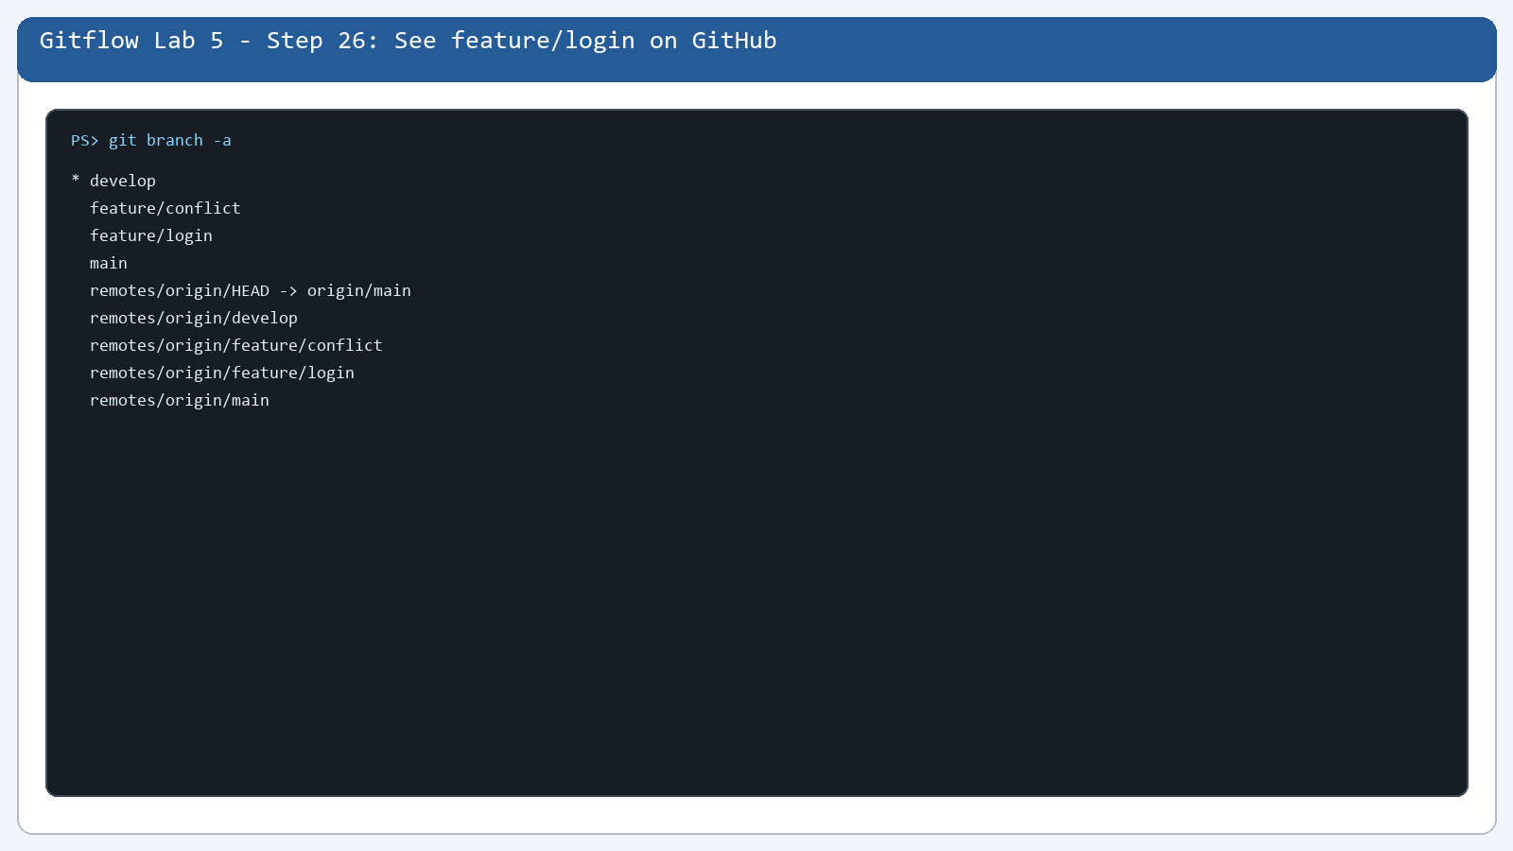

Step 27. Open feature/login Branch
What you see: feature/login contains app.py and README.md.
Command: git show --stat --oneline 0af0536
Purpose: feature/login contains app.py and README.md.
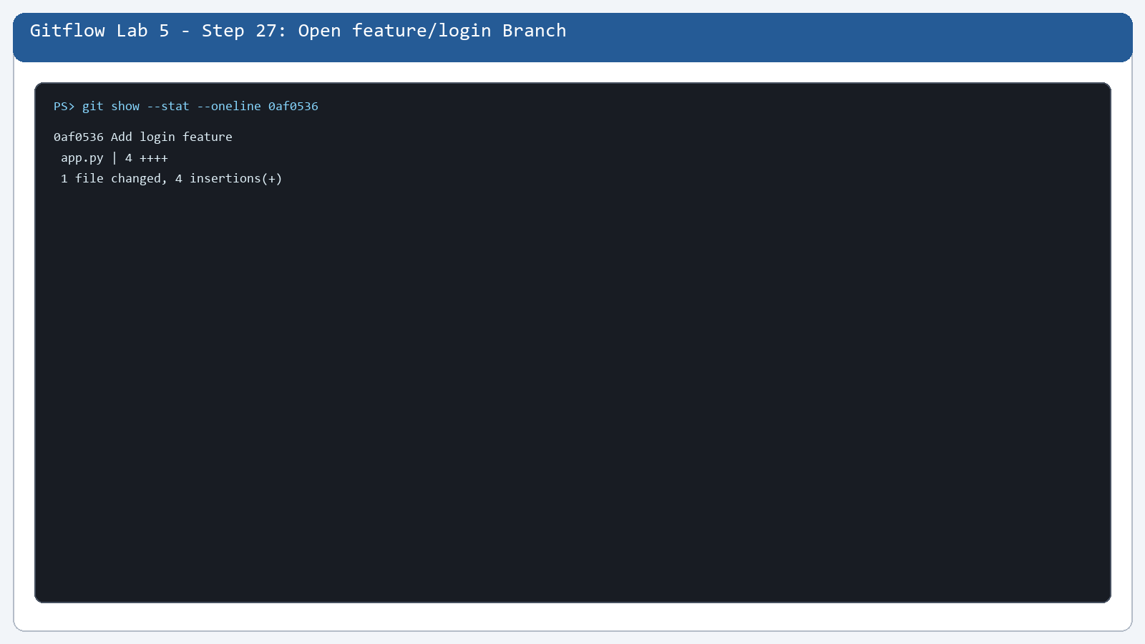

Step 28. Review feature/login History
What you see: The feature history is checked.
Command: git log --oneline --all
Purpose: The feature history is checked.
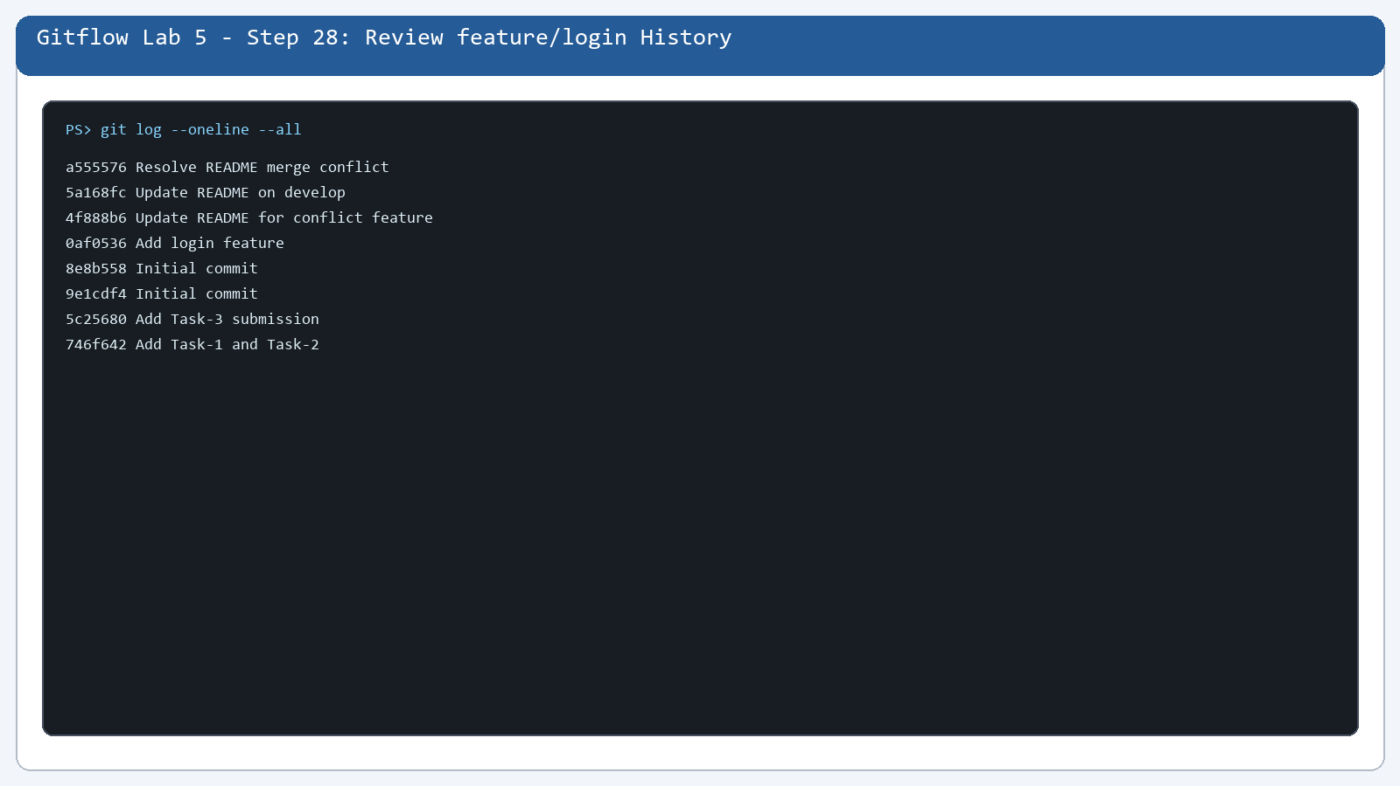

Step 29. Finish the feature/login Push
What you see: The feature branch is updated remotely.
Command: git branch -avv
Purpose: The feature branch is updated remotely.
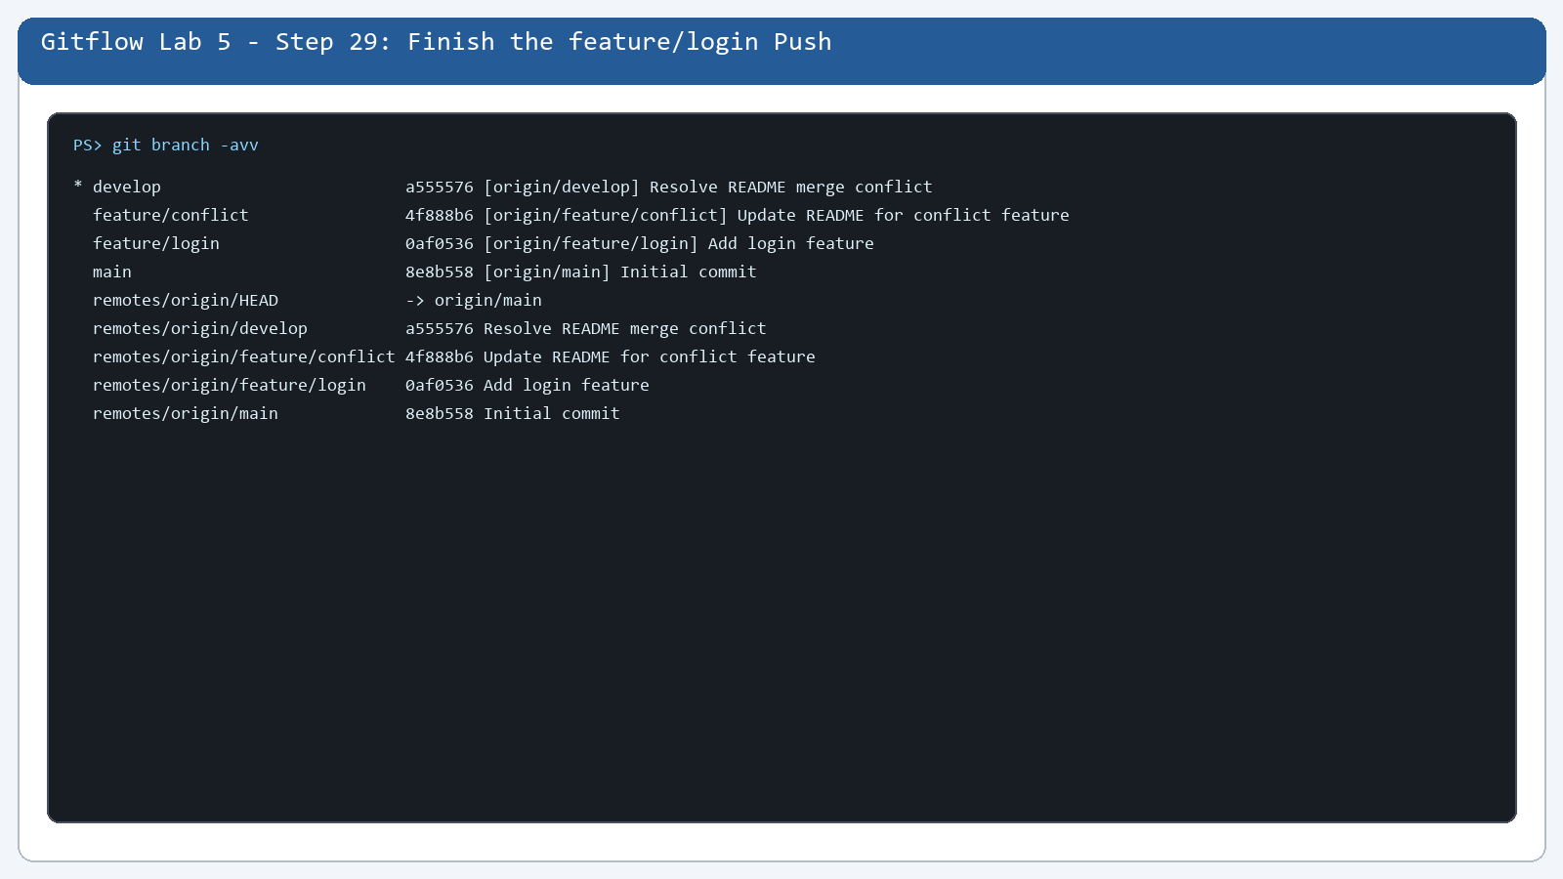

Step 30. Merge feature/login into develop
What you see: The login feature is included in develop.
Command: git log --oneline --decorate --graph --all
Purpose: The login feature is included in develop.
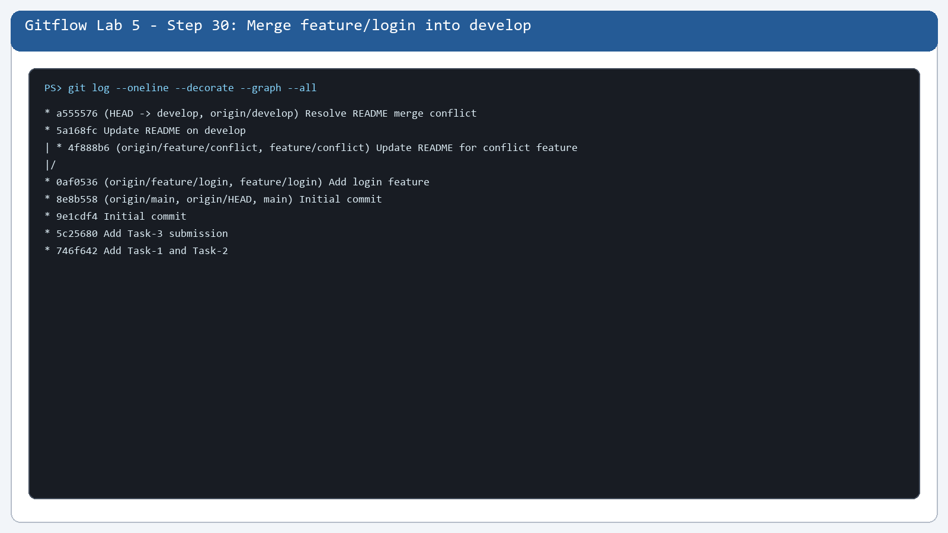

Step 31. Push Updated develop
What you see: The updated develop branch is available.
Command: git branch -avv
Purpose: The updated develop branch is available.
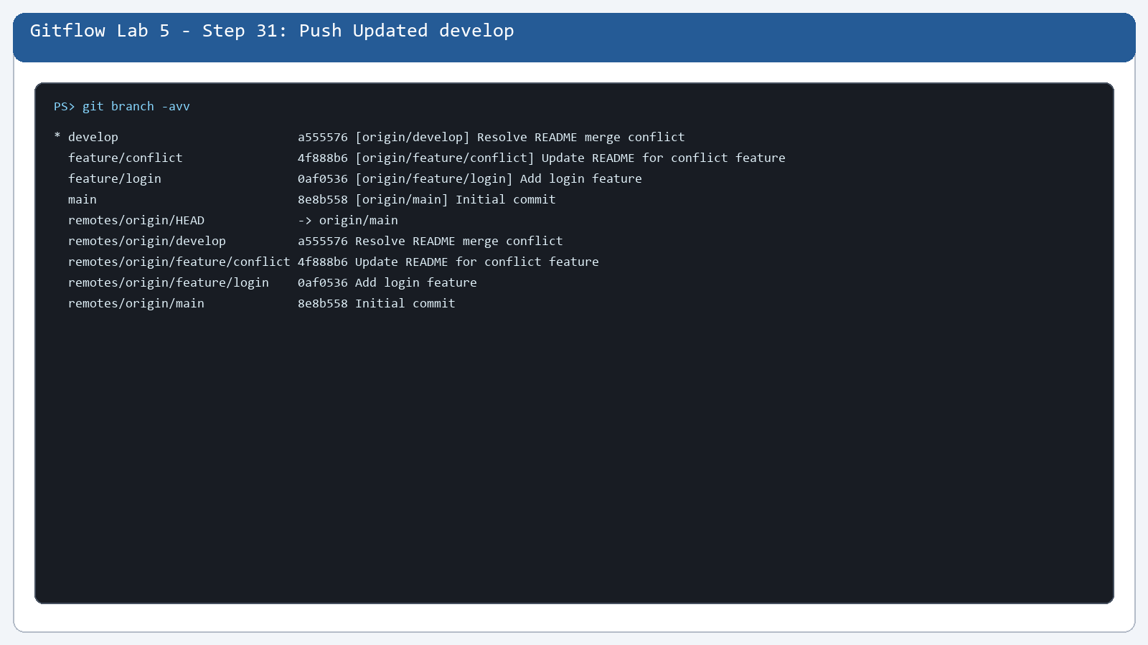

Step 32. Check GitHub Branches
What you see: main, develop, and feature/login are listed.
Command: git branch -a
Purpose: main, develop, and feature/login are listed.
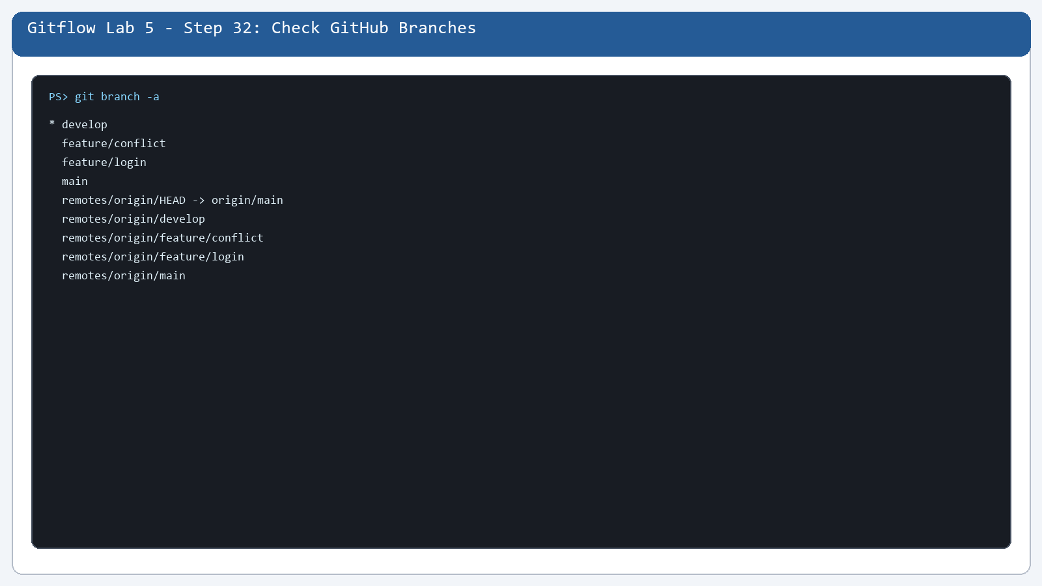

Step 33. Prepare the Conflict Branch
What you see: feature/conflict is created for the merge conflict.
Command: git branch -avv
Purpose: feature/conflict is created for the merge conflict.
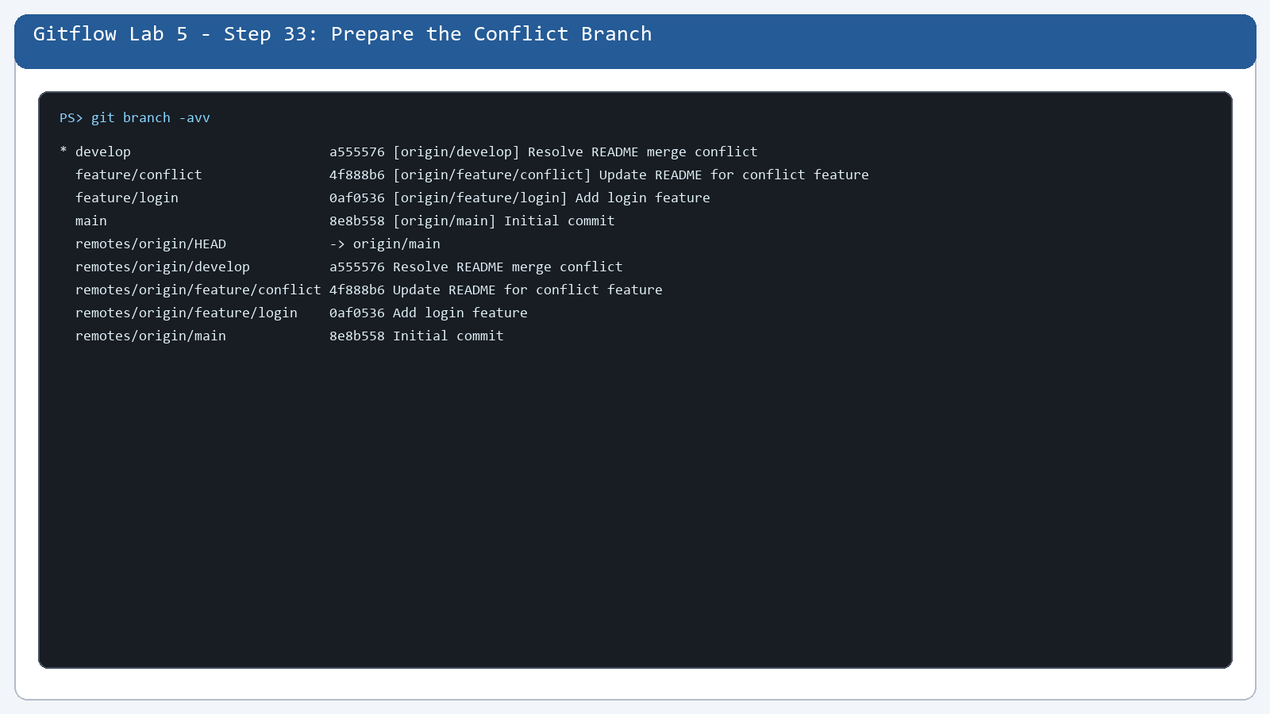

Step 34. Open README.md
What you see: README.md is the file used for the conflict.
Command: git show develop:README.md
Purpose: README.md is the file used for the conflict.
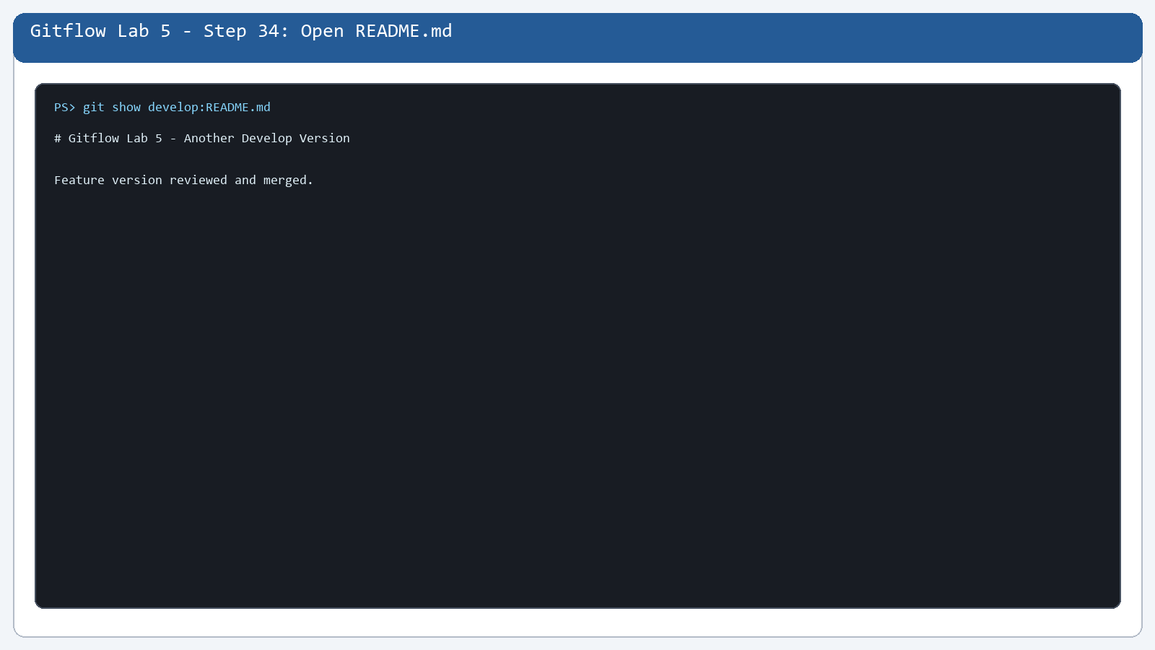

Step 35. Change the Feature Version
What you see: The feature-side README version is recorded.
Command: git show feature/conflict:README.md
Purpose: The feature-side README version is recorded.
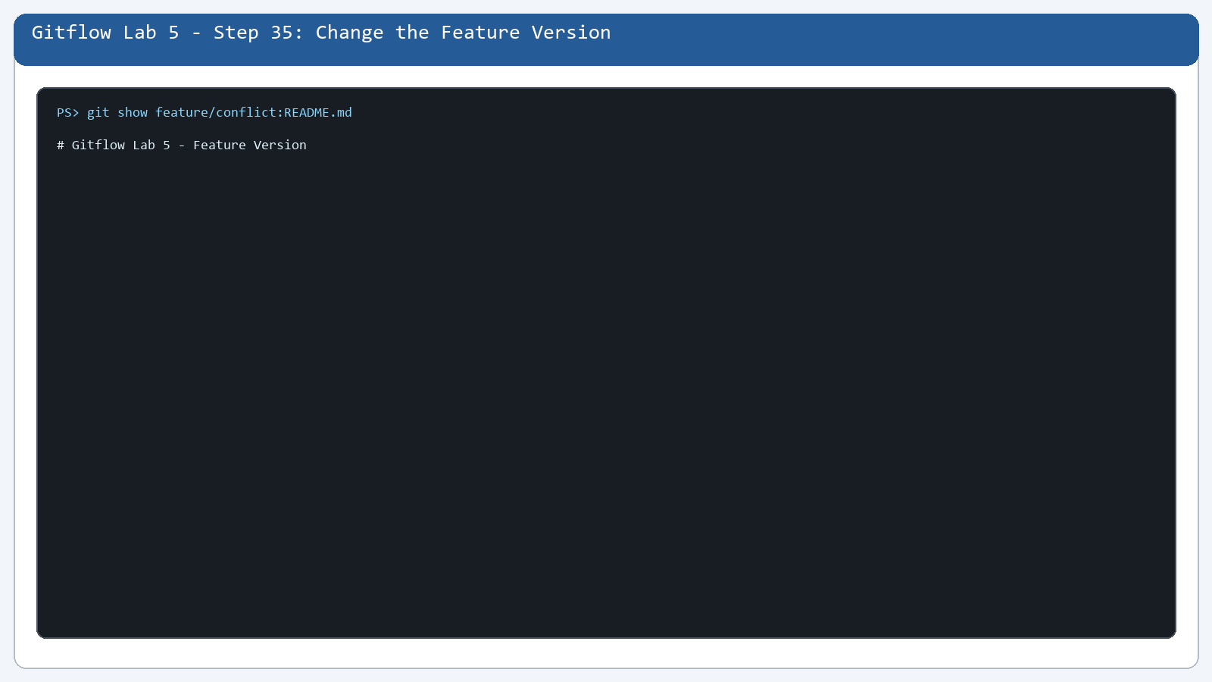

Step 36. Switch to feature/conflict
What you see: The conflict branch is selected.
Command: git branch -avv
Purpose: The conflict branch is selected.
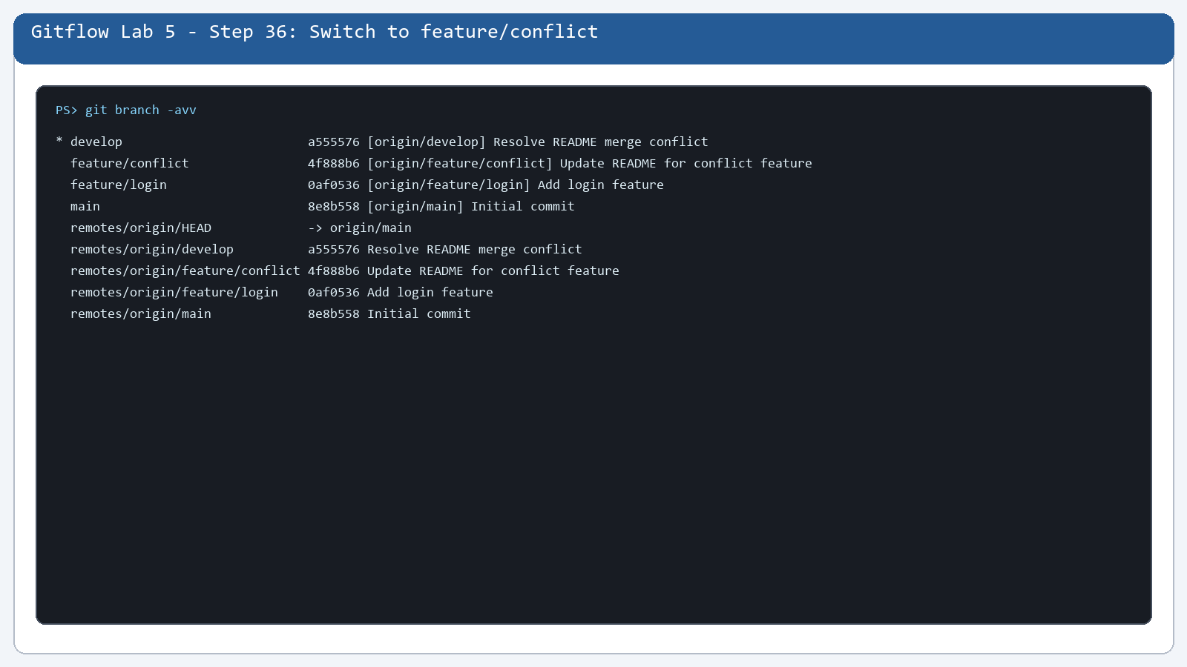

Step 37. Stage README.md on feature/conflict
What you see: The feature README is staged.
Command: git show --stat --oneline 4f888b6
Purpose: The feature README is staged.
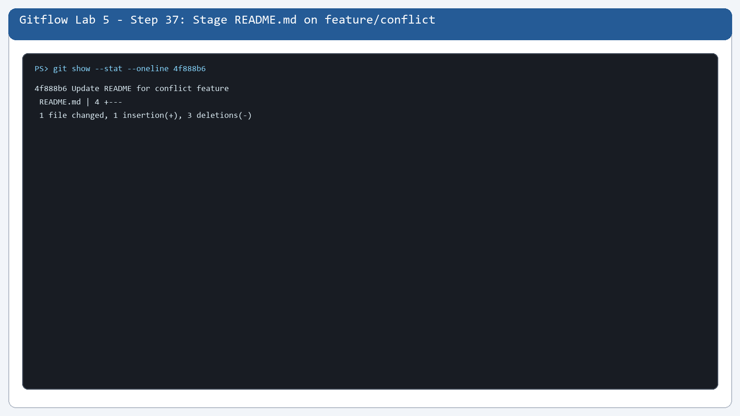

Step 38. Commit the Conflict Feature
What you see: The feature README change is committed.
Command: git show --stat --oneline 4f888b6
Purpose: The feature README change is committed.
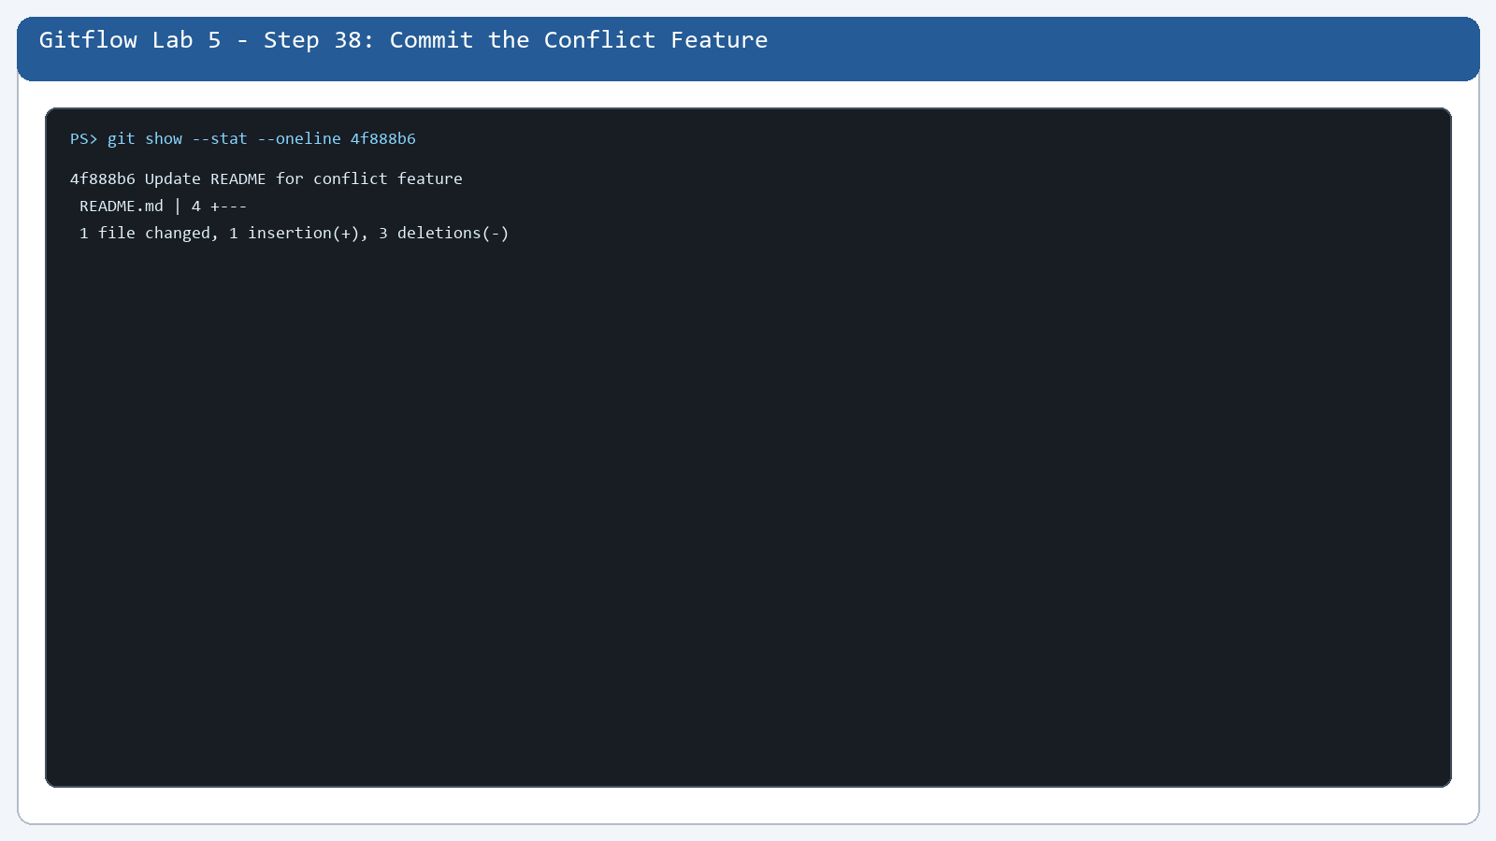

Step 39. Confirm the Conflict Feature Commit
What you see: The conflict feature commit is visible.
Command: git log --oneline --all
Purpose: The conflict feature commit is visible.
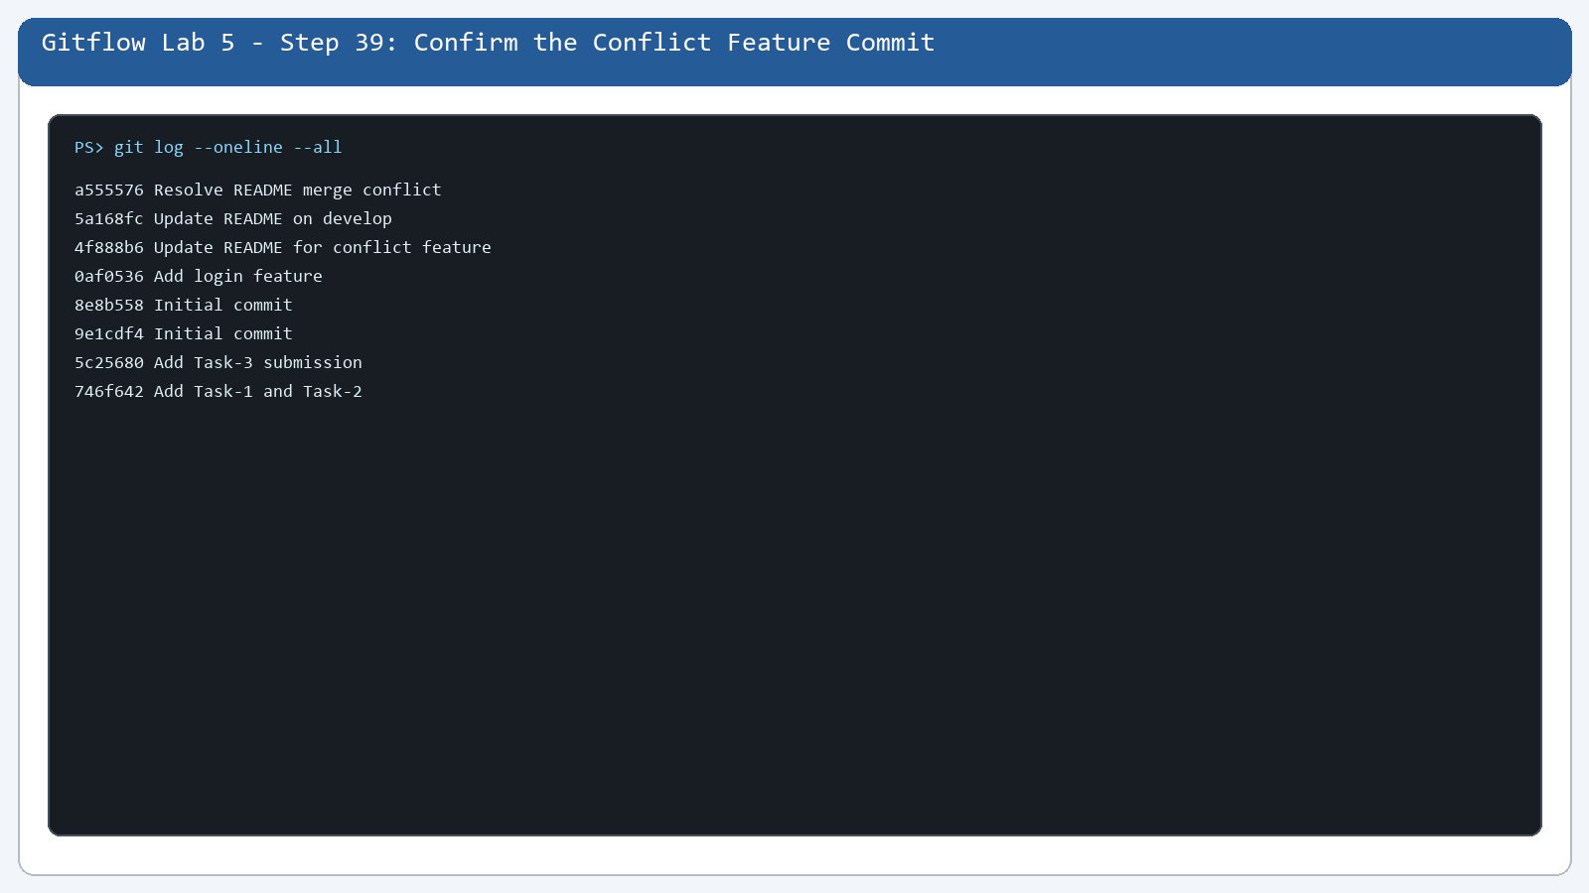

Step 40. Create the Develop Version
What you see: Develop has a different README version.
Command: git show 5a168fc:README.md
Purpose: Develop has a different README version.
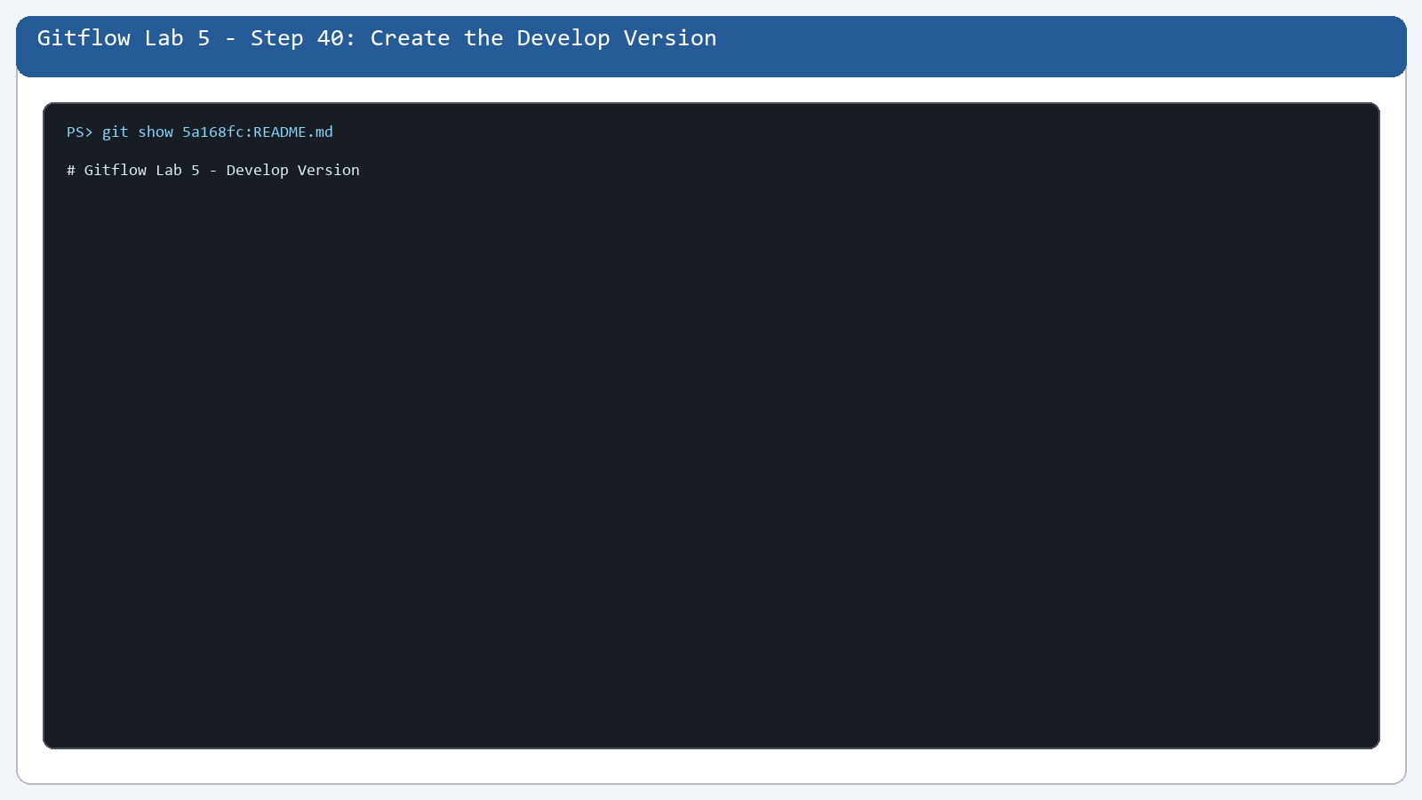

Step 41. Review the Branch History
What you see: All branch histories are visible.
Command: git log --oneline --decorate --graph --all
Purpose: All branch histories are visible.
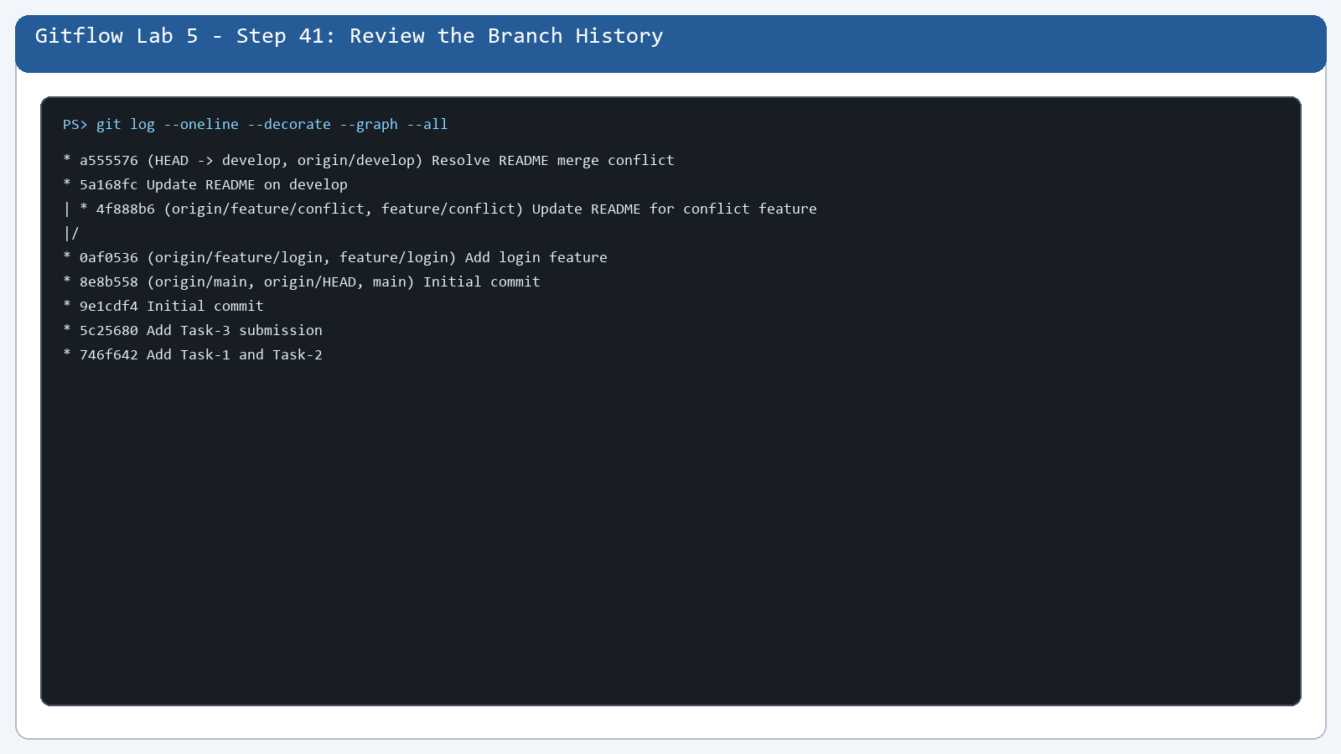

Step 42. Review the Project History
What you see: The README changes are in Git history.
Command: git log --oneline -- README.md
Purpose: The README changes are in Git history.
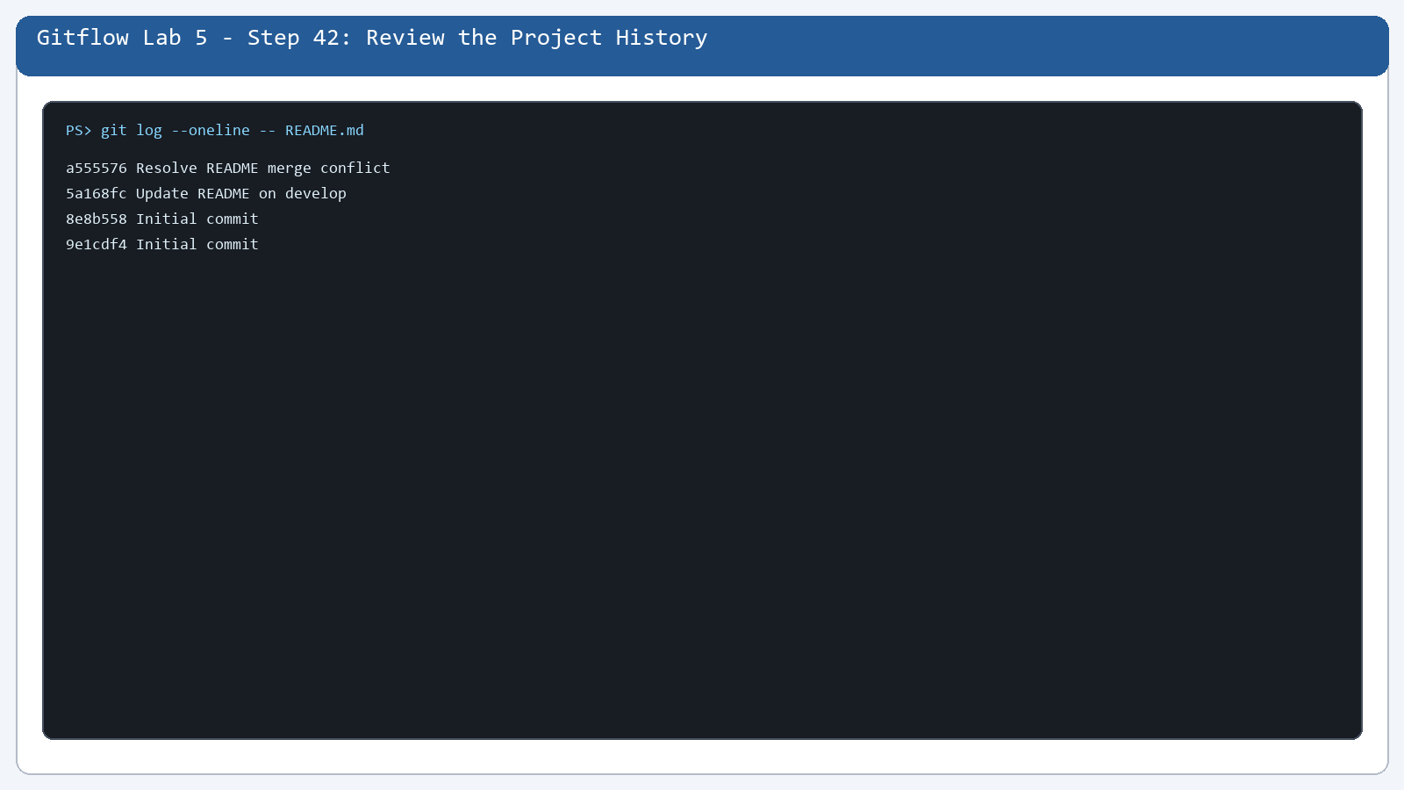

Step 43. Continue the Develop Change
What you see: The develop-side README content is checked.
Command: git show develop:README.md
Purpose: The develop-side README content is checked.
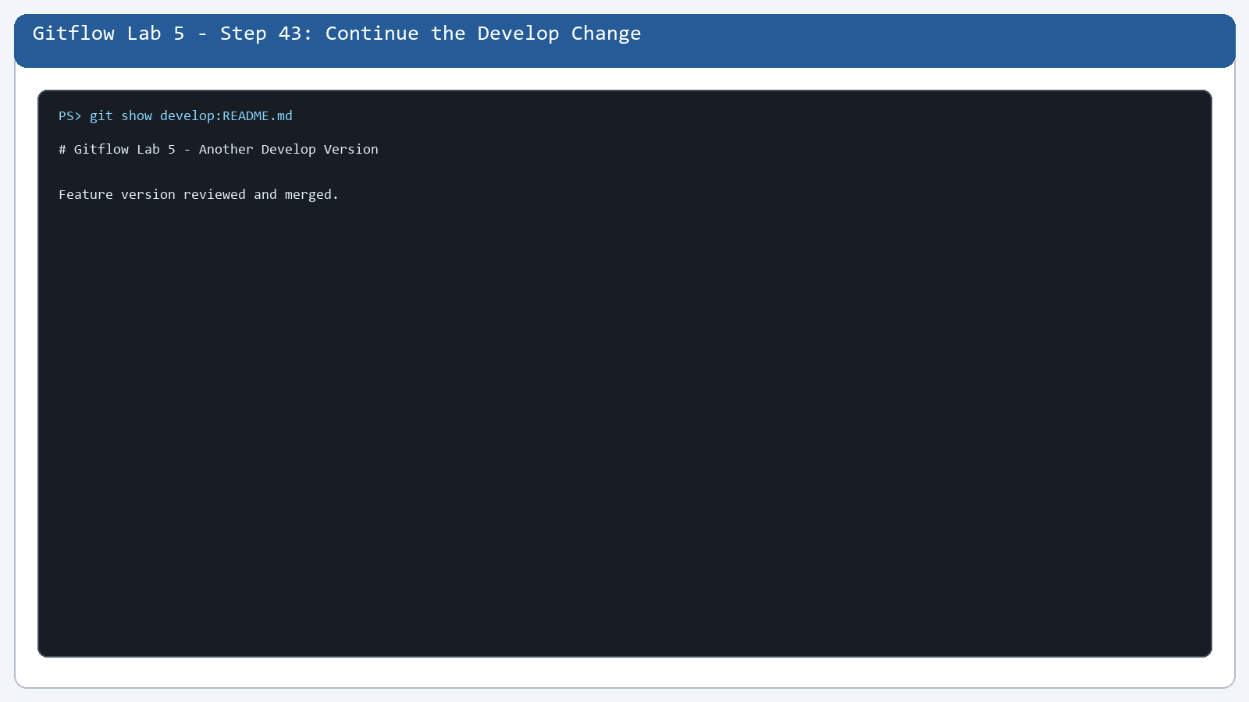

Step 44. Check develop Status
What you see: Git status is checked before staging.
Command: git status
Purpose: Git status is checked before staging.
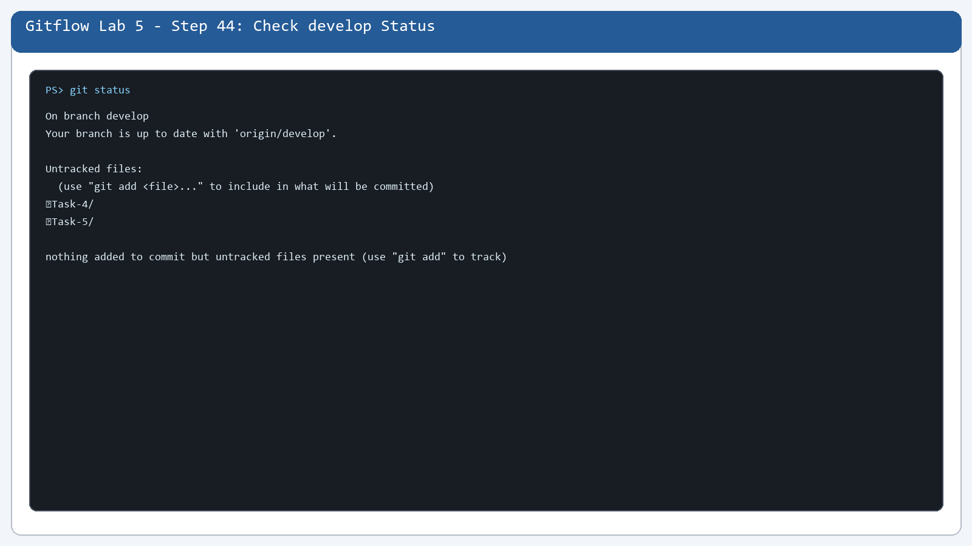

Step 45. Stage the Develop Change
What you see: The develop README is staged.
Command: git show --stat --oneline 5a168fc
Purpose: The develop README is staged.
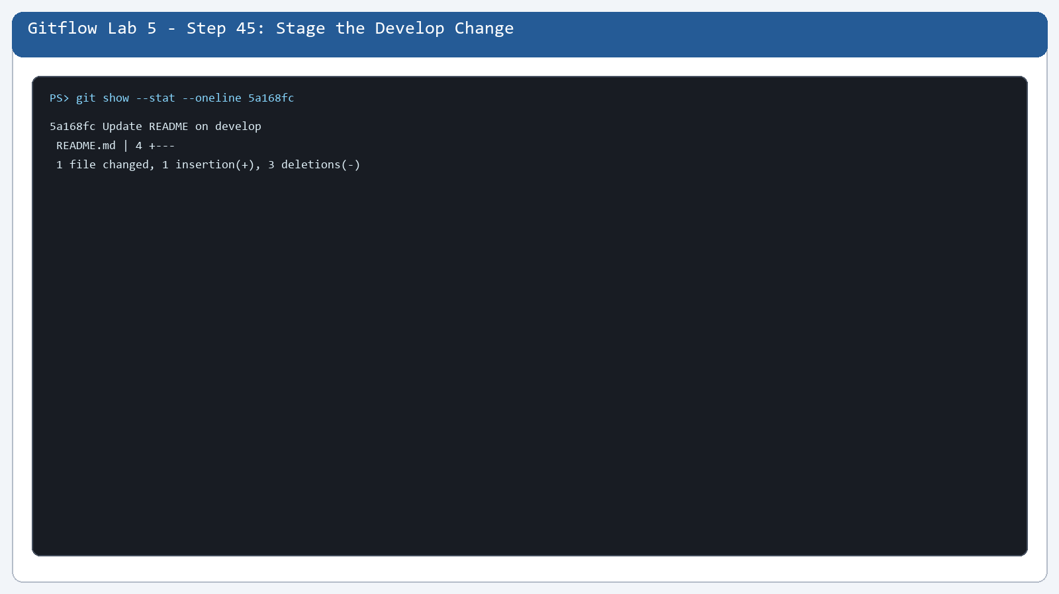

Step 46. Commit the Develop README
What you see: The develop README commit is recorded.
Command: git show --stat --oneline 5a168fc
Purpose: The develop README commit is recorded.
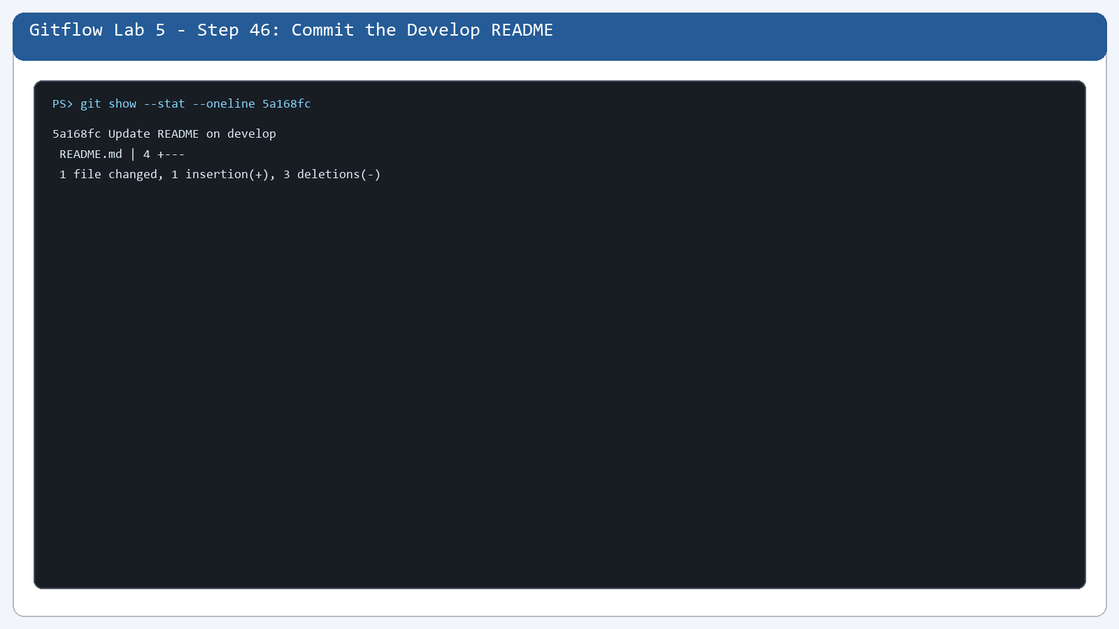

Step 47. Create the Conflict Version
What you see: The conflict workflow is prepared.
Command: git show feature/conflict:README.md
Purpose: The conflict workflow is prepared.
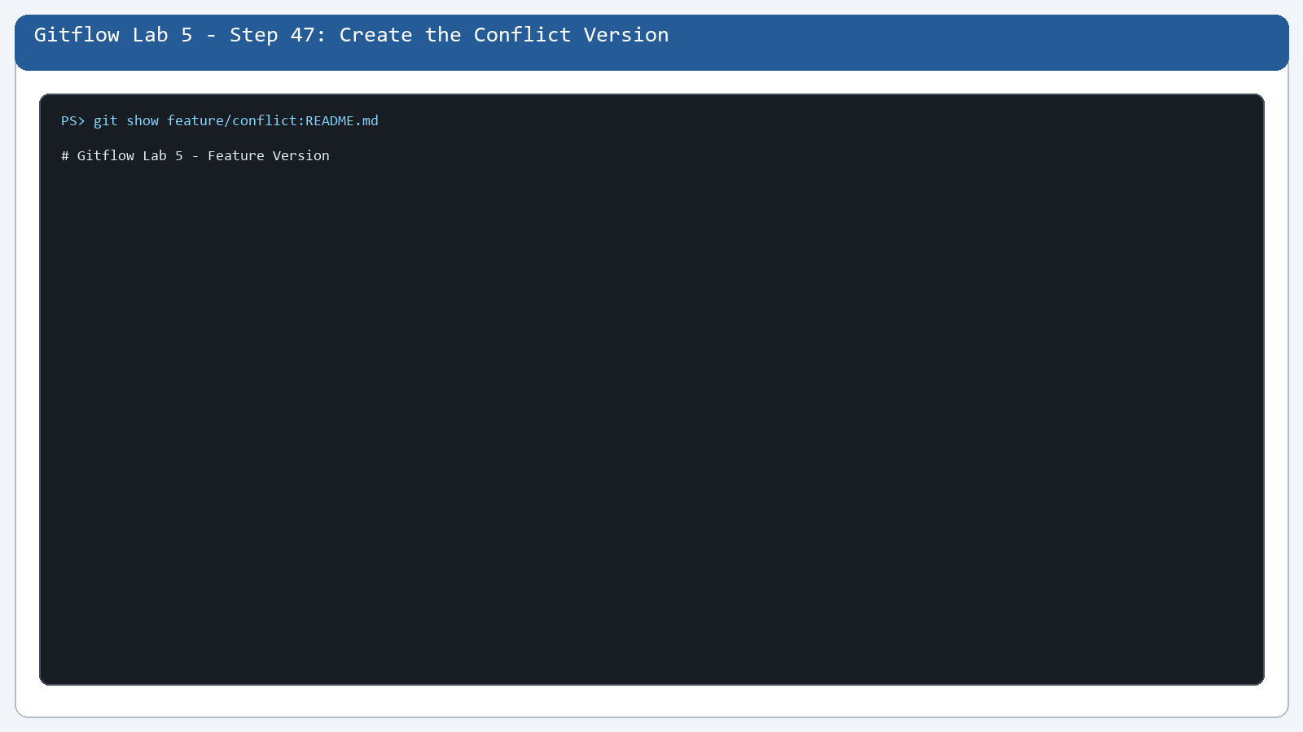

Step 48. Open the Merge State
What you see: The merge state is reviewed.
Command: git status --short --branch
Purpose: The merge state is reviewed.
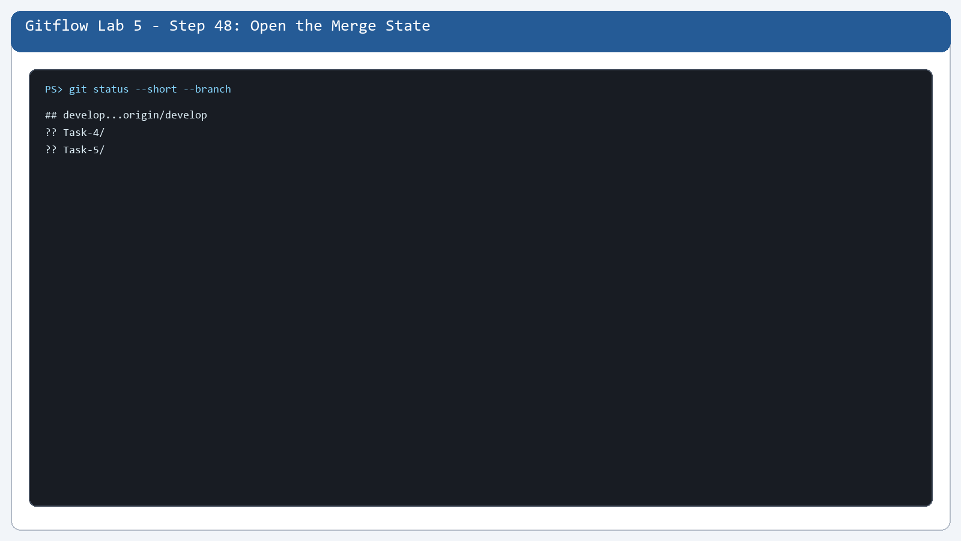

Step 49. Review the Conflict-Feature History
What you see: The feature-side history is reviewed.
Command: git log --oneline feature/conflict
Purpose: The feature-side history is reviewed.
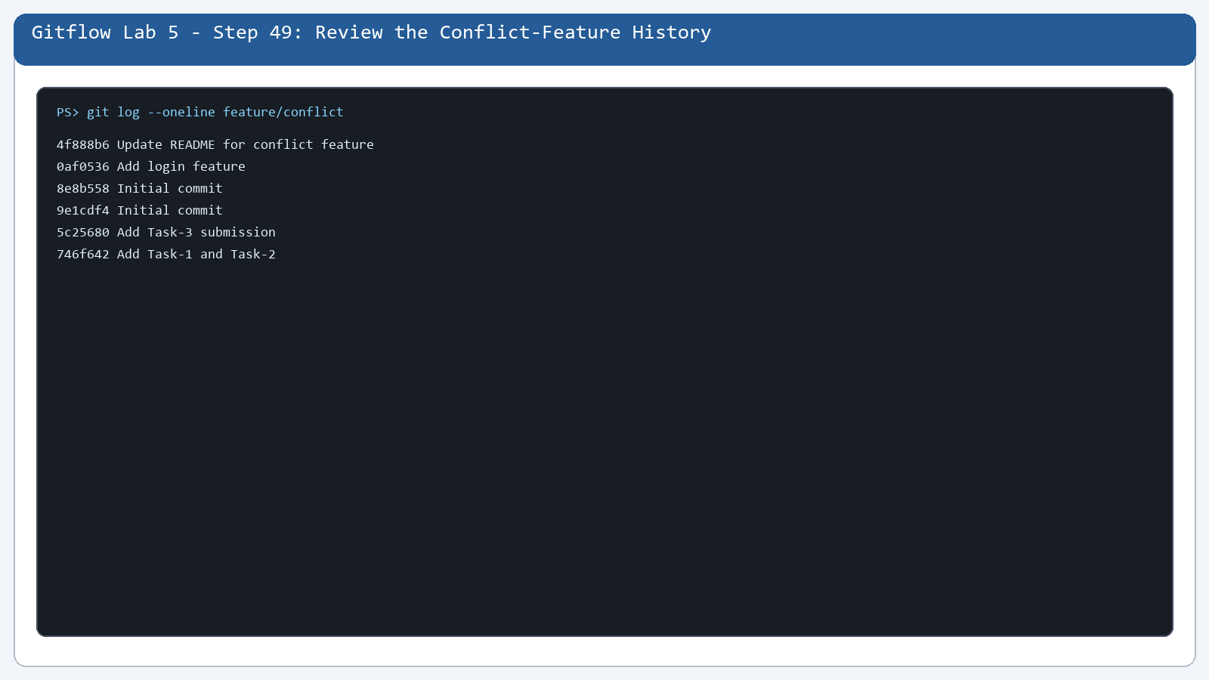

Step 50. Review the Develop History
What you see: The develop-side history is reviewed.
Command: git log --oneline develop
Purpose: The develop-side history is reviewed.
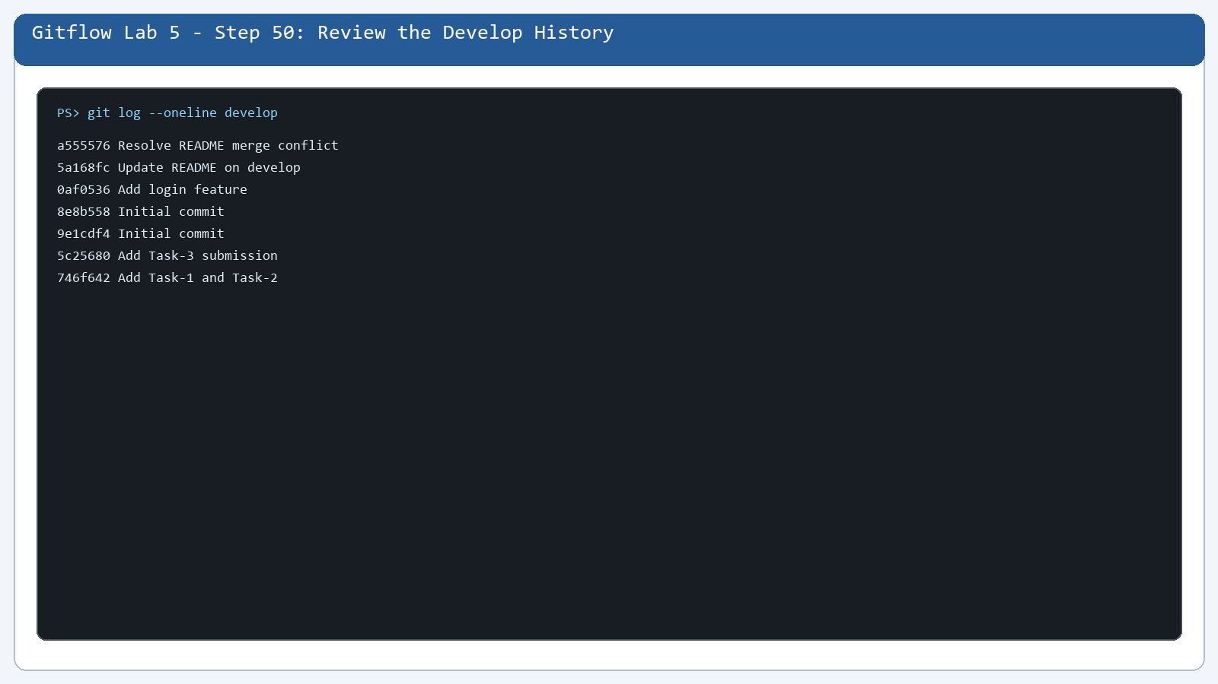

Step 51. Create Another Develop Version
What you see: Develop has content different from the feature.
Command: git show develop:README.md
Purpose: Develop has content different from the feature.
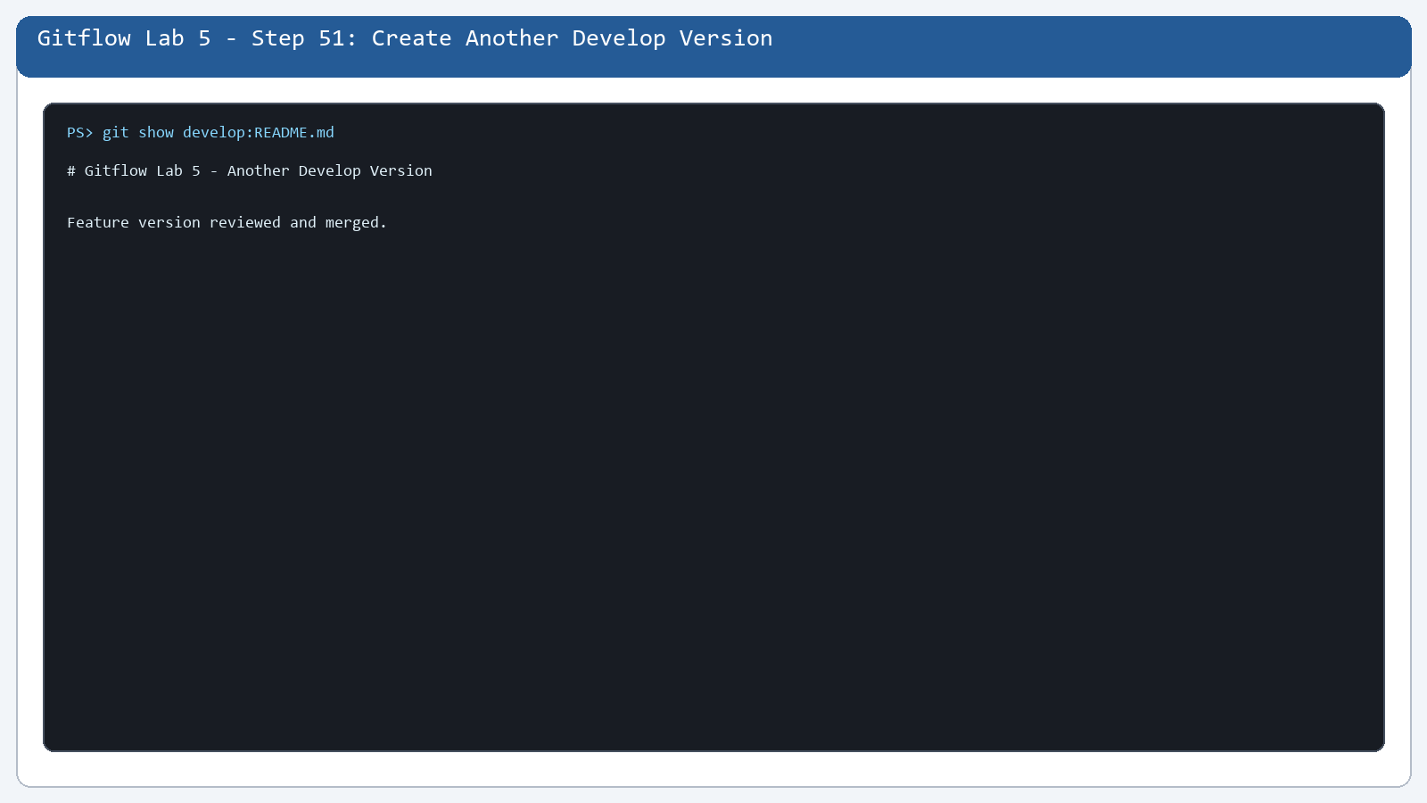

Step 52. Open the Merge Editor
What you see: Both branch versions are compared.
Command: git diff feature/conflict..develop -- README.md
Purpose: Both branch versions are compared.
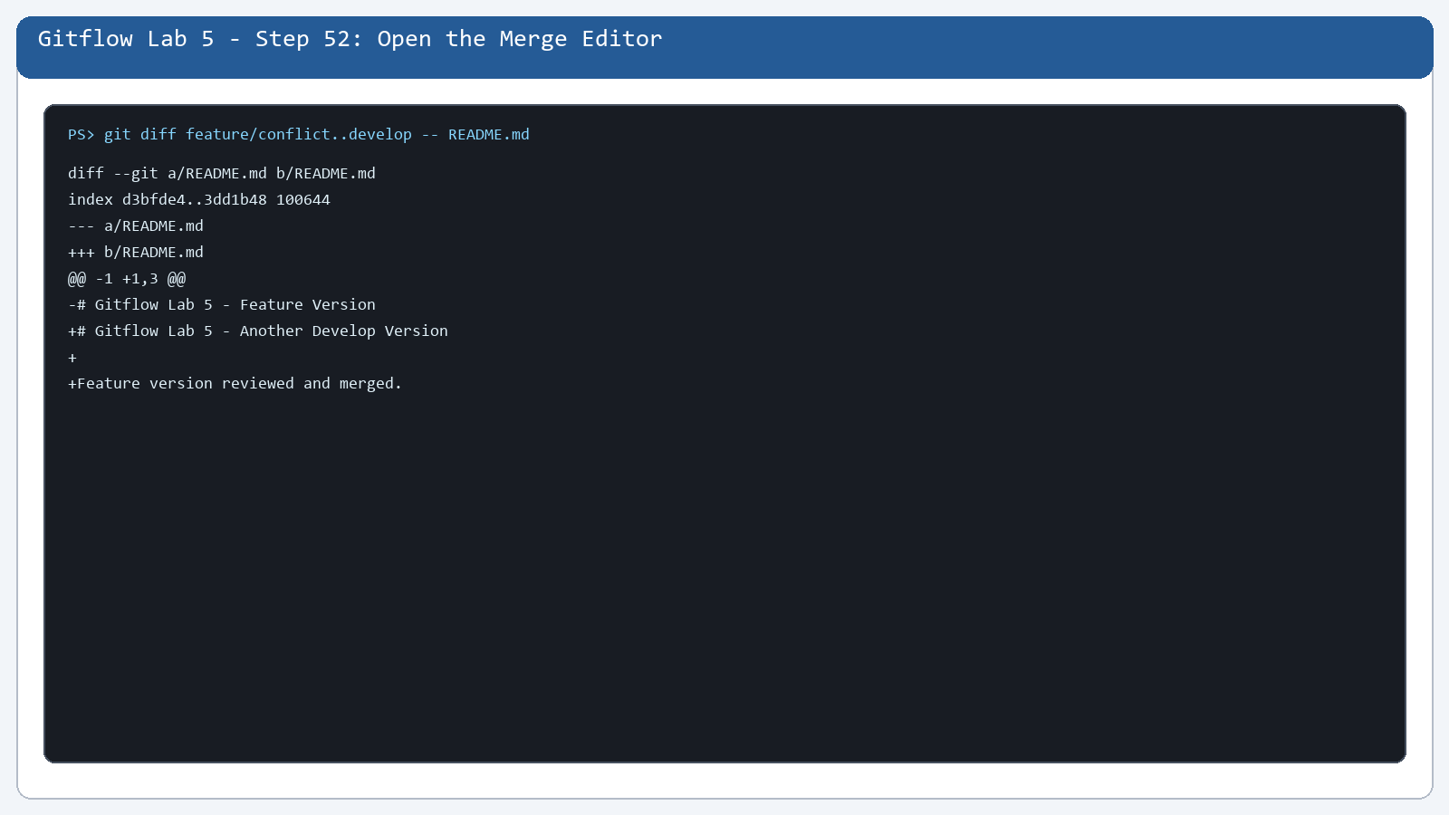

Step 53. See Both Versions Together
What you see: The two README versions are displayed.
Command: git diff feature/conflict..develop -- README.md
Purpose: The two README versions are displayed.
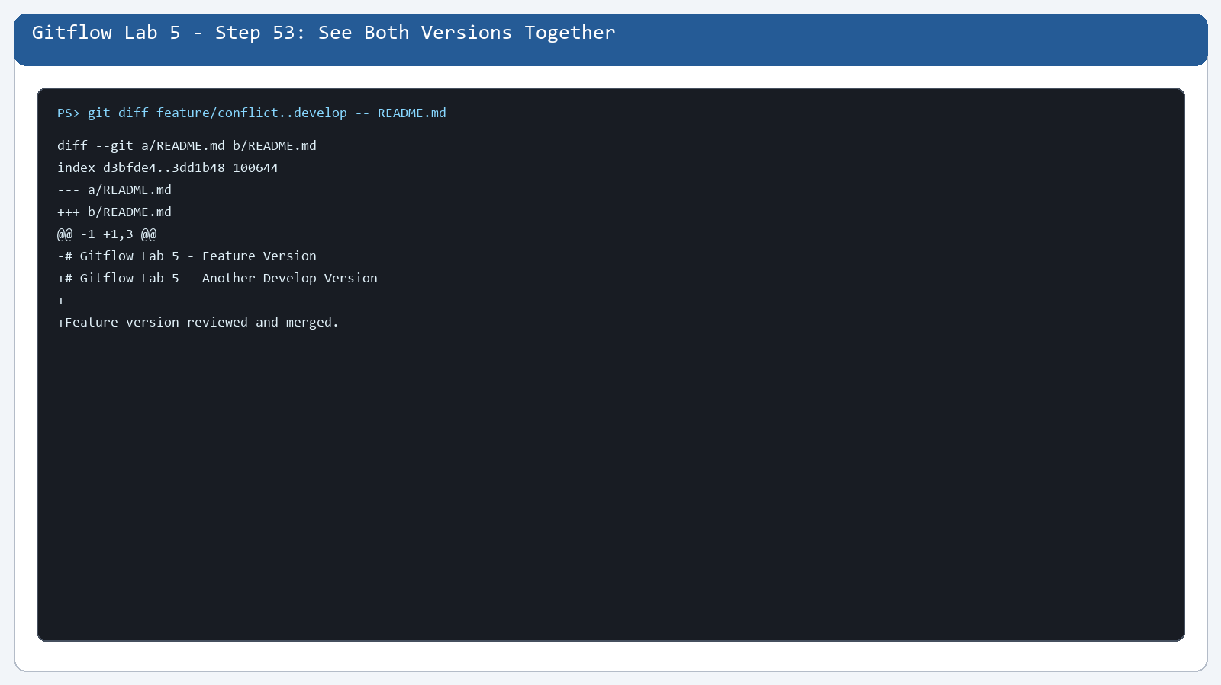

Step 54. Complete the Conflict Resolution in Source Control
What you see: The resolved README is staged.
Command: git status --short
Purpose: The resolved README is staged.
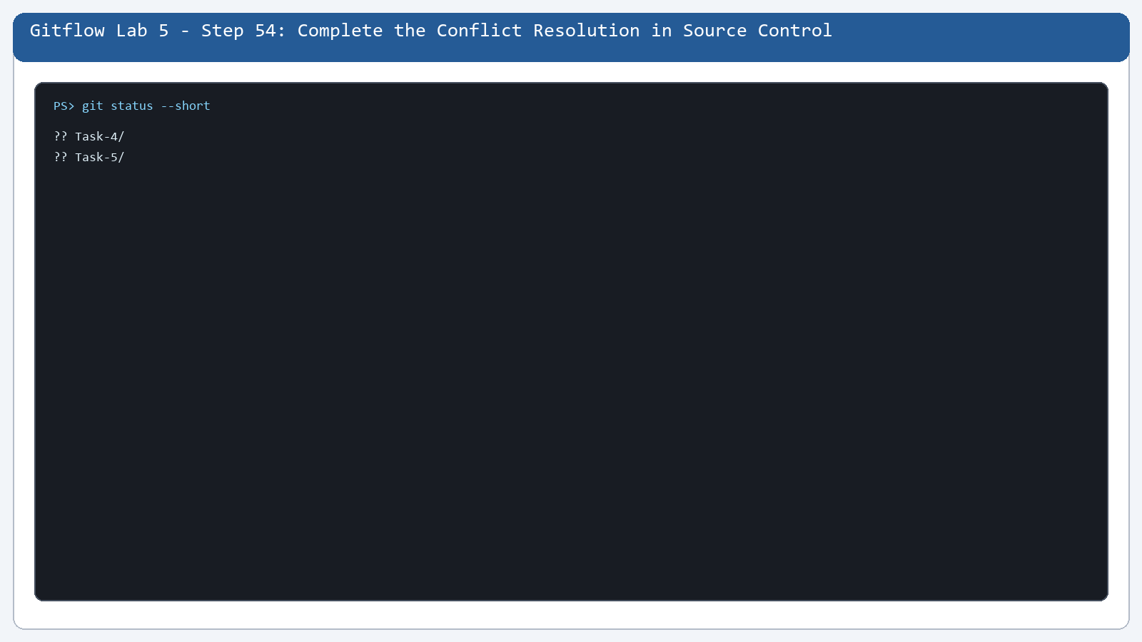

Step 55. Review the Merge History
What you see: The merge history is checked.
Command: git log --oneline --decorate --graph --all
Purpose: The merge history is checked.
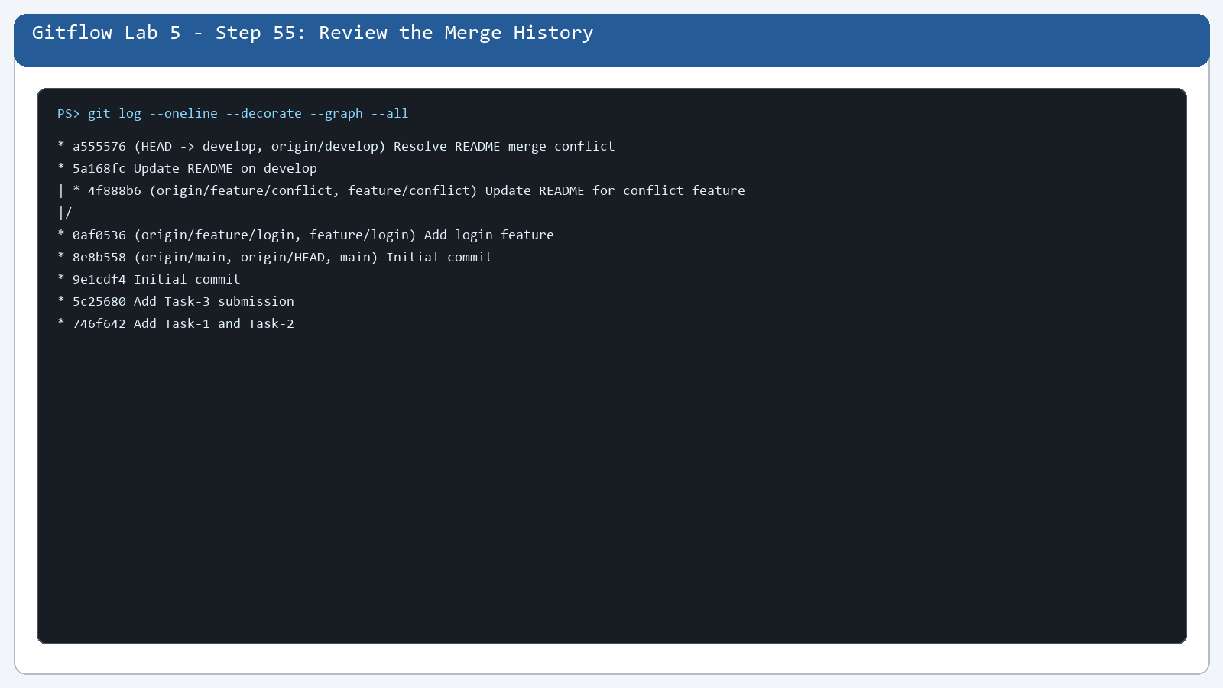

Step 56. Review the Final Local History
What you see: The final local history is visible.
Command: git log --oneline --decorate --graph --all
Purpose: The final local history is visible.
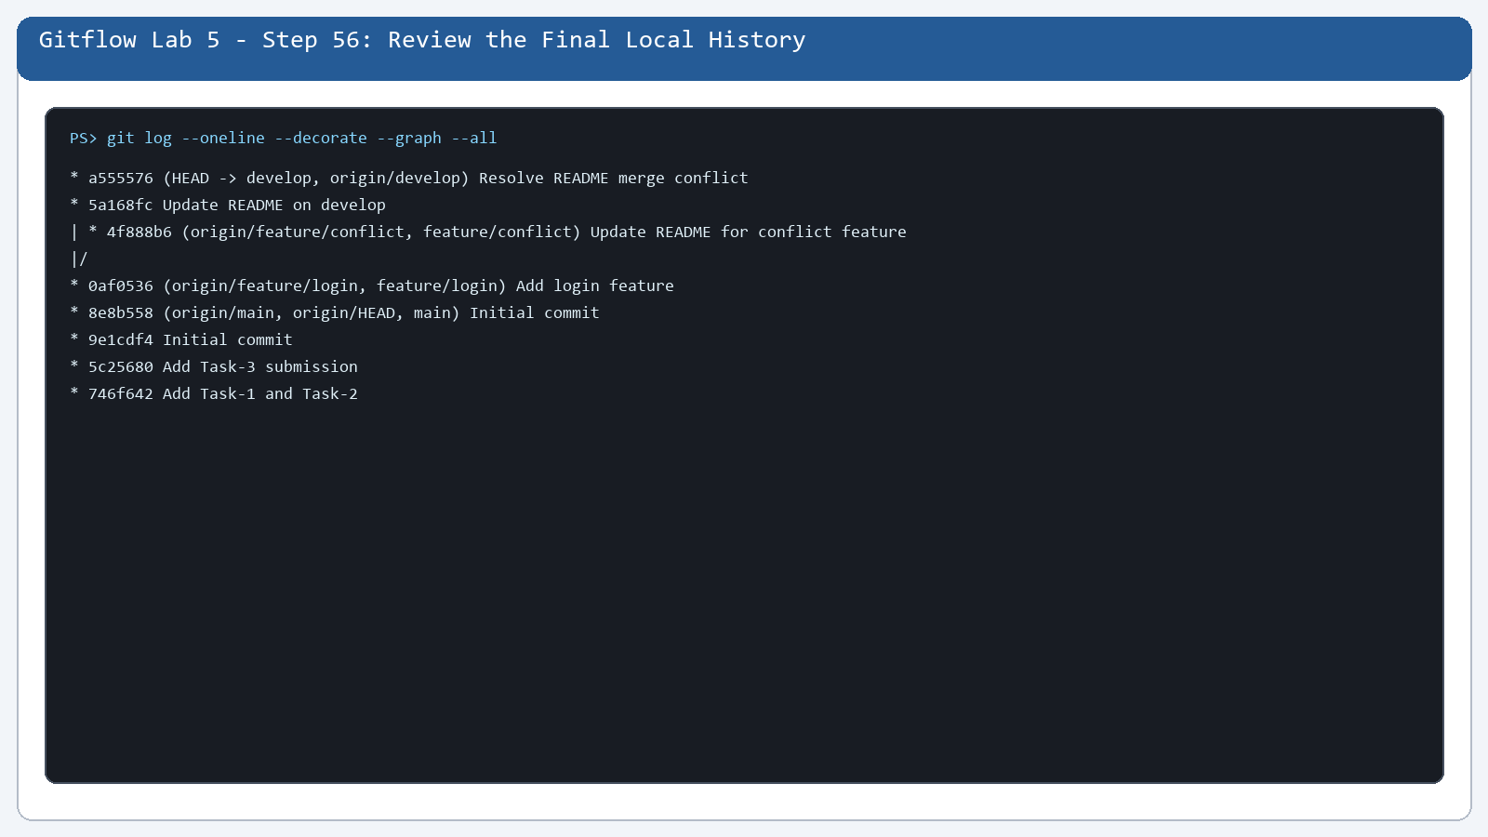

Step 57. Check GitHub Branches and Recent Pushes
What you see: Remote branches are verified.
Command: git branch -r
Purpose: Remote branches are verified.
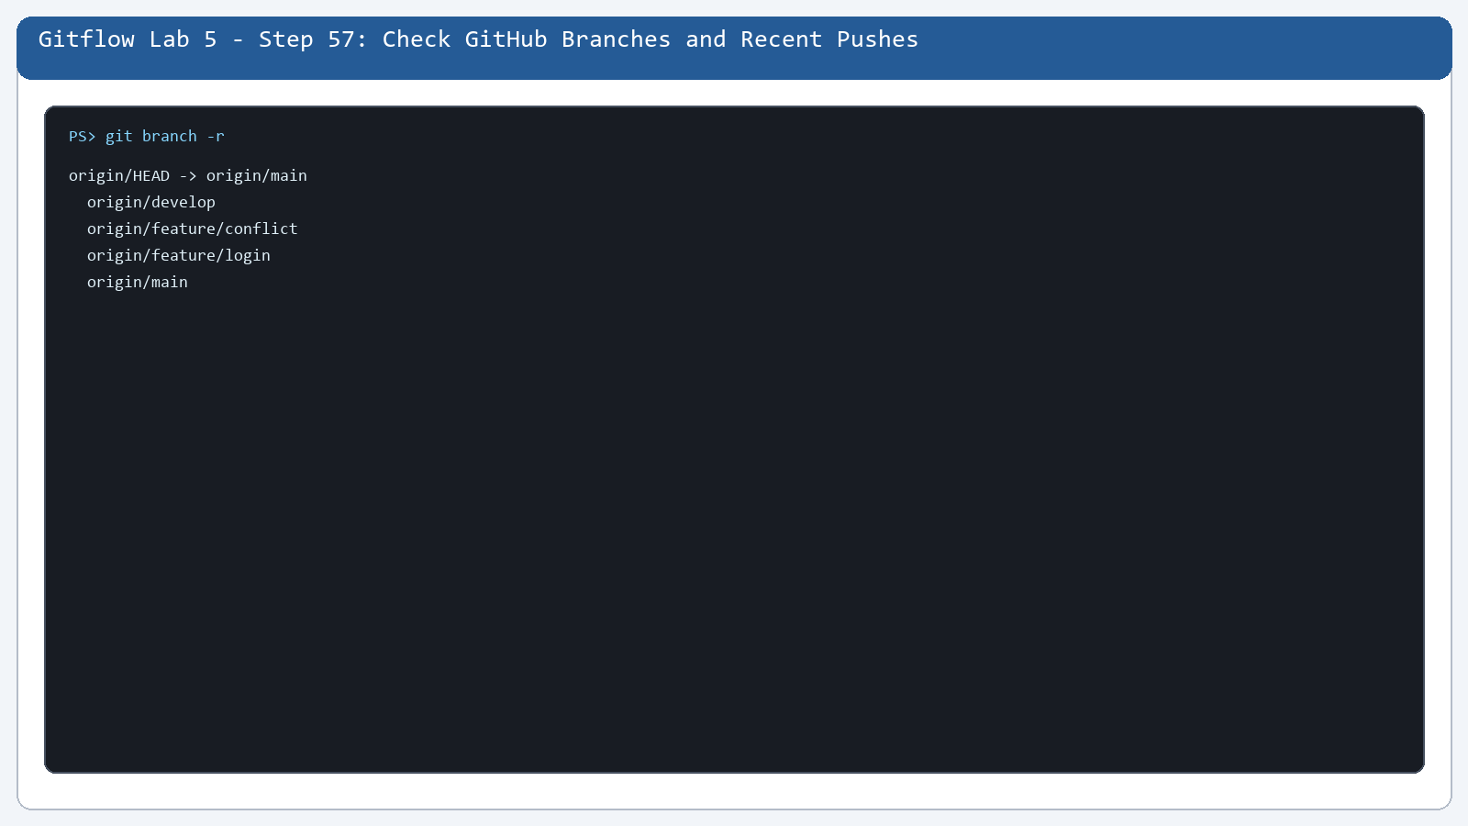

Step 58. Open the Final develop Branch
What you see: develop contains README.md, app.py, and the resolved merge.
Command: git show --stat --oneline develop
Purpose: develop contains README.md, app.py, and the resolved merge.
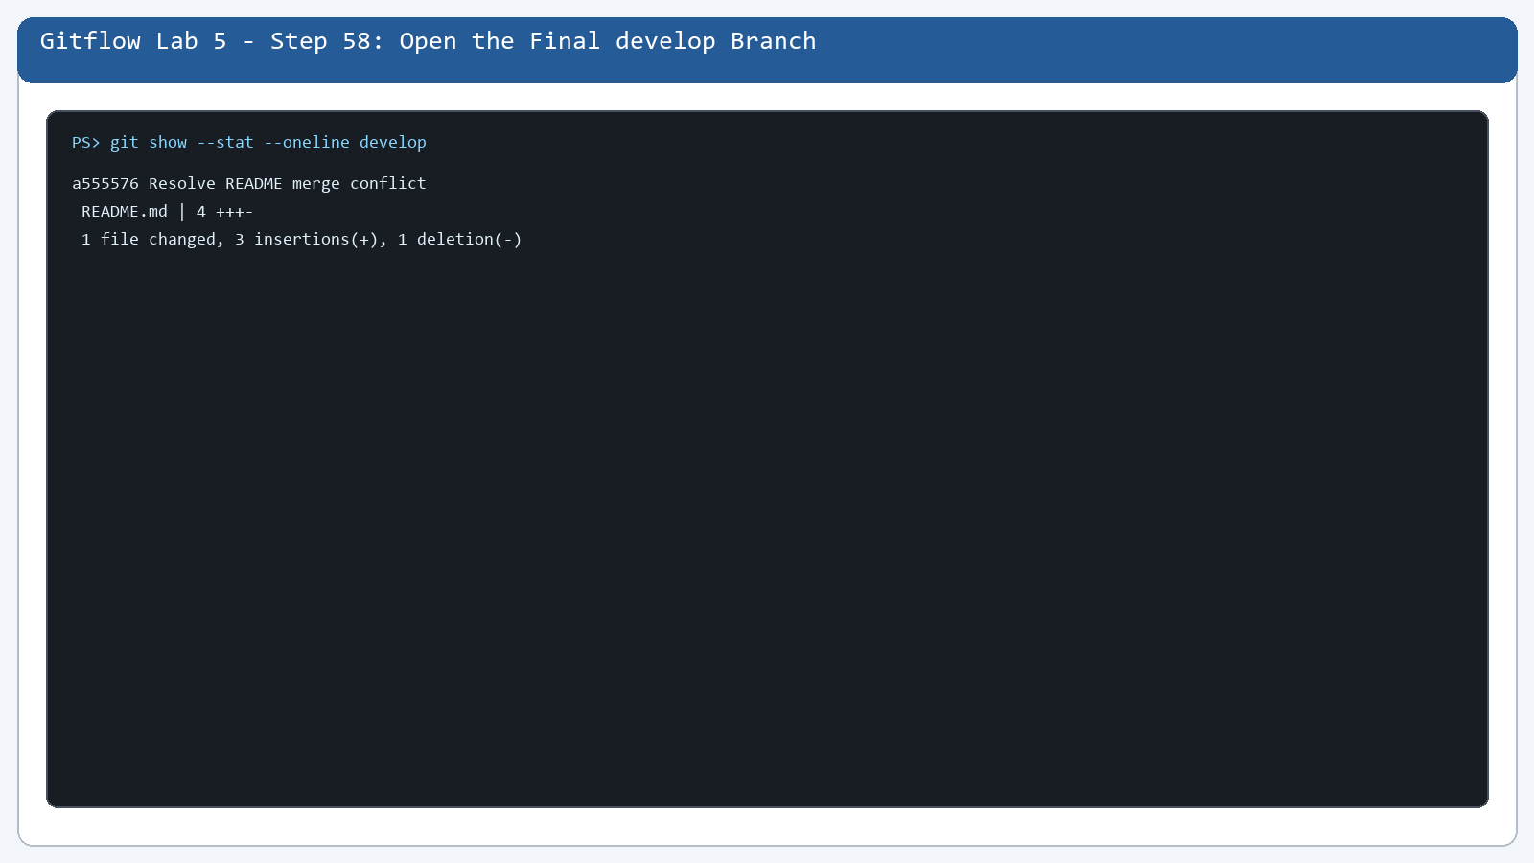

Final Revision
Create GitHub repository -> connect the local project -> create develop -> create feature/login -> commit -> push -> merge into develop -> create feature/conflict -> make different changes -> merge -> resolve the conflict -> stage -> commit -> push -> verify on GitHub.

Most Important Commands
- git status
- git branch
- git checkout -b branch-name
- git add file-name
- git commit -m "message"
- git push
- git merge branch-name
- python app.py

