Enumeration/recursion/string pool

: Can we extend an Enum to add elements?
A: No, we cannot extend Enum further in the Code. It is defined only with keyword Enum and filled with elements but these elements cannot be added further in the program using some alternative method.
Q: Can we create object of Enum?
A: No, it is not possible to create the object of Enum.
Q: What are advantages of using Enum in Java?
A: 1.) Enum improves safety
2.) Enum can be placed in or out of a class
3.) Enum can be easily used in switch case
4.) Enum cannot extend any class
5.) Object of enum cannot be made
6.) Enum can have variables, constructors and methods

Q: Give an example of using Enum using switch case?
A: Enum can be passed as an argument in switch case: package com.java1;
public class SwitchEnum {
enum Color
{
RED,GREEN,BLUE
}
public static void main(String[] args) {

Color k;
k = Color.GREEN;

switch(k)
{
case RED:
System.out.println("I am "+k);
break;
case GREEN:
System.out.println("I am "+k);
break;
case BLUE:
System.out.println("I am "+k);
break;

}
}
}
Q: What does ordinal() method do in Enum?
A: Ordinal method returns the order in which Enum instance are declared inside Enum. For example in a DayOfWeek Enum, you can declare days in order they come e.g.
public enum WeekDay{
MONDAY, TUESDAY, WEDNESDAY, THURSDAY, FRIDAY, SATURDAY, SUNDAY;
}
Ordinal arranges or assigns numbers to each element in Enum starting from 0. MONDAY will be 0, TUESDAY will be 1 and so on. If we call WeekDay.Thursday.ordinal() it will return 3.
Q: Can Enum implement interface in Java?
A: Yes, Enum can implement interface in Java. Since enum is a type, similar to class and interface, it can implement interface. This gives a lot of flexibility to use Enum as specialized implementation in some cases

:
Can you convert this Recursion function into a loop?
Junior

 Recursion 9

Problem
Can you convert this recursion function into a loop?
A(x) {
if x<0 return 0;
return something(x) + A(x-1)}
Answer
Any recursive function can be made to iterate (into a loop) but you need to use a stack yourself to keep the state.
A(x) {
temp = 0;
for i in 0..x {
temp = temp + something(i);
}
return temp;}

Having Tech or Coding Interview? Check 👉 9 Recursion Interview Questions
Source: stackoverflow.com

Q2:
How Dynamic Programming is different from Recursion and Memoization?
Junior

 Dynamic Programming 12

Answer
- Memoization is when you store previous results of a function call (a real function always returns the same thing, given the same inputs). It doesn't make a difference for algorithmic complexity before the results are stored.
- Recursion is the method of a function calling itself, usually with a smaller dataset. Since most recursive functions can be converted to similar iterative functions, this doesn't make a difference for algorithmic complexity either.
- Dynamic programming is the process of solving easier-to-solve sub-problems and building up the answer from that. Most DP algorithms will be in the running times between a Greedy algorithm (if one exists) and an exponential (enumerate all possibilities and find the best one) algorithm.
  - DP algorithms could be implemented with recursion, but they don't have to be.
  - DP algorithms can't be sped up by memoization, since each sub-problem is only ever solved (or the "solve" function called) once.

Having Tech or Coding Interview? Check 👉 12 Dynamic Programming Interview Questions
Source: stackoverflow.com

Q3:
Return the N-th value of the Fibonacci sequence Recursively
Junior

 Fibonacci Series 14

Answer
Recursive solution looks pretty simple (see code).
Let’s look at the diagram that will help you understand what’s going on here with the rest of our code. Function fib is called with argument 5:
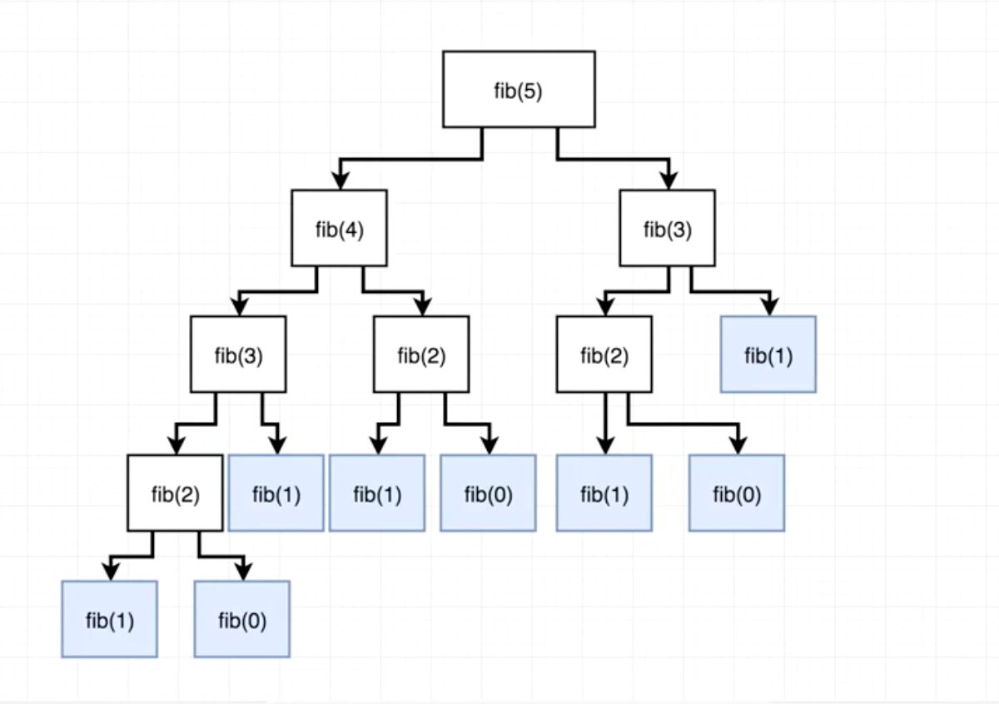
Basically our fib function will continue to recursively call itself creating more and more branches of the tree until it hits the base case, from which it will start summing up each branch’s return values bottom up, until it finally sums them all up and returns an integer equal to 5.
Complexity Analysis
Time:
Constant
O(1)
Dbl. Logarithmic
O(log log n)
Logarithmic
O(log n)
Square Root
O(√n)
Linear
O(n)
Linearithmic
O(n log n)
Quadratic
O(n2)
Exponential
O(2n)
Factorial
O(n!)
In case of recursion the solution take exponential time, that can be explained by the fact that the size of the tree exponentially grows when n increases. So for every additional element in the Fibonacci sequence we get an increase in function calls. Big O in this case is equal to O(2n). Exponential Time complexity denotes an algorithm whose growth doubles with each addition to the input data set.
Implementation
JavaScript JS
Java Java
Python PY
function fib(n) {
if (n < 2){
return n
}
return fib(n - 1) + fib (n - 2)}

Having Tech or Coding Interview? Check 👉 14 Fibonacci Series Interview Questions
Source: medium.com

Q4:
What is a good example of Recursion (other than generating a Fibonacci sequence)?
Junior

Recursion 9

Answer
There are some:
- The binary tree search
- Check for a palyndrome
- Finding factorial
- Traversing the folder hierarchy of a directory tree as part of a file system
- Towers of Hanoi
- Merge sort
- Catalan numbers

Having Tech or Coding Interview? Check 👉 9 Recursion Interview Questions
Source: stackoverflow.com

Q5:
What is the difference between Backtracking and Recursion?
Junior

 Backtracking 8

Answer
- Recursion describes the calling of the same function that you are in. The typical example of a recursive function is the factorial. You always need a condition that makes recursion stop (base case).
- Backtracking is when the algorithm makes an opportunistic decision*, which may come up to be wrong. If the decision was wrong then the backtracking algorithm restores the state before the decision. It builds candidates for the solution and abandons those which cannot fulfill the conditions. A typical example for a task to solve would be the Eight Queens Puzzle. Backtracking is also commonly used within Neuronal Networks. Many times backtracking is not implemented recursively. If backtracking uses recursion its called Recursive Backtracking
P.S. * Opportunistic decision making refers to a process where a person or group assesses alternative actions made possible by the favorable convergence of immediate circumstances recognized without reference to any general plan.

Having Tech or Coding Interview? Check 👉 8 Backtracking Interview Questions
Source: www.quora.com

11 Painful Git Interview Questions You Will Cry On

Git 36

Q6:
Convert a Binary Tree to a Doubly Linked List
Mid

 Binary Tree 26

Answer
This can be achieved by traversing the tree in the in-order manner that is, left the child -> root ->right node.
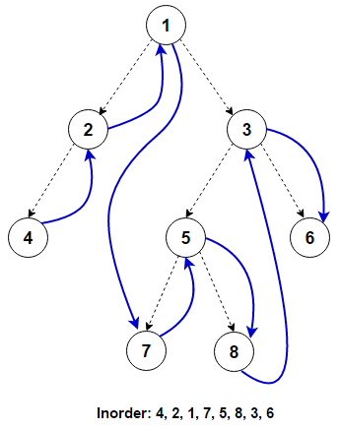
In an in-order traversal, first the left sub-tree is traversed, then the root is visited, and finally the right sub-tree is traversed.
One simple way of solving this problem is to start with an empty doubly linked list. While doing the in-order traversal of the binary tree, keep inserting each element output into the doubly linked list. But, if we look at the question carefully, the interviewer wants us to convert the binary tree to a doubly linked list in-place i.e. we should not create new nodes for the doubly linked list.
This problem can be solved recursively using a divide and conquer approach. Below is the algorithm specified.
- Start with the root node and solve left and right sub-trees recursively
- At each step, once left and right sub-trees have been processed:
  - fuse output of left subtree with root to make the intermediate result
  - fuse intermediate result (built in the previous step) with output from the right sub-tree to make the final result of the current recursive call
Complexity Analysis
Time:
Constant
O(1)
Dbl. Logarithmic
O(log log n)
Logarithmic
O(log n)
Square Root
O(√n)
Linear
O(n)
Linearithmic
O(n log n)
Quadratic
O(n2)
Exponential
O(2n)
Factorial
O(n!)
Space:
Constant
O(1)
Dbl. Logarithmic
O(log log n)
Logarithmic
O(log n)
Square Root
O(√n)
Linear
O(n)
Linearithmic
O(n log n)
Quadratic
O(n2)
Exponential
O(2n)
Factorial
O(n!)
Recursive solution has O(h) memory complexity as it will consume memory on the stack up to the height of binary tree h. It will be O(log n) for balanced tree and in worst case can be O(n).
Implementation
Java Java
Python PY
public static void BinaryTreeToDLL(Node root) {
if (root == null)
return;
BinaryTreeToDLL(root.left);
if (prev == null) { // first node in list
head = root;
} else {
prev.right = root;
root.left = prev;
}
prev = root;
BinaryTreeToDLL(root.right);
if (prev.right == null) { // last node in list
head.left = prev;
prev.right = head;
}}

Having Tech or Coding Interview? Check 👉 26 Binary Tree Interview Questions
Source: www.educative.io

Q7:
Explain what is DFS (Depth First Search) algorithm for a Graph and how does it work?
Mid

Backtracking 8

Answer
Depth First Traversal or Depth First Search is a edge based recursive algorithm for traversing (visiting) all the vertices of a graph or tree data structure using a stack. The purpose of the algorithm is to mark each vertex as visited while avoiding cycles. DFS traverse/visit each vertex exactly once and each edge is inspected exactly twice. DFS is a genuinely recursive algorithm that uses stack for backtracking purposes, not for storing the vertex discovery "front" (as is the case in BFS).
The DFS algorithm works as follows:
- Start by putting any one of the graph's vertices on top of a stack.
- Take the top item of the stack and add it to the visited list.
- Create a list of that vertex's adjacent nodes. Add the ones which aren't in the visited list to the top of the stack.
- Keep repeating steps 2 and 3 until the stack is empty.
DFS example step-by-step:
- Considering A as the starting vertex which is explored and stored in the stack.
- B successor vertex of A is stored in the stack.
- Vertex B have two successors E and F, among them alphabetically E is explored first and stored in the stack.
- The successor of vertex E, i.e., G is stored in the stack.
- Vertex G have two connected vertices, and both are already visited, so G is popped out from the stack.
- Similarly, E s also removed.
- Now, vertex B is at the top of the stack, its another node(vertex) F is explored and stored in the stack.
- Vertex F has two successor C and D, between them C is traversed first and stored in the stack.
- Vertex C only have one predecessor which is already visited, so it is removed from the stack.
- Now vertex D connected to F is visited and stored in the stack.
- As vertex D doesn’t have any unvisited nodes, therefore D is removed.
- Similarly, F, B and A are also popped.
- The generated output is – A, B, E, G, F, C, D.
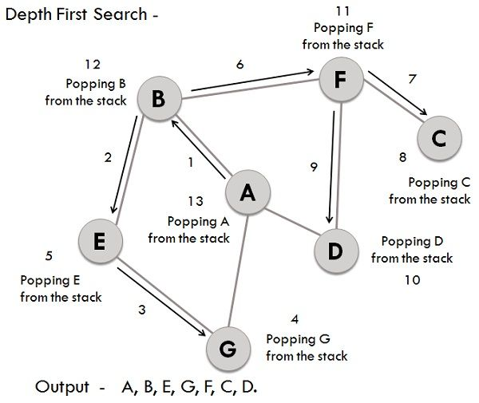

Having Tech or Coding Interview? Check 👉 8 Backtracking Interview Questions
Source: techdifferences.com

Q8:
Binet's formula: How to calculate Fibonacci numbers without Recursion or Iteration?
Senior

Fibonacci Series 14

Answer
Join FullStack.Cafe to open this Answer. It's Free!
Get Free Access To Answer
Join 120k+ Developer Who Trust FullStack.Cafe
Full-Stack, Web & Mobile
 Algorithms & Data Structures
 System Design & Architecture

 Azure 59

 jQuery 51

Kotlin 68

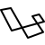 Laravel 41

LINQ 38

Design Patterns 68

OOP 58

MongoDB 77

 AngularJS 61

 Reactive Programming 12

🤖 Having Machine Learning & DS Interview? Check MLStack.Cafe - 1704 Data Science & ML Interview Questions & Answers!

Q9:
Calculate n-th Fibonacci number using Tail Recursion
Senior

Fibonacci Series 14

Answer
Join FullStack.Cafe to open this Answer. It's Free!
Get Free Access To Answer
Join 120k+ Developer Who Trust FullStack.Cafe

45 Advanced React Interview Questions (With Hooks) Devs Must Clarify and Know

React 130

Q10:
How to recursively reverse a Linked List?
Senior

 Linked Lists 43

Answer
Join FullStack.Cafe to open this Answer. It's Free!
Get Free Access To Answer
Join 120k+ Developer Who Trust FullStack.Cafe

Q11:
How to use Memoization for N-th Fibonacci number?
Senior

Dynamic Programming 12

Answer
Join FullStack.Cafe to open this Answer. It's Free!
Get Free Access To Answer
Join 120k+ Developer Who Trust FullStack.Cafe

Q12:
Is it always possible to write a non-recursive form for every Recursive function?
Senior

Recursion 9

Answer
Join FullStack.Cafe to open this Answer. It's Free!

1. Can you explain the concept of recursion?
Recursion is a fundamental concept in computer science, and understanding this concept is essential for writing efficient and effective algorithms. Interviewers may ask this question to assess your understanding of the topic, and your ability to communicate it. Define recursion and explain how it works in your response.
Example answer: Recursion is a method of solving a problem by dividing it into subproblems that are smaller versions of the main problem but take smaller inputs. The recursive function calls itself repeatedly until it reaches the base condition, which terminates the recursion. The compiler uses a stack data structure internally to implement recursion. This stack stores all information about the recursive function, such as the current state of the program and local variables.
Every time a function calls itself, the compiler allocates memory and pushes it to the top of the stack. Each function call adds another layer to this stack, where each layer has its local variables. After all the function calls are complete, the stack's top layer contains the base condition. When returning the output, the compiler pops each layer and provides the output value to the layer under it. This continues until the stack is empty. The output of the last layer solves the main problem.
Related: What Is Computer Programming? (With Definition And Types)

2. How do you determine the base case in a recursive function?
The base case is an essential component of a recursive function and determines when the recursion stops. Determining the base case is critical for avoiding infinite recursion and ensuring the function terminates successfully. Interviewers may ask this question to test your understanding of this concept and your ability to identify the base case in a recursive function. Explain what the base case is and how to use it to terminate the recursive function.
Example answer: A recursive function comprises the recursive and the base cases. With the recursive case, the function calls itself repeatedly for smaller inputs each time, while the base case decides the termination of the recursive function. An undefined recursive function runs continuously in an infinite loop. I can determine the base case by identifying the simplest problem to solve without recursion.
For example, if I want to determine the factorial of 12, I can write a recursive function that finds the factorial of each number below 12 until it reaches one. Finding the factorial of one is a simple problem that does not require recursion and determining the factorial of negative numbers is not possible. Here, the base case is the condition that the input number is one. Once the input reaches one, the recursion terminates.
Related: How To List Programming Skills On A Resume (With Examples)

3. How do you avoid infinite recursion in a recursive function?
Infinite recursion can cause a program to crash or hang and is a standard error in recursive functions. Interviewers may ask this question to determine your understanding of this concept and your approach to avoid infinite recursion. Explain what infinite recursion is and the reason for its occurrence. Mention the techniques to debug a recursive function stuck in an infinite loop.
Example answer: Infinite recursion can result in a stack overflow error, causing the program to crash. It occurs because the recursion never reaches an endpoint and calls itself repeatedly. Using a base case that terminates the recursion program avoids this. When writing a recursive program, ensure that each function call progresses towards this base case. I use conditional statements to check if the input meets a certain condition and end the recursion if the condition is true. I can test the function with various inputs to ensure that it terminates correctly and produces the expected output.
Related: Top 60 Coding Interview Questions (With Sample Answers)

4. What are the advantages and disadvantages of using recursion?
This question determines your knowledge of the pros and cons of using recursion. In your response, include reasons such as simplicity, and clarity as pros and increased memory usage along with the risk of infinite recursion as cons.
Example answer: For some algorithms, recursion is easier to write and understand than the iterative version. It is helpful for problems you can divide into smaller subproblems and solve independently. Its disadvantages include increased memory usage and runtime, which can affect code performance. Recursion problems are also harder to debug in comparison to iterative versions. If you do not define the base condition correctly, it can result in infinite recursion, causing the program to crash.
Related: 6 Common Dynamic Programming Interview Questions (With Tips)

5. How does the use of recursion affect an algorithm's time and space complexity?
Recursion can have a significant impact on the time and space complexity of an algorithm. It is helpful to understand this impact when choosing between recursion and iteration. Interviewers may ask this question to evaluate your understanding of this concept and your ability to analyse the complexity of a recursive function. Discuss the impact of recursion on the time and space complexity of an algorithm. State the formula of space and time complexity in your response.
Example answer: You can consider the recursion function similar to a recursion tree for simplicity. The breadth of the tree represents the number of recursive function calls made and is proportional to the function's time complexity. The tree's depth represents the number of return statements executed until the base condition and is proportional to the function's space complexity. As the number of levels of this tree is equal to the recursion depth, a recursive function's space complexity is O(recursion depth). The recursion depth is proportional to the size of the input n. This means a recursive function's space complexity is O(n).
The breadth of the tree is the number of nodes present in the last level of the binary tree. In a binary tree, as each node has two branches and the tree has a total depth of n, the breath of the tree is O(2n-1-1) or in order of powers of two. A recursive function's time complexity is O(2n). Using recursion can result in an exponential increase in running time and a linear increase in storage. When you use tail recursion, the time complexity becomes linear and the space complexity becomes constant.

