UNIVERSITY ACADEMIC MANAGEMENT SYSTEM
A DBMS Capstone Project Report submitted in partial fulfillment of the requirements for the award of the degree of
BACHELOR OF TECHNOLOGY
in
ARTIFICIAL INTELLIGENCE AND MACHINE LEARNING

Submitted By
P. THANU SREE – 25B11AI946
G. PARDHIVA SAI – 25B11AI346
K. SANDEEP – 25B11AI524
M. PADMAVATHI – 25B11AI717

Under the esteemed guidance of
Mr. T.Srinivasulu M.Tech, (Ph.D.)
Assistant Professor



DEPARTMENT OF ARTIFICIAL INTELLIGENCE AND MACHINE LEARNING
ADITYA UNIVERSITY
(Formerly Aditya Engineering College (A))
Aditya Nagar, ADB Road, Surampalem, Andhra Pradesh, India
2026 – 2027

Aditya Nagar, ADB Road, Surampalem, Andhra Pradesh, India
DEPARTMENT OF ARTIFICIAL INTELLIGENCE AND MACHINE LEARNING
CERTIFICATE
This is to certify that the DBMS Capstone Project report entitled “University Academic Management System” is being submitted by P. THANU SREE (Roll No. 25B11AI946), G. PARDHIVA SAI (Roll No. 25B11AI346), K. SANDEEP (Roll No. 25B11AI524) and M. PADMAVATHI (Roll No. 25B11AI717) in partial fulfillment of the requirements for the award of the B.Tech. degree in Artificial Intelligence and Machine Learning. The work documented in this report was carried out as part of the Capstone Project for the course Database Management Systems (2501IT05) during the academic year 2026–2027, and records the database design, implementation and documentation undertaken by the team.

Project Guide Head of the Department
Mr. T. Srinivasulu, M. Tech, (Ph.D.) Dr. K. Naga Bhargavi, M. Tech, Ph.D. Associate professor Associate Professor & HOD

External Examiner

DECLARATION
We hereby declare that the DBMS Capstone Project entitled “University Academic Management System” is a genuine work carried out by us. The database design, SQL implementation, queries and documentation presented in this report are our own work, completed under the guidance of Mr. T. Srinivasulu, Department of Artificial Intelligence and Machine Learning, Aditya University, Surampalem. We further declare that this work has not been submitted, in full or in part, for the award of any degree of this or any other educational institution.

Project Associates
P. THANU SREE (25B11AI946)
G. PARDHIVA SAI (25B11AI346)
K. SANDEEP (25B11AI524)
M. PADMAVATHI (25B11AI717)

Date: 29 September 2026
Place: Surampalem

ACKNOWLEDGEMENT
It is with immense pleasure that we express our sincere gratitude to our project guide, Mr. T. Srinivasulu, Assistant Professor, Department of Artificial Intelligence and Machine Learning, for his guidance, encouragement and valuable suggestions throughout this DBMS capstone project. We are grateful to Dr. K. Naga Bhargavi, Associate Professor & HOD, for providing academic support and the facilities required for completing the work.
We extend our thanks to the Management, Dr. M. Sreenivasa Reddy, Deputy Pro-Chancellor, Dr. M. B. Srinivas, Vice-Chancellor, and Dr. A. Ramesh, Pro Vice-Chancellor (Engineering & Sciences), for providing a supportive academic environment.
We also thank the teaching and non-teaching staff, our parents and our friends for their direct and indirect support. Their encouragement helped us complete the design, implementation, testing and documentation of the University Academic Management System.
Not to forget, we thank the Teaching and Non-Teaching Staff, our parents and our friends, who have directly or indirectly supported us in completing this project on time.

Project Associates
P. THANU SREE – 25B11AI946
G. PARDHIVA SAI – 25B11AI346
K. SANDEEP – 25B11AI524
M. PADMAVATHI – 25B11AI717

ABSTRACT
The University Academic Management System is a centralized relational database developed to organize and manage academic information within a university environment. The system addresses the difficulty of maintaining student, faculty, department, course, subject, enrollment, examination and attendance records when information is handled separately or manually. The database contains eight main entities/tables: Department, Faculty, Course, Student, Subject, Enrollment, Examination and Attendance. PostgreSQL is used as the database server and pgAdmin is used as the query and administration tool. The system applies primary keys, foreign keys, NOT NULL, UNIQUE, CHECK and DEFAULT constraints to maintain data accuracy, consistency and referential integrity. SQL operations implemented include DDL for table creation and alteration, DML for insertion, updating and deletion, DQL for retrieval, CRUD operations, joins, aggregate functions, GROUP BY, views and filtering. Sample academic data was inserted into all major tables and used to demonstrate database operations and validation. The resulting design is normalized up to Third Normal Form (3NF), reducing redundancy and supporting reliable storage and retrieval of university academic information.

INDEX
Chapter | Title | Page No.
 | Certificate | i
 | Declaration | ii
 | Acknowledgement | iii
 | Abstract | iv
 | List of Figures | v
 | List of Tables | vi
1 | Introduction | 9
 | 1.1 Introduction to the Domain | 9
 | 1.2 Problem Statement | 9
 | 1.3 Motivation and Need for a Database | 9
 | 1.4 Objectives of the Project | 10
 | 1.5 Scope of the Project | 10
 | 1.6 Organization of the Report | 10
2 | System Study and Tools | 11
 | 2.1 Existing System and Its Limitations | 11
 | 2.2 Proposed Database System | 11
 | 2.3 Tools and Technologies Used | 11
 | 2.4 Software and Hardware Requirements | 12
3 | Database Design (Review – I) | 13
 | 3.1 Identified Entities | 13
 | 3.2 Entity Attributes and Attribute Types | 13
 | 3.3 ER Diagram | 13
 | 3.4 Relationships and Cardinality | 14
 | 3.5 Relational Database Schema | 15
 | 3.6 Primary Keys and Foreign Keys | 15
 | 3.7 Normalization up to 3NF | 16
4 | Database Implementation (Review – II) | 17
 | 4.1 Database and Table Creation – DDL | 17
 | 4.2 Sample Data Insertion – DML | 18
 | 4.3 Constraints and Data Integrity | 19
 | 4.4 Data Validation Rules | 20
5 | SQL Operations and Queries | 21
 | 5.1 DQL – Basic Retrieval Queries | 21
 | 5.2 Join Operations | 21
 | 5.3 Aggregate Functions, GROUP BY and HAVING | 21
 | 5.4 Nested and Correlated Subqueries | 21
 | 5.5 Views and Relational Set Operations | 22
 | 5.6 DCL and TCL Operations | 22
6 | Modules and Functionalities | 23
7 | Results – Sample Outputs and Screenshots | 24
8 | Testing and Data Validation | 26
9 | GitHub Repository and Team Contribution | 27
10 | Conclusion and Future Enhancements | 28
 | References | 29
 | Appendix A – Complete SQL Script | 30

LIST OF FIGURES
Figure No. | Title of the Figure | Page No.
3.1 | ER Diagram of the University Academic Management System | 13
3.2 | Relational Schema Diagram | 15
4.1 | Successful Creation of Tables | 18
4.2 | Sample Data Inserted | 19
4.3 | Referential Integrity Validation | 20
7.1 | Sample academic data output | 24
7.2 | Highest subject credits query | 24
7.3 | Subjects grouped by semester | 25
7.4 | Subject details output | 25

LIST OF TABLES
Table No. | Title of the Table | Page No.
2.1 | Tools and Technologies Used | 11
2.2 | Software and Hardware Requirements | 12
3.1 | Entities Identified | 12
3.2 | Entity Attributes | 12
3.3 | Relationships and Cardinality | 13
3.4 | Relational Database Schema | 14
3.5 | Primary and Foreign Key Definitions | 15
3.6 | Normalization Steps | 16
4.1 | Sample Data Summary | 18
4.2 | Constraints and Data Integrity Rules | 19
5.1 | Basic Retrieval Queries | 21
5.2 | Join Operations | 21
5.3 | Aggregate, GROUP BY and HAVING Queries | 21
5.4 | Nested and Correlated Subqueries | 21
5.5 | Views and Set Operations | 22
5.6 | DCL and TCL Operations | 22
6.1 | Modules and Their Functionalities | 23
8.1 | Test Cases and Results | 26
9.1 | Team Responsibilities | 27
9.2 | Review-wise Progress Record | 27

CHAPTER 1: INTRODUCTION

1.1 Introduction to the Domain
The selected domain is University Academic Management. A university handles a large volume of academic information every day, including student profiles, faculty details, departments, courses, subjects, enrollment records, examinations and attendance. These records are related to one another and need to be maintained consistently so that academic information can be retrieved accurately when required.
The proposed University Academic Management System provides a centralized relational database for these activities. It connects the major academic entities through primary and foreign keys and applies integrity constraints to reduce duplication, prevent invalid values and maintain valid relationships.

1.2 Problem Statement
When academic information is maintained manually or in separate files, duplicate and inconsistent records can occur. Student and faculty information, course and subject details, enrollment, attendance and examination records may become difficult to maintain and retrieve. Preparing reports and checking relationships between records can also take additional time. The proposed centralized database addresses these limitations by storing related information in structured tables connected through keys and constraints.

1.3 Motivation and Need for a Database
A DBMS is required because the academic data is related, frequently accessed and subject to integrity rules. Files or spreadsheets can lead to duplicated information, inconsistent updates and difficulty enforcing relationships. A relational DBMS provides structured tables, primary and foreign keys, constraints, SQL querying and controlled data manipulation. PostgreSQL therefore provides a suitable foundation for maintaining the academic records in a consistent and retrievable form.

1.4 Objectives of the Project
Objective 1: To develop a centralized database for university academic information.
Objective 2: To maintain student and faculty records in an organized manner.
Objective 3: To manage departments, courses, subjects, and semesters efficiently.
Objective 4: To record and manage enrollment, attendance, marks, and examinations.
Objective 5: To generate accurate results and academic reports quickly.
Objective 6: To reduce duplicate data and improve data accuracy.
Objective 7: To provide secure and controlled access to academic information.

1.5 Scope of the Project
The project covers the database design and implementation of university academic records: student and faculty information, departments, courses, subjects, enrollment, examinations and attendance. It includes ER modelling, relational schema design, normalization up to 3NF, table creation, sample data, constraints, SQL operations and validation. The current scope does not include a front-end application, user authentication, role-based access control, automated reporting, stored procedures/triggers or production backup and recovery. These are considered future enhancements.

1.6 Organization of the Report
This report is organized into ten chapters. Chapter 1 introduces the university academic domain, problem, motivation, objectives and scope. Chapter 2 describes the existing and proposed systems and the tools used. Chapter 3 presents the entities, attributes, ER diagram, relationships, relational schema, keys and normalization. Chapter 4 documents DDL, sample data, constraints and validation. Chapter 5 presents SQL operations and queries. Chapter 6 explains system modules. Chapter 7 contains execution screenshots. Chapter 8 records testing and validation. Chapter 9 documents GitHub and team contribution. Chapter 10 presents the conclusion, limitations and future enhancements, followed by references and the complete SQL appendix.

CHAPTER 2: SYSTEM STUDY AND TOOLS

2.1 Existing System and Its Limitations
In the existing approach, academic information may be maintained through separate files, spreadsheets or manually managed records. This can cause duplicate student or faculty information, inconsistent updates, missing values, weak relationship enforcement and slower retrieval. It also makes it harder to prepare consolidated academic information from several record types.

2.2 Proposed Database System
The proposed system stores the academic information in eight related PostgreSQL tables. Primary keys uniquely identify records and foreign keys connect departments, faculty, courses, subjects, students, enrollment, examinations and attendance. Constraints such as NOT NULL, UNIQUE, CHECK and DEFAULT improve data integrity. SQL queries allow the stored information to be retrieved and manipulated efficiently.

2.3 Tools and Technologies Used
Table 2.1: Tools and Technologies Used
Category | Tool / Technology Used | Version / Remarks
Database Server | PostgreSQL | Relational DBMS
Query / Admin Tool | pgAdmin | SQL execution and administration
ER Diagram Tool | diagrams.net / draw.io | ER and schema modelling
Version Control | GitHub | Repository and collaboration
Documentation | Microsoft Word | Final report
Operating System | Windows | Development environment

PostgreSQL is used as the relational database server; pgAdmin is used for SQL execution and database administration; diagrams.net/draw.io is used for ER modelling; GitHub is used for version control and project files; Microsoft Word is used for documentation. Operating system: Windows.

2.4 Software and Hardware Requirements
Software: PostgreSQL, pgAdmin, diagrams.net/draw.io, GitHub and Microsoft Word on Windows. Hardware: a standard laptop/desktop with a modern multi-core processor, at least 4 GB RAM, sufficient storage for PostgreSQL and project files, keyboard, mouse and display. An internet connection is useful for GitHub access and documentation resources.
Requirement Type | Specification
Software | PostgreSQL + pgAdmin; diagrams.net; GitHub; MS Word
OS | Windows
Processor | Modern multi-core processor
RAM | 4 GB minimum recommended
Storage | Adequate free space for DBMS and project files
Network | Internet access for GitHub/resources

CHAPTER 3: DATABASE DESIGN
(Deliverables of Review – I)

3.1 Identified Entities
Minimum six entities are required. Give a one-line description of each.
Table 3.1: Entities Identified for the Selected Domain
S.No | Entity Name | Description
1 | Student | Stores personal and academic information of students.
2 | Faculty | Stores information about faculty members.
3 | Department | Stores department details such as department name, HOD and office location.
4 | Course | Stores courses offered by departments.
5 | Subject | Stores subject, credits, semester, course and faculty details.
6 | Enrollment | Stores student enrollment details for courses.
7 | Examination | Stores examination details for students and subjects.
8 | Attendance | Stores attendance date and present/absent status for students and subjects.

3.2 Entity Attributes and Attribute Types
List every attribute of every entity. Mark the key column as PK, FK or —, and classify each attribute as Simple, Composite, Multi-valued or Derived.
Table 3.2: Attributes of Each Entity
Entity | Attribute | Data Type | Key (PK / FK / —) | Attribute Type
Student | Student_ID | INT | PK | Simple
Student | Student_Name | VARCHAR(100) | — | Simple
Student | Date_of_Birth | DATE | — | Simple
Student | Gender | VARCHAR(10) | — | Simple
Student | Email | VARCHAR(100) | — | Simple
Student | Phone | VARCHAR(15) | — | Simple
Student | Address | VARCHAR(200) | — | Simple
Student | Course_ID | INT | FK | Simple
Faculty | Faculty_ID | INT | PK | Simple
Faculty | Faculty_Name | VARCHAR(100) | — | Simple
Faculty | Email | VARCHAR(100) | — | Simple
Faculty | Phone | VARCHAR(15) | — | Simple
Faculty | Designation | VARCHAR(50) | — | Simple
Faculty | Department_ID | INT | FK | Simple
Department | Department_ID | INT | PK | Simple
Department | Department_Name | VARCHAR(100) | — | Simple
Department | HOD_Name | VARCHAR(100) | — | Simple
Department | Office_Location | VARCHAR(100) | — | Simple
Course | Course_ID | INT | PK | Simple
Course | Course_Name | VARCHAR(100) | — | Simple
Course | Duration | INT | — | Simple
Course | Department_ID | INT | FK | Simple
Subject | Subject_ID | INT | PK | Simple
Subject | Subject_Name | VARCHAR(100) | — | Simple
Subject | Credits | INT | — | Simple
Subject | Semester | INT | — | Simple
Subject | Course_ID | INT | FK | Simple
Subject | Faculty_ID | INT | FK | Simple
Enrollment | Enrollment_ID | INT | PK | Simple
Enrollment | Student_ID | INT | FK | Simple
Enrollment | Course_ID | INT | FK | Simple
Enrollment | Enrollment_Date | DATE | — | Simple
Examination | Exam_ID | INT | PK | Simple
Examination | Student_ID | INT | FK | Simple
Examination | Subject_ID | INT | FK | Simple
Examination | Exam_Type | VARCHAR(50) | — | Simple
Examination | Exam_Date | DATE | — | Simple
Examination | Total_Marks | INT | — | Simple
Attendance | Attendance_ID | INT | PK | Simple
Attendance | Student_ID | INT | FK | Simple
Attendance | Subject_ID | INT | FK | Simple
Attendance | Attendance_Date | DATE | — | Simple
Attendance | Status | VARCHAR(20) | — | Simple

3.3 ER Diagram
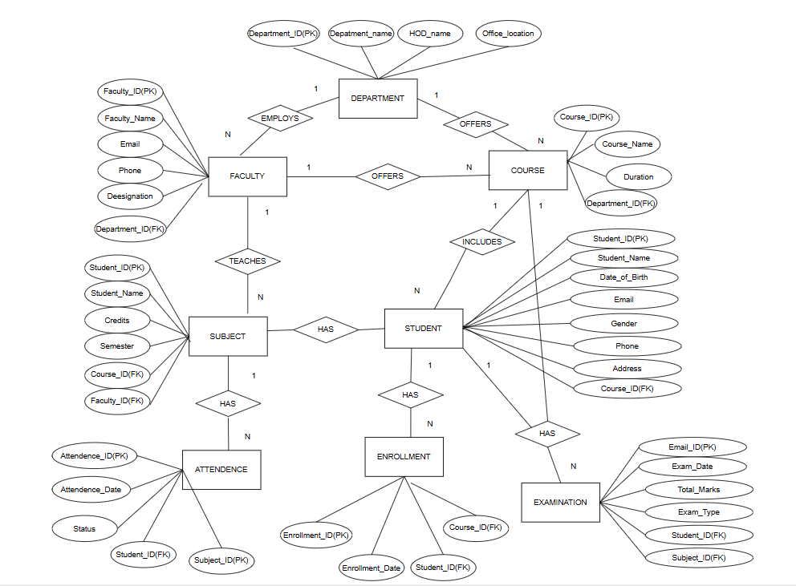

Fig. 3.1: ER Diagram of the University Academic Management System

3.4 Relationships and Cardinality
Table 3.3: Relationships and Cardinality
Entity 1 | Relationship | Entity 2 | Cardinality (1:1 / 1:N / M:N) | Participation
Department | Has Faculty | Faculty | 1:N | Faculty participates; Department can have many Faculty
Department | Offers | Course | 1:N | Course belongs to one Department
Faculty | Teaches | Subject | 1:N | Subject is assigned to one Faculty
Course | Contains | Student | 1:N | Student is assigned to one Course
Student | Enrolls in | Course | M:N | Implemented through Enrollment
Course | Has | Subject | 1:N | Subject belongs to one Course
Student | Has | Examination | 1:N | Examination belongs to one Student
Subject | Has | Examination | 1:N | Examination belongs to one Subject
Student | Has | Attendance | 1:N | Attendance belongs to one Student
Subject | Has | Attendance | 1:N | Attendance belongs to one Subject

3.5 Relational Database Schema
Table 3.4: Relational Database Schema
Table Name | Column Name | Data Type | Key (PK / FK / —) | Constraints
Department | Department_ID | INT | PK | PRIMARY KEY; NOT NULL; UNIQUE name; DEFAULT office
Faculty | Faculty_ID | INT | PK | PRIMARY KEY; NOT NULL; UNIQUE email/phone; FK Department_ID
Course | Course_ID | INT | PK | PRIMARY KEY; UNIQUE name; CHECK Duration > 0; FK Department_ID
Student | Student_ID | INT | PK | PRIMARY KEY; NOT NULL; UNIQUE email/phone; CHECK gender; FK Course_ID
Subject | Subject_ID | INT | PK | PRIMARY KEY; UNIQUE name; CHECK Credits/Semester; FK Course_ID, Faculty_ID
Enrollment | Enrollment_ID | INT | PK | PRIMARY KEY; UNIQUE(Student_ID,Course_ID); FK Student_ID, Course_ID
Examination | Exam_ID | INT | PK | PRIMARY KEY; NOT NULL; CHECK Total_Marks; FK Student_ID, Subject_ID
Attendance | Attendance_ID | INT | PK | PRIMARY KEY; DEFAULT date; CHECK Status; FK Student_ID, Subject_ID

Schema Diagram
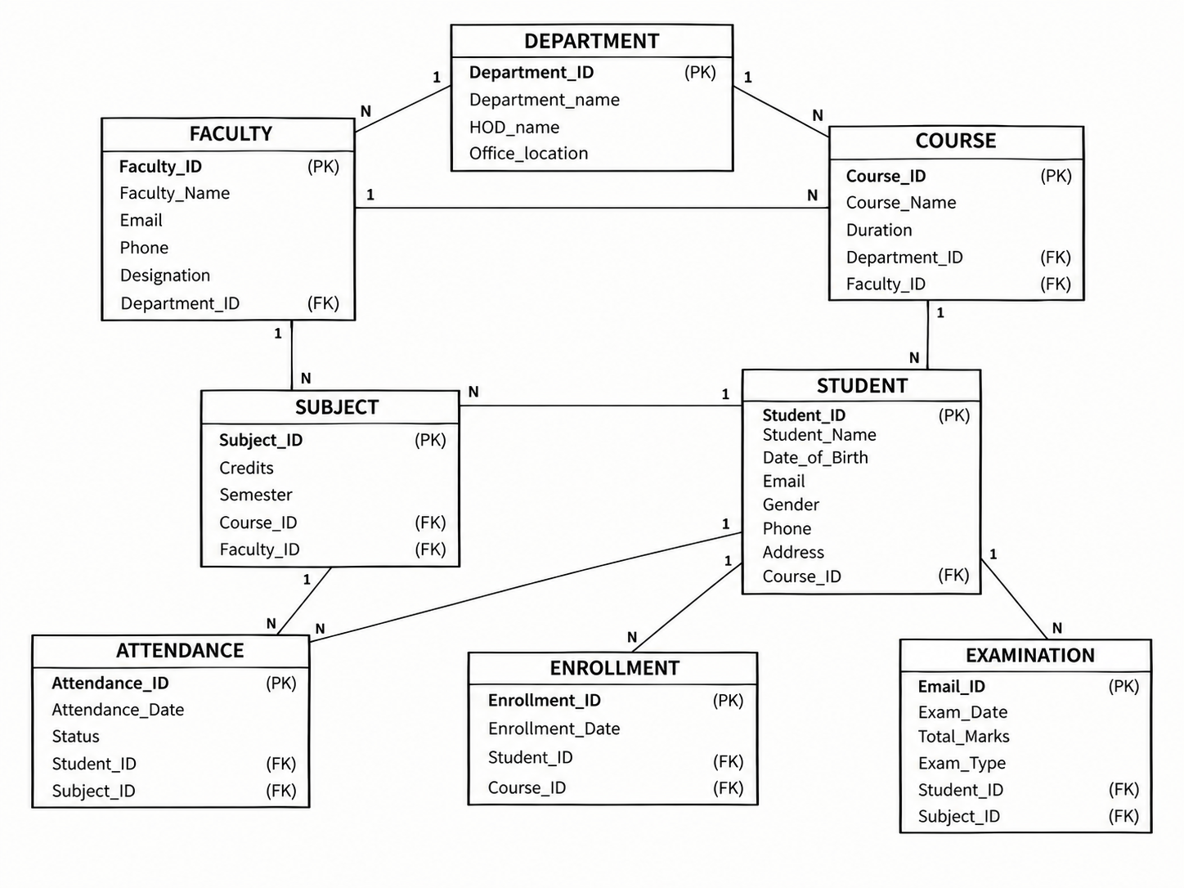

Fig. 3.2: Relational Schema Diagram

3.6 Primary Keys and Foreign Keys
Table 3.5: Primary Key and Foreign Key Definitions
Table | Primary Key | Foreign Key | References (Table.Column)
Department | Department_ID | — | —
Faculty | Faculty_ID | Department_ID | Department.Department_ID
Course | Course_ID | Department_ID | Department.Department_ID
Student | Student_ID | Course_ID | Course.Course_ID
Subject | Subject_ID | Course_ID, Faculty_ID | Course.Course_ID; Faculty.Faculty_ID
Enrollment | Enrollment_ID | Student_ID, Course_ID | Student.Student_ID; Course.Course_ID
Examination | Exam_ID | Student_ID, Subject_ID | Student.Student_ID; Subject.Subject_ID
Attendance | Attendance_ID | Student_ID, Subject_ID | Student.Student_ID; Subject.Subject_ID

3.7 Normalization up to 3NF
The functional dependencies are represented by the primary-key structure: Student_ID determines student details; Faculty_ID determines faculty details; Department_ID determines department details; Course_ID determines course details; Subject_ID determines subject details; Enrollment_ID determines enrollment details; Exam_ID determines examination details; and Attendance_ID determines attendance details. Foreign keys represent dependencies between related entities. The design reaches 3NF by keeping each entity's descriptive attributes in its own table and linking related entities through foreign keys.
UNF → 1NF → 2NF → 3NF
Table 3.6: Normalization Steps
Normal Form | Condition Satisfied | Anomaly Removed | Resulting Tables
UNF | Academic records may contain repeated/combined information. | Repeating groups and duplicated details. | Student/Faculty/Course/Subject etc. identified
1NF | Each attribute stores one atomic value; no repeating groups. | Repeating groups and multi-valued fields. | Atomic columns in all eight tables
2NF | Non-key attributes depend on the whole primary key. | Partial dependency in composite-key designs. | Separate entities and associative Enrollment table
3NF | Non-key attributes depend only on the key. | Transitive dependency and update anomalies. | Eight related normalized tables

CHAPTER 4: DATABASE IMPLEMENTATION
(Deliverables of Review – II)

4.1 Database and Table Creation – DDL
Paste the CREATE DATABASE and CREATE TABLE statements for all tables, including NOT NULL, UNIQUE, CHECK, DEFAULT, PRIMARY KEY and FOREIGN KEY constraints. Include any ALTER statements used.
CREATE TABLE Department (
Department_ID INT PRIMARY KEY,
Department_Name VARCHAR(100) NOT NULL UNIQUE,
HOD_Name VARCHAR(100) NOT NULL,
Office_Location VARCHAR(100) DEFAULT 'Main Block'
);
CREATE TABLE Faculty (
Faculty_ID INT PRIMARY KEY,
Faculty_Name VARCHAR(100) NOT NULL,
Email VARCHAR(100) NOT NULL UNIQUE,
Phone VARCHAR(15) UNIQUE,
Designation VARCHAR(50) DEFAULT 'Assistant Professor',
Department_ID INT NOT NULL,
FOREIGN KEY (Department_ID) REFERENCES Department(Department_ID)
);
CREATE TABLE Course (
Course_ID INT PRIMARY KEY,
Course_Name VARCHAR(100) NOT NULL UNIQUE,
Duration INT CHECK (Duration > 0),
Department_ID INT NOT NULL,
FOREIGN KEY (Department_ID) REFERENCES Department(Department_ID)
);
CREATE TABLE Student (
Student_ID INT PRIMARY KEY,
Student_Name VARCHAR(100) NOT NULL,
Date_of_Birth DATE NOT NULL,
Gender VARCHAR(10) CHECK (Gender IN ('Male','Female','Other')),
Email VARCHAR(100) NOT NULL UNIQUE,
Phone VARCHAR(15) UNIQUE,
Address VARCHAR(200) DEFAULT 'Not Provided',
Course_ID INT NOT NULL,
FOREIGN KEY (Course_ID) REFERENCES Course(Course_ID)
);
CREATE TABLE Subject (
Subject_ID INT PRIMARY KEY,
Subject_Name VARCHAR(100) NOT NULL UNIQUE,
Credits INT CHECK (Credits BETWEEN 1 AND 6),
Semester INT CHECK (Semester BETWEEN 1 AND 8),
Course_ID INT NOT NULL,
Faculty_ID INT NOT NULL,
FOREIGN KEY (Course_ID) REFERENCES Course(Course_ID),
FOREIGN KEY (Faculty_ID) REFERENCES Faculty(Faculty_ID)
);
CREATE TABLE Enrollment (
Enrollment_ID INT PRIMARY KEY,
Student_ID INT NOT NULL,
Course_ID INT NOT NULL,
Enrollment_Date DATE DEFAULT CURRENT_DATE,
FOREIGN KEY (Student_ID) REFERENCES Student(Student_ID),
FOREIGN KEY (Course_ID) REFERENCES Course(Course_ID),
UNIQUE (Student_ID, Course_ID)
);
CREATE TABLE Examination (
Exam_ID INT PRIMARY KEY,
Student_ID INT NOT NULL,
Subject_ID INT NOT NULL,
Exam_Type VARCHAR(50) NOT NULL,
Exam_Date DATE NOT NULL,
Total_Marks INT DEFAULT 100 CHECK (Total_Marks > 0),
FOREIGN KEY (Student_ID) REFERENCES Student(Student_ID),
FOREIGN KEY (Subject_ID) REFERENCES Subject(Subject_ID)
);
CREATE TABLE Attendance (
Attendance_ID INT PRIMARY KEY,
Student_ID INT NOT NULL,
Subject_ID INT NOT NULL,
Attendance_Date DATE DEFAULT CURRENT_DATE,
Status VARCHAR(20) DEFAULT 'Present' CHECK (Status IN ('Present','Absent')),
FOREIGN KEY (Student_ID) REFERENCES Student(Student_ID),
FOREIGN KEY (Subject_ID) REFERENCES Subject(Subject_ID)
);

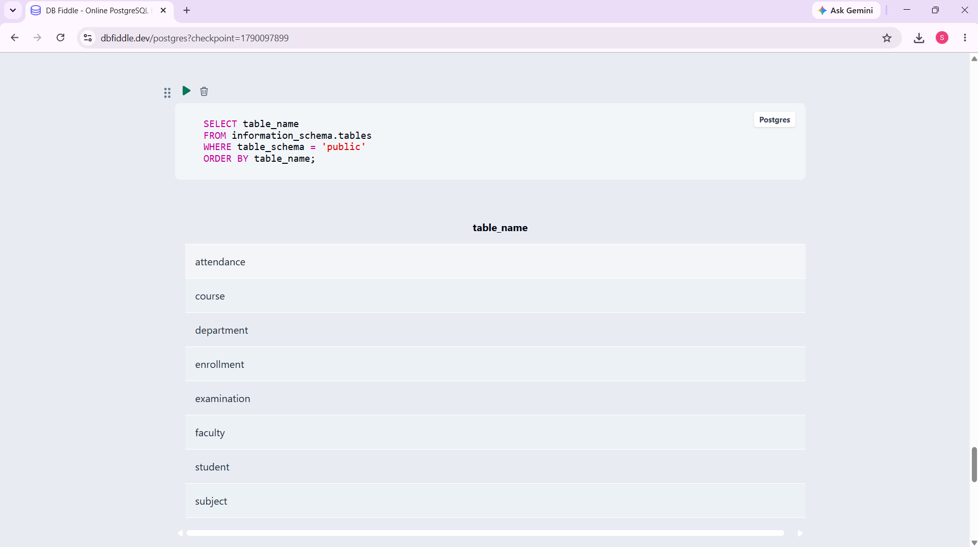

Fig. 4.1: Successful creation of the University Academic Management System tables in PostgreSQL/pgAdmin.

4.2 Sample Data Insertion – DML
Insert sufficient sample data into every table. Include INSERT, UPDATE and DELETE examples.
Table 4.1: Sample Data Summary
S.No | Table Name | No. of Records Inserted | Screenshot Reference
1 | Department | 3 | Fig. 4.2
2 | Faculty | 4 | Fig. 4.2
3 | Course | 3 | Fig. 4.2
4 | Student | 5 | Fig. 4.2
5 | Subject | 5 | Fig. 4.2
6 | Enrollment | 5 | Fig. 4.2
7 | Examination | 5 | Fig. 4.2
8 | Attendance | 5 | Fig. 4.2

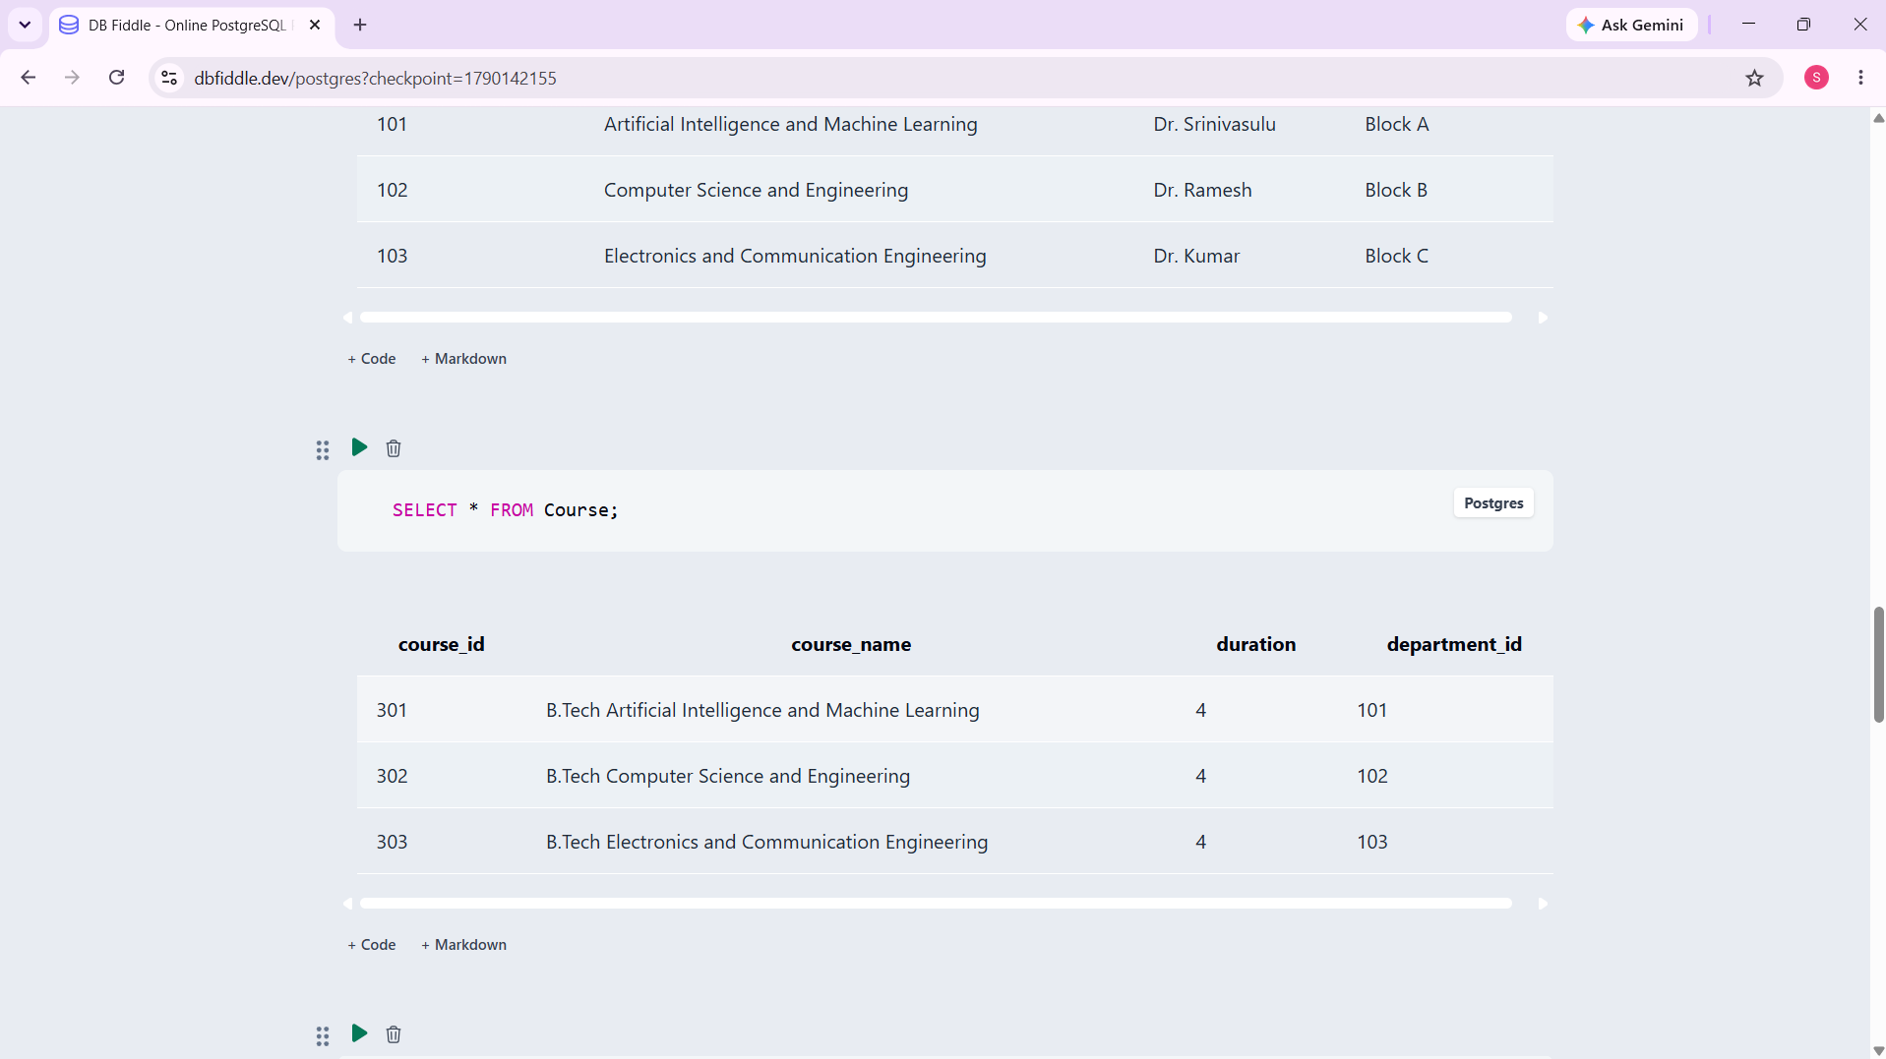

Fig. 4.2: Sample data inserted and queried in the PostgreSQL database.

4.3 Constraints and Data Integrity
Table 4.2: Constraints and Data Integrity Rules
Constraint / Validation | Applied On (Table.Column) | Purpose | Evidence / Screenshot Ref.
PRIMARY KEY | All 8 tables | Uniquely identifies each record and prevents duplicate IDs. | DDL / table definition
FOREIGN KEY | Faculty.Department_ID; Course.Department_ID; Student.Course_ID | Maintains valid relationships and referential integrity. | DDL / FK definitions
NOT NULL | Names, IDs and required academic fields | Prevents missing mandatory values. | DDL / constraints
UNIQUE | Department_Name, Faculty Email/Phone, Course_Name, Student Email/Phone, Subject_Name | Prevents duplicate important values. | DDL / constraints
CHECK | Student.Gender; Course.Duration; Subject.Credits/Semester; Attendance.Status; Examination.Total_Marks | Restricts values to valid ranges/categories. | DDL / constraints
DEFAULT | Office_Location, Designation, Enrollment_Date, Total_Marks, Attendance_Date, Status | Provides sensible values when omitted. | DDL / constraints
COMPOSITE UNIQUE | Enrollment(Student_ID,Course_ID) | Prevents duplicate enrollment of the same student in the same course. | DDL / constraint
REFERENTIAL INTEGRITY | All foreign-key columns | Prevents orphan records that reference nonexistent parent rows. | Integrity test

4.4 Data Validation Rules
Duplicate IDs are prevented by primary keys and unique constraints; invalid values are rejected by CHECK constraints; missing mandatory data is rejected by NOT NULL; and orphan records are prevented by foreign keys. Example validation: attempting to insert a Faculty row with a Department_ID that does not exist causes a PostgreSQL foreign-key violation. Example: INSERT INTO Faculty VALUES (205,'Test Faculty','test@university.com','9999999999','Assistant Professor',999);
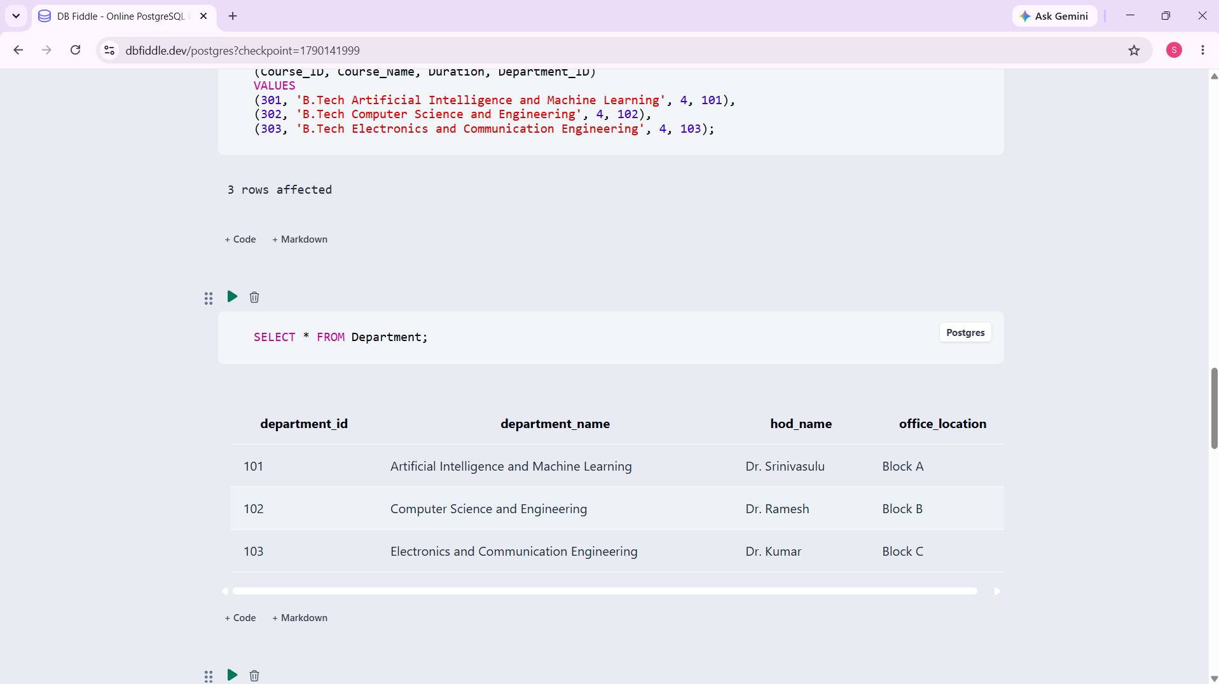

Fig. 4.3: Referential Integrity Enforced by the Database

CHAPTER 5: SQL OPERATIONS AND QUERIES

5.1 DQL – Basic Retrieval Queries
Table 5.1: Basic Retrieval Queries
Q.No | Purpose of the Query | SQL Statement | Output Ref.
Q1 | Display all student records | SELECT * FROM Student; | Student table output
Q2 | Display subject names | SELECT Subject_Name FROM Subject; | Subject list
Q3 | Filter female students | SELECT * FROM Student WHERE Gender = 'Female'; | Female student rows
Q4 | Display examinations | SELECT Subject_ID, Exam_Type, Exam_Date, Total_Marks FROM Examination; | Examination rows
Q5 | Display students alphabetically | SELECT * FROM Student ORDER BY Student_Name; | Sorted student rows

5.2 Join Operations
Table 5.2: Join Operations
Q.No | Type of Join | SQL Statement | Output Ref.
Q6 | NATURAL JOIN | SELECT Student_Name, Course_Name FROM Student NATURAL JOIN Course; | Student-course output
Q7 | EQUI JOIN | SELECT Student_Name, Course_Name FROM Student JOIN Course ON Student.Course_ID=Course.Course_ID; | Student-course output
Q8 | INNER JOIN | SELECT Subject_Name, Faculty_Name FROM Subject INNER JOIN Faculty ON Subject.Faculty_ID=Faculty.Faculty_ID; | Subject-faculty output
Q9 | LEFT OUTER JOIN | SELECT Course_Name, Student_Name FROM Course LEFT JOIN Student ON Course.Course_ID=Student.Course_ID; | All courses with students
Q10 | RIGHT OUTER JOIN | SELECT Course_Name, Student_Name FROM Student RIGHT JOIN Course ON Student.Course_ID=Course.Course_ID; | All courses retained
Q11 | FULL OUTER JOIN | SELECT Department_Name, Course_Name FROM Department FULL OUTER JOIN Course ON Department.Department_ID=Course.Department_ID; | All departments/courses

5.3 Aggregate Functions, GROUP BY and HAVING
Table 5.3: Aggregate, GROUP BY and HAVING Queries
Q.No | Function Used | SQL Statement | Output Ref.
Q12 | COUNT | SELECT COUNT(*) AS Total_Students FROM Student; | 5
Q13 | COUNT + GROUP BY | SELECT Course_ID, COUNT(*) AS Student_Count FROM Student GROUP BY Course_ID; | 301→2, 302→2, 303→1
Q14 | MAX | SELECT MAX(Total_Marks) AS Highest_Marks FROM Examination; | 100
Q15 | MIN / AVG | SELECT MIN(Total_Marks) AS Lowest_Marks, AVG(Total_Marks) AS Average_Marks FROM Examination; | 0/100? Use actual sample: both 100
Q16 | GROUP BY + HAVING | SELECT Faculty_ID, COUNT(*) AS Subject_Count FROM Subject GROUP BY Faculty_ID HAVING COUNT(*) >= 1; | Faculty subject counts

5.4 Nested and Correlated Subqueries
Table 5.4: Subqueries
Q.No | Type (Nested / Correlated) | SQL Statement | Output Ref.
Q17 | Nested | SELECT Student_Name FROM Student WHERE Course_ID IN (SELECT Course_ID FROM Course WHERE Duration=4); | Students in 4-year courses
Q18 | Nested | SELECT Subject_Name FROM Subject WHERE Credits=(SELECT MAX(Credits) FROM Subject); | Subjects with highest credits
Q19 | Nested | SELECT Student_Name FROM Student WHERE Student_ID IN (SELECT Student_ID FROM Examination WHERE Total_Marks=(SELECT MAX(Total_Marks) FROM Examination)); | Students with maximum marks
Q20 | Correlated | SELECT s.Student_Name FROM Student s WHERE EXISTS (SELECT 1 FROM Examination e WHERE e.Student_ID=s.Student_ID); | Students having exams
Q21 | Correlated | SELECT sub.Subject_Name FROM Subject sub WHERE (SELECT COUNT(*) FROM Examination e WHERE e.Subject_ID=sub.Subject_ID)>0; | Subjects having examinations

5.5 Views and Relational Set Operations
Table 5.5: Views and Set Operations
Q.No | View / Set Operation | SQL Statement | Output Ref.
Q22 | Updatable view | CREATE VIEW Student_Basic_View AS SELECT Student_ID, Student_Name, Email FROM Student; | View creation
Q23 | Non-updatable view | CREATE VIEW Student_Course_View AS SELECT Student_Name, Course_Name FROM Student JOIN Course ON Student.Course_ID=Course.Course_ID; | Join view
Q24 | UNION | SELECT Course_ID FROM Student UNION SELECT Course_ID FROM Enrollment; | 301,302,303
Q25 | INTERSECT | SELECT Course_ID FROM Student INTERSECT SELECT Course_ID FROM Enrollment; | 301,302,303
Q26 | EXCEPT | SELECT Course_ID FROM Course EXCEPT SELECT Course_ID FROM Enrollment; | No rows with current sample data

5.6 DCL and TCL Operations
Table 5.6: DCL and TCL Operations
Q.No | Command | Purpose | SQL Statement | Output Ref.
Q27 | GRANT | Give SELECT permission | GRANT SELECT ON Student TO academic_user; | Permission granted if role exists
Q28 | REVOKE | Remove SELECT permission | REVOKE SELECT ON Student FROM academic_user; | Permission revoked
Q29 | COMMIT | Make transaction changes permanent | COMMIT; | Transaction committed
Q30 | SAVEPOINT | Create a rollback point | SAVEPOINT before_update; | Savepoint created
Q31 | ROLLBACK | Undo changes to savepoint | ROLLBACK TO SAVEPOINT before_update; | Changes after savepoint undone
Q32 | ROLLBACK | Cancel uncommitted transaction | ROLLBACK; | Transaction rolled back

CHAPTER 6: MODULES AND FUNCTIONALITIES
Table 6.1: Modules and Their Functionalities
S.No | Module Name | Functionality | Tables Involved
1 | Student Management | Stores student ID, name, DOB, gender, email, phone, address and course. | Student, Course
2 | Faculty Management | Maintains faculty identity, contact details, designation and department. | Faculty, Department
3 | Department Management | Manages department name, HOD and office location. | Department
4 | Course Management | Stores course name, duration and associated department. | Course, Department
5 | Subject Management | Manages subject name, credits, semester and assigned course/faculty. | Subject, Course, Faculty
6 | Enrollment Management | Records student enrollment in courses and enrollment dates. | Enrollment, Student, Course
7 | Examination Management | Stores examination type, date and total marks for students and subjects. | Examination, Student, Subject
8 | Attendance Management | Records attendance date and Present/Absent status. | Attendance, Student, Subject

The modules collectively provide a structured view of the academic database. Student and faculty modules manage people-related records; department, course and subject modules manage academic structure; enrollment connects students with courses; examination stores assessment records; and attendance records student presence for subjects. Foreign keys connect these modules so that related information remains consistent.

CHAPTER 7: RESULTS – SAMPLE OUTPUTS AND SCREENSHOTS

Fig. 7.1: Sample academic data and query output in PostgreSQL/pgAdmin.
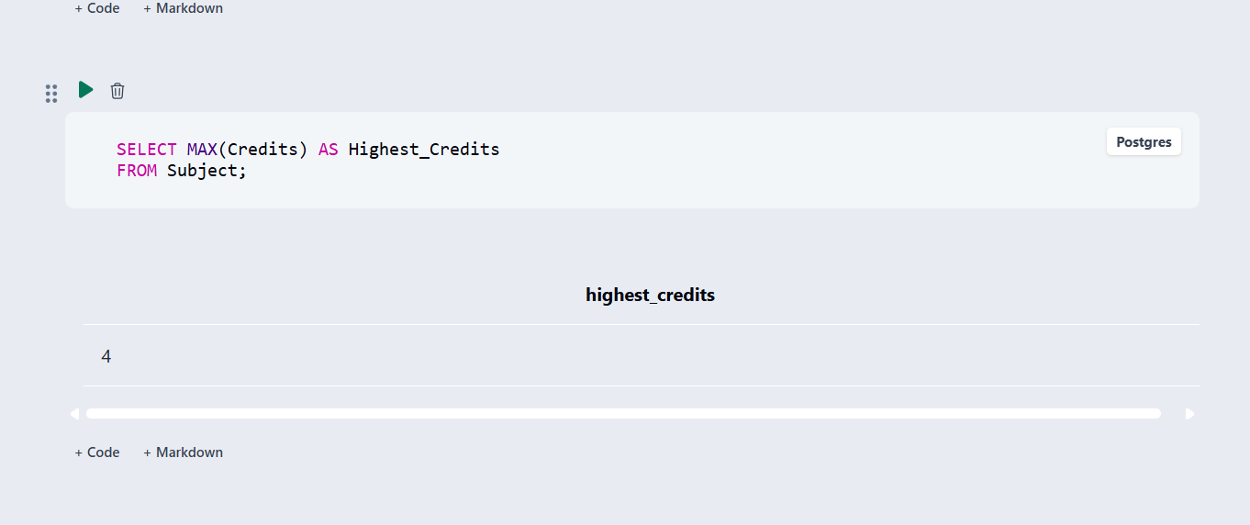

Fig. 7.2: Query to find the highest subject credits.
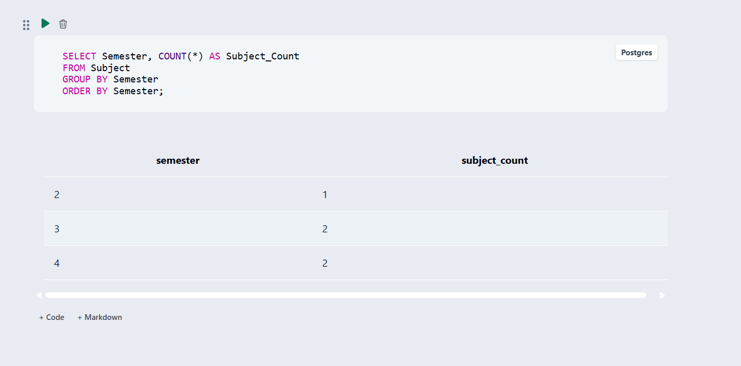

Fig. 7.3: Subjects grouped by semester.
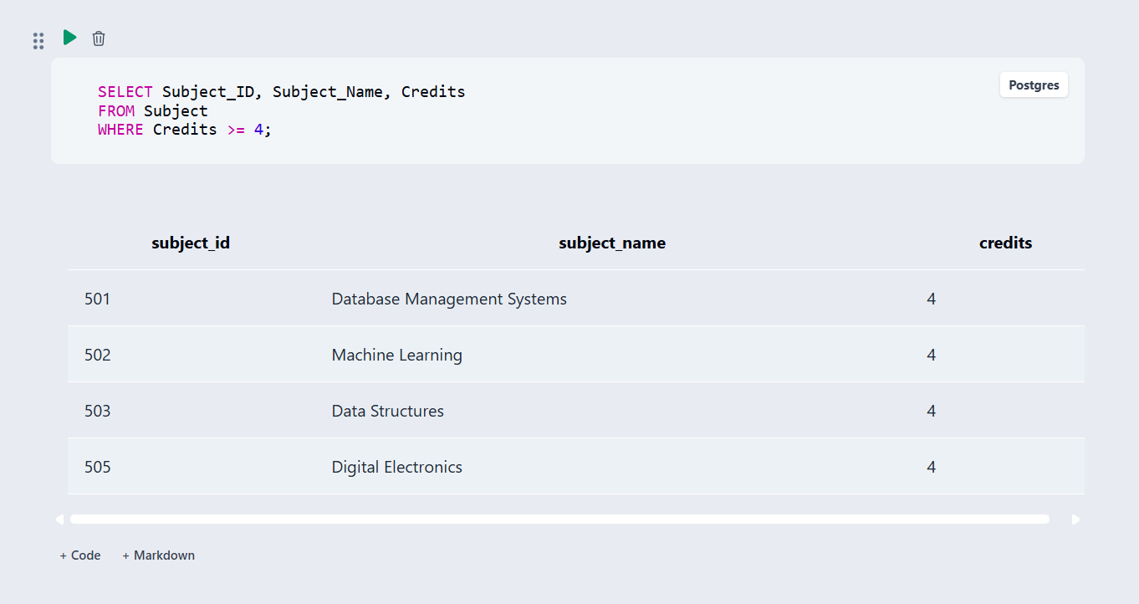

Fig. 7.4: Subject details retrieved from the database.

CHAPTER 8: TESTING AND DATA VALIDATION
Record the test cases used to verify the database. Include constraint tests, referential integrity tests and query-correctness tests.
Table 8.1: Test Cases and Results
TC No. | Test Case Description | Input / Action | Expected Result | Actual Result | Status
TC1 | Primary key uniqueness | Insert duplicate Student_ID 401 | Duplicate key error | Duplicate rejected | PASS
TC2 | Foreign key integrity | Insert Faculty with Department_ID 999 | Foreign key violation | Invalid parent reference rejected | PASS
TC3 | NOT NULL | Insert Student without Student_Name | NOT NULL violation | Missing mandatory value rejected | PASS
TC4 | UNIQUE | Insert duplicate Student email | Unique violation | Duplicate email rejected | PASS
TC5 | CHECK Gender | Insert Gender='Unknown' | CHECK violation | Invalid gender rejected | PASS
TC6 | CHECK Credits | Insert Credits=9 | CHECK violation | Invalid credit value rejected | PASS
TC7 | Enrollment uniqueness | Repeat same Student_ID and Course_ID | Unique constraint violation | Duplicate enrollment rejected | PASS
TC8 | DQL correctness | SELECT * FROM Student | Five sample student rows | Five rows retrieved | PASS
TC9 | Join correctness | Student JOIN Course | Student-course pairs | Related course names returned | PASS

CHAPTER 9: GITHUB REPOSITORY AND TEAM CONTRIBUTION

9.1 Repository Details
GitHub Repository Link: To be inserted by the team after confirming the final repository URL.
The final SQL script and all project files must be pushed to the team repository.

9.2 Team Responsibilities and Contribution
Table 9.1: Team Responsibilities
S.No | Student Name | Roll Number | Role / Responsibility | Modules Contributed
1 | P. THANU SREE | 25B11AI946 | Database design & documentation | ER design, schema, documentation
2 | G. PARDHIVA SAI | 25B11AI346 | SQL implementation | DDL, constraints, sample data
3 | K. SANDEEP | 25B11AI524 | SQL operations & testing | DML/DQL, joins, aggregate queries, validation
4 | M. PADMAVATHI | 25B11AI717 | Presentation & outputs | Screenshots, module description, presentation

9.3 Review-wise Progress
Table 9.2: Review-wise Progress Record
Review | Date | Deliverables Presented | Remarks of the Guide
Review I | As per review schedule | Problem, objectives, entities, attributes, ER diagram, relationships, schema, PK/FK and normalization | Design review completed
Review II | As per review schedule | Database creation, constraints, sample data, DDL/DML/DQL, CRUD, joins, aggregates, views and validation | Implementation review completed
Final | 29 Sep 2026 | Final documentation, screenshots, conclusion and SQL appendix | Final report prepared

CHAPTER 10: CONCLUSION AND FUTURE ENHANCEMENTS

10.1 Conclusion
The University Academic Management System provides a centralized relational database for managing eight academic entities: Department, Faculty, Course, Student, Subject, Enrollment, Examination and Attendance. The design uses primary and foreign keys and is normalized up to 3NF. PostgreSQL was used for implementation and pgAdmin for database administration and SQL execution. DDL, DML, DQL, CRUD operations, joins, aggregate functions, GROUP BY, views and validation queries were demonstrated. The objectives were addressed by organizing academic records, connecting related tables, enforcing integrity constraints and supporting retrieval and manipulation of sample academic information.

10.2 Limitations of the Present Work
The current implementation is a database-focused academic project. It does not yet provide a dedicated web or desktop front end, user authentication, role-based access control, automated report generation, stored procedures/triggers, advanced indexing, production backup/recovery or a complete result/grade calculation module. The sample dataset is also limited and is intended for demonstration rather than real university deployment.

10.3 Future Enhancements
Future enhancements include a user-friendly web or desktop interface; authentication and role-based access control; automated student, examination and attendance reports; a result management module for marks and grades; attendance percentage reports; stored procedures and triggers for automation; indexes and query optimization for larger datasets; backup and recovery; stronger security and audit controls; and scalability for larger academic populations.

REFERENCES
References used for the project include PostgreSQL documentation, pgAdmin documentation, standard DBMS textbooks and the project team's SQL implementation materials.
- PostgreSQL Global Development Group, “PostgreSQL Documentation,” https://www.postgresql.org/docs/
- pgAdmin Development Team, “pgAdmin Documentation,” https://www.pgadmin.org/docs/
- Abraham Silberschatz, Henry F. Korth and S. Sudarshan, “Database System Concepts,” 8th Edition, McGraw-Hill.
- Ramez Elmasri and Shamkant B. Navathe, “Fundamentals of Database Systems,” 7th Edition, Pearson.
- Raghu Ramakrishnan and Johannes Gehrke, “Database Management Systems,” 3rd/4th Edition, McGraw-Hill.

APPENDIX A – COMPLETE SQL SCRIPT
Appendix A contains the complete SQL script used for database creation, sample data, DDL/DML/DQL, CRUD, joins, aggregate queries, subqueries, views, set operations and transaction/access-control demonstrations.
CREATE TABLE Department (
Department_ID INT PRIMARY KEY,
Department_Name VARCHAR(100) NOT NULL UNIQUE,
HOD_Name VARCHAR(100) NOT NULL,
Office_Location VARCHAR(100) DEFAULT 'Main Block'
);
CREATE TABLE Faculty (
Faculty_ID INT PRIMARY KEY,
Faculty_Name VARCHAR(100) NOT NULL,
Email VARCHAR(100) NOT NULL UNIQUE,
Phone VARCHAR(15) UNIQUE,
Designation VARCHAR(50) DEFAULT 'Assistant Professor',
Department_ID INT NOT NULL,
FOREIGN KEY (Department_ID) REFERENCES Department(Department_ID)
);
CREATE TABLE Course (
Course_ID INT PRIMARY KEY,
Course_Name VARCHAR(100) NOT NULL UNIQUE,
Duration INT CHECK (Duration > 0),
Department_ID INT NOT NULL,
FOREIGN KEY (Department_ID) REFERENCES Department(Department_ID)
);
CREATE TABLE Student (
Student_ID INT PRIMARY KEY,
Student_Name VARCHAR(100) NOT NULL,
Date_of_Birth DATE NOT NULL,
Gender VARCHAR(10) CHECK (Gender IN ('Male','Female','Other')),
Email VARCHAR(100) NOT NULL UNIQUE,
Phone VARCHAR(15) UNIQUE,
Address VARCHAR(200) DEFAULT 'Not Provided',
Course_ID INT NOT NULL,
FOREIGN KEY (Course_ID) REFERENCES Course(Course_ID)
);
CREATE TABLE Subject (
Subject_ID INT PRIMARY KEY,
Subject_Name VARCHAR(100) NOT NULL UNIQUE,
Credits INT CHECK (Credits BETWEEN 1 AND 6),
Semester INT CHECK (Semester BETWEEN 1 AND 8),
Course_ID INT NOT NULL,
Faculty_ID INT NOT NULL,
FOREIGN KEY (Course_ID) REFERENCES Course(Course_ID),
FOREIGN KEY (Faculty_ID) REFERENCES Faculty(Faculty_ID)
);
CREATE TABLE Enrollment (
Enrollment_ID INT PRIMARY KEY,
Student_ID INT NOT NULL,
Course_ID INT NOT NULL,
Enrollment_Date DATE DEFAULT CURRENT_DATE,
FOREIGN KEY (Student_ID) REFERENCES Student(Student_ID),
FOREIGN KEY (Course_ID) REFERENCES Course(Course_ID),
UNIQUE (Student_ID, Course_ID)
);
CREATE TABLE Examination (
Exam_ID INT PRIMARY KEY,
Student_ID INT NOT NULL,
Subject_ID INT NOT NULL,
Exam_Type VARCHAR(50) NOT NULL,
Exam_Date DATE NOT NULL,
Total_Marks INT DEFAULT 100 CHECK (Total_Marks > 0),
FOREIGN KEY (Student_ID) REFERENCES Student(Student_ID),
FOREIGN KEY (Subject_ID) REFERENCES Subject(Subject_ID)
);
CREATE TABLE Attendance (
Attendance_ID INT PRIMARY KEY,
Student_ID INT NOT NULL,
Subject_ID INT NOT NULL,
Attendance_Date DATE DEFAULT CURRENT_DATE,
Status VARCHAR(20) DEFAULT 'Present' CHECK (Status IN ('Present','Absent')),
FOREIGN KEY (Student_ID) REFERENCES Student(Student_ID),
FOREIGN KEY (Subject_ID) REFERENCES Subject(Subject_ID)
);
-- SAMPLE DATA
INSERT INTO Department VALUES (101,'Computer Science','Dr. Ravi Kumar','Block A');
INSERT INTO Department VALUES (102,'Artificial Intelligence','Dr. Priya Sharma','Block B');
INSERT INTO Department VALUES (103,'Electronics','Dr. Suresh Rao','Block C');
INSERT INTO Faculty VALUES (201,'Anil Kumar','anil@university.com','9876543210','Professor',101);
INSERT INTO Faculty VALUES (202,'Swathi Reddy','swathi@university.com','9876543211','Assistant Professor',101);
INSERT INTO Faculty VALUES (203,'Kiran Das','kiran@university.com','9876543212','Associate Professor',102);
INSERT INTO Faculty VALUES (204,'Meena Devi','meena@university.com','9876543213','Assistant Professor',103);
INSERT INTO Course VALUES (301,'B.Tech CSE',4,101);
INSERT INTO Course VALUES (302,'B.Tech AI & ML',4,102);
INSERT INTO Course VALUES (303,'B.Tech ECE',4,103);
INSERT INTO Student VALUES (401,'Rahul','2005-05-15','Male','rahul@gmail.com','9000000001','Kakinada',301);
INSERT INTO Student VALUES (402,'Sneha','2006-02-20','Female','sneha@gmail.com','9000000002','Rajahmundry',302);
INSERT INTO Student VALUES (403,'Arjun','2005-12-10','Male','arjun@gmail.com','9000000003','Amalapuram',301);
INSERT INTO Student VALUES (404,'Priya','2006-03-25','Female','priya@gmail.com','9000000004','Vizag',303);
INSERT INTO Student VALUES (405,'Kavya','2006-07-12','Female','kavya@gmail.com','9000000005','Kakinada',302);
INSERT INTO Subject VALUES (501,'Database Management Systems',4,3,301,201);
INSERT INTO Subject VALUES (502,'Python Programming',4,3,302,203);
INSERT INTO Subject VALUES (503,'Data Structures',4,3,301,202);
INSERT INTO Subject VALUES (504,'Digital Electronics',3,3,303,204);
INSERT INTO Subject VALUES (505,'Artificial Intelligence',4,3,302,203);
INSERT INTO Enrollment VALUES (601,401,301,'2026-07-01');
INSERT INTO Enrollment VALUES (602,402,302,'2026-07-02');
INSERT INTO Enrollment VALUES (603,403,301,'2026-07-01');
INSERT INTO Enrollment VALUES (604,404,303,'2026-07-03');
INSERT INTO Enrollment VALUES (605,405,302,'2026-07-02');
INSERT INTO Examination VALUES (701,401,501,'Mid term','2026-08-10',100);
INSERT INTO Examination VALUES (702,402,502,'Mid term','2026-08-11',100);
INSERT INTO Examination VALUES (703,403,503,'Mid term','2026-08-12',100);
INSERT INTO Examination VALUES (704,404,504,'Mid term','2026-08-13',100);
INSERT INTO Examination VALUES (705,405,505,'Mid term','2026-08-14',100);
INSERT INTO Attendance VALUES (801,401,501,'2026-08-20','Present');
INSERT INTO Attendance VALUES (802,402,502,'2026-08-20','Present');
INSERT INTO Attendance VALUES (803,403,503,'2026-08-20','Absent');
INSERT INTO Attendance VALUES (804,401,503,'2026-08-21','Present');
INSERT INTO Attendance VALUES (805,402,501,'2026-08-21','Present');
-- DDL TEST
CREATE TABLE Test_Table (Test_ID INT PRIMARY KEY, Test_Name VARCHAR(50) NOT NULL);
ALTER TABLE Test_Table ADD Test_Date DATE;
DROP TABLE Test_Table;
-- DML TEST
INSERT INTO Department VALUES (104,'Mechanical','Dr. Kumar','Block D');
UPDATE Department SET HOD_Name='Dr. Anil Kumar' WHERE Department_ID=104;
DELETE FROM Department WHERE Department_ID=104;
-- DQL / CRUD
SELECT * FROM Student;
SELECT Subject_Name FROM Subject;
SELECT * FROM Student WHERE Gender='Female';
INSERT INTO Student VALUES (406,'Ravi','2006-03-15','Male','ravi@gmail.com','9000000006','Kakinada',301);
SELECT * FROM Student WHERE Student_ID=406;
UPDATE Student SET Address='Rajahmundry' WHERE Student_ID=406;
DELETE FROM Student WHERE Student_ID=406;
-- JOINS
SELECT Student_Name, Course_Name FROM Student NATURAL JOIN Course;
SELECT Student_Name, Course_Name FROM Student JOIN Course ON Student.Course_ID=Course.Course_ID;
SELECT Subject_Name, Faculty_Name FROM Subject INNER JOIN Faculty ON Subject.Faculty_ID=Faculty.Faculty_ID;
SELECT Course_Name, Student_Name FROM Course LEFT JOIN Student ON Course.Course_ID=Student.Course_ID;
SELECT Course_Name, Student_Name FROM Student RIGHT JOIN Course ON Student.Course_ID=Course.Course_ID;
SELECT Department_Name, Course_Name FROM Department FULL OUTER JOIN Course ON Department.Department_ID=Course.Department_ID;
-- AGGREGATES
SELECT COUNT(*) AS Total_Students FROM Student;
SELECT Course_ID, COUNT(*) AS Student_Count FROM Student GROUP BY Course_ID;
SELECT Faculty_ID, COUNT(*) AS Subject_Count FROM Subject GROUP BY Faculty_ID;
SELECT MAX(Total_Marks) AS Highest_Marks FROM Examination;
SELECT MIN(Total_Marks) AS Lowest_Marks FROM Examination;
SELECT AVG(Total_Marks) AS Average_Marks FROM Examination;
SELECT Faculty_ID, COUNT(*) AS Subject_Count FROM Subject GROUP BY Faculty_ID HAVING COUNT(*)>=1;
-- SUBQUERIES
SELECT Student_Name FROM Student WHERE Course_ID IN (SELECT Course_ID FROM Course WHERE Duration=4);
SELECT Subject_Name FROM Subject WHERE Credits=(SELECT MAX(Credits) FROM Subject);
SELECT Student_Name FROM Student WHERE Student_ID IN (SELECT Student_ID FROM Examination WHERE Total_Marks=(SELECT MAX(Total_Marks) FROM Examination));
SELECT s.Student_Name FROM Student s WHERE EXISTS (SELECT 1 FROM Examination e WHERE e.Student_ID=s.Student_ID);
SELECT sub.Subject_Name FROM Subject sub WHERE (SELECT COUNT(*) FROM Examination e WHERE e.Subject_ID=sub.Subject_ID)>0;
-- VIEWS
CREATE VIEW Student_Basic_View AS SELECT Student_ID, Student_Name, Email FROM Student;
SELECT * FROM Student_Basic_View;
CREATE VIEW Student_Course_View AS SELECT Student_Name, Course_Name FROM Student JOIN Course ON Student.Course_ID=Course.Course_ID;
SELECT * FROM Student_Course_View;
-- SET OPERATIONS
SELECT Course_ID FROM Student UNION SELECT Course_ID FROM Enrollment;
SELECT Course_ID FROM Student INTERSECT SELECT Course_ID FROM Enrollment;
SELECT Course_ID FROM Course EXCEPT SELECT Course_ID FROM Enrollment;
-- DCL (requires an existing role)
GRANT SELECT ON Student TO academic_user;
REVOKE SELECT ON Student FROM academic_user;
-- TCL
BEGIN;
SAVEPOINT before_update;
UPDATE Student SET Address='Rajahmundry' WHERE Student_ID=401;
ROLLBACK TO SAVEPOINT before_update;
COMMIT;

