1.Generate a python code to check whether a number is prime or not and take input in dynamic way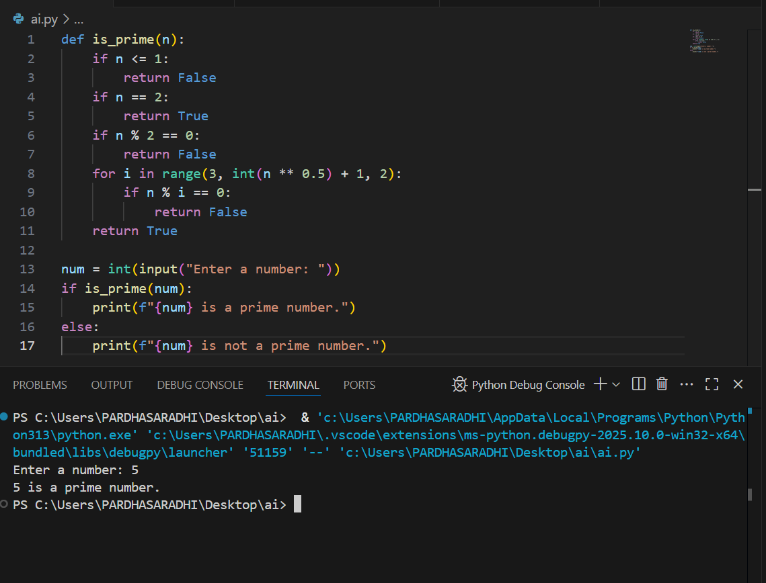

2.Generate a python code to reverse a string using function and take input in dynamic way

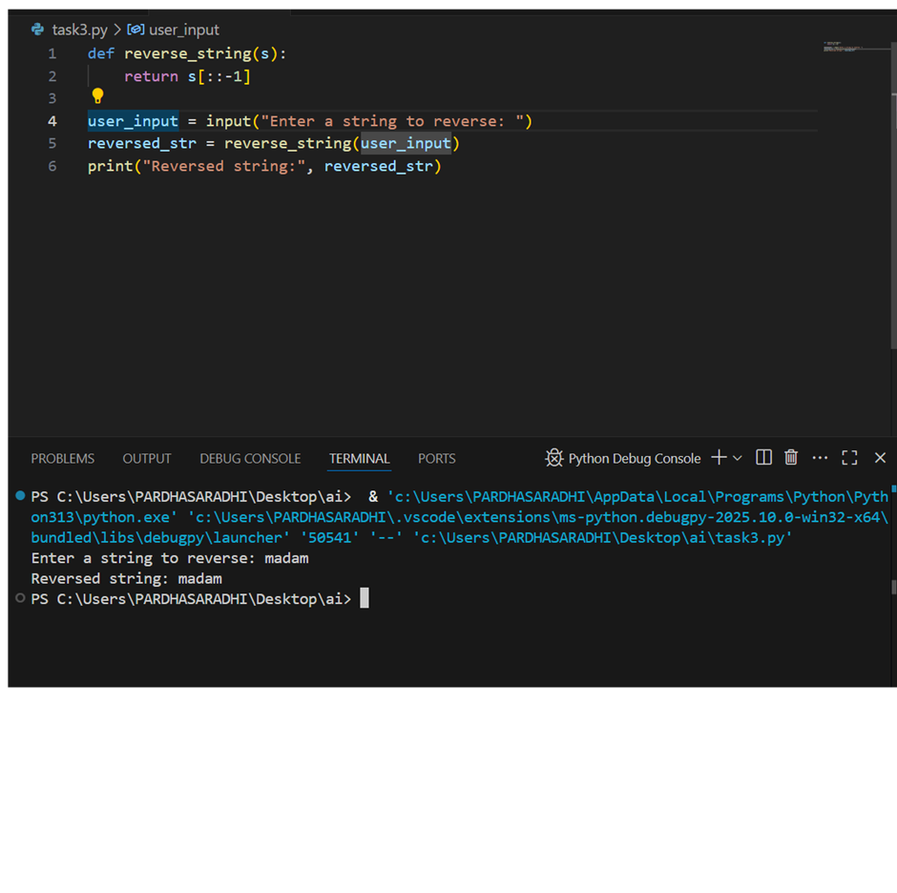

3.Generate both recursive and iterative version of a factorial using comments by python program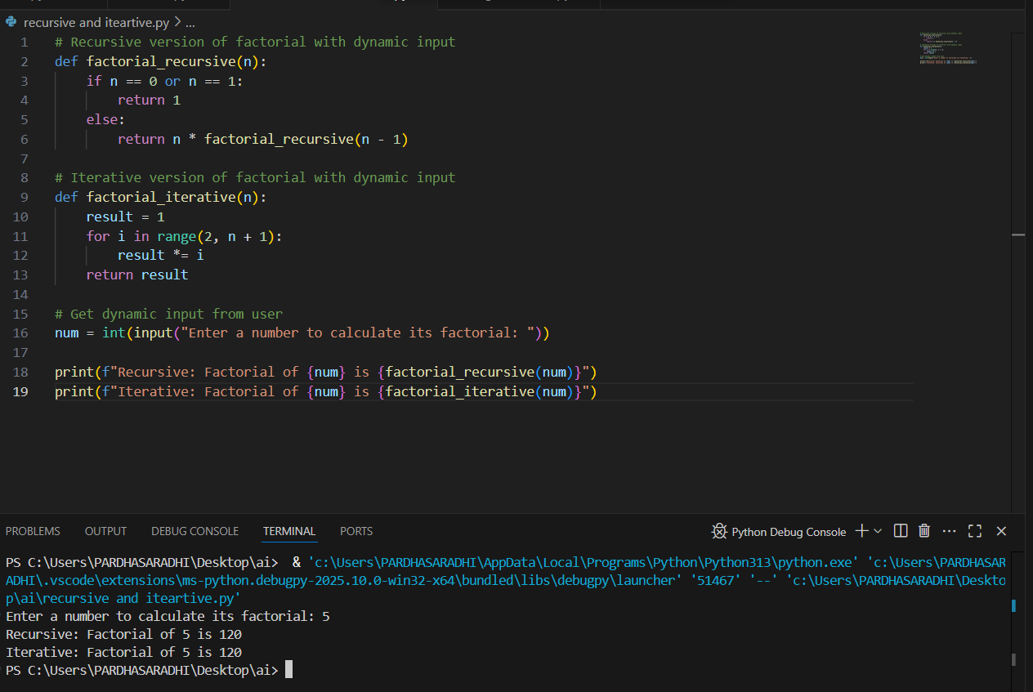

4.Generate a python code to find the largest number in a list and assess code *quality* and efficiency 