LAB-7.2

TOPIC :

Error Debugging with AI

Name : K.Pardhasaradhi

Enrollment_no : 2403a52001

Batch_no : 01

Date: 16-09-2025

Task-01: Syntax Error in Conditionals

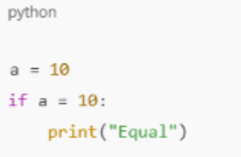

Used prompt :

a = 10 if a =10: print("equal")

identify and mention the error in the given code and correct the code.

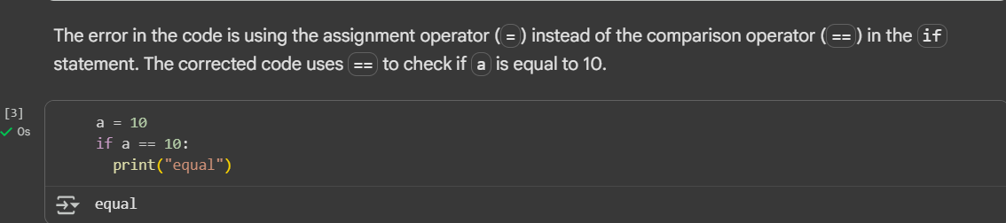

Observation: The error in the given code is in the if statement .The given code contains a=10 . The correct way of using Comparing Operater is a==10.

Task-02: Loop Off-By-One Error

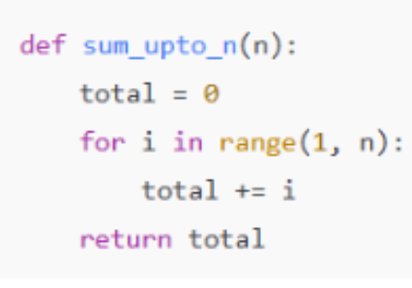

Used prompt :

def sum_upto_n(n): total = 0 for i in range(1,n): total += i return total .identify and mention the error in the given code and correct the code.

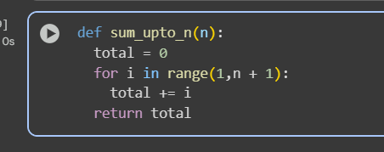

Observation: I have observed that a small logical error in the sum_upto_n function. The range(1,n) function generates numbers from 1 upto, but not including,n. to include the n in the sum we use range(1,n+1).

Task-03: AttributeError  
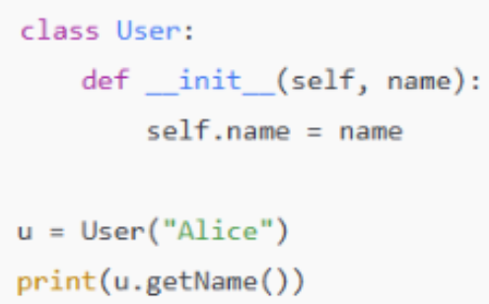

Used prompt :

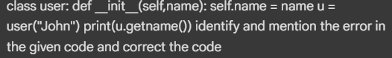

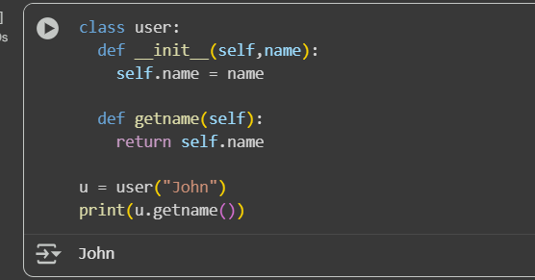

Observation:I have observed that a Attribute Error .there is no attribute present in user object .therefore we need to add a method called getname to the class that will returns the users name .

Task-04:

Incorrect Class Attribute Initialization.

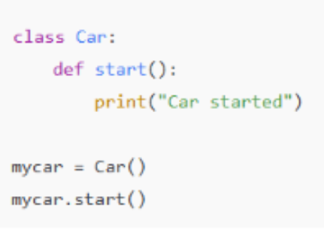

Used prompt :

class car: def start(): print("car started") mycar=car() mycar.start() identify and mention the error in the given.

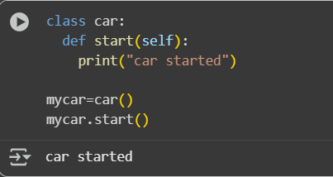

Observation:I have observed that there is no one argument present in the car.start() function. I have included self as the parament in the start method.

Task-05:

Conditional Logic Error in Grading System

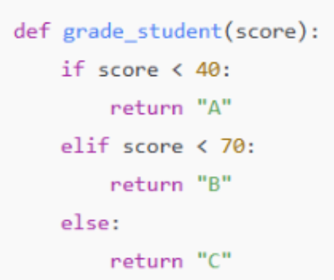

Used prompt :

def grade_student(score):

if score < 40:

return "A"

elif score < 70:

return "B"

else: return "C"

in this code, make changes that if score >:= 90 return A if score < 70 return B else return C.

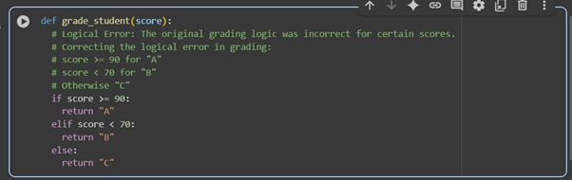

Observation:In this code we have a logical error. The corrected logic is that if score >=90 return A, if score > 70 return B and if score < 40 return C