SPACE LAW

Space law can be described as the body of law governing space-related activities. Space law, much like general international law, comprises a variety of international agreements, treaties, conventions, and United Nations General Assembly resolutions as well as rules and regulations of international organizations.
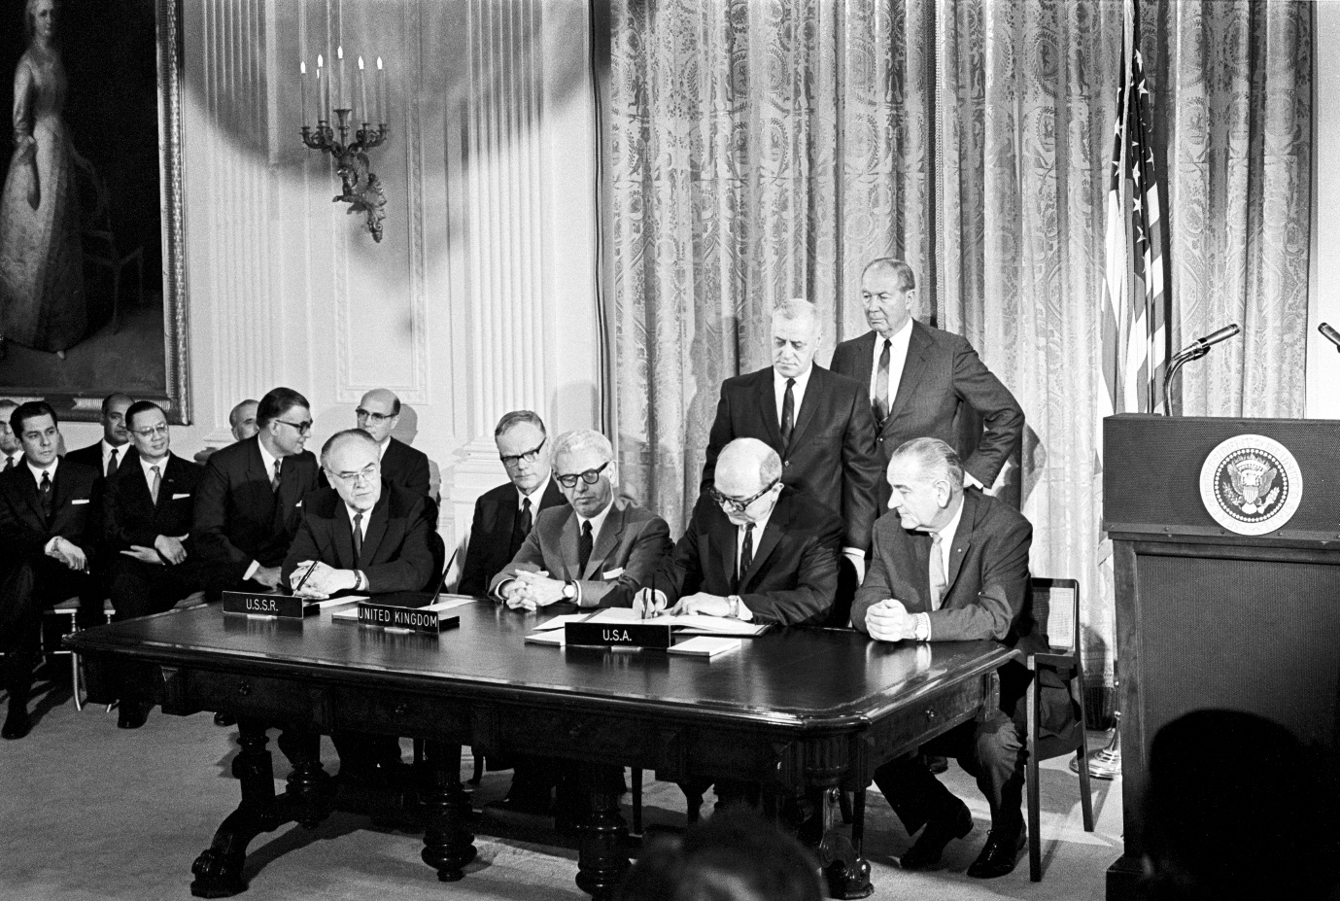Photo: UN PhotoThe term "space law" is most often associated with the rules, principles and standards of international law appearing in the five international treaties and five sets of principles governing outer space which have been developed under the auspices of the United Nations. In addition to these international instruments, many states have national legislation governing space-related activities.
Space law addresses a variety of matters, such as, for example, the preservation of the space and Earth environment, liability for damages caused by space objects, the settlement of disputes, the rescue of astronauts, the sharing of information about potential dangers in outer space, the use of space-related technologies, and international cooperation. A number of fundamental principles guide the conduct of space activities, including the notion of space as the province of all humankind, the freedom of exploration and use of outer space by all states without discrimination, and the principle of non-appropriation of outer space.
The Office provides information and advice, upon request, to governments, non-governmental organizations and the general public on space law in order to promote understanding, acceptance and implementation of the international space law agreements concluded under United Nations auspices. Tailored legal advisory services are provided through a mandated, extra-budgetary Global Space Law project, which assist Member States with developing, revising and/or implementing their national space legislation, regulation and policies.

The Evolution of Astromathematics: A Journey of 14 Years (2012-2026)
Meritorious Professor Dr. Syed Arif Kamal profdrakamal@gmail.com • vita
PhD; MA (Astrophysics), Johns Hopkins; MS (Gravitation Physics), Indiana; MSc, summa cum laude (Theoretical Physics, special courses in Space Physics), Ex-Acting Vice Chancellor and Ex-Dean, Faculties of Science and Engineering, University of Karachi, PO Box No. 8423, Karachi 75270, Pakistan
Visiting Faculty, IST, Islamabad, Consultant, GNC Labs.* & Ex-SSO, Control-Systems Labs., SUPARCO (Plant)
Astromathematics focuses on geometry to study orbits from a kinematical perspective. This branch of mathematics was introduced by the speaker on October 8, 2012 (Fig. 1) during the First National Conference on Space Sciences (NCSS 2012). In contrast to astrodynamics, the force expressions do not, explicitly, appear in the formulation of astromathematics. Even if there appears a need to study force interactions, these are expressed as space-time-curvature equivalents. This formulation seems to be, generically, more suitable for accelerated frames governed by geometrodynamics. This keynote lecture shall cover the evolution of astromathematics during the last 13 years. With space entrepreneurship as the focus of the current technological era, this lecture should emphasize the importance of developing commercial satellite-launching sites in Pakistan, which has the unique advantage of being near the equatorial circle, hence offering saving in fuel consumption as the velocity of earth rotation is added up in the velocity of satellites to be launched.
The speaker worked in developing these technologies indigenously, in particular, explicit-guidance schemes (for a spacecraft approaching a destination, explicit-guidance scheme draws a path containing the current position of spacecraft, destination and center-of-earth in order to compute velocity vectors required to achieve the destination during the remaining transfer time) for satellite-launch vehicles, viz. the Lambert scheme with cross-range error included, the multistage-Lambert scheme, the inverse-Lambert scheme, the multistage-$Q$ system, the inverse-$Q$ system as well as the extended-$Q$ system, through a deep study of astrodynamics and space-flight dynamics (the speaker was able to point out and to communicate mistakes in Richard H. Battin's classic on the subject, who, very kindly, acknowledged them in his letter). Cross-product steering, put forward by Battin, was incomplete and needed an additional condition. This condition was added by the speaker and the new control law (a control law is a relation, which is implemented on the original system to make it perform according to pre-decided standards) was termed as the extended-cross-product steering, which was later adapted for the normal-component-cross-product steering.
Further, the dot-product steering and the normal-component-dot-product steering were formulated (if the components of velocity perpendicular and normal to the desired orbit are made to vanish, the spacecraft shall remain in that orbit unless there is a perturbation applied) and, finally, the ellipse-orientation steering. Two-body problem in the elliptic-astrodynamical-coördinate mesh, reducing the degrees-of-freedom from 12 to 1 (Fig. 2) as well as the hyperbolic-astrodynamical-coördin mesh has, already, been set up. Control laws, (extended-cross-product steering and dot-product steering) were expressed in the hyperbolic-astrodynamical-coördinate mesh.
Air-Spacecrafts of the Third Millennium, traveling on the elliptical trajectory, ASTM 786-E, was proposed in 2010, and the one traveling on the hyperbolic trajectory, ASTM 786-H, was proposed in October of this year. Later, VTOHL (vertical take-off and hovercraft-landing), stealth and pilotless modes were added as well as GPS navigation replaced by INS navigation to prevent ASTM 786-H-M from EMP attacks and GP-signal blocking/blinding. Recently, nuclear-weapon-carrying capability was added to the system. Further contributions include computation of down-range and down-range errors for SRBMs. Future challenges of astromathematics include formulating the two-body problem in the parabolic-astrodynamical-coörd mesh. This should be followed by writing control laws and working out guidance schemes in these coördinate meshes.
Keywords: Astrodynamics • Control laws • Down-range and cross-range errors • Explicit-guidance schemes • Orbit theory • Satellite-launch vehicle • Space-flight dynamics • Power-Point-Show Slides • Video-Recorded Presentation
Web address of this document: https://www.ngds-ku.org/Presentations/Astromathematics26.pdf
Highest security clearance by virtue of service in Pakistan Space and Upper Atmosphere Research Commission • Throughout First Class First Position (100% marks in all subjects in the final semester of MSc) • Listed in "Marquis Who's Who in the World" and "Dictionary of International Biography" • Referee of "Astrophysics & Space Science" • Current affiliation: Department of Physics, University of Karachi • Institutional e-mail: sakamal@uok.edu.pk
*Guidance, Navigation and Control Laboratories, Pakistan Space and Upper Atmosphere Research Commission

