Delivery Route Optimizer
Delivery Route Optimizer
Project Report submitted for the partial fulfilment of grade for the course

Data Structures and Algorithms -3 (25CS2103E)
in

A.Y. 2026-2027

Submitted by
S. Pardhu Saradhi (2520090043)
U. Shiva Reddy (2520090172)

Team Number: 23
Section: 10

Under the guidance of

K. Chandusha
Asst. Prof., CS&IT
Hyderabad-500090, Telangana, India.

K L (Deemed to be) University
DEPARTMENT OF COMPUTER SCIENCE ENGINEERING / COMPUTER SCIENCE AND INFORMATION TECHNOLOGY/ARTIFICIAL INTELLIGENCE & DATA SCIENCE



DECLARATION

The Mini Project Report entitled “Delivery Route Optimizer” is a record of bonafide work of S. Pardhu Saradhi (2520090043) and U. Shiva Reddy (2520090172), submitted in partial fulfillment for the course Data Structures and Algorithms -3 (25CS2103E) at K L (Deemed to be) University during the academic year 2026-2027. The project work is based on the concepts and implementation described in the submitted project materials.

S. Pardhu Saradhi (2520090043)
U. Shiva Reddy (2520090172)
Team Number: 23

K L (Deemed to be) University
DEPARTMENT OF COMPUTER SCIENCE ENGINEERING / COMPUTER SCIENCE AND INFORMATION TECHNOLOGY
CERTIFICATE

This is to certify that the mini project based report entitled “Delivery Route Optimizer” is a bonafide work done and submitted by S. Pardhu Saradhi (2520090043) and U. Shiva Reddy (2520090172) in partial fulfillment of the requirements for the course Data Structures and Algorithms -3 (25CS2103E), during the academic year 2026-2027, under the guidance of K. Chandusha, Asst. Prof., CS&IT.

Signature of the Supervisor

Signature of the HOD Signature of the External Examiner

ACKNOWLEDGEMENT

The success in this project would not have been possible but for the timely help and guidance rendered by many people. Our wish to express my sincere thanks to all those who has assisted us in one way or the other for the completion of my project.

Our greatest appreciation to our guide, K. Chandusha, Asst. Prof., CS&IT, for the support, encouragement and guidance provided throughout this project.

We express our gratitude to Dr. P.Venkateshwar Rao (CSE)/Dr. Khaja Shareef (CSIT)/ Dr. Sreenath Itikela (AI&DS), Head of the Department for Computer Science Engineering/ Department for Computer Science and Information Technology/Department of Artificial Intelligence and Data Science for providing us with adequate facilities, ways and means by which we are able to complete this project-based Lab.

We thank all the members of teaching and non-teaching staff members, and also who have assisted me directly or indirectly for successful completion of this project. Finally, I sincerely thank my parents, friends and classmates for their kind help and cooperation during my work.

S. Pardhu Saradhi (2520090043)
U. Shiva Reddy (2520090172)
Team Number: 23

TABLE OF CONTENTS

S.No. | Contents | Page no.
1. | Abstract | 6
2. | Introduction | 7
3. | Literature survey | 8
4. | Problem Statement and Objectives | 9
5. | Hardware and Software requirements | 10
6. | Implementation | 11
7. | Results & Discussion | 12
8. | Conclusion & Future Scope | 13
9. | References

1.ABSTRACT

The Delivery Route Optimizer is a DSA-based application developed to assist logistics companies in planning efficient delivery routes. In the transportation industry, selecting the shortest path between multiple delivery locations helps reduce fuel consumption, delivery time, and operational costs. The project models a road network as a weighted graph where locations are represented as vertices and roads are represented as weighted edges. The system applies Dijkstra’s Shortest Path Algorithm along with Priority Queues (Min Heap) to compute the shortest route between a warehouse and customer locations. The application allows users to add new locations, connect them with road distances, modify existing routes, and find the optimal delivery path. The graph is implemented using an adjacency list to improve memory efficiency and performance. The project demonstrates practical applications of Graphs, Hash Maps, Arrays, Priority Queues, and Greedy Algorithms and provides an easy-to-use interface for visualizing delivery routes and generating optimized paths.
Team Name: Team 23
Team Members:
- 1. S. Pardhu Saradhi (2520090043)
- 2. U. Shiva Reddy (2520090172)

- INTRODUCTION

Delivery companies need efficient routes to reduce travel time, fuel consumption, and operational costs. The Delivery Route Optimizer addresses this routing problem by finding the shortest and most efficient path between delivery locations. The road network is represented as a weighted graph, where locations are vertices and roads are weighted edges. Dijkstra’s Shortest Path Algorithm is used to calculate optimal routes. The system supports adding locations, connecting them with road distances, modifying existing routes, and finding the optimal delivery path. An adjacency list is used for efficient graph representation, while a Min Heap Priority Queue helps process the smallest current distance. The project demonstrates practical use of Graphs, Arrays, Hash Maps, Priority Queues, and Greedy Algorithms.
The report presents the project background, literature survey, problem statement and objectives, requirements, implementation approach, results discussion, conclusion and future scope.

- LITERATURE SURVEY
The Delivery route optimizer identifies several limitations in common routing approaches. Manual route planning is time-consuming and difficult to optimize. Basic graph traversal may not provide the shortest weighted path, while inefficient graph representations can require more memory for large networks. Searching many possible routes can also be computationally expensive. The proposed approach uses Dijkstra’s Algorithm with a Min Heap and an Adjacency List to provide an efficient shortest-path solution. The supplied PPT/abstract does not contain specific external project URLs or named prior systems.

- Problem Statement and Objectives

Problem Statement: A clear and specific articulation of the problem, outlining its importance.
Finding an efficient shortest route between a warehouse and multiple delivery locations while reducing travel distance, delivery time, fuel consumption, and operational cost.

Problem Description: A concise explanation of the issue or challenge that needs to be solved.
Manual or inefficient route planning can increase travel time and operating cost. A weighted-graph-based shortest-path approach is needed to identify an optimal delivery route.
Objectives:
The project is designed to:
Objectives:
1. Represent delivery locations and roads as a weighted graph.
2. Store graph connections efficiently using an adjacency list.

3. Use Dijkstra’s Shortest Path Algorithm to calculate the optimal route.
4. Use a Priority Queue / Min Heap to efficiently select the smallest distance.
5. Allow locations and road connections to be added or modified.
6. Visualize and display the optimized delivery path.

- HARDWARE AND SOFTWARE REQUIREMENTS
Hardware Requirements:
- • Processor: Intel Core i3 or equivalent
- • RAM: Minimum 4 GB
- • Storage: Minimum 500 MB free space; standard monitor, keyboard and mouse
Software Requirements:
- • Programming Language: C / C++ / Java (based on implementation)
- • IDE: VS Code / Code::Blocks / IntelliJ
- • Operating System: Windows or Linux
- • Data Structures: Graph, Array, Hash Map, Priority Queue
• Graph Representation: Adjacency List
• Algorithm: Dijkstra’s Shortest Path Algorithm
• Internet connection is optional for the basic algorithm

- IMPLEMENTATION

Implementation is organized around the following modules described in the final PPT:
1. Input Module – accepts delivery locations and road distances.
- 2. Graph Module – creates the weighted graph and stores connections using an adjacency list.
• Input: delivery locations and road distances are provided.
• Processing: the graph is stored using an adjacency list and Dijkstra’s Algorithm is processed with a Min Heap.
• Output: the system traces the shortest route from the warehouse to the selected customer location.
• The approach is intended to reduce unnecessary travel distance, delivery time, fuel consumption and operational cost.
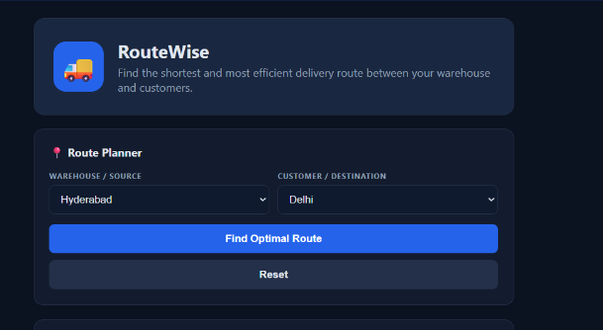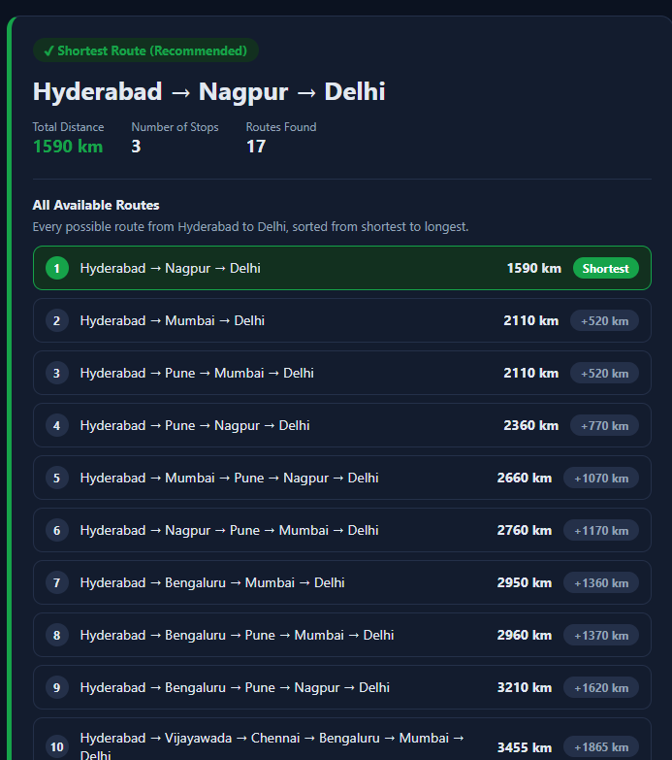

- CONCLUSION & FUTURE SCOPE
The Delivery Route Optimizer applies Data Structures and Algorithms to a practical logistics routing problem. The project represents locations and roads using a weighted graph and uses an adjacency list for efficient storage. Dijkstra’s Shortest Path Algorithm with a Min Heap Priority Queue is used to identify the shortest delivery route. The project demonstrates the practical use of Graphs, Arrays, Hash Maps, Priority Queues and Greedy Algorithms.

Future Scope: The system can be extended with real-time traffic information, GPS/map integration, multiple-vehicle route planning, dynamic road conditions, larger delivery networks, and additional optimization techniques. These extensions would make the optimizer more suitable for real-world logistics applications.

- REFERENCES

1. Delivery Route Optimizer – final project PPT, Data Structures and Algorithms – 3 (25CS2103E), Team 23, A.Y. 2026-2027.
2. Delivery Route Optimizer – project abstract, Data Structures and Algorithms – 3 (25CS2103E), Team 23, A.Y. 2026-2027.
3. Note: No external reference URLs were provided in the supplied final PPT or abstract.
4. Note: No additional external sources are listed in the supplied project materials.

