AI-Based Underwater Environmental Analytics
Final Technical Report — Draft (Day 26)

1. Executive Summary
This project packages a reproducible exploratory pipeline for predicting next-row pH from current-row pH. The selected method is one-feature Linear Regression with median imputation. It achieved held-out MAE 1.4815 and RMSE 1.9005, only marginally better than a constant-mean baseline. The source dataset is static and timestamps were synthetically generated.

2. Data and Task
The source file contains 3,276 rows but no genuine timestamps. Synthetic timestamps were added for pipeline testing. After timestamp validity filtering and next-row target construction, 2,771 supervised rows remain. The target is ph.shift(-1); the sole predictor is current-row ph.

3. Preprocessing and Split
Timestamp parsing uses coercion; invalid timestamps are dropped; rows are stably sorted ascending. The no-shuffle chronological split is 1,939 train, 416 validation and 416 test rows. Median imputation is fitted inside the saved pipeline. No scaling is applied.

4. Model Selection
Day 22 validation: pH-only Linear Regression MAE 1.25976, RMSE 1.57824; constant-median baseline MAE 1.25978, RMSE 1.57826. The simple Linear Regression candidate had the lowest reported validation RMSE, but the baseline was effectively tied. This is a simplicity-based prototype choice, not strong evidence of predictive signal.

5. Held-Out Test Results
Linear Regression MAE 1.481534, RMSE 1.900469. Constant-mean baseline MAE 1.481718, RMSE 1.901536. Improvements are only 0.000184 MAE and 0.001067 RMSE. Linear Regression had lower absolute error on 221/416 rows (53.125%). The aggregate difference is negligible.

6. Runtime and Model Size
The Linear Regression artifact is 1,227 bytes (~1.20 KB). Median inference for a batch of 416 rows was 1.086 ms and p95 2.952 ms in the recorded environment. The constant-mean baseline is 655 bytes and median inference was 0.034 ms. Runtime values are machine-dependent.

7. Error Analysis
Day 25 inspected all 416 held-out predictions. Maximum absolute error was 7.0694. The current-pH coefficient is approximately 0.010011 and the intercept approximately 6.998942; the fitted predictions therefore remain close to a near-constant value. Descriptive lower and upper pH ranges showed larger errors than middle ranges; these bins are not safety thresholds.

8. Software Workflow
The package includes a saved model, inference helper and command-line runner. A CSV with numeric `ph` is loaded; the pipeline imputes missing values and predicts next-row pH; the output preserves input columns and adds `predicted_next_ph`. Example input and output are included.

9. Limitations
Timestamps are synthetic and source data is static. The next-row target is pseudo-temporal, not a verified future underwater observation. The model uses one feature and ignores multivariate interactions. Dissolved oxygen and pressure are absent. No labelled anomaly ground truth exists. Large residuals do not prove sensor faults or physical causes. No operational underwater deployment validation has been performed.

10. Recommended Next Steps
Collect genuine time-stamped underwater sensor observations and sensor-quality metadata; confirm target and forecast horizon; include relevant sensor variables where available; obtain expert-reviewed anomaly labels; compare against simple baselines on a new chronological evaluation; and conduct deployment testing before operational claims.

11. Conclusion
The project now has a frozen, lightweight and reproducible software prototype with a documented evaluation workflow. Performance is nearly indistinguishable from a constant baseline. This should be presented as a research prototype and limitation record, not a production-ready underwater analytics system.
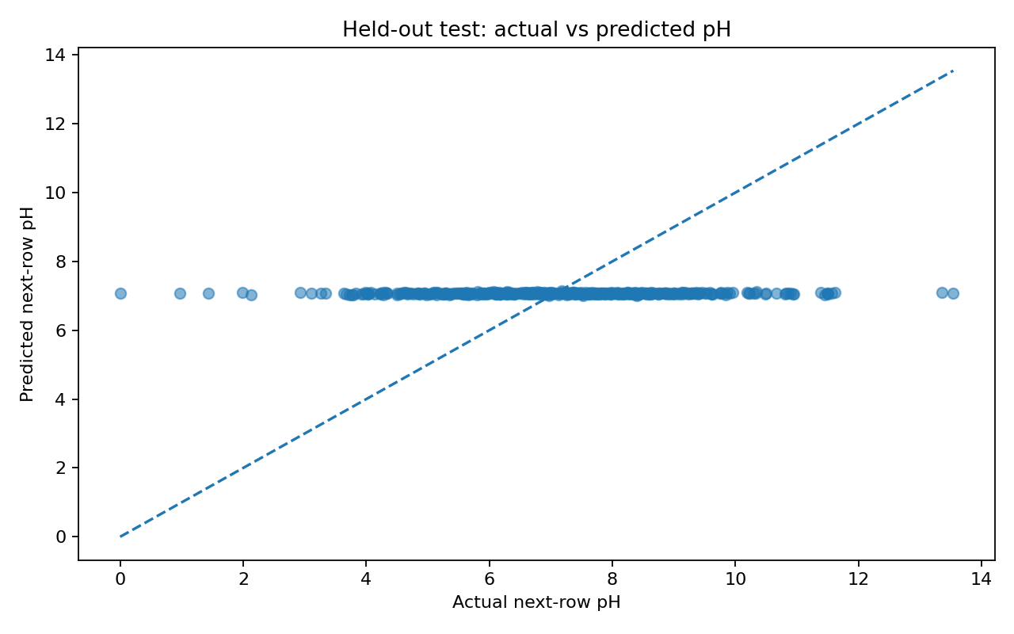
Figure 1. Actual versus predicted next-row pH.
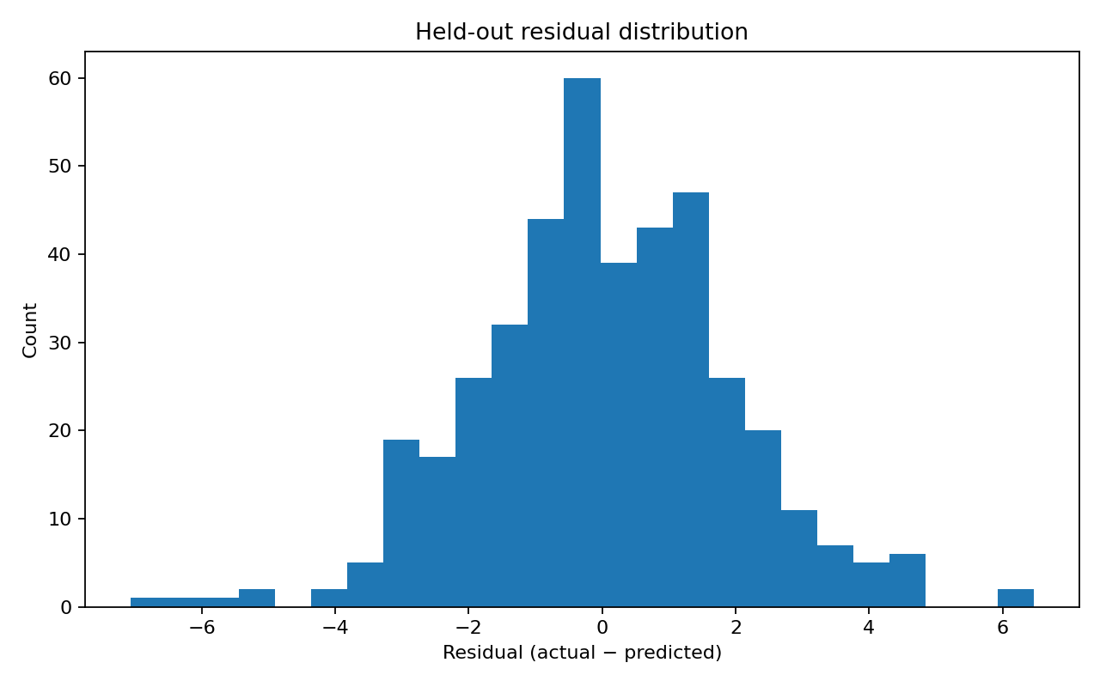
Figure 2. Held-out residual distribution.
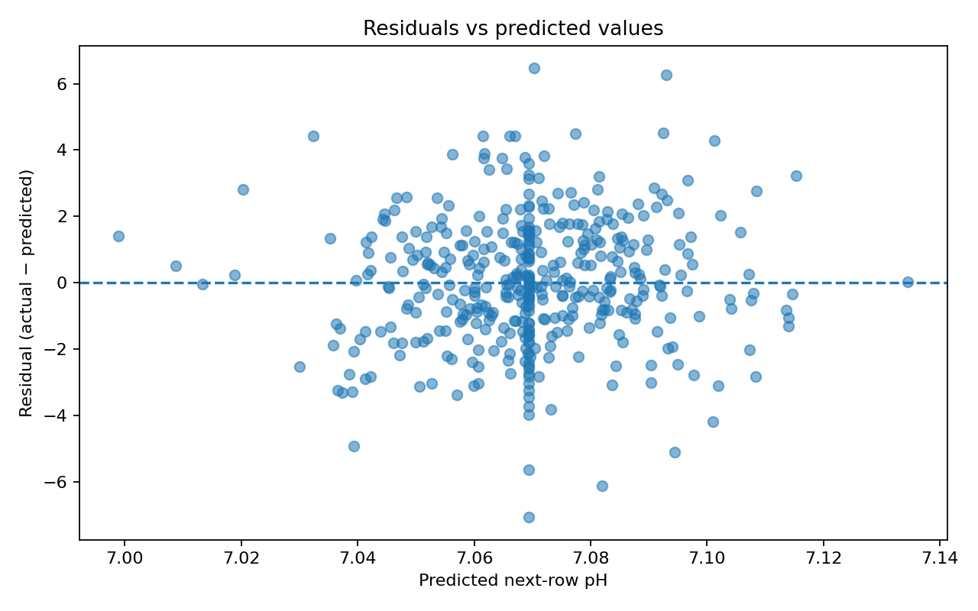
Figure 3. Residuals versus predicted values.
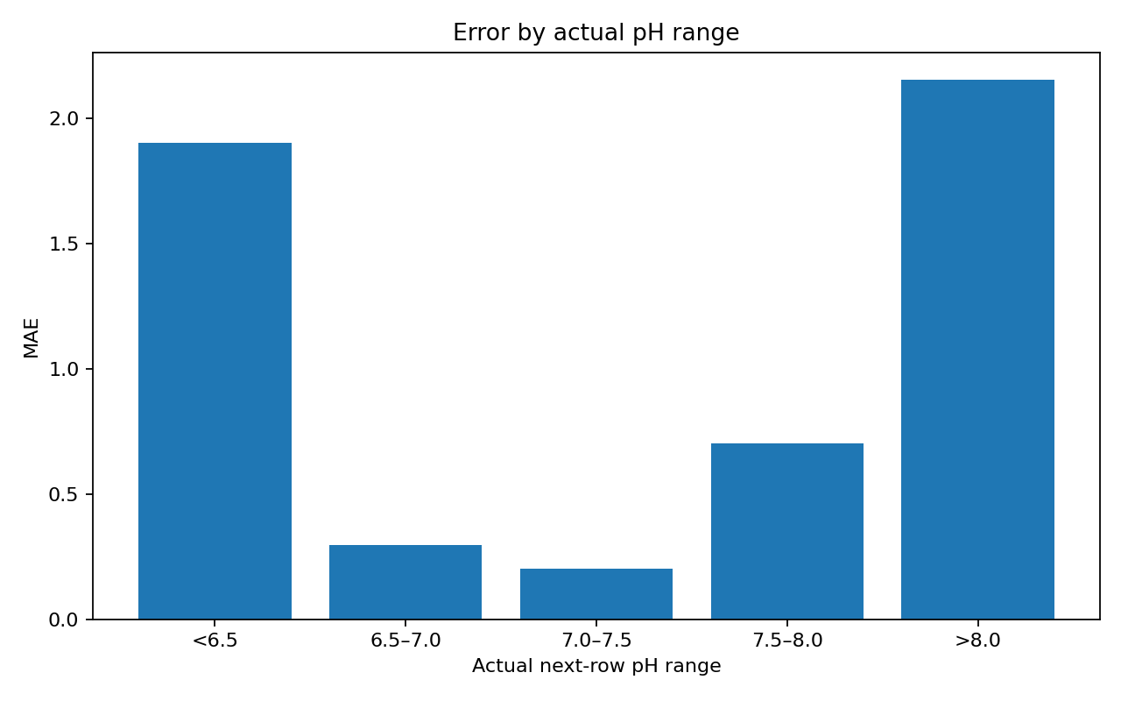
Figure 4. Descriptive MAE by actual pH range.
Draft prepared for mentor review. Mentor corrections and approval remain pending.

