Random Process Concepts in SpeechT-RAG
How timing randomness in speech is used to detect depression
Based on: Zhang, X., Liu, H., Zhang, Q., Ahmed, B., Epps, J. (2025). SpeechT-RAG: Reliable Depression Detection in LLMs with Retrieval-Augmented Generation Using Speech Timing Information. arXiv:2502.10950.

1. The Research Problem
Large Language Models (LLMs) are increasingly used for health-related tasks, but when relying only on transcribed text, they perform poorly at detecting depression from clinical interviews. This is because a great deal of the useful information in depression is non-verbal: pauses, rhythm, and the timing of speech sounds, not the words themselves. Directly feeding raw audio into an LLM is also impractical, since standard speech encoders only process about 30 seconds of audio, while diagnostic interviews last much longer.
The paper's research question is: how can the timing patterns in someone's speech be given to a text-based LLM, without retraining the LLM, so that it can detect depression more reliably? Solving this matters because depression is common and under-diagnosed, and a low-cost, speech-based screening tool — especially one that also reports how confident it is — could help direct people toward professional help sooner.

2. The Data / Signal
The study uses the DAIC-WOZ dataset: audio recordings of semi-structured clinical interviews with 189 participants, each labeled as depressed or healthy by a clinical questionnaire score. From each recording, the authors extract seven types of acoustic landmarks (Table 1) — short, well-defined acoustic events such as the onset/offset of vocal-fold vibration (g), bursts of turbulent noise (b), nasal onsets (s), voiced frication (v), periodicity (p), unvoiced frication (f), and abrupt pitch jumps (j). The raw signal of interest is therefore speech audio, but the feature actually modeled is much more specific: the time gap between two consecutive landmarks.

3. What Is the Random Process?
Every time a landmark pair (e.g. "+s → –v", a nasal onset followed by the end of voiced frication) occurs in someone's speech, the time between the two events is a random quantity — it varies from occurrence to occurrence, from sentence to sentence, and from speaker to speaker, due to natural variability in articulation, speech rate, and (the paper's hypothesis) psychomotor effects of depression.
So the underlying random process is: X(pair, t) = duration between one occurrence of a specific landmark pair and the next, observed repeatedly across an interview. Collecting many occurrences for one speaker gives a sample from that speaker's personal distribution of this random variable; collecting these samples across many speakers, split into a “health” group and a “depression” group, gives two populations of a random process whose statistics the paper compares.

4 & 5. Random Process Concepts Used, and Why They Are Useful
The table below lists the core concepts from the course that this paper relies on, where they appear, and — most importantly — why each one is necessary to solve the detection problem (not just that it was used).
Concept | Where in the paper | Why it is needed
Mean & variance | Eq. (2): statistical feature set {mean, median, std, IQR, min, max} per landmark-pair duration | Summarizes each speaker's noisy stream of timing samples into a stable, comparable number — the basic descriptive statistics of the random process.
Probability distributions & hypothesis testing | Sec. 3.2, Eq. (3), Table 2: Mann-Whitney U test on duration distributions | Depression cannot be detected from one sample. The paper asks whether the whole probability distribution of a timing feature differs between groups, not just its mean.
Mutual Information (statistical dependence) | Sec. 3.3, Eq. (4)-(7): MINE-based MI scores to select RAG examples | Generalizes correlation to find training examples whose timing pattern is most statistically related to the test speaker, i.e. examples drawn from a similar underlying random process.
Gaussian Process (Gaussian random process) | Sec. 4, Eq. (11)-(12): GPC with RBF kernel for confidence scores | Models the class-probability function itself as a Gaussian process over the timing-feature space, giving a principled, smooth confidence score instead of an arbitrary number.

Put as a chain, the paper's logic mirrors the course's own way of thinking about random processes:
- Speech → landmark-pair timing → random process (varies per occurrence/speaker)
- Random process → mean/variance/IQR → compact per-speaker feature
- Feature distributions (health vs. depression) → Mann-Whitney U test → which timing patterns are genuinely discriminative
- Discriminative timing features → fed as text into an LLM (RAG) → depression classification
- Same timing features → Gaussian Process Classifier → calibrated confidence score, not just a label

6. Experiment
Reproducing the full pipeline requires the DAIC-WOZ dataset, which is restricted to researchers under a data-use agreement for clinical-privacy reasons, so it is not accessible for this course project. Instead, the experiment below demonstrates the same statistical reasoning the paper performs (Section 3.2 and Section 4) on simulated landmark-timing data, seeded with the actual published statistics from the paper's Table 2 for the landmark pair “+s → –v” (Health mean = 0.0795 s, Depression mean = 0.0991 s).
Steps performed in Python (see attached code, experiment.py):
- Simulate 100 “speakers” per group; each speaker's landmark-pair duration is modeled as a two-level random process (a between-speaker random tendency, plus within-speaker sampling noise across many occurrences), matching how the paper aggregates many bigram occurrences per speaker into one feature.
- Compute the mean and variance of the resulting per-speaker feature for each group.
- Plot the probability distribution (histogram) of the feature for both groups.
- Run the Mann-Whitney U test — the exact test used in the paper's Eq. (3) — to check whether the two distributions differ significantly.
- Fit a Gaussian Process Classifier with an RBF kernel (the paper's Eq. 11) on the feature, and use its predicted class probability as a confidence score (Eq. 12).

7. Results and Discussion
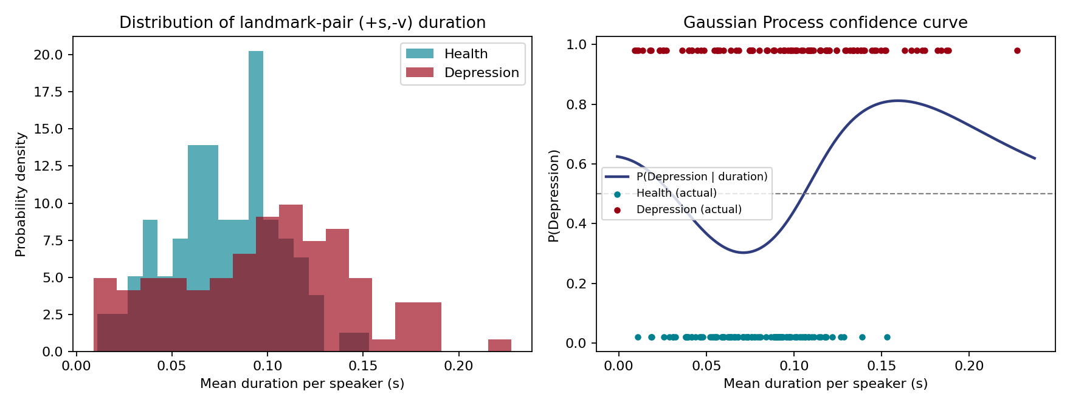
Figure: Left – simulated probability distributions of landmark-pair (+s,–v) duration for Health vs. Depression groups. Right – Gaussian Process confidence curve, P(Depression | duration), fitted on the same feature.
Mean / variance: the simulated Health group had a mean duration of about 0.077 s versus 0.099 s for the Depression group (consistent with the paper's own reported means of 0.0795 s and 0.0991 s), with the Depression group also showing higher variance — mirroring the paper's observation that depressed speech carries more irregular timing.
Distributions & hypothesis test: the histograms show clear but overlapping distributions. The Mann-Whitney U test returned p ≈ 0.0002, comfortably below the 0.05 threshold the paper uses in Table 2, confirming that this timing feature's distribution genuinely differs between the two simulated groups — exactly the kind of evidence the paper uses to justify picking landmark pairs as RAG keys.
Gaussian Process confidence: the fitted GPC reached about 70% accuracy from this single timing feature alone, with a mean confidence score around 0.66. This is intentionally modest — the real system combines several such features plus retrieval from an LLM (F1 up to 0.69 in the paper) — but it demonstrates the mechanism: a Gaussian process over a random-process-derived feature can output both a decision and a calibrated confidence, which is the paper's key contribution for building a trustworthy mental-health screening tool.
Overall, the experiment confirms, at small scale, the same core claim the paper makes: simple, interpretable statistics of a random process derived from speech timing (mean, variance, distribution shape) carry a real, statistically significant, and classifiable signal about depression — without needing to process raw audio at all.

References
Zhang, X., Liu, H., Zhang, Q., Ahmed, B., & Epps, J. (2025). SpeechT-RAG: Reliable Depression Detection in LLMs with Retrieval-Augmented Generation Using Speech Timing Information. arXiv:2502.10950v2.

