The Supporting Material is divided up into three parts. The first part contains figures that show model fits to kinetic data followed by a few, brief discussion points. The second part contains parameter tables for fixed and adjustable parameters. For the adjustable parameters, the kinetic and ROS parameters are shown in two tables. And the ranked indices are relative for each set. The third part contains the list of constitutive equations that govern the model behavior. Wherever used as a subscript, Q and QH₂ represent Q₁₀ and Q₁₀H₂, respectively, or one of their analogues (e.g. Q₁ and Q₁H₂ or DQ and DQH₂). All proton concentrations written as [H⁺] correspond to the concentration in the mitochondrial matrix. Where necessary, subscripts will be used to differentiate between proton concentrations in the matrix or outside it. For the matrix compartment, the subscript n is used. For the extra-matrix compartment, the subscript p is used.
PART 1
Figure S1 shows model simulations compared to data for NADH oxidation rates using Q₁ as the electron acceptor. The data were obtained from purified enzyme [1], bovine heart submitochondrial particles obtained by ultrasonic irradiation [2], or freeze-thawed mitochondria [3]. In general, the model captures the observed behavior. For Q₁, there exists a 2nd binding site located at the flavin site [4]. Due to the size and hydrophilic nature of Q₁, the FMN is able to reduce Q₁ and short circuit the reaction at the Q-reductase site. Since we did not include this site in our model, we ascribe any deviation from the data to this phenomenon.
Figures S2 shows model simulations reproducing data obtained using DQ as the electron acceptor. The data were obtained from permeabilized mitochondria [5], but the endogenous Q₁₀ pool is a confounding factor. In this experimental system, the Q₁₀ and DQ pools likely interact either directly or through Complex I. With the available data, the extent and nature cannot be ascertained with any degree of certainty. Therefore, three parameters were required to vary from the DQ parameters as indicated in Table S2. The model captures the observed rates of NADH oxidation as a function of various substrate and product combinations well.
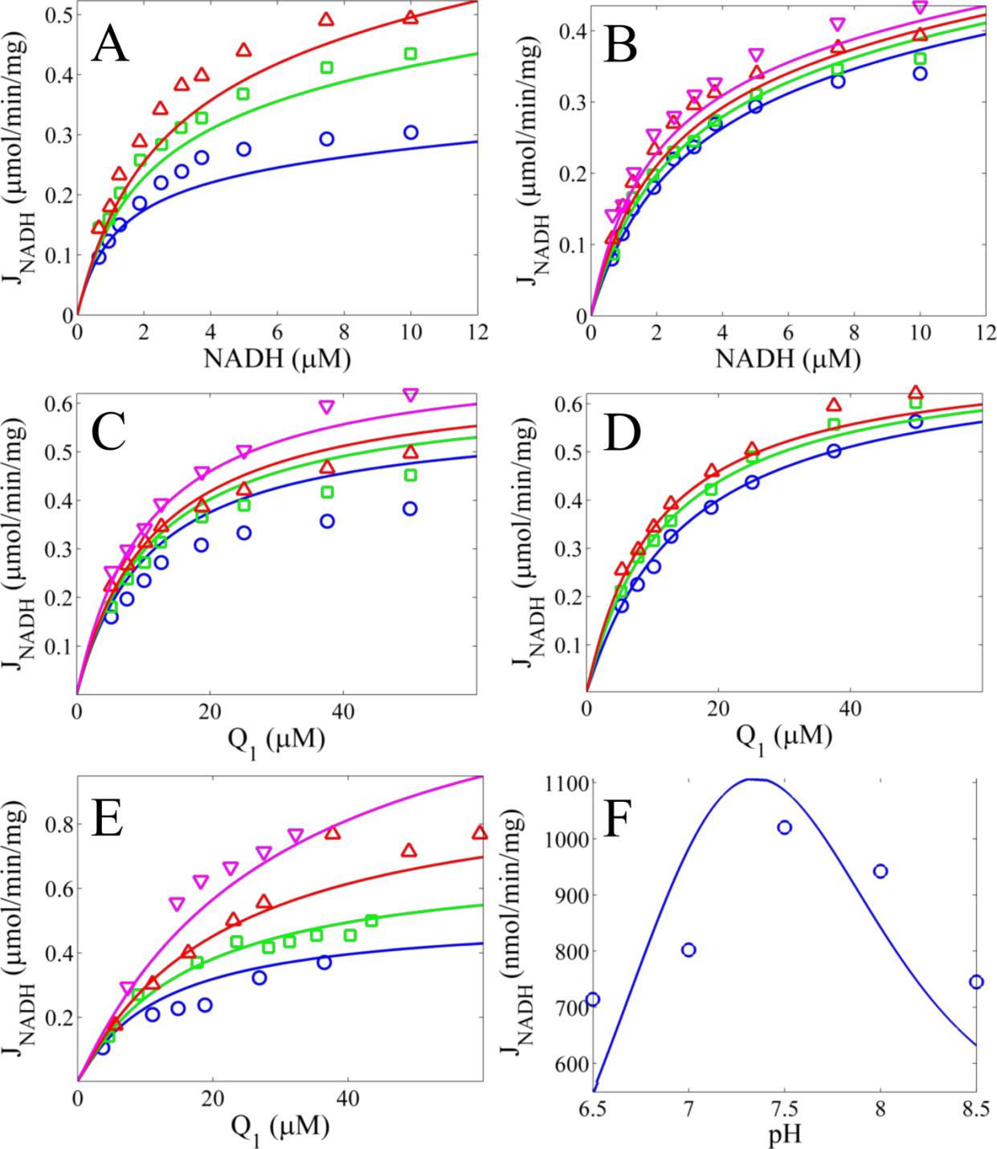
Figure S1. Model simulations of NADH oxidation rates as a function of Q1 and pH. A) Model simulations are compared with data for variable NADH concentrations at fixed Q₁ concentrations. The Q₁ concentrations are 10, 25 and 50 μM for blue, green, and red lines, respectively. B) Model simulations are compared with data for variable NADH concentrations at a fixed Q₁ concentration of 25 μM and fixed NAD⁺ concentrations. The NAD⁺ concentrations are 200, 80 20, and 0 μM for blue, green, red and magenta lines, respectively. C) Model simulations are compared with data for variable Q1 concentrations at a fixed NADH concentration of 6 μM at and fixed NAD⁺ concentrations. The NAD⁺ concentrations are 400, 200, 100, and 0 μM for blue, green, red, and magenta lines, respectively. D) Model simulations are compared with data for variable Q1 concentrations at a fixed NADH concentration of 6 μM and fixed Q₁H₂ concentrations of 0, 25, and 75 μM for blue, green, and red lines, respectively. E) Model simulations are compared with data for variable Q₁ concentrations at fixed NADH concentrations. The NADH concentrations are 4.27, 7.13, 14.19, and 75 μM for blue, green, red, and magenta lines, respectively. F) Model simulations compared with data for variable pH at an NADH concentration of 40 μM and a Q₁ concentration of 40 μM. The pH for the simulations was 8.0 for A-D, 7.5 for E, and variable for F. Data are represented by symbols and are from [1] in panels A-D, from [2] in E, and from [3] in F.
Figure S2. Model simulations of NADH oxidation rates as a function of a mixture of DQ and Q₁₀ compared to data from [5]. A) NADH concentrations are varied for fixed DQ concentrations of 1.1, 2.2, 4.4, 7.6, 10.9, 16.4, 32.7, 54.5, and 70.0 μM for blue, green, red, magenta, cyan, yellow, black, orange, and teal lines, respectively. B) DQ concentrations are varied for fixed NADH concentrations of 1.9, 3.8, 6.7, 9.5, 14.3, 20.9, 28.5, and 47.5 μM for blue, green, red, magenta, cyan, yellow, black, orange and teal lines, respectively. C) DQH₂ concentrations are varied at a fixed NADH concentration of 28.5 μM and fixed DQ concentrations of 10.9 and 54.5 μM for blue and green lines, respectively. D) NAD⁺ concentrations are varied at fixed NADH and DQ concentration combinations of 38.0 and 68.6, 95.0 and 68.6, and 95.0 and 114.1 μM for blue, green, and red lines, respectively. E) The percent of DQH₂ is varied for a fixed NADH concentration of 42.8 μM and a DQ pool size of 56.8 μM. All data are represented by symbols.
PART 2
Table 1. Fixed Model Parameters at Thermodynamic Standard State (T=298.15 K, pH = 0)
Parameter | Definition | Value | Ref.
R | Gas Constant | 8.314 J/mol/K | -
F | Faraday Constant | 96.485 J/mV/mol | -
 | NAD⁺/NADH midpoint potential | -111.7 mV | a
 | FMN/FMNH₂ midpoint potential | 55.14 mV | [6]^{b}
 | FMN/FMNH^{.-} midpoint potential | 23.54 mV | [6]^{b}
 | FMNH^{.-}/FMNH₂ midpoint potential | 86.74 mV | [6]^{b}
 | FMNH₂ pK | 7.1 | [6]^{b}
 | FMNH^{.-} pK | 7.9 | [6]^{b}
 | N2_{ox}/N2_{red} midpoint potential | -90 mV | [7]^{c}
 | N2_{ox} pK | 6 | [7]^{c}
 | N2_{red} pK | 8.5 | [7]^{c}
 | Q/QH₂ midpoint potential | 476.67 mV | d
 | O₂/O₂^{.-} midpoint potential | 33 mV | [8]
 | O₂/H₂O₂ midpoint potential | 780 mV | [8]
N_{tot} | Endogenous NAD(H) pool size | 3 mM | [9]
Q_{tot} | Endogenous Q pool size | 20 mM | [10]
ªExtrapolated to pH 0 from -320 mV at pH 7. ^{b}Refit from data in Figures 1, 2 and 3 of Sled et al. ^{c}Rrefit from data in Figure 1 of Ingledew and Ohnishi. ^{d}Extrapolated to pH 0 from 60 mV at pH 7.
Table 2. Fitted Kinetic Model Parameters
Parameter | Definition | Value | Sensitivityª | Rank
 | NADH dissociation constant for oxidized FMN | 4.74E-05 | 3.32E-01 | 5
 | NAD⁺ dissociation constant for oxidized FMN | 8.58E-04 | 6.90E-02 | 17
 | NADH dissociation constant for reduced FMN | 5.01E-04 | 3.94E-03 | 23
 | NAD⁺ dissociation constant for reduced FMN | 1.17E-05 | 1.53E-01 | 10
 | NADH dissociation constant for FMN radical | 5.90E-01 | 1.90E-05 | 27
 | NAD⁺ dissociation constant for FMN radical | 2.78E-04 | 4.81E-02 | 21
 | Q₁H₂ dissociation constant | 1.76E-04 | 1.01E-01 | 15
 | Q₁ dissociation constant | 8.09E-05 | 8.77E-02 | 16
 | Q₁ stability constant^{b} | 3.00E-08 | 2.26E-01 | 8
 | DQH₂ dissociation constant | 3.10E-04 | 1.32E-01 | 13
 | DQ dissociation constant | 5.86E-04 | 5.70E-02 | 19
 | DQ stability constant^{b} | 7.68E-10 | 2.18E-01 | 9
 | DQH₂/Q₁₀H₂ dissociation constant | 5.28E-06 | 5.50E-01 | 2
 | DQ/Q₁₀ dissociation constant | 3.24E-05 | 1.38E-01 | 12
 | DQ/Q₁₀ stability constant^{b} | 5.78E-07 | 2.42E-01 | 7
 | Q₁₀H₂ dissociation constant | 9.10E-02 | 3.65E-02 | 22
 | Q₁₀ dissociation constant | 2.96E-02 | 8.79E-04 | 24
 | Q₁₀ stability constant^{b} | 1.00E+01 | 1.02E-01 | 14
 | NADH oxidation rate for state 0 | 1.30E+05 | 2.95E-01 | 6
 | NADH oxidation rate for state 1 | 1.11E+04 | 6.74E-02 | 18
 | NADH oxidation rate for state 2 | 2.53E+02 | 5.53E-02 | 20
 | Q reduction rate for state 2 | 2.54E+05 | 5.85E-01 | 1
 | Q reduction rate for state 3 | 1.00E+13 | 8.15E-05 | 26
 | Q reduction rate for state 4 | 3.21E+05 | 2.56E-04 | 25
β | Charge translocation parameter | 0.5 | 4.21E-01 | 4
 | NADH oxidase site pK | 7.40 | 1.50E-01 | 11
 | Q reductase site pK | 6.53 | 5.42E-01 | 3
ªLocal sensitivity coefficients are normalized and averaged using the following: where f_{i} is the ith model output, p is the parameter of interest, and N_{i} is the number of model outputs with non-zero. ^{b}Stability constants defined at pH 7.
Table 3. Fitted ROS Model Parameters
Parameter | Definition | Value (M⁻¹min⁻¹) | Sensitivityª | Rank
 | Superoxide production rate from semiquinone for state 1 | 1.00E+11 | 8.75E-03 | 4
 | Superoxide production rate from semiquinone for state 2a | 1.24E-01 | 5.64E-13 | 11
 | Superoxide production rate from semiquinone for state 2b | 5.12E-02 | 2.44E-09 | 9
 | Superoxide production rate from semiquinone for state 3a | 6.87E-04 | 2.69E-13 | 13
 | Superoxide production rate from semiquinone for state 3b | 1.44E-07 | 4.09E-14 | 14
 | Superoxide production rate from semiquinone for state 4 | 1.30E-05 | 2.79E-13 | 12
 | Superoxide production rate from FMNH₂ for state 2 | 2.66E+07 | 3.64E-02 | 1
 | Superoxide production rate from FMNH₂ for state 3a | 3.49E-02 | 3.75E-10 | 10
 | Superoxide production rate from FMNH₂ for state 3b | 1.67E-03 | 3.87E-15 | 17
 | Superoxide production rate from FMNH₂ for state 4 | 3.11E+07 | 7.63E-03 | 5
 | Superoxide production rate from FMNH^{.-} for state 1 | 1.84E+08 | 3.55E-02 | 2
 | Superoxide production rate from FMNH^{.-} for state 2a | 2.42E-09 | 5.28E-15 | 16
 | Superoxide production rate from FMNH^{.-} for state 2b | 7.17E-06 | 8.23E-18 | 18
 | Superoxide production rate from FMNH^{.-} for state 3 | 1.39E+00 | 1.26E-08 | 8
 | Hydrogen peroxide production rate from FMNH₂ for state 2 | 4.69E-05 | 1.08E-14 | 15
 | Hydrogen peroxide production rate from FMNH₂ for state 3a | 2.65E+08 | 9.54E-03 | 3
 | Hydrogen peroxide production rate from FMNH₂ for state 3b | 2.65E+08 | 1.24E-03 | 6
 | Hydrogen peroxide production rate from FMNH₂ for state 4 | 2.87E+03 | 5.92E-07 | 7
ªLocal sensitivity coefficients are normalized and averaged using the following: where f_{i} is the ith model output, p is the parameter of interest, and N_{i} is the number of model outputs with non-zero.
PART 3

Reactant Binding Polynomials
Eq. 1
Eq. 2
Eq. 3
Eq. 4

Proton Binding Polynomials
Eq. 5
Eq. 6

Redox Center Protonation Binding Polynomials
Eq. 7
Eq. 8
Eq. 9
Eq. 10

Redox Center Midpoint Potentials
Eq. 11
Eq. 12
Eq. 13
Eq. 14
Eq. 15
Eq. 16
Eq. 17
Eq. 18
Eq. 19
Eq. 20

Equilibrium Constants Relative to Catalysis
Eq. 21
Eq. 22
Eq. 23
Eq. 24
Eq. 25

Equilibrium Constants Relative to Reactive Oxygen Species
Eq. 26
Eq. 27
Eq. 28
Eq. 29
Eq. 30

Substate Equilibrium Constants
Eq. 31
Eq. 32
Eq. 33

State 0 Substates
Eq. 34
Eq. 35

State 1 Substates
Eq. 36
Eq. 37
Eq. 38
Eq. 39

State 2 Substates
Eq. 40
Eq. 41
Eq. 42
Eq. 43
Eq. 44

State 3 Substates
Eq. 45
Eq. 46
Eq. 47
Eq. 48

State 4 Substates
Eq. 49
Eq. 50

Reverse State Transition Rates
Eq. 51
Eq. 52
Eq. 53
Eq. 54
Eq. 55
Eq. 56
The proton electrochemical potential, , is defined as FΔΨ+RTln([H⁺]_{p}/[H⁺]_{n}) where the subscript p denotes “positive” (extra-matrix) and n denotes “negative” (matrix) sides of the mitochondrial inner membrane.
NADH-dependent Transitions
Eq. 57
Eq. 58
Eq. 59
Eq. 60
Eq. 61
Eq. 62

Q-dependent Transitions
Eq. 63
Eq. 64
Eq. 65
Eq. 66
Eq. 67
Eq. 68

O₂^{.-}-dependent Transitions
Eq. 69
Eq. 70
Eq. 71
Eq. 72
Eq. 73
Eq. 74
Eq. 75
Eq. 76

H₂O₂-depdendent Transitions
Eq. 77
Eq. 78
Eq. 79
Eq. 80
Eq. 81
Eq. 82

Net State-Transition Rates
Eq. 83
Eq. 84
Eq. 85
Eq. 86
Eq. 87
Eq. 88
Eq. 89
Eq. 90
Eq. 91
Eq. 92
Eq. 93
Eq. 94
Eq. 95
Eq. 96

Steady-State Fractional Occupancies
Eq. 97

NADH Oxidation Rate
Eq. 98

Q Reduction Rate
Eq. 99

Superoxide Production Rate
Eq. 100

Hydrogen Peroxide Production Rate
Eq. 101

References
1. Nakashima, Y., et al., Steady-state kinetics of NADH:coenzyme Q oxidoreductase isolated from bovine heart mitochondria. J Bioenerg Biomembr, 2002. 34(1): p. 11-9.
2. Fato, R., et al., Steady-state kinetics of the reduction of coenzyme Q analogs by complex I (NADH:ubiquinone oxidoreductase) in bovine heart mitochondria and submitochondrial particles. Biochemistry, 1996. 35(8): p. 2705-16.
3. Sadek, H.A., P.A. Szweda, and L.I. Szweda, Modulation of mitochondrial complex I activity by reversible Ca2+ and NADH mediated superoxide anion dependent inhibition. Biochemistry, 2004. 43(26): p. 8494-502.
4. King, M.S., M.S. Sharpley, and J. Hirst, Reduction of hydrophilic ubiquinones by the flavin in mitochondrial NADH:ubiquinone oxidoreductase (Complex I) and production of reactive oxygen species. Biochemistry, 2009. 48(9): p. 2053-62.
5. Ransac, S., M. Heiske, and J.P. Mazat, From in silico to in spectro kinetics of respiratory complex I. Biochim Biophys Acta, 2012. 1817(10): p. 1958-69.
6. Sled, V.D., et al., Thermodynamic analysis of flavin in mitochondrial NADH:ubiquinone oxidoreductase (complex I). Biochemistry, 1994. 33(33): p. 10069-75.
7. Ingledew, W.J. and T. Ohnishi, An analysis of some thermodynamic properties of iron-sulphur centres in site I of mitochondria. Biochem J, 1980. 186(1): p. 111-7.
8. Petlicki, J. and T.G.M. van de Ven, The equilibrium between the oxidation of hydrogen peroxide by oxygen and the dismutation of peroxyl or superoxide radicals in aqueous solutions in contact with oxygen. Journal of the Chemical Society, Faraday Transactions, 1998. 94(18): p. 2763-2767.
9. Beard, D.A., A biophysical model of the mitochondrial respiratory system and oxidative phosphorylation. PLoS Comput Biol, 2005. 1(4): p. e36.
10. Bazil, J.N., et al., Analysis of the kinetics and bistability of ubiquinol:cytochrome c oxidoreductase. Biophys J, 2013. 105(2): p. 343-55.

