Supplementary Materials for the article:

Extra-matrix Mg²⁺ limits Ca²⁺ uptake and modulates Ca²⁺ uptake–independent respiration and redox state in cardiac isolated mitochondria
Age D. Boelens¹, Ranjan K. Pradhan^{2,3}, Christoph A. Blomeyer¹,
Amadou K. S. Camara^{1,4}, Ranjan K. Dash^{2,3}, David F. Stowe^{1,2,4-6}

¹Department of Anesthesiology, ²Department of Physiology, ³Biotechnology and Bioengineering Center and ⁴Cardiovascular Research Center, Medical College of Wisconsin, Milwaukee, Wisconsin 53226, USA; ⁵Research Service, Zablocki Veterans Affairs Medical Center, Milwaukee, Wisconsin, 53295, USA; ⁶Department of Biomedical Engineering, Marquette University, Milwaukee, Wisconsin, 53201, USA

Determination of Ca²⁺ K_{d} for indo-1
The K_{d} for indo-1 on its introduction as a marker for intracellular [Ca²⁺] was reported to be approximately 250 nM [Ca²⁺] at pH 7.05 at 37°C. It is well known that temperature, protein concentration, and pH can greatly influence the apparent K_{d} of indo-1 (Grynkiewicz et al 1985). Therefore, these factors must be measured and accounted for in determining the K_{d} for a particular set of experiments. We determined the K_{d} for indo-1 AM and indo-1 pentapotassium (PP) salt dye under our specific experimental conditions based on a modified protocol by Petr et al. (Petr et al 1997). We used a calibration kit provided by Invitrogen (C3008MP), which contained two bottles of 50 ml calibration solution with 100 mM KCl and 30 mM MOPS at pH 7.2, which approximate our experimental buffer conditions at 25 °C. We used 10 mM K₂-EGTA (0 [Ca²⁺] and 10 mM Ca-EGTA (maximal [Ca²⁺] of 39 µM) to determine min and max values of Ca²⁺. These stock solutions were mixed to produce solutions within this range. Free [Ca²⁺] was calculated using the formula:
Free [Ca²⁺] = K_{d}^{EGTA} • [Ca-EGTA]/[K₂-EGTA]
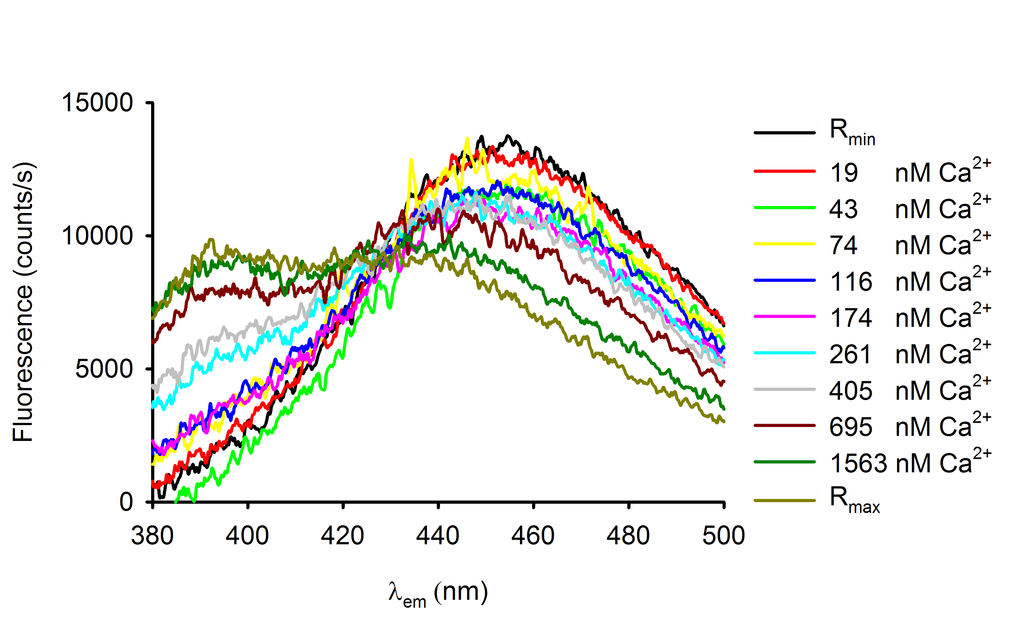
Mitochondria were loaded with either indo-1-AM or DMSO (for background measurement) at 0.5 mg protein/ml, and were suspended in calibration solution with 11 different free [Ca²⁺]. Ionomycin and CCCP were present to equilibrate Ca²⁺ and protons (pH), respectively, across the intra-mitochon-drial membrane (IMM). Continuous emission (λ_{em}) scans were recorded over the range 380 to 500 nm at excitation (λ_{ex}) 350 nm. Representative traces of emission scans from 0 to 10 mM Ca-EGTA are illustrated in Fig. S1.
Fig. S1. Fluorescence intensities (F) were measured at 456 nm and 390 nm and R was calculated by dividing F₃₉₀/F₄₅₆. 0 µM free Ca²⁺ was used to determine the ratio when all of the dye was unbound (R_{min}) and 39 µM free Ca²⁺ for ratio when all of the dye was bound (R_{max}). In a plot of –log [Ca²⁺] on the x-axis vs. –log β[(R-R_{min})/(R_{max}-R) on the y-axis, the data points formed a straight line with the x-intercept representing the pK_{d} (Fig. S2). The K_{d} for indo-1-AM inside the mitochondrial matrix (m) was determined as 326 ± 20 nM [Ca²⁺]_{m} with n =5.
We similarly determined the K_{d} for indo-1-PP salt in the presence of mitochondria under the same buffer conditions (figure not shown). For these experiments indo-1-PP salt was added to the calibration solutions directly. Mitochondria, thus not loaded with indo-1-AM, were added at 0.5 mg protein/ml. No ionomycin or CCCP was added because Ca²⁺ and protons did not need to be equilibrated. Emission scans were performed and data was processed as for indo-1-AM. The K_{d} for indo-1-PP in the external (e) medium was determined as 311 ± 24 nM [Ca²⁺]_{e} with n =3.
Fig. S2. Determination of pK_{d} for indo 1-AM

Added MgCl₂ reduces state 3 respiration via adenine nucleotide translocase
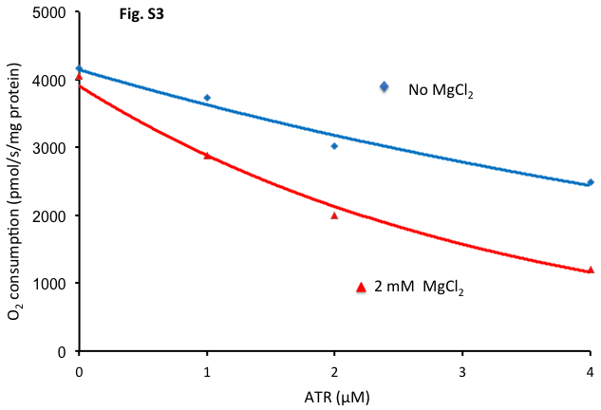
ATP/ADP (adenyl nucleotide) translocase (ANT) enables ATP⁴⁻ and ADP³⁻ to be exchanged across the mitochondrial inner membrane and requires consumption of one mole of H⁺ for each mole of nucleotide exchanged. Atractyloside (ATR) binds to ANT locking the cytosolic side in the open confirmation. Fig. S3 shows stepwise inhibition of state 3 respiration by ATR in the presence and absence of 2 mM MgCl₂ with 0.6 mM CaCl₂. Note that at 1 µM ATR, 2 mM MgCl₂ reduced O₂ consumption by about 20%; 1 mM MgCl₂ with 0.6 mM CaCl₂ reduced O₂ consumption by about 10% (Fig. 9A). This effect to reduce state 3 respiration may be due in part to greater binding of Mg²⁺ to nucleotides, which impedes ADP/ATP translocation.

Added MgCl₂ enhances state 4 respiration via Mg²⁺-dependent ATPase
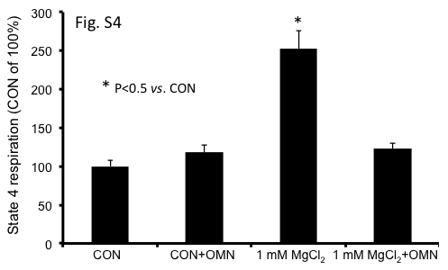
In isolated mitochondrial experiments state 4 is generally faster than state 2 because of residual ATP-ases that convert the newly formed ATP to ADP, which stimulates respiration. A slowing of state 4 respiration by oligomycin (OMN) may indicate that hydrolysis of newly formed ATP accounts for some of this effect. Moreover, since OMN blocked the effect of added MgCl₂ to enhance state 4 respiration (Fig. S4), there may be a role for higher [Mg²⁺] to enhance Mg²⁺ dependent ATPase activity.
Fig. S4. Effect of oligomycin (OMN) to reverse increase in state 4 respiration by 1 mM MgCl₂.

Effect of Mg²⁺ to reduce state 3 respiration when Ca²⁺ uptake is blocked by ruthenium red

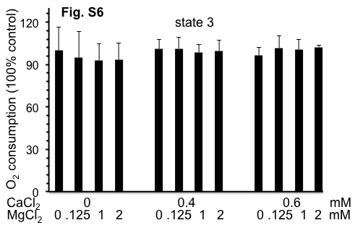
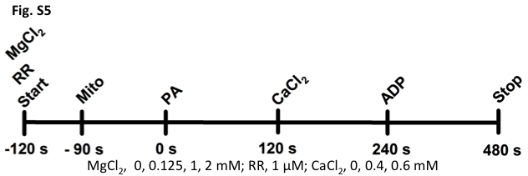
To further demonstrate that the inhibiting effect of MgCl₂ on Ca²⁺-stimulated state 3 respiration is mediated in part by elevated matrix [Ca²⁺], we conducted additional experiments in which MgCl₂ was added at different buffer [CaCl₂ ], but this time in the presence of 1 µM ruthenium red (RR) to completely block all mCa²⁺ uptake by the Ca²⁺ uniporter (CU) (Cox and Matlib, 1993; McCormack et al, 1989). Our original protocol (Fig. 1) was amended to add RR to the respiration buffer before adding CaCl₂ or MgCl₂ (Fig. S5) to prevent any Ca²⁺uptake. For these supplemental experiments, [MgCl₂] were 0, 0.125, 1 and 2 mM and [CaCl₂] were 0, 0.4 and 0.6 mM. For each [CaCl₂], RR completely inhibited the [Ca²⁺]_{m}-induced increase in state 3 respiration (Fig. S6) we observed in the absence of RR. Moreover, this effect of RR on state 3 respiration was not only observed in the absence, but also in the presence of each [MgCl₂] so that there was no difference among the groups (Fig. S6). This supplemental data agrees with the no added Ca²⁺ data shown in Fig. 9A,C). That is, under conditions where there was no Ca²⁺ uptake adding MgCl₂ did not alter state 3 respiration.

Fig. S6. State 3 respiration (n=3 hearts) at different [MgCl₂] and [CaCl₂] after adding 1 µM ruthenium red.

Ruthenium Red does not alter the external Mg²⁺⁻induced increase in state 4 respiration

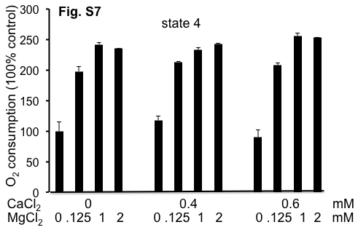
In the presence of RR at any [CaCl₂], RR did not block the increase in state 4 respiration observed by adding MgCl₂ (Fig. S7). This further confirmed that this indirect effect of Mg²⁺ to enhance state 4 respiration is independent of any change in [Ca²⁺]_{m}. Overall, these supplemental findings with RR agree with our results shown in Fig. 9B,D, i.e., increasing [MgCl₂] enhanced state 4 respiration both in the absence (Fig. 9B,D) and in the presence (Fig. S7) of RR. This effect of Mg²⁺ on state 4 respiration independent of any change in [Ca²⁺]_{m} supports our contention that the increase in state 4 respiration by MgCl₂ was caused by stimulation of extra-matrix ATPases (Fig. S4).

Fig. S7. State 4 respiration (n=3 hearts) at different [MgCl₂] and [CaCl₂] after adding 1 µM ruthenium red.

References
Cox DA, Matlib MA (1993) A role for the mitochondrial Na⁺-Ca²⁺ exchanger in the regulation of oxidative phosphorylation in isolated heart mitochondria. J Biol Chem 268(2);938-947
Grynkiewicz G, Poenie M, Tsien RY (1985) A new generation of Ca²⁺ indicators with greatly improved fluorescence properties. J Biol Chem 260(6);3440-3450
McCormack JG, Browne HM, Dawes NJ (1989) Studies on mitochondrial Ca²⁺-transport and matrix Ca²⁺ using fura-2-loaded rat heart mitochondria. Biochim Biophys Acta 973(3);420-427
Petr MJ, Wurster RD (1997) Determination of in situ dissociation constant for Fura-2 and quantitation of background fluorescence in astrocyte cell line U373-MG. Cell Calcium 21(3);233-240

