

Boundary Conditions

♦ Background

This is related to basic structural conditions of relative fixity at layer boundaries. A fixed support is one that prevents translations or rotations but supports a moment. A partially restrained support will allow some minimal amount of rotation or translation. A free support will allow displacements and rotations at its ends. Fixed supports at the base and a free support at the ends and vice versa could suffice for the demonstration that follows.

♦ Learning Objective

The relevance of the type of wave propagation obtained from different boundary conditions will be studied and related to the impedance ratio values (discussed below) of 0 and infinity and their physical meanings i.e. infinity value indicating travel of an incident wave to a fixed support.

♦Things to do

1. Open the Dr. Layer program. By default we get twelve layers. The top six layers are hardwired into the system with a very fast velocity. The bottom six layers are hardwired with a very slow velocity.

2. For our purposes we can select the bottom eleven layers to have a very slow wave speed.

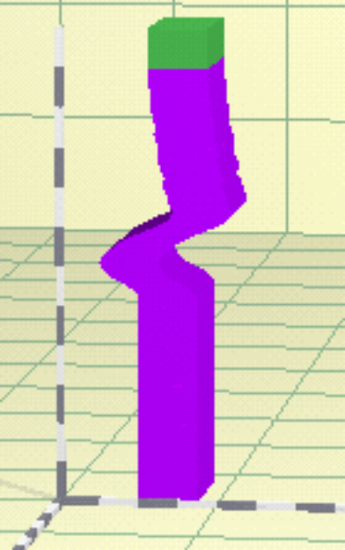

- Send a wave through the media with different load types and record your observation. Pay attention to the wave reflection and travel.

- Change the top layer to medium wavespeed. Note what you observe about the wave.

- Change the top layer to very slow wavespeed. Note what you observe about the wave.

- Repeat with another load type.

Observation

The “stiffer” member on top was made to supply some degree of fixity to the support. Although perfect fixity was not attained with our method. A trend should be noticed showing the amount of reflection obtained is a function of how rigid the boundary layer is. Ideally the end member is still considered free.

♦On your own

- Obtain motions along a string with
- The string end fixed to a wall the other end held in the hands.
- The string end free to move the other end held in the hands.

