# REDIS CLUSTER HA SOLUTIONS

**SCENERIO #1 : 2 Data Center (3 Ins per DC ), Balanced Master Distribution**

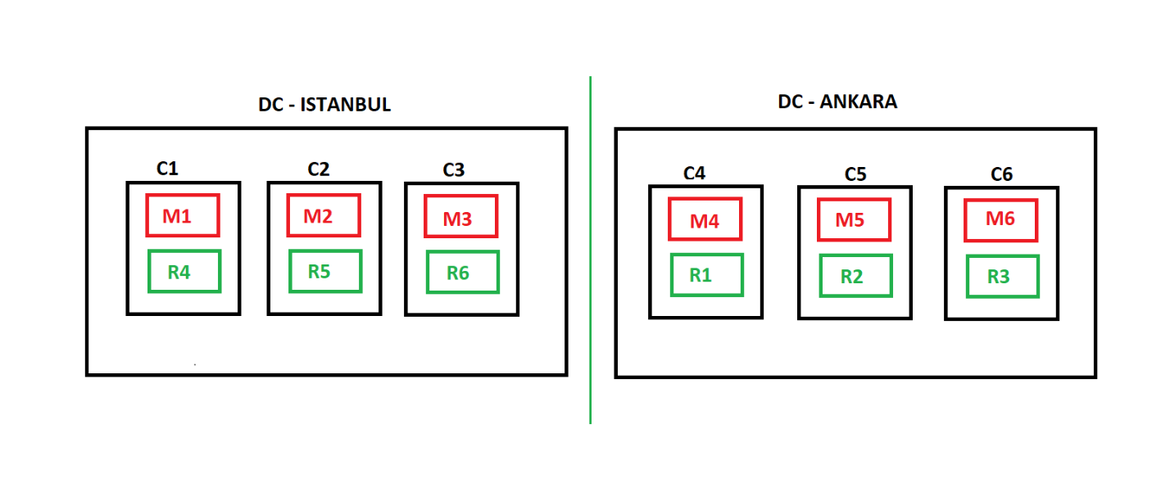

**Test #1 :**

**A -) C2, C6 Down ( Same Time ) --> Works – Cluster Status OK – No Down Time**

**B -) C5, C6 Down ( Same Time ) --> Works – Cluster Status OK – No Down Time**

**C -) C2, C3 Down ( Same Time ) --> Works – Cluster Status OK – No Down Time**

**D -) C1, C2, C3 Down ( Sequential ) --> Works (Istanbul DC ) – Cluster Status OK - No Down T.**

**E -) C4, C5, C6 Down ( Sequential) --> Works (Ankara DC) – Cluster Status OK - No Down T.**

**F -) C1, C3, C5 Down ( Sequential) --> Works – Cluster Status OK - No Down T.**

**G -) DC- Ist. Down ( Same Time ) --> Does not Works – Cluster Status FAIL – DR process**

**H -) DC- Ank. Down ( Same Time ) --> Does not Works – Cluster Status FAIL – DR process**

**Note : For sutiation G and H, there is a down-time period between 1 - 20 minutes, depends on data size. It requires manuel Disaster Recovery steps.**

**SCENERIO #2 : 2 Data Center (3 Ins per DC ), Unbalanced Master Disturbution**

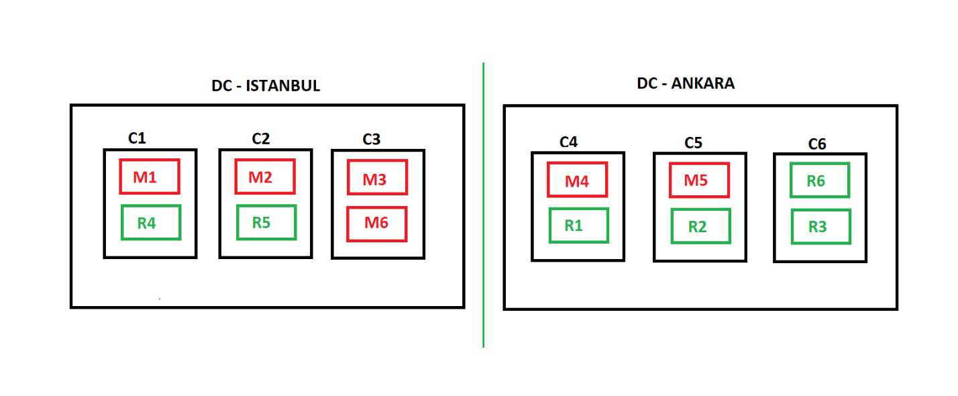

**Test #2 :**

**A -) C2, C6 Down ( Same Time ) --> Works – Cluster Status OK – No Down Time**

**B -) C5, C6 Down ( Same Time ) --> Works – Cluster Status OK – No Down Time**

**C -) C2, C3 Down ( Same Time ) --> Works – Cluster Status OK – No Down Time**

**D -) C1, C2, C3 Down ( Sequential ) --> Works (Istanbul DC ) – Cluster Status OK - No Down T.**

**E -) C4, C5, C6 Down ( Sequential) --> Works (Ankara DC) – Cluster Status OK - No Down T.**

**F -) C1, C3, C5 Down ( Sequential) --> Works – Cluster Status OK - No Down T.**

**G -) DC- Ist. Down ( Same Time ) --> Does not Works – Cluster Status FAIL – DR process**

**H -) DC- Ank. Down ( Same Time ) --> Works (Istanbul DC) – Cluster Status OK - No Down T.**

**Note : For sutiation G, there is a down-time period between 1 - 20 minutes, depends on data size. It requires manuel Disaster Recovery steps for Ankara DC.**

**SCENERIO #3 : 3 Data Center (2 Ins per DC ), Balanced Master Disturbution**

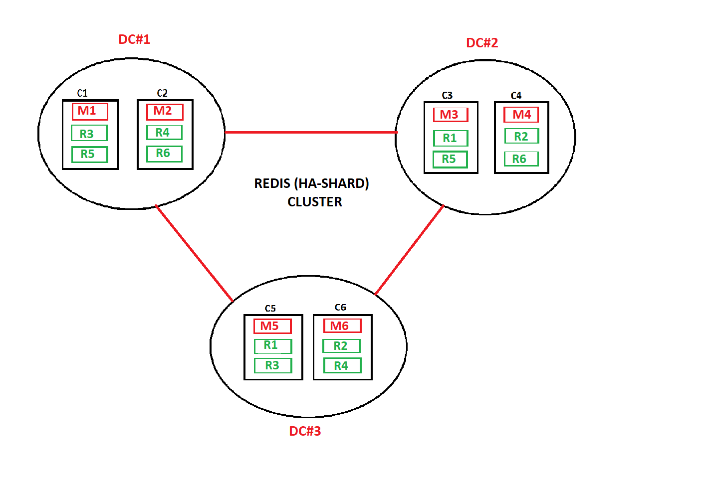

**Test #3 :**

**A -) C2, C6 Down ( Same Time ) --> Works – Cluster Status OK – No Down Time**

**B -) C5, C6 Down ( Same Time ) --> Works – Cluster Status OK – No Down Time**

**C -) C2, C3 Down ( Same Time ) --> Works – Cluster Status OK – No Down Time**

**D -) C1, C2, C3 Down ( Sequential ) --> Works – Cluster Status OK - No Down T.**

**E -) C4, C5, C6 Down ( Sequential) --> Works – Cluster Status OK - No Down T.**

**F -) C1, C3, C5 Down ( Sequential) --> Works – Cluster Status OK - No Down T.**

**G -) DC#1 Down ( Same Time ) --> Works (DC#2,DC#3) – Cluster Status OK - No Down T.**

**H -) DC#2 Down ( Same Time ) --> Works (DC#1,DC#3) – Cluster Status OK - No Down T.**

**I -) DC#3 Down ( Same Time ) --> Works (DC#1,DC#2) – Cluster Status OK - No Down T.**

**J -) DC#2,DC#3 Down ( Same Time ) --> Does not Works – Cluster Status FAIL – DR process**