# REDIS CLUSTER SCENARIOS

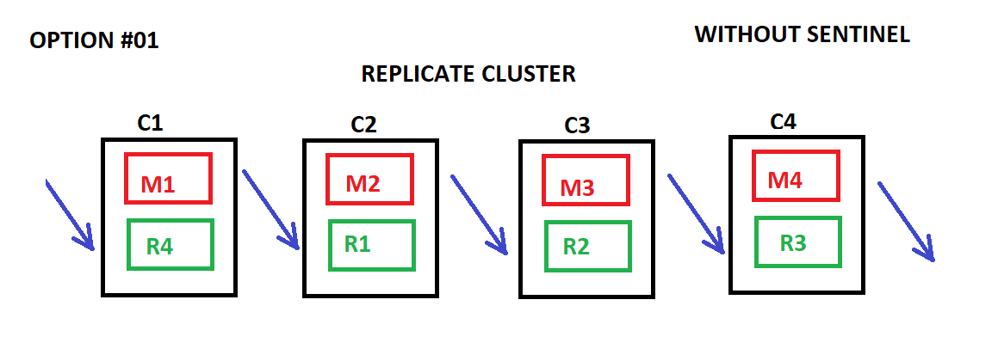

## Advantages :

* Sharding Performance Improvement
* No need to use Sentinel Configuration (Simplicity)
* Disaster Recover Power : 1

## Disadvantages :

* Memory Reduce RAM/2 ( %50 )
* No Auto-Failover
* Tested

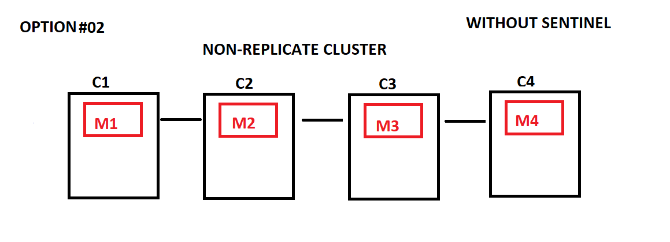

## Advantages :

* Sharding Performance Improvement
* Basic Configuration (Simplicity)
* Full Memory Capacity ( RAM %100 )

## Disadvantages :

* No Disaster – Recovery ( Highly Data Loss Probability )
* Tested

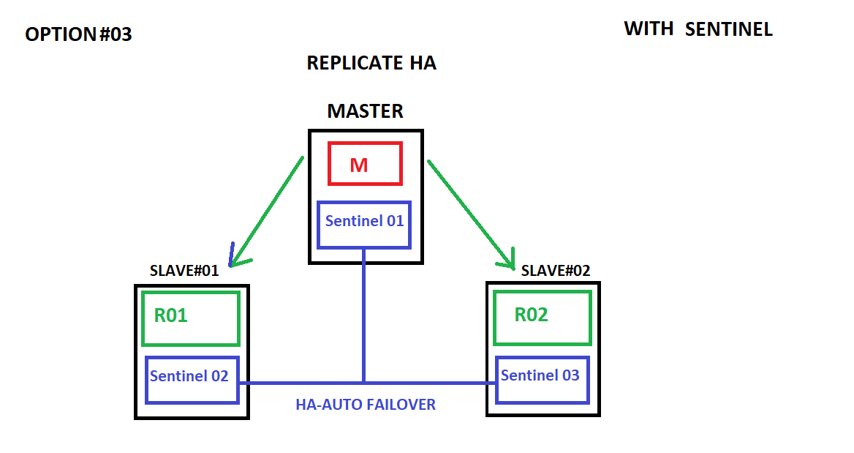

## Advantages :

* Read-Only Performance Improvement
* Disaster Recover Power : 2
* Auto-Failover

## Disadvantages :

* Memory Capacity Reduce RAM/3 ( %33 )
* More Complex Configuration
* Clients need to be smart
* Tested

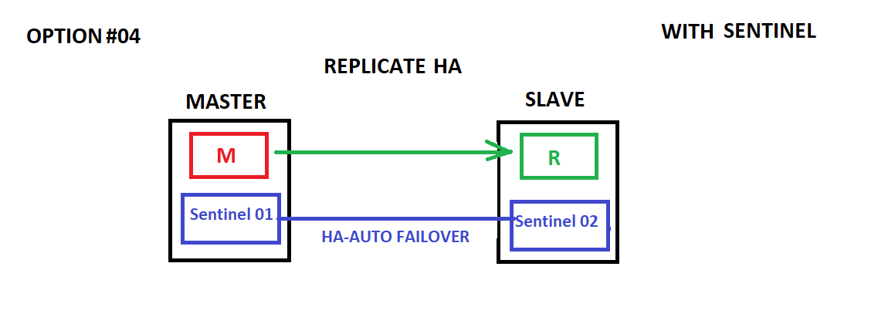

## Advantages :

* Comparatively Less Memory Capacity Reducing RAM/2 (%50 )
* Auto-Failover
* Disaster Recover Power : 1

## Disadvantages :

* Inconsistency ( Highly Risky – NOT RECOMMENDED )
* Clients need to be smart

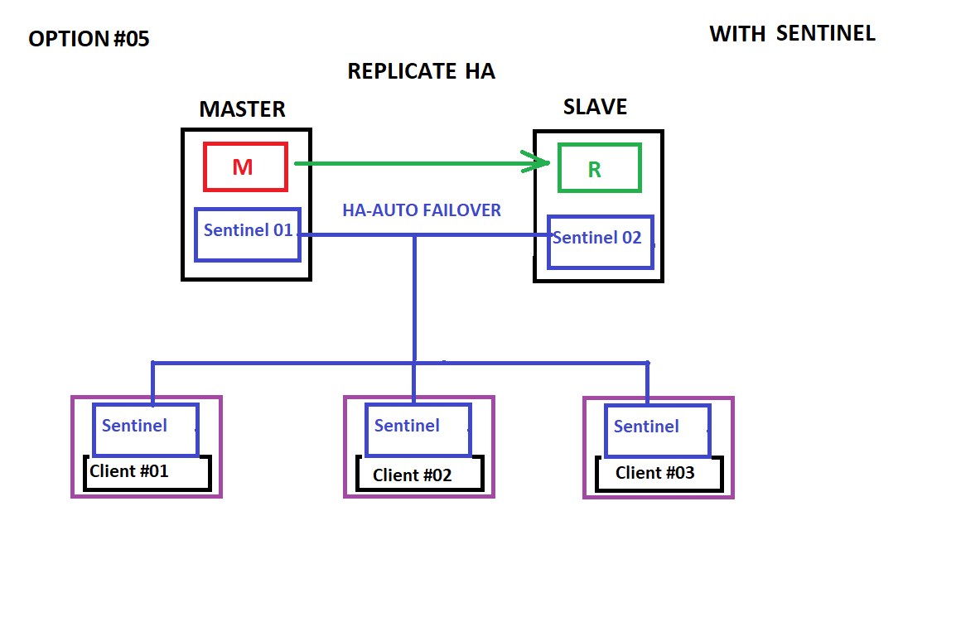

## Advantages :

* Comparatively Less Memory Capacity Reducing RAM/2 (%50 )
* Consistent Auto-Failover

## Disadvantages :

* Client Side Configuration Needs
* Clients need to be smart

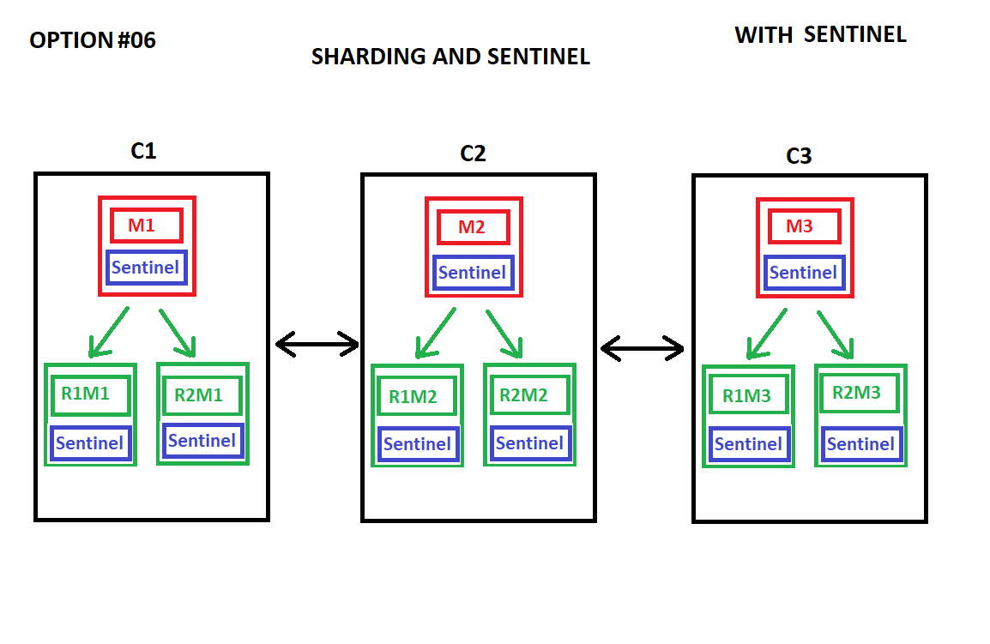

## Test Results :

* THIS DOES NOT WORK PROPERLY
* MAINTENANCE NIGTHMARE
* Have to choose Cluster or Sentinel Solution (Not Both)
* Tested