DATA ANALYTICS + MACHINE LEARNING
Student Performance Analytics
and Score Prediction
A beginner-friendly end-to-end analytics project
Prepared by | Harsh Pareek
Internship | AICTE | IBM SkillsBuild Data Analytics with AI Internship 2026 | BharatCares
Project methods | Data cleaning, EDA, visualisation, regression, model evaluation
Report date | 10 October 2026
DATA NOTE
The supplied dataset is simulated for learning and reproducibility. It contains no real student records. All numeric findings and model metrics in this report describe the simulated sample only.

1. Executive Summary
This project demonstrates how a structured dataset can be explored and used to build a simple predictive model. The notebook analyses 600 simulated student records, checks data quality, visualises score patterns, and compares Linear Regression with a Random Forest Regressor. It uses a fixed 80/20 train-test split to make the evaluation reproducible.
The average simulated final score was 71.64, with a median of 71.30. Linear Regression achieved a test MAE of 5.66 points and RMSE of 6.85 points. It performed better than the Random Forest model on this particular generated sample. This is plausible because the synthetic score was produced using mostly additive relationships.

2. Problem Statement and Objectives
Educational data can be summarised to understand patterns and demonstrate predictive analytics. The project question is: can study-related indicators and prior assessment results be used to estimate a simulated final score, and what can a beginner learn from model evaluation?
- Inspect data structure, missing values, duplicates, and value ranges.
- Use exploratory data analysis (EDA) and charts to examine score patterns.
- Build and compare two supervised regression models.
- Explain MAE, RMSE, R², and feature importance in accessible language.
- Identify limitations and safeguards for any future real-world use.

3. Dataset Description
The project includes a deterministic synthetic dataset generated with Python and random seed 42. It contains 600 rows and 11 columns, including a synthetic record identifier and simulated indicators for daily study time, attendance, previous score, assignment completion, sleep, extracurricular hours, internet access, parent support, tutoring sessions, and the final-score target.
Dataset property | Value | Notes
Rows / columns | 600 / 11 | Synthetic records
Target variable | final_score | Simulated score from 0 to 100
Missing values | 0 | None in the included CSV
Duplicate full rows | 0 | None in the included CSV
Score range | 35.4–100.0 | Clipped to valid illustrative range
No real student, school, or personally identifiable information is included. The dataset is deliberately simulated to allow the complete workflow to run offline and reproducibly.

4. Tools and Methodology
The project was created in Python and a Jupyter Notebook. pandas and NumPy support data handling; Matplotlib and Seaborn support visualisation; scikit-learn supports preprocessing, train-test splitting, regression, and model evaluation.
- Data loading: read the included CSV, or create the same 600-row sample if the CSV is unavailable.
- Data checks: inspect types, missing values, duplicates, descriptive statistics, and the final-score range.
- EDA: plot score and study-hour distributions; examine study hours and attendance against final score; calculate correlations and grouped attendance summaries.
- Preprocessing: exclude the identifier, scale numeric inputs, and one-hot encode categorical inputs using a ColumnTransformer and Pipeline.
- Training: reserve 20% for testing with random_state=42; train Linear Regression and Random Forest models on the remaining 80%.
- Evaluation: compare MAE, RMSE, and R² on held-out test data; inspect the Random Forest feature-importance ranking.

5. Exploratory Data Analysis Findings
The simulated final score had a mean of 71.64, median of 71.30, standard deviation of 10.50, minimum of 35.4, and maximum of 100.0. In this deliberately generated sample, final score had a positive correlation with previous score (r = 0.474), attendance rate (r = 0.375), and study hours per day (r = 0.280). These are patterns built into the simulated sample and should not be interpreted as causal or real-world findings.
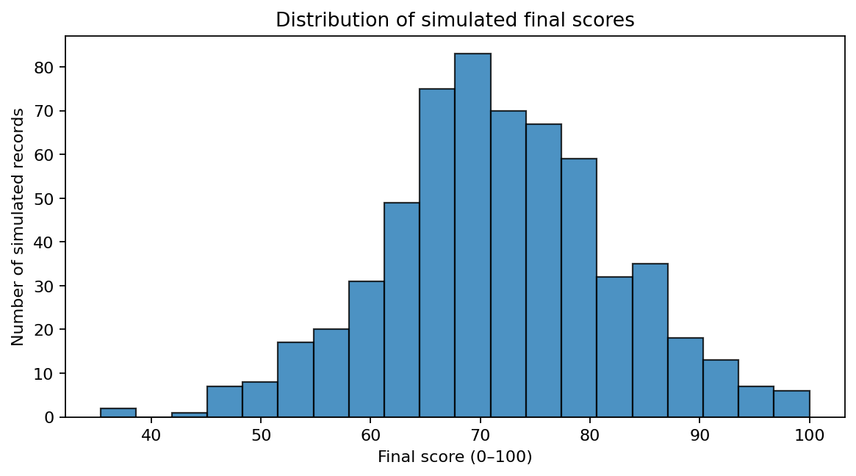
Figure 1. Distribution of the synthetic final-score target.

6. Predictive Modelling and Results
The project compares a simple Linear Regression baseline with a Random Forest Regressor. The model is selected using the lower RMSE on the held-out test set. MAE expresses the average absolute error in score points. RMSE gives larger errors more weight. R² summarises the fraction of target variation explained on this test split.
Model | MAE ↓ | RMSE ↓ | R² ↑
Linear Regression | 5.659 | 6.853 | 0.575
Random Forest | 6.425 | 7.957 | 0.427
Linear Regression was the better model for this particular dataset: MAE 5.659, RMSE 6.853, and R² 0.575. Random Forest had MAE 6.425, RMSE 7.957, and R² 0.427. The result illustrates why more complex models do not automatically outperform simpler baselines.
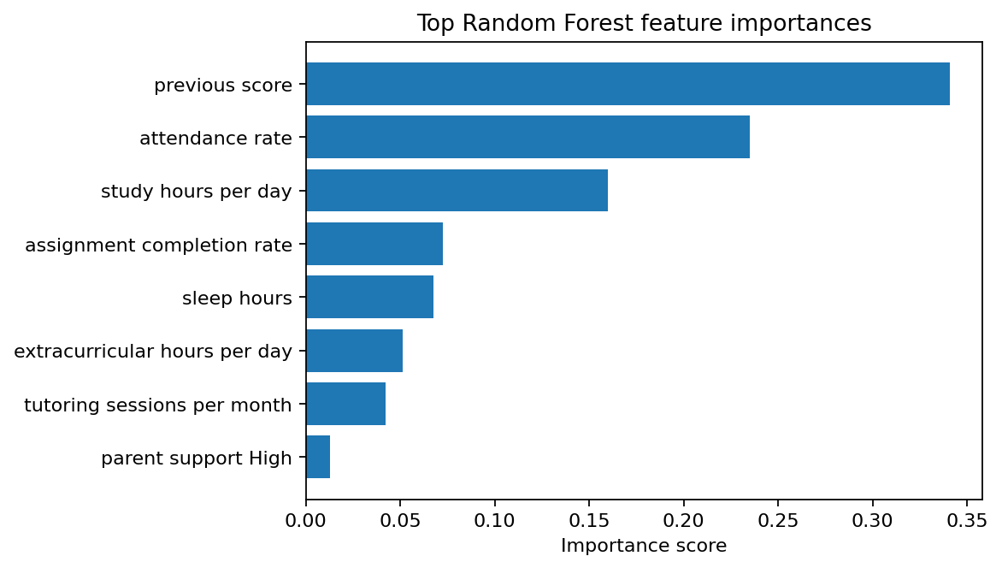
Figure 2. Random Forest feature importances in the fitted model.
The leading importance indicators were previous score, attendance rate, study hours per day, assignment completion rate. Feature importance reflects the fitted model’s use of each input; it does not show that changing a feature will necessarily cause a score change.

7. Recommendations and Responsible Use
- For a learning exercise, focus on reproducible analysis and explain metrics instead of trying to maximise a single score.
- In a real educational setting, treat predictions as prompts for supportive human review, not as labels or final decisions.
- Use consented, representative and appropriately protected data; minimise collection of sensitive information.
- Evaluate model errors across relevant student groups and monitor performance before considering any deployment.
- Do not use such predictions alone for admissions, grading, discipline, or deciding access to resources.

8. Limitations
- The dataset is synthetic and has no claim to represent real student populations.
- The sample uses a known formula to create the target; performance metrics therefore describe this formula and random noise, not a real forecasting task.
- Only two regression models and one train-test split were used; cross-validation, hyperparameter search, uncertainty estimates, and subgroup evaluation are outside this beginner project.
- Correlation and feature importance are descriptive and do not demonstrate causation.

9. Conclusion
The project demonstrates the main steps of an introductory data analytics and AI workflow: preparing structured data, investigating patterns, visualising distributions, fitting and evaluating regression models, and documenting ethical limitations. In the included synthetic sample, Linear Regression performed better than Random Forest on the selected test metrics. The main learning outcome is the complete, reproducible workflow—not a claim about real students.

10. References
1. Included project file: student_performance_synthetic.csv (generated synthetic dataset; no real student records).
2. UCI Machine Learning Repository, Student Performance dataset: https://archive.ics.uci.edu/dataset/320/student+performance (listed as an optional real-data reference only; not analysed in this submission).
3. Python library documentation: pandas (https://pandas.pydata.org/docs/), Matplotlib (https://matplotlib.org/stable/), Seaborn (https://seaborn.pydata.org/), and scikit-learn (https://scikit-learn.org/stable/).

