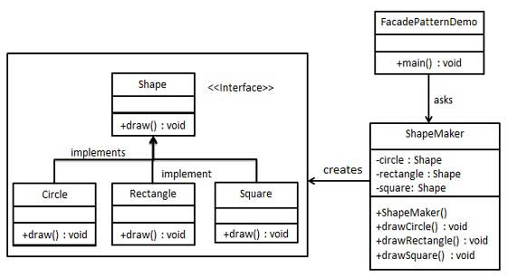
Facade Pattern:

public class facade {
public interface Shape {
void draw();
}

public class Rectangle implements Shape {

@Override
public void draw() {
System.out.println("Rectangle::draw()");
}
}

public class Square implements Shape {

@Override
public void draw() {
System.out.println("Square::draw()");
}
}

public class Circle implements Shape {

@Override
public void draw() {
System.out.println("Circle::draw()");
}
}

//facade class
public class ShapeMaker {
private Shape circle;
private Shape rectangle;
private Shape square;

public ShapeMaker() {
circle = new Circle();
rectangle = new Rectangle();
square = new Square();
}

public void drawCircle(){
circle.draw();
}
public void drawRectangle(){
rectangle.draw();
}
public void drawSquare(){
square.draw();
}
}
Step 4
Use the facade to draw various types of shapes.

FacadePatternDemo.java

public class FacadePatternDemo {
public static void main(String[] args) {
ShapeMaker shapeMaker = new ShapeMaker();

shapeMaker.drawCircle();
shapeMaker.drawRectangle();
shapeMaker.drawSquare();
}
}

